United States

SECURITIES AND EXCHANGE COMMISSION

Washington, D.C. 20549

 |  |  |  | Form 8-K
 |  |  |  | Current Report
 |  |  | Pursuant to Section 13 or 15(d) of the
 |  |  |  | Securities Exchange Act of 1934
 | Date of Report (Date of earliest event reported): November 15, 2021
 |  |  |  | Archimedes Tech SPAC Partners Co.
 |  |  | (Exact Name of Registrant as Specified in its Charter)
Delaware | 001-40193 |  |  |  |  |  |  | 86-1286799
(State or other jurisdiction |  |  |  | (Commission File Number) |  |  |  | (I.R.S. Employer
of incorporation) |  |  |  |  |  |  |  | Identification No.)
 |  |  |  | 2093 Philadelphia Pike #1968
 |  |  |  | Claymont, DE 19703
 |  |  | (Address of Principal Executive Offices and Zip Code)
 | Registrant’s telephone number, including area code: (650) 560-4753

(Former name or former address, if changed since last report)

Check the appropriate box below if the Form 8-K filing is intended to simultaneously satisfy the filing obligation of the registrant under any of the following provisions:

- Written communications pursuant to Rule 425 under the Securities Act (17 CFR 230.425)

- Soliciting material pursuant to Rule 14a-12 under the Exchange Act (17 CFR 240.14a-12)

- Pre-commencement communications pursuant to Rule 14d-2(b) under the Exchange Act (17 CFR 240.14d-2(b))

- Pre-commencement communications pursuant to Rule 13e-4(c) under the Exchange Act (17 CFR 240.13e-4(c)) Securities registered pursuant to Section 12(b) of the Act:
Title of each class |  | Trading Symbol(s) |  | Name of each exchange on which registered
Units, each consisting of one subunit and one-quarter of one warrant |  | ATSPU |  | The Nasdaq Stock Market LLC
Subunits included as part of the units, each consisting of one share of |  | ATSPT |  | The Nasdaq Stock Market LLC
common stock, $0.0001 par value, and one-quarter of one warrant
Common stock, par value $0.0001 per share |  | ATSP |  | The Nasdaq Stock Market LLC
Redeemable warrants |  | ATSPW |  | The Nasdaq Stock Market LLC

Indicate by check mark whether the registrant is an emerging growth company as defined in Rule 405 of the Securities Act of 1933 (17 CFR §230.405) or Rule 12b-2 of the Securities Exchange Act of 1934 (17 CFR §240.12b-2).

Emerging growth company ☒

If an emerging growth company, indicate by check mark if the registrant has elected not to use the extended transition period for complying with any new or revised financial accounting standards provided pursuant to Section 13(a) of the Exchange Act. ☐

Item 1.01 Entry into a Material Definitive Agreement

Merger Agreement

On November 15, 2021, Archimedes Tech SPAC Partners Co., a Delaware corporation (“Archimedes”), entered into a Merger Agreement (the “Merger Agreement”) by and among Archimedes, ATSPC Merger Sub, Inc., a Delaware corporation and a wholly owned subsidiary of Archimedes (“Merger Sub”), and SoundHound, Inc., a Delaware corporation (“SoundHound”). Pursuant to the terms of the Merger Agreement, a business combination between Archimedes and SoundHound will be effected through the merger of Merger Sub with and into SoundHound, with SoundHound surviving the merger as a wholly owned subsidiary of Archimedes (the “Merger”). The board of directors of Archimedes has (i) approved and declared advisable the Merger Agreement, the Merger and the other transactions contemplated thereby and (ii) resolved to recommend approval of the Merger Agreement and related transactions by the stockholders of Archimedes.

Merger Consideration

The total consideration to be paid by Archimedes to SoundHound security holders at the Closing will be an amount equal to $2.0 billion, with outstanding SoundHound stock options and warrants assumed by Archimedes included on a net exercise basis.

Treatment of SoundHound Securities

Cancellation of Securities. Each share of SoundHound capital stock, if any, that is owned by Archimedes, Merger Sub, SoundHound, or any of their subsidiaries (as treasury stock or otherwise) immediately prior to the Effective Time, will automatically be cancelled and retired without any conversion or consideration.

Preferred Stock. Immediately prior to the Effective Time, each issued and outstanding share of SoundHound’s (i) Series A Preferred Stock, (ii) Series B Preferred Stock, (iii) Series C Preferred Stock, (iv) Series C-1 Preferred Stock, (v) Series D Preferred Stock, (vi) Series D-1 Preferred Stock, (vii) Series D-2 Preferred Stock, (viii) Series D-3 Preferred Stock, and (ix) Series D-3A Preferred Stock (collectively, “SoundHound Preferred Stock”), will be converted into shares of Class A Common Stock, par value $0.0001 per share, of SoundHound (the “SoundHound Class A Common Stock”) at the Conversion Ratio. The “Conversion Ratio” as defined in the Merger Agreement means an amount equal to (a)(i) the sum of (A) $2,000,000,000, plus (B) the aggregate exercise price of outstanding SoundHound in-the-money stock options and warrants, divided by (ii) the number of fully diluted SoundHound shares (including in-the-money stock options and warrants); divided by (b) $10.00.

Class A Common Stock. Each share of SoundHound Class A Common Stock issued and outstanding immediately prior to the Effective Time (other than any such shares of SoundHound capital stock cancelled as described above and any dissenting shares) will be converted into the right to receive a number of shares of Class A Common Stock, par value $0.0001 per share, of Archimedes (“Class A Common Stock”) at the Conversion Ratio.

Class B Common Stock. SoundHound does not currently have any Class B Common Stock authorized or outstanding. SoundHound intends to set up a special committee of disinterested independent directors to consider a proposal from SoundHound’s founders to (1) authorize the creation of a new class of common stock, Class B Common Stock, which will be identical to the SoundHound Class A Common Stock, but will entitle the holders thereof to multiple votes per share on all matters on which stockholders are entitled to vote, with the number of votes per share to be determined by the special committee and the founders if they reach agreement on the matter, and (2) immediately prior to the Closing, exchange the shares of SoundHound Class A Common Stock held by SoundHound’s founders for Class B Common Stock in exchange for consideration to be provided by SoundHound’s founders and as agreed to by SoundHound’s founders and the special committee, and, in each case, subject to approval and ratification by SoundHound’s stockholders (excluding SoundHound’s founders and their affiliates). If SoundHound’s founders and the special committee reach agreement with respect to the authorization and issuance of the Class B Common Stock, which is approved and ratified by SoundHound’s stockholders (excluding SoundHound’s founders and their affiliates), and accordingly shares of Class B Common Stock are issued by SoundHound prior to the closing of Merger, then such shares of Class B Common Stock will be converted into the right to receive a number of shares of Class B Common Stock of Archimedes (“Archimedes Class B Common Stock”) at the Conversion Ratio. The Archimedes Class B Common Stock will have the same multiple votes per share as SoundHound’s Class B Common Stock.

1

Merger Sub Securities. Each share of common stock, par value $0.0001 per share, of Merger Sub issued and outstanding immediately prior to the Effective Time will be converted into and become one newly issued share of common stock of the Archimedes.

Stock Options. At the Effective Time, each outstanding option to purchase shares of SoundHound Common Stock will be converted into an option to purchase, subject to substantially the same terms and conditions as were applicable under such options prior to the Effective Time, shares of Class A Common Stock equal to the number of shares subject to such option prior to the Effective Time multiplied by the Conversion Ratio, with the per share exercise price equal to the exercise price prior to the Effective Time divided by the Conversion Ratio.

Warrants. Immediately prior to the Effective Time, each outstanding warrant to purchase shares of SoundHound capital stock that is unvested as of immediately prior to the Effective Time shall be automatically converted into a warrant to purchase, subject to substantially the same terms and conditions as were applicable under such warrants prior to the Effective Time, shares of the Class A Common Stock, proportionately adjusted for the Conversion Ratio, with the per share exercise price equal to the exercise price prior to the Effective Time divided by the Conversion Ratio.

Restricted Stock and SoundHound RSUs. Any outstanding restricted shares of SoundHound Common Stock that have not vested as of the Effective Time will have the same continuing vesting periods apply to the Merger Consideration Shares (as defined in the Merger Agreement) issued in exchange for such restricted shares.

Prior to the Closing, each SoundHound RSU (as defined in the Merger Agreement) will be converted into a restricted stock unit of Archimedes, subject to substantially the same terms and conditions as were applicable under the SoundHound RSU, except that upon conversion thereof, the holder of a SoundHound RSU will receive the same consideration that they would have received if such SoundHound RSU was converted into SoundHound Common Stock immediately prior to the Effective Time.

Representations and Warranties

The Merger Agreement contains customary representations and warranties of the parties thereto with respect to, among other things, (a) corporate existence and power,

- authorization to enter into the Merger Agreement and related transactions, (c) governmental authorization, (d) capital structure, (e) corporate records, (f) subsidiaries, (g) consents, (h) financial statements, (i) books and records, (j) internal accounting controls, (k) absence of changes, (l) real and personal property, (m) litigation, (n) material contracts, (o) licenses and permits, (p) compliance with laws, (q) intellectual property, (r) accounts payable and affiliate loans, (s) employee matters and benefits, (t) tax matters,
- environmental laws, (v) directors and officers, (w) insurance, (x) related party transactions, and (y) listing of securities.

Covenants

The Merger Agreement includes customary covenants of the parties with respect to operation of their respective businesses prior to consummation of the Merger and efforts to satisfy conditions to consummation of the Merger. The Merger Agreement also contains additional covenants of the parties, including, among others, access to information, cooperation in the preparation of the Form S-4 and Proxy Statement (as each such terms are defined in the Merger Agreement) required to be filed in connection with the Merger and to obtain all requisite approvals of each party’s respective stockholders including, in the case of Archimedes, approvals of the second amended and restated certificate of incorporation, amended and restated bylaws, the omnibus incentive plan and employee stock purchase plan, post-merger board of directors, and the share issuance under Nasdaq rules. Archimedes has also agreed to include in the Proxy Statement the recommendation of its board that stockholders approve all of the proposals to be presented at the special meeting.

2

Each party’s representations, warranties and pre-Closing covenants will not survive Closing and no party has any post-Closing indemnification obligations.

Archimedes Omnibus Incentive Plan and Employee Stock Purchase Plan

Archimedes has agreed to approve and adopt an omnibus equity incentive plan (the “Incentive Plan”) and employee stock purchase plan (the “ESPP”), in each case to be effective as of the Closing and in a form mutually acceptable to Archimedes and SoundHound, subject to approval of the Incentive Plan and the ESPP by the Archimedes’ stockholders. The Incentive Plan will provide for an initial aggregate share reserve equal to 10% of the number of shares of Archimedes Common Stock on a fully diluted basis at the Closing and a 5% “evergreen” provision that will provide for an automatic increase on the first day of each fiscal year in the number of shares available for issuance under the Incentive Plan as mutually determined by SoundHound and Archimedes.

Non-Solicitation Restrictions

Each of Archimedes and SoundHound has agreed that from the date of the Merger Agreement to the Effective Time or, if earlier, the valid termination of the Merger Agreement in accordance with its terms, it will not initiate any negotiations with any party relating to an Acquisition Proposal or Alternative Transaction (as such terms are defined in the Merger Agreement) or enter into any agreement relating to such a proposal. Each of Archimedes and SoundHound has also agreed to be responsible for any acts or omissions of any of its respective representatives that, if they were the acts or omissions of the Archimedes or SoundHound, as applicable, would be deemed a breach of the party’s obligations with respect to these non-solicitation restrictions.

Conditions to Closing

The consummation of the Merger is conditioned upon, among other things, (i) the absence of any applicable law or order restraining, prohibiting or imposing any condition on the consummation of the Merger and related transactions, (ii) the expiration or termination of the waiting period under the Hart-Scott-Rodino Antitrust Improvements Act of 1976, as amended, (iii) receipt of any consent, approval or authorization required by any Authority (as defined in the Merger Agreement), (iv) have no action brought by any Authority to enjoin or otherwise restrict the consummation of the Closing, (v) Archimedes having at least $5,000,001 of net tangible assets either immediately prior to or upon consummation of the Merger, (vi) approval by SoundHound stockholders of the Merger and related transactions, (vii) approval by Archimedes stockholders of the Merger and related transactions, (viii) the conditional approval for listing by Nasdaq of the shares of Class A Common Stock to be issued in connection with the transactions contemplated by the Merger Agreement and the Subscription Agreements (as defined herein) and satisfaction of initial and continued listing requirements, (ix) the Form S-4 becoming effective in accordance with the provisions of the Securities Act of 1933, as amended (“Securities Act”), (x) solely with respect to Archimedes and Merger Sub, (A) SoundHound having duly performed or complied with all of its obligations under the Merger Agreement in all material respects, (B) the representations and warranties of SoundHound being true and correct in all respects unless failure would not have or reasonably be expected to have a Material Adverse Effect (as defined in the Merger Agreement) on SoundHound or any of its subsidiaries, (C) no event having occurred that would result in a Material Adverse Effect on SoundHound or any of its subsidiaries, and (D) resignation of certain SoundHound directors as set forth in the Merger Agreement, and (xi) solely with respect to SoundHound, (A) Archimedes and Merger Sub having duly performed or complied with all of their respective obligations under the Merger Agreement in all material respects, (B) no event having occurred that would result in a Material Adverse Effect on Archimedes or Merger Sub, (C) the size and composition of the post-Closing board of directors of Archimedes being established as set forth in the Merger Agreement, (D) the amount of Parent Closing Cash (as defined in the Merger Agreement) being at least equal to the aggregate amount of commitments under the Subscription Agreements as of the date of the Merger Agreement, (E) total fees and expenses of Archimedes incurred or payable at Closing in connection with consummation of the Merger and related transactions not exceeding $10,300,000, and (F) Archimedes having amended its warrant agreement for its private warrants dated March 10, 2021 as necessary in order for the private warrants to be accounted for as equity (rather than as liabilities) under U.S. GAAP, SEC requirements and other applicable law.

3

Termination

The Merger Agreement may be terminated at any time prior to the Effective Time as follows:

- by either Archimedes or SoundHound if the Merger and related transactions are not consummated on or before the six month anniversary of the Merger Agreement (the “Outside Date”), provided that, if the SEC has not declared the Form S-4 effective on or prior to the five month anniversary of the Merger Agreement, then the Outside Date will be extended by one additional month, provided further that, the failure to consummate the transaction by the Outside Date is not due to a material breach by the party seeking to terminate the Agreement;

- by either Archimedes or SoundHound if any Authority has issued any final decree, order, judgment, award, injunction, rule or consent or enacted any law, having the effect of permanently enjoining or prohibiting the consummation of the Merger, provided that, the party seeking to terminate cannot have breached its obligations under the Merger Agreement and such breach was a substantial cause of, or substantially resulted in, such action by the Authority.

- by mutual written consent of Archimedes and SoundHound duly authorized by each of their respective boards of directors;

- by either Archimedes or SoundHound if the other party has breached any of its covenants or representations and warranties such that closing conditions would not be satisfied by the earlier of (A) the Outside Date and (B) 30 days following receipt by the breaching party of a written notice of the breach;

- by Archimedes if SoundHound has not received approval from SoundHound stockholders for the Merger and related transactions by five business days following the effective date of the Form S-4, provided that upon SoundHound receiving the such stockholder approval, Archimedes will no longer have any right to so terminate the Merger Agreement;

The Merger Agreement and other agreements described below have been included to provide investors with information regarding their respective terms. They are not intended to provide any other factual information about Archimedes, SoundHound or the other parties thereto. In particular, the assertions embodied in the representations and warranties in the Merger Agreement were made as of a specified date, are modified or qualified by information in one or more confidential disclosure letters prepared in connection with the execution and delivery of the Merger Agreement, may be subject to a contractual standard of materiality different from what might be viewed as material to investors, or may have been used for the purpose of allocating risk between the parties. Accordingly, the representations and warranties in the Merger Agreement are not necessarily characterizations of the actual state of facts about Archimedes, SoundHound or the other parties thereto at the time they were made or otherwise and should only be read in conjunction with the other information that Archimedes makes publicly available in reports, statements and other documents filed with the SEC. Archimedes and SoundHound investors and securityholders are not third-party beneficiaries under the Merger Agreement.

Certain Related Agreements

Parent Support Agreements. In connection with the execution of the Merger Agreement, certain stockholders of Archimedes, SoundHound and Archimedes entered into support agreements (the “Parent Support Agreements”) pursuant to which the stockholders of Archimedes that are parties to the Parent Support Agreements have agreed to vote all shares of common stock, par value $0.0001 per share, of Archimedes beneficially owned by them in favor of the Merger and related transactions.

Company Support Agreements. In connection with the execution of the Merger Agreement, certain stockholders of SoundHound, SoundHound and Archimedes entered into support agreements (the “Company Support Agreements”), pursuant to which the stockholders of SoundHound that are parties to the Company Support Agreements have agreed to vote all shares of SoundHound Stock beneficially owned by them in favor of the Merger and related transactions.

4

Subscription Agreements. In connection with the execution of the Merger Agreement, Archimedes entered into subscription agreements (collectively, the “Subscription Agreements”) with certain accredited investors (the “Subscribers”) pursuant to which the Subscribers have agreed to purchase, and Archimedes has agreed to sell to the Subscribers, an aggregate of 11,100,000 shares of Class A Common Stock (“PIPE Shares”), for a purchase price of $10.00 per share and an aggregate purchase price of $111,000,000. The purpose of the sale of the PIPE Shares is to raise additional capital for use in connection with the Merger and to meet the minimum cash requirements provided in the Merger Agreement. The PIPE Shares are identical to the shares of Class A Common Stock that will be held by Archimedes’ public stockholders at the time of the Closing, except that the PIPE Shares will not be entitled to any redemption rights and will not be registered with the SEC. The obligations to consummate the transactions contemplated by the Subscription Agreements are conditioned upon, among other things, customary closing conditions and the consummation of the Merger and related transactions contemplated by the Merger Agreement.

Lock-Up Agreements. In connection with the execution of the Merger Agreement, certain key SoundHound stockholders have agreed, subject to certain customary exceptions, not to (i) sell, offer to sell, contract or agree to sell, pledge or otherwise dispose of, directly or indirectly, any shares of Class A Common Stock and Class B Common Stock (collectively, “Common Stock”) held by them (such shares, together with any securities convertible into or exchangeable for or representing the rights to receive shares of Common Stock if any, acquired during the Lock-Up Period (as defined below), the “Lock-up Shares”), (ii) enter into a transaction that would have the same effect, (iii) enter into any swap, hedge or other arrangement that transfers to another, in whole or in part, any of the economic consequences of ownership of the Lock-Up Shares or otherwise, or engage in any short sales or other arrangement with respect to the Lock-Up Shares or (iv) publicly announce any intention to effect any transaction specified in clause (i) or (ii) until the date that is six months after the Closing Date (the period from the date of the agreement until such date, the “Lock-Up Period”).

Amended and Restated Registration Rights Agreement. At the closing, Archimedes will enter into an amended and restated registration rights agreement (the “Amended and Restated Registration Rights Agreement”) with certain existing stockholders of Archimedes with respect to the shares of Class A Common Stock they own at the Closing, and with certain SoundHound stockholders who will be affiliates of Archimedes with respect to the Merger Consideration after the Closing. The Amended and Restated Registration Rights Agreement will require Archimedes to, among other things, file a resale shelf registration statement on behalf of the stockholders no later than 60 days after the Closing. The Amended and Restated Registration Rights Agreement will also provide certain demand registration rights and piggyback registration rights to the stockholders, subject to underwriter cutbacks and issuer blackout periods. Archimedes will agree to pay certain fees and expenses relating to registrations under the Amended and Restated Registration Rights Agreement.

The foregoing descriptions of agreements and the transactions and documents contemplated thereby are not complete and are subject to and qualified in their entirety by reference to the Merger Agreement, form of Parent Support Agreement, form of Company Support Agreement, form of Subscription Agreement, form of Lock-Up Agreement and form of Amended and Restated Registration Rights Agreement, copies of which are filed with this Current Report on Form 8-K as Exhibits 2.1, 10.1, 10.2, 10.3, 10.4 and 10.5, respectively, and the terms of which are incorporated by reference herein.

Item 3.02 Unregistered Sales of Equity Securities.

The information set forth above in Item 1.01 of this Report under the heading “Subscription Agreements” is incorporated by reference herein. The shares of Common Stock to be issued in connection with the Subscription Agreements and the transactions contemplated thereby will not be registered under the Securities Act, in reliance on the exemption from registration provided by Section 4(a)(2) of the Securities Act and/or Regulation D promulgated thereunder.

Item 7.01 Regulation FD Disclosure.

On November 16, 2021, Archimedes and SoundHound issued a joint press release announcing the execution of the Merger Agreement and related matters. A copy of the press release is furnished hereto as Exhibit 99.1.

Furnished as Exhibits 99.2 and 99.3 hereto are the investor presentation that will be used by Archimedes and SoundHound in connection with the Merger and related matters and the transcript of the investor call on November 16, 2021 discussing the Merger and related matters.

5

The information in this Item 7.01 and Exhibits 99.1, 99.2 and 99.3, attached hereto shall not be deemed “filed” for purposes of Section 18 of the Securities Exchange Act of 1934, as amended (the “Exchange Act”), or otherwise subject to the liabilities of that section, nor shall it be deemed incorporated by reference in any filing under the Securities Act or the Exchange Act, except as expressly set forth by specific reference in such filing.

Important Information for Investors and Stockholders

This document relates to a proposed transaction between Archimedes and SoundHound. This document does not constitute an offer to sell or exchange, or the solicitation of an offer to buy or exchange, any securities, nor shall there be any sale of securities in any jurisdiction in which such offer, sale or exchange would be unlawful prior to registration or qualification under the securities laws of any such jurisdiction. Archimedes intends to file a registration statement on Form S-4 with the SEC, which will include a document that serves as a prospectus and proxy statement of Archimedes, referred to as a proxy statement/prospectus. A proxy statement/prospectus will be sent to all Archimedes stockholders. Archimedes also will file other documents regarding the proposed transaction with the SEC. Before making any voting or investment decision, investors and security holders of Archimedes are urged to read the registration statement, the proxy statement/prospectus and all other relevant documents filed or that will be filed with the SEC in connection with the proposed transaction as they become available because they will contain important information about the proposed transaction.

Investors and security holders will be able to obtain free copies of the registration statement, the proxy statement/prospectus and all other relevant documents filed or that will be filed with the SEC by Archimedes through the website maintained by the SEC at www.sec.gov.

Forward Looking Statements

Certain statements included in this Current Report on Form 8-K are not historical facts but are forward-looking statements. Forward-looking statements generally are accompanied by words such as "believe," "may," "will," "estimate," "continue," "anticipate," "intend," "expect," "should," "would," "plan," "future," "outlook," and similar expressions that predict or indicate future events or trends or that are not statements of historical matters, but the absence of these words does not mean that a statement is not forward-looking. These forward-looking statements include, but are not limited to, statements regarding estimates and forecasts of other performance metrics and projections of market opportunity. These statements are based on various assumptions, whether or not identified in this Current Report on Form 8-K and on the current expectations of Archimedes’ and SoundHound’s respective management and are not predictions of actual performance. These forward-looking statements are provided for illustrative purposes only and are not intended to serve as, and must not be relied on by any investor as, a guarantee, an assurance, a prediction or a definitive statement of fact or probability. Actual events and circumstances are difficult or impossible to predict and will differ from assumptions. Many actual events and circumstances are beyond the control of Archimedes and SoundHound. Some important factors that could cause actual results to differ materially from those in any forward-looking statements could include changes in domestic and foreign business, market, financial, political and legal conditions.

These forward-looking statements are subject to a number of risks and uncertainties, including, the inability of the parties to successfully or timely consummate the Merger, including the risk that any required regulatory approvals are not obtained, are delayed or are subject to unanticipated conditions that could adversely affect the Company or the expected benefits of the Merger, if not obtained; the failure to realize the anticipated benefits of the Merger; matters discovered by the parties as they complete their respective due diligence investigation of the other parties; the ability of Archimedes prior to the Merger, and the Company following the Merger, to maintain the listing of the Company’s shares on Nasdaq; costs related to the Merger; the failure to satisfy the conditions to the consummation of the Merger, including the approval of the Merger Agreement by the shareholders of Archimedes, the satisfaction of the minimum cash requirements of the Merger Agreement, which is an amount equal to the PIPE commitments as of the date of the Merger Agreement, following any redemptions by Archimedes’ public shareholders; the risk that the Merger may not be completed by the stated deadline and the potential failure to obtain an extension of the stated deadline; the inability to complete a PIPE transaction; the outcome of any legal proceedings that may be instituted against Archimedes or SoundHound related to the Merger; the attraction and retention of qualified directors, officers, employees and key personnel of Archimedes and SoundHound prior to the Merger, and SoundHound following the Merger; the ability of SoundHound to compete effectively in a highly competitive market; the ability to protect and enhance SoundHound’s corporate reputation and brand; the impact from future regulatory, judicial, and legislative changes in SoundHound’s industry; the uncertain effects of the COVID-19 pandemic; competition from larger technology companies that have greater resources, technology, relationships and/or expertise; future financial performance of SoundHound following the Merger including the ability of future revenues to meet projected annual bookings; the ability of SoundHound to forecast and maintain an adequate rate of revenue growth and appropriately plan its expenses; the ability of SoundHound to generate sufficient revenue from each of its revenue streams; the ability of SoundHound’s patents and patent applications to protect SoundHound’s core technologies from competitors; SoundHound’s ability to manage a complex set of marketing relationships and realize projected revenues from subscriptions, advertisements, product sales and/or services; SoundHound’s ability to execute its business plans and strategy; and those factors set forth in documents of Archimedes filed, or to be filed, with SEC. The foregoing list of risks is not exhaustive.

6

If any of these risks materialize or our assumptions prove incorrect, actual results could differ materially from the results implied by these forward-looking statements. There may be additional risks that neither Archimedes nor SoundHound presently know, or that Archimedes and SoundHound currently believe are immaterial that could also cause actual results to differ from those contained in the forward-looking statements. In addition, forward-looking statements reflect Archimedes’ and SoundHound’s current expectations, plans and forecasts of future events and views as of the date hereof. Nothing in this Current Report on Form 8-K and the attachments hereto should be regarded as a representation by any person that the forward-looking statements set forth herein will be achieved or that any of the contemplated results of such forward-looking statements will be achieved. You should not place undue reliance on forward-looking statements in this Current Report on Form 8-K and the attachments hereto, which speak only as of the date they are made and are qualified in their entirety by reference to the cautionary statements herein and the risk factors of Archimedes and SoundHound described above. Archimedes and SoundHound anticipate that subsequent events and developments will cause their assessments to change. However, while Archimedes and SoundHound may elect to update these forward-looking statements at some point in the future, they each specifically disclaim any obligation to do so, except as required by law. These forward-looking statements should not be relied upon as representing Archimedes’ or SoundHound’s assessments as of any date subsequent to the date of this Current Report. Accordingly, undue reliance should not be placed upon the forward-looking statements.

Participants in the Solicitation

Archimedes and SoundHound and their respective directors and executive officers may be deemed to be participants in the solicitation of proxies from Archimedes’ stockholders in connection with the proposed transaction. A list of the names of the directors and executive officers of Archimedes and information regarding their interests in the Merger will be contained in the proxy statement/prospectus when available. You may obtain free copies of these documents as described in the preceding paragraph.

This communication does not constitute an offer to sell or the solicitation of an offer to buy any securities or a solicitation of any vote or approval, nor shall there be any sale of any securities in any state or jurisdiction in which such offer, solicitation, or sale would be unlawful prior to registration or qualification under the securities laws of such other jurisdiction.

Item 9.01 |  | Financial Statements and Exhibits.
(d) Exhibits:
Exhibit |  | Description
2.1* |  | Merger Agreement dated as of November 15, 2021 by and among Archimedes Tech SPAC Partners Co., ATSPC Merger Sub, Inc. and SoundHound, Inc.
10.1 |  | Form of Parent Support Agreement dated as of November 15, 2021 by and among Archimedes Tech SPAC Partners Co, SoundHound, Inc. and certain
 |  | stockholders of Archimedes Tech SPAC Partners Co.
10.2 |  | Form of Company Support Agreement dated as of November 15, 2021 by and among Archimedes Tech SPAC Partners Co., SoundHound, Inc. and certain
 |  | stockholders of SoundHound, Inc.
10.3 |  | Form of Subscription Agreement.
10.4 |  | Form of Lock-Up Agreement.
10.5 |  | Form of Amended and Restated Registration Rights Agreement.
99.1 |  | Press Release issued by Archimedes Tech SPAC Partners Co. and SoundHound, Inc. on November 16, 2021.
99.2 |  | Investor Presentation dated November 16, 2021
99.3 |  | Transcript of Investor Call dated November 16, 2021
104 |  | Cover Page Interactive Data File - the cover page XBRL tags are embedded within the Inline XBRL document.

- Certain exhibits and schedules to this Exhibit have been omitted in accordance with Regulation S-K Item 601(b)(2). Archimedes agrees to furnish supplementally a copy of all omitted exhibits and schedules to the Securities and Exchange Commission upon its request.

7

SIGNATURES

Pursuant to the requirements of the Securities Exchange Act of 1934, the Registrant has duly caused this report to be signed on its behalf by the undersigned hereunto duly authorized.

Dated: November 16, 2021

Archimedes Tech SPAC Partners Co.

By: | /s/ Stephen N. Cannon
Name: | Stephen N. Cannon
Title: | Chief Executive Officer

8

Exhibit 2.1

MERGER AGREEMENT

dated as of

November 15, 2021

by and among

SoundHound, Inc.,

Archimedes Tech SPAC Partners Co.,

and

ATSPC Merger Sub, Inc.

 | TABLE OF CONTENTS
 |  | Page
ARTICLE I DEFINITIONS |  | 2
1.1 | Definitions | 2
1.2 | Construction | 16
ARTICLE II MERGER |  | 18
2.1 | Merger | 18
2.2 | Merger Effective Time | 18
2.3 | Effect of the Merger | 18
2.4 | U.S. Tax Treatment | 18
2.5 | Certificate of Incorporation; Bylaws | 19
2.6 | Closing | 19
2.7 | Directors and Officers of Surviving Corporation | 19
2.8 | Directors of Parent | 19
2.9 | Taking of Necessary Action; Further Action | 20
2.10 | No Further Ownership Rights in Company Capital Stock | 20
ARTICLE III EFFECT OF THE MERGER |  | 20
3.1 | Effect of the Merger on Company Capital Stock | 20
3.2 | Treatment of Company Options, Company Warrants, Company Restricted Stock and Company RSUs | 21
3.3 | Dissenting Shares | 22
3.4 | Surrender and Payment | 22
3.5 | Consideration Spreadsheet | 23
3.6 | Adjustment | 24
3.7 | No Fractional Shares | 25
3.8 | Withholding | 25
3.9 | Lost or Destroyed Certificates | 25
ARTICLE IV REPRESENTATIONS AND WARRANTIES OF THE COMPANY |  | 25
4.1 | Corporate Existence and Power | 25
4.2 | Authorization | 26

i

 | TABLE OF CONTENTS CONTINUED
 |  | Page
4.3 | Governmental Authorization | 26
4.4 | Non-Contravention | 27
4.5 | Capitalization | 27
4.6 | Corporate Records | 28
4.7 | Subsidiaries | 28
4.8 | Consents | 28
4.9 | Financial Statements | 28
4.10 | Books and Records | 29
4.11 | Internal Accounting Controls | 29
4.12 | Absence of Certain Changes | 29
4.13 | Properties; Title to the Company’s Assets | 29
4.14 | Litigation | 30
4.15 | Contracts | 30
4.16 | Licenses and Permits | 31
4.17 | Compliance with Laws | 32
4.18 | Intellectual Property | 32
4.19 | Accounts Payable; Affiliate Loans | 35
4.20 | Employees; Employment Matters | 35
4.21 | Withholding | 37
4.22 | Employee Benefits | 37
4.23 | Real Property | 38
4.24 | Tax Matters | 39
4.25 | Environmental Laws | 40
4.26 | Finders’ Fees | 40
4.27 | Powers of Attorney, Suretyships and Bank Accounts | 40
4.28 | Directors and Officers | 40
4.29 | Anti-Money Laundering Laws | 40
4.30 | Insurance | 41
4.31 | Related Party Transactions | 41
4.32 | Information Supplied | 41

ii

 | TABLE OF CONTENTS CONTINUED
 |  | Page
ARTICLE V REPRESENTATIONS AND WARRANTIES OF PARENT AND MERGER SUB |  | 42
5.1 | Corporate Existence and Power | 42
5.2 | Corporate Authorization | 42
5.3 | Governmental Authorization | 42
5.4 | Non-Contravention | 43
5.5 | Finders’ Fees | 43
5.6 | Issuance of Shares | 43
5.7 | Capitalization | 43
5.8 | Information Supplied | 44
5.9 | Trust Fund | 44
5.10 | Listing | 44
5.11 | Board Approval | 44
5.12 | Parent SEC Documents and Financial Statements | 45
5.13 | Certain Business Practices | 46
5.14 | Anti-Money Laundering Laws | 46
5.15 | Compliance with Laws | 46
5.16 | Affiliate Transactions | 46
5.17 | Litigation; Permits | 46
5.18 | Indebtedness | 46
5.19 | Absence of Certain Changes | 46
5.20 | Employees and Employee Benefit Plans | 46
5.21 | Properties | 47
5.22 | Parent Material Contracts | 47
5.23 | Insurance | 47
5.24 | Investment Company Act | 47
5.25 | PIPE Financing | 48
5.26 | Tax Matters | 48
5.27 | CFIUS Foreign Person Status | 49

iii

 | TABLE OF CONTENTS CONTINUED
 |  | Page
ARTICLE VI COVENANTS OF THE PARTIES PENDING CLOSING |  | 49
6.1 | Conduct of the Business | 49
6.2 | Exclusivity | 52
6.3 | Access to Information | 53
6.4 | Notices of Certain Events | 53
6.5 | Cooperation with Form S-4/Proxy Statement; Other Filings | 53
6.6 | Trust Account | 55
6.7 | Obligations of Merger Sub | 55
6.8 | Cooperation with Antitrust Law Approvals | 56
6.9 | Subscription Agreements | 56
6.10 | Parent Private Warrant Amendment | 56
ARTICLE VII COVENANTS OF THE COMPANY |  | 56
7.1 | No Insider Trading | 56
7.2 | [reserved] | 57
7.3 | Company’s Stockholders Approval | 57
7.4 | Additional Financial Information | 57
7.5 | Lock-Up Agreements | 57
7.6 | Company Amended Charter and Class B Share Exchange | 57
ARTICLE VIII COVENANTS OF ALL PARTIES HERETO |  | 58
8.1 | Commercially Reasonable Efforts; Further Assurances; Governmental Consents | 58
8.2 | Compliance with SPAC Agreements | 59
8.3 | Confidentiality | 59
8.4 | Directors’ and Officers’ Indemnification and Liability Insurance | 59
8.5 | Parent Public Filings; NASDAQ | 60
8.6 | Certain Tax Matters | 60
8.7 | Parent Equity Incentive Plan and Employee Stock Purchase Plan | 60
8.8 | Parent Expenses | 60
ARTICLE IX CONDITIONS TO CLOSING |  | 60
9.1 | Condition to the Obligations of the Parties | 60
9.2 | Conditions to Obligations of Parent and Merger Sub | 61
9.3 | Conditions to Obligations of the Company | 62

iv

 | TABLE OF CONTENTS CONTINUED
 |  | Page
ARTICLE X TERMINATION |  | 63
10.1 | Termination Without Default | 63
10.2 | Termination Upon Default | 63
10.3 | Effect of Termination | 64
ARTICLE XI MISCELLANEOUS |  | 64
11.1 | Notices | 64
11.2 | Amendments; No Waivers; Remedies | 65
11.3 | Arm’s Length Bargaining; No Presumption Against Drafter | 65
11.4 | Publicity | 65
11.5 | Expenses | 66
11.6 | No Assignment or Delegation | 66
11.7 | Governing Law | 66
11.8 | Counterparts; Facsimile Signatures | 66
11.9 | Entire Agreement | 66
11.10 | Severability | 66
11.11 | Further Assurances | 66
11.12 | Third Party Beneficiaries | 67
11.13 | Waiver | 67
11.14 | No Other Representations; No Reliance | 67
11.15 | Waiver of Jury Trial | 68
11.16 | Submission to Jurisdiction | 69
11.17 | Arbitration | 69
11.18 | Remedies | 70
11.19 | Non-Recourse | 70
Exhibit A – | Form of Company Support Agreements
Exhibit B – | Form of Parent Support Agreement
Exhibit C – | Form of Lock-Up Agreement
Exhibit D – | Form of Registration Rights Agreement
Exhibit E – | Form of Subscription Agreement

v

MERGER AGREEMENT

MERGER AGREEMENT dated as of November 15, 2021 (this “Agreement”), by and among SoundHound, Inc., a Delaware corporation (the “Company”), Archimedes Tech SPAC Partners Co., a Delaware corporation (“Parent”), and ATSPC Merger Sub, Inc., a Delaware corporation (“Merger Sub”).

W I T N E S E T H:

A. The Company and its Subsidiaries (the “Company Group”) are in the business of developing, owning and commercializing voice, sound and natural language artificial intelligence technologies and related activities (as conducted or currently proposed to be conducted by the Company Group, the “Business”);

B. Parent is a blank check company formed for the sole purpose of entering into a share exchange, asset acquisition, share purchase, recapitalization, reorganization or other similar business combination with one or more businesses or entities, and Merger Sub is a wholly-owned subsidiary of Parent;

C. Merger Sub will merge with and into the Company (the “Merger”), after which the Company will be the surviving company (the “Surviving Corporation”) and a wholly-owned subsidiary of Parent and Parent shall change its name to “SoundHound AI, Inc.”;

D. Contemporaneously with the execution of, and as a condition and an inducement to Parent and the Company entering into this Agreement, certain Company Securityholders are entering into and delivering Support Agreements, substantially in the form attached hereto as Exhibit A (each, a “Company Support Agreement”), pursuant to which each such Securityholders has agreed to vote in favor of this Agreement and the Merger and the other transactions contemplated hereby, and to the extent applicable, participate in the Class B Share Exchange (as defined below);

E. Contemporaneously with the execution of, and as a condition and an inducement to Parent and the Company entering into this Agreement, Sponsor and certain other stockholders of Parent that are officers or directors of Parent are entering into and delivering Support Agreements, substantially in the form attached hereto as Exhibit B (each, a “Parent Support Agreement”), pursuant to which each such Parent stockholder has agreed (i) not to transfer or redeem any shares of Parent Common Stock held by such Parent stockholder, (ii) to vote in favor of this Agreement and the Merger at the Parent Stockholder Meeting, and (iii) subject to and effective upon the Closing, to effect the Parent Private Warrant Amendment (as defined herein);

F. Prior to or simultaneously with the execution and delivery of this Agreement, Parent has entered into subscription agreements in the form attached as Exhibit E hereto (each, a “Subscription Agreement”) with certain investors (the “PIPE Investors”) for an aggregate investment of $111,000,000 (the “PIPE Financing Amount”) at $10.00 per share (for an aggregate of $11,100,000 shares of Parent Class A Common Stock (as defined below) (the “PIPE Shares”)) in a private placement in Parent to be consummated substantially concurrently with the Closing (the “PIPE Financing”);

G. For U.S. federal income tax purposes, the parties hereto intend that the Merger will qualify as a reorganization within the meaning of Section 368(a) of the Code and the Company’s Board of Directors and the Boards of Directors of Parent and Merger Sub have approved this Agreement and intend that it constitute a plan of reorganization within the meaning of Treasury Regulation Section 1.368-2(g); and

H. The Boards of Directors of each of the Company, Parent and Merger Sub have (i) approved and declared advisable this Agreement and the transactions contemplated by this Agreement and the Additional Agreements to which they are or will be party, including the Merger, and the performance of their respective obligations hereunder or thereunder, on the terms and subject to the conditions set forth herein or therein, (ii) determined that this Agreement and such transactions are fair to, and in the best interests of, them and their respective stockholders and (iii) resolved to recommend that their stockholders approve the Merger and such other transactions and adopt this Agreement and the Additional Agreements to which they are or will be a party and the performance of such party of its obligations hereunder and thereunder.

In consideration of the mutual covenants and promises set forth in this Agreement, and other good and valuable consideration, the receipt and sufficiency of which are hereby acknowledged, the parties hereby agree as follows:

ARTICLE I

DEFINITIONS

1.1 Definitions.

“AAA” has the meaning set forth in Section 11.17.

“AAA Procedures” has the meaning set forth in Section 11.17.

“Action” means any legal action, litigation, suit, claim, hearing, proceeding or investigation, including any audit, claim or assessment for Taxes or otherwise, by or before any Authority.

“Additional Agreements” means the Registration Rights Agreement, the Company Support Agreements, the Subscription Agreements, the Parent Support Agreements and the Lock-Up Agreements.

“Additional Parent SEC Documents” has the meaning set forth in Section 5.12(a).

“Affiliate” means, with respect to any Person, any other Person directly or indirectly Controlling, Controlled by or under common Control with such Person.

“Aggregate Exercise Price” means the aggregate dollar amount payable to the Company upon the exercise or conversion of all in-the money Company Options and in-the-money Company Warrants that are outstanding immediately prior to the Effective Time or any Company Options or Company Warrants that have been exercised or converted into shares of capital stock of the Company between the date of this Agreement and the Closing.

“Agreement” has the meaning set forth in the preamble.

“AI Technologies” means deep learning, machine learning, and other artificial intelligence technologies, including any and all (A) proprietary algorithms, software or systems that make use of or employ neural networks, statistical learning algorithms (like linear and logistic regression, support vector machines, random forests, k-means clustering), or reinforcement learning, and (B) proprietary embodied artificial intelligence and related hardware or equipment.

“Alternative Proposal” has the meaning set forth in Section 6.2(b).

“Alternative Transaction” has the meaning set forth in Section 6.2(a).

2

“Amended Company Charter” has the meaning set forth in Section 7.6.

“Amended Parent Charter” has the meaning set forth in Section 6.5(e).

“Annual Financial Statements” has the meaning set forth in Section 4.9(a).

“Anti-Corruption Laws” has the meaning set forth in Section 4.29(a).

“Antitrust Laws” means any applicable Laws that are designed to prohibit, restrict or regulate actions having the purpose or effect of monopolization or restraint of trade, including the HSR Act.

“Applicable Taxes” mean such Taxes as defined in IRS Notice 2020-65 (and any corresponding Taxes under state or local tax Applicable Law).

“Applicable Wages” mean such wages as defined in IRS Notice 2020-65 (and any corresponding wages under state or local tax Applicable Law).

“Artificial Intelligence” means the development and application of computer systems able to perform tasks that normally require human intelligence, such as visual perception, speech and sound recognition, decision-making, and translation between languages.

“Authority” means any federal, state, local or foreign government or political subdivision thereof, or any agency or instrumentality of such government or political subdivision, or any self-regulated organization or other non-governmental regulatory authority or quasi-governmental authority exercising executive, legislative, judicial, regulatory or administrative functions (to the extent that the rules, regulations or orders of such organization or authority have the force of Law), or any arbitrator, court or tribunal of competent jurisdiction.

“Balance Sheet” means the audited consolidated balance sheet of the Company as of December 31, 2020.

“Balance Sheet Date” has the meaning set forth in Section 4.9(a).

“Books and Records” means all books and records, ledgers, employee records, customer lists, files, correspondence, and other records of every kind (whether written, electronic, or otherwise embodied) owned or controlled by a Person in which a Person’s assets, the business or its transactions are otherwise reflected, other than stock books and minute books.

“Business” has the meaning set forth in the recitals to this Agreement.

“Business Combination” has the meaning set forth in Section 5.11(a).

“Business Day” means any day other than a Saturday, Sunday or a legal holiday on which commercial banking institutions in New York, New York are authorized to close for business, excluding as a result of “stay at home”, “shelter-in-place”, “non-essential employee” or any other similar orders or restrictions or the closure of any physical branch locations at the direction of any governmental authority so long as the electronic funds transfer systems, including for wire transfers, of commercially banking institutions in New York, New York are generally open for use by customers on such day.

“Certificate of Merger” has the meaning set forth in Section 2.2.

“Class B Share Exchange” has the meaning set forth in Section 7.6.

3

“Closing” has the meaning set forth in Section 2.6.

“Closing Date” has the meaning set forth in Section 2.6.

“COBRA” means collectively, the requirements of Sections 601 through 606 of ERISA and Section 4980B of the Code.

“Code” means the Internal Revenue Code of 1986.

“Company” has the meaning set forth in the Preamble.

“Company AI Product” means all products and services of the Company that employ or make use of AI Technologies.

“Company Capital Stock” means Company Common Stock and Company Preferred Stock.

“Company Certificate of Incorporation” means the Amended and Restated Certificate of Incorporation of the Company, filed with the Secretary of State of the State of Delaware on August 6, 2020.

“Company Class A Common Stock” means, (i) prior to the adoption of the Amended Company Charter, if applicable, the common stock of the Company, par value $0.0001 per share, and (ii) after the adoption of the Amended Company Charter, if applicable, the Class A common stock of the Company, par value $0.0001 per share, in accordance with the Amended Company Charter.

“Company Class B Common Stock” means, if the Amended Company Charter is adopted and approved the by the Company Special Committee and the High Vote Company Stockholder Approval, and subject to the terms as agreed to by the Company Special Committee and the Company Founders, the Class B common stock of the Company, par value $0.0001 per share, which shall have the same exact rights and obligations of shares of Company Class A Common Stock, except that each share of Company Class B Common Stock shall be entitled to a number of votes per share equal to ten (10) or such other number in excess of one (1) vote as agreed by the Company Special Committee and the Company Founders, if any.

“Company Common Stock” means the Company Class A Common Stock and the Company Class B Common Stock, including any restricted shares. Any reference in this Agreement to the Company Common Stock prior to the adoption of the Amended Company Charter, if applicable, shall mean the Company Class A Common Stock.

“Company Convertible Notes” means the promissory notes of the Company set forth on Schedule 1.1(i) hereto.

“Company Consent” has the meaning set forth in Section 4.8.

“Company Exclusively Licensed IP” means all Company Licensed IP that is exclusively licensed to or purported to be exclusively licensed to any member of the Company Group.

“Company Financial Statements” has the meaning set forth in Section 4.9(a).

“Company Founders” means Keyvan Mohajer, Majid Emami and James Hom.

“Company Fundamental Representations” means the representations and warranties of the Company set forth in Section 4.1 (Corporate Existence and Power), Section 4.2 (Authorization), Section 4.5 (Capitalization) and Section 4.26 (Finders’ Fees).

4

“Company Group” has the meaning set forth in the recitals to this Agreement.

“Company Information Systems” has the meaning set forth in Section 4.18(n).

“Company IP” means, collectively, all Company Owned IP and Company Licensed IP.

“Company Licensed IP” means all Intellectual Property owned by a third Person and licensed to or purported to be licensed to any member of the Company Group or that any member of the Company Group otherwise has a right to use or purports to have a right to use.

“Company Option” means each option (whether vested or unvested) to purchase Company Class A Common Stock granted, and that remains outstanding, under the Equity Incentive Plan.

“Company Owned IP” means all Intellectual Property owned or purported to be owned by any member of the Company Group, in each case, whether exclusively, jointly with another Person or otherwise.

“Company Preferred Stock” means, collectively, (i) the Series A Preferred Stock of the Company, par value $0.0001 per share, (ii) the Series B Preferred Stock of the Company, par value $0.0001 per share, (iii) the Series C Preferred Stock of the Company, par value $0.0001 per share, (iv) the Series C-1 Preferred Stock of the Company, par value $0.0001 per share, (v) the Series D Preferred Stock of the Company, par value $0.0001 per share, (vi) the Series D-1 Preferred Stock of the Company, par value $0.0001 per share, (vii) the Series D-2 Preferred Stock of the Company, par value $0.0001 per share, (viii) the Series D-3 Preferred Stock of the Company, par value $0.0001 per share, and (ix) the Series D-3A Preferred Stock of the Company, par value $0.0001 per share.

“Company RSU” means a restricted stock unit of the Company.

“Company Securities” means the Company Common Stock, the Company Preferred Stock, the Company Options, the Company Warrants and the Company

RSUs.

“Company Securityholder” means each Person who holds Company Securities.

“Company Special Committee” has the meaning set forth in Section 7.6.

“Company Stock Certificate” has the meaning set forth in Section 2.10.

“Company Stockholders” means, at any given time, the holders of Company Capital Stock.

“Company Stockholder Approval” has the meaning set forth in Section 4.2(b).

“Company Stockholder Written Consent” has the meaning set forth in Section 7.3(a).

“Company Stockholder Written Consent Deadline” has the meaning set forth in Section 7.3(a).

“Company Support Agreement” has the meaning set forth in the recitals to this Agreement.

“Company Warrant” means each warrant to purchase shares of Company Capital Stock that is outstanding and unexercised (in whole or in part).

5

“Confidential Information” means any information, knowledge or data concerning the businesses and affairs of the Company Group, or any suppliers, customers or agents of the Company Group that is not already generally available to the public, including any Intellectual Property.

“Confidentiality Agreement” means the Confidentiality Agreement dated as of June 8, 2021 by and between the Company and Parent.

“Consideration Spreadsheet” has the meaning set forth in Section 3.5(a).

“Contracts” means the Lease and all other contracts, agreements, leases (including equipment leases, car leases and capital leases), licenses, Permits, commitments, client contracts, statements of work (SOWs), sales and purchase orders and similar instruments, oral or written, to which any member of the Company Group is a party or by which any of its respective properties or assets is bound.

“Control” of a Person means the possession, directly or indirectly, of the power to direct or cause the direction of the management and policies of such Person, whether through the ownership of voting securities, by contract, or otherwise. “Controlled”, “Controlling” and “under common Control with” have correlative meanings.

“Conversion Ratio” means an amount equal to (a) the Per Share Merger Consideration Amount, divided by (b) $10.00.

“Converted RSU” has the meaning set forth in Section 3.2(c)(ii).

“Converted Stock Option” has the meaning set forth in Section 3.2(a)(i).

“Converted Warrant” has the meaning set forth in Section 3.2(b).

“Copyleft Licenses” means all licenses or other Contracts to Software that requires as a condition of use, modification, or distribution of such Software that other Software or technology incorporated into, derived from, or distributed with such Software (i) be disclosed or distributed in source code form, (ii) be licensed for the purpose of making derivative works or (iii) be redistributable at no or minimal charge.

“Copyrights” has the meaning set forth in the definition of “Intellectual Property.”

“Data Protection Laws” means all applicable Laws in any applicable jurisdiction relating to the Processing, privacy, security, or protection of Personal Information, and all regulations or guidance issued thereunder.

“DGCL” has the meaning set forth in Section 2.1.

“Dispute” has the meaning set forth in Section 11.17.

“Dissenting Shares” has the meaning set forth in Section 3.3.

“Domain Names” has the meaning set forth in the definition of “Intellectual Property.”

“DPA” has the meaning set forth in Section 5.27.

“Draft September 30, 2021 Financial Statements” has the meaning set forth in Section 4.9(a).

6

“Effective Time” has the meaning set forth in Section 2.2.

“Employee Stock Purchase Plan” has the meaning set forth in Section 8.7(b).

“Enforceability Exceptions” has the meaning set forth in Section 4.2(a).

“Environmental Laws” shall mean all applicable Laws that prohibit, regulate or control any Hazardous Material or any Hazardous Material Activity, including the Comprehensive Environmental Response, Compensation, and Liability Act of 1980, the Resource Recovery and Conservation Act of 1976, the Federal Water Pollution Control Act, the Clean Air Act, the Hazardous Materials Transportation Act and the Clean Water Act.

“Equity Incentive Plan” means, collectively, the Company’s 2006 Stock Plan, as amended, and the Company’s 2016 Equity Incentive Plan, as amended.

“ERISA” means the Employee Retirement Income Security Act of 1974.

“ERISA Affiliate” means each entity, trade or business that is, or was at the relevant time, a member of a group described in Section 414(b), (c), (m) or (o) of the Code or Section 4001(b)(1) of ERISA that includes or included the Company Group, or that is, or was at the relevant time, a member of the same “controlled group” as the Company Group pursuant to Section 4001(a)(14) of ERISA.

“Exchange Act” means the Securities Exchange Act of 1934, as amended.

“Exchange Agent” has the meaning set forth in Section 3.4(a).

“Exchange Fund” has the meaning set forth in Section 3.4(a).

“Excluded Matter” means any one or more of the following: (a) general economic or political conditions; (b) conditions generally affecting the industries in which such Person or its Subsidiaries operates; (c) any changes in financial, banking or securities markets in general, including any disruption thereof and any decline in the price of any security or any market index or any change in prevailing interest rates; (d) acts of war (whether or not declared), armed hostilities or terrorism, or the escalation or worsening thereof; (e) any action required or permitted by this Agreement or any action or omission taken by the Company or its Subsidiaries with the written consent or at the request of Parent or any action or omission taken by Parent or Merger Sub with the written consent or at the request of the Company; (f) (i) any changes in applicable Laws (including in connection with the COVID-19 pandemic) or accounting rules (including U.S. GAAP) or the enforcement, implementation or interpretation thereof, or (ii) in the case of Parent, new pronouncements by the SEC or other U.S. federal regulators with respect to prior accounting rules, including changes to, and the restatement of Parent’s audited financial statements as of and for the fiscal year ended December 31, 2020 or for future periods, as a result of the SEC pronouncement on April 12, 2021 relating to the accounting of warrants (the “SEC Warrant Pronouncement”); (g) the announcement, pendency or completion of the transactions contemplated by this Agreement; (h) any natural or man-made disaster, acts of God or pandemics, including the COVID-19 pandemic, or the worsening thereof; or (i) any failure by a party to meet any internal or published projections, forecasts or revenue or earnings predictions (it being understood that the facts or occurrences giving rise or contributing to such failure that are not otherwise excluded from the definition of a “Material Adverse Effect” may be taken into account in determining whether there has been a Material Adverse Effect); provided, however, that the exclusions provided in the foregoing clauses (a) through (d), clause (f) and clause (h) shall not apply to the extent that Parent and Merger Sub, taken as a whole, on the one hand, or the Company Group, taken as a whole, on the other hand, is disproportionately affected by any such exclusions or any change, event or development to the extent resulting from any such exclusions relative to all other similarly situated companies that participate in the industry in which they operate.

7

“Export Control Laws” has the meaning set forth in Section 4.29(a).

“Final September 30, 2021 Financial Statements” has the meaning set forth in Section 7.4.

“Foreign Corrupt Practices Act” has the meaning set forth in Section 4.17(a).

“Form S-4” has the meaning set forth in Section 6.5(a).

“Fully Diluted Company Shares” means the sum, without duplication, of (a) all shares of Company Common Stock that are issued and outstanding immediately prior to the Effective Time; plus (b) all shares of Company Preferred Stock (on an as converted to Company Common Stock basis) that are issued and outstanding immediately prior to the Effective Time; plus (c) the aggregate number of Rollover Warrant Shares for in-the-money Company Warrants; plus (d) the aggregate number of Rollover Option Shares for in-the-money Company Options; plus (d) all shares of Company Common Stock and all shares of Company Preferred Stock (on an as converted to Company Common Stock basis) issuable upon conversion of the issued and outstanding Company Convertible Notes; plus (e) all Company RSUs that are issued and outstanding immediately prior to the Effective Time; plus (f) all shares of Company Common Stock and all shares of Company Preferred Stock (on an as converted to Company Common Stock basis) issuable upon conversion, exercise or exchange of any other in-the-money securities of the Company convertible into or exchangeable or exercisable for shares of Company Capital Stock.

“Hazardous Material” shall mean any material, emission, chemical, substance or waste that has been designated by any Authority to be radioactive, toxic, hazardous, a pollutant or a contaminant.

“Hazardous Material Activity” shall mean the transportation, transfer, recycling, storage, use, treatment, manufacture, removal, remediation, release, exposure of others to, sale, labeling, or distribution of any Hazardous Material or any product or waste containing a Hazardous Material, or product manufactured with ozone depleting substances, including any required labeling, payment of waste fees or charges (including so-called e-waste fees) and compliance with any recycling, product take-back or product content requirements.

“High Vote Company Stockholder Approval” has the meaning set forth in Section 7.6.

“HSR Act” shall mean the Hart-Scott-Rodino Antitrust Improvements Act of 1976, as amended, and any rules or regulations promulgated thereunder.

“Indebtedness” means with respect to any Person, (a) all obligations of such Person for borrowed money, including with respect thereto, all interests, fees and costs, (b) all obligations of such Person evidenced by bonds, debentures, notes or similar instruments, (c) all obligations of such Person under conditional sale or other title retention agreements relating to property purchased by such Person, (d) all obligations of such Person issued or assumed as the deferred purchase price of property or services (other than accounts payable to creditors for goods and services incurred in the ordinary course of business consistent with past practices), (e) all Indebtedness of others secured by (or for which the holder of such Indebtedness has an existing right, contingent or otherwise, to be secured by) any lien or security interest on property owned or acquired by such Person, whether or not the obligations secured thereby have been assumed, (f) all obligations of such Person under leases required to be accounted for as capital leases under U.S. GAAP, (g) all guarantees by such Person of the Indebtedness of another Person, (h) all liability of such Person with respect to any hedging obligations, including interest rate or currency exchange swaps, collars, caps or similar hedging obligations, (i) any obligations that the Company has elected to defer pursuant to the CARES Act or as a result of COVID-19, including any deferred rent or deferred Taxes, and any liabilities associated with any loans or other stimulus packages received by the Company under the CARES Act and applicable rules and regulations thereunder, and (j) any agreement to incur any of the same.

8

“Intellectual Property” means all of the worldwide intellectual property rights and proprietary rights associated with any of the following, whether registered, unregistered or registrable, to the extent recognized in a particular jurisdiction: discoveries, inventions, ideas, technology, know-how, trade secrets, and Software, in each case whether or not patentable or copyrightable (including proprietary or confidential information, systems, methods, processes, procedures, practices, algorithms, formulae, techniques, knowledge, results, protocols, models, designs, drawings, specifications, materials, technical data or information, and other information related to the development, marketing, pricing, distribution, cost, sales and manufacturing) (collectively, “Trade Secrets”); trade names, trademarks, service marks, trade dress, product configurations, other indications of origin, registrations thereof or applications for registration therefor, together with the goodwill associated with the foregoing (collectively, “Trademarks”); patents, patent applications, utility models, industrial designs, supplementary protection certificates, and certificates of inventions, including all re-issues, continuations, divisionals, continuations-in-part, re-examinations, renewals, counterparts, extensions, and validations thereof (“collectively, “Patents”); works of authorship, copyrights, copyrightable materials, copyright registrations and applications for copyright registration (collectively, “Copyrights”); domain names and URLs (collectively, “Domain Names”), social media accounts, and other intellectual property, and all embodiments and fixations thereof and related documentation and registrations and all additions, improvements and accessions thereto.

“Interim Period” has the meaning set forth in Section 6.1(a).

“International Trade Control Laws” has the meaning set forth in Section 4.29(a).

“IP Contracts” means, collectively, any and all Contracts to which any member of the Company Group is a party or by which any of its respective properties or assets is bound, in any case under which the Company Group (i) is granted a right (including option rights, rights of first offer, first refusal, first negotiation, etc.) in or to any Intellectual Property of a third Person, (ii) grants a right (including option rights, rights of first offer, first refusal, first negotiation, etc.) to a third Person in or to any Intellectual Property owned or purported to be owned by the Company Group or (iii) has entered into an agreement not to assert or sue with respect to any Intellectual Property (including settlement agreements and co-existence arrangements), in each case other than (A) “shrink wrap” or other licenses for generally commercially available software (including Publicly Available Software) or hosted services, (B) customer, distributor or channel partner Contracts on Company’s standard forms, (C) Contracts with the Company Group’s employees or contractors on Company’s standard forms, and (D) customary non-disclosure agreements entered into in the ordinary course of business consistent with past practices (subparts (A)-(D) collectively, the “Standard Contracts”).

“IPO” means the initial public offering of Parent pursuant to the Prospectus.

“Knowledge” with respect to the Company means the actual knowledge after reasonable inquiry of Keyvan Mohajer, Mike Zagorsek, Warren Heit, Majid Emami or James Hom.

“Knowledge” with respect to Parent means the actual knowledge after reasonable inquiry of Steve Cannon, Long Long, or Daniel Sheehan.

9

“Law” means any domestic or foreign, federal, state, municipality or local law, statute, ordinance, code, rule, or regulation.

“Lease” means the lease described on Schedule 1.1(a) attached hereto, together with all fixtures and improvements erected on the premises leased thereby.

“Letter of Transmittal” has the meaning set forth in Section 3.4(b).

“Lien” means, with respect to any property or asset, any mortgage, lien, pledge, charge, claim, security interest or encumbrance of any kind in respect of such property or asset, and any conditional sale or voting agreement or proxy, including any agreement to give any of the foregoing.

“Lock-Up Agreement” means the agreement, in substantially the form attached hereto as Exhibit C, restricting the sale, transfer or other disposition of the shares of Parent Common Stock received by certain of the Company Securityholders at the Closing in connection with the Merger.

“Material Adverse Effect” means any fact, effect, event, development, change, state of facts, condition, circumstance, violation or occurrence (an “Effect”) that, individually or together with one or more other contemporaneous Effect, (i) has or would reasonably be expected to have a materially adverse effect on the financial condition, assets, liabilities, business or results of operations of the Company Group, on the one hand, or on Parent and Merger Sub, on the other hand, taken as a whole; or (ii) prevents or materially impairs or would reasonably be expected to prevent or materially impair the ability of the Company Securityholders and the Company Group, on the one hand, or on Parent and Merger Sub, on the other hand to consummate the Merger and the other transactions contemplated by this Agreement in accordance with the terms and conditions of this Agreement; provided, however, that a Material Adverse Effect shall not be deemed to include Effects (and solely to the extent of such Effects) resulting from an Excluded Matter.

“Material Contracts” has the meaning set forth in Section 4.15(a). “Material Contracts” shall not include any Contracts that are also Plans.

“Merger” has the meaning set forth in the recitals to this Agreement.

“Merger Consideration Shares” means an aggregate number of shares of Parent Common Stock equal to the product of (i) the Conversion Ratio, multiplied by

- the aggregate number of issued and outstanding shares of Company Common Stock issued and outstanding as of the Closing, treating for such purposes any Company Preferred Stock on an as-converted to Company Class A Common Stock basis.

“Merger Sub” has the meaning set forth in the Preamble.

“Merger Sub Common Stock” has the meaning set forth in Section 5.7(b).

“NASDAQ” means the Nasdaq Stock Market LLC.

“Offer Documents” has the meaning set forth in Section 6.5(a).

“Order” means any decree, order, judgment, writ, award, injunction, stipulation, determination, award, rule or consent of or by an Authority.

“OSHA” has the meaning set forth in Section 4.20(l).

10

“Other Filings” means any filings to be made by Parent required under the Exchange Act, Securities Act or any other United States federal, foreign or blue sky laws, other than the SEC Statement and the other Offer Documents.

“Outside Closing Date” has the meaning set forth in Section 10.1(a).

“Parent” has the meaning set forth in the Preamble.

“Parent Board Recommendation” has the meaning set forth in Section 5.11(a).

“Parent Closing Cash” means (a) the amount of cash available in the Trust Account immediately prior to the Effective Time after deducting the amount required to satisfy the Parent Redemption Amount plus (b) the PIPE Financing Amount actually received by Parent prior to or substantially concurrently with the Closing.

“Parent Class A Common Stock” means, (i) prior to the adoption of the Amended Parent Charter at the Closing, the common stock of Parent, par value $0.0001 per share, and (ii) after the adoption of the Amended Parent Charter at the Closing, the Class A common stock of Parent, par value $0.0001 per share, in accordance with the Amended Parent Charter.

“Parent Class B Common Stock” means, if the Amended Company Charter is adopted and approved by the Company Special Committee and the High Vote Company Stockholder Approval, and subject to the terms as agreed to by the Company Special Committee and the Company Founders, then, after the adoption of the Amended Parent Charter at the Closing, the Class B common stock of Parent, par value $0.0001 per share, in accordance with the Amended Parent Charter, which shall have the same exact rights and obligations of shares of Parent Class A Common Stock, except that each share of Parent Class B Common Stock shall be entitled to a number of votes per share equal to the number of votes per share as the Company Class B Common Stock.

“Parent Common Stock” means the Parent Class A Common Stock and, if the Company Class B Common Stock is approved and adopted and issued by the Company prior to the Closing, the Parent Class B Common Stock. Any reference in this Agreement to the Parent Common Stock prior to the adoption of the Amended Parent Charter shall mean the Parent Class A Common Stock.

“Parent Equity Incentive Plan” has the meaning set forth in Section 8.7(a).

“Parent Material Contract” has the meaning set forth in Section 5.22(a).

“Parent Parties” has the meaning set forth in ARTICLE V.

“Parent Preferred Stock” has the meaning set forth in Section 5.7(a).

“Parent Private Subunit” means each subunit of Parent contained in the Parent Private Units, comprised of (a) one share of Parent Class A Common Stock and (b) one-quarter of one Parent Private Warrant.

“Parent Private Unit” means each unit of Parent issued to the Sponsor and EarlyBirdCapital, Inc. in a private placement at the time of the consummation of the IPO at a price of $10.00 per Parent Private Unit comprised of (a) one Parent Private Subunit and (b) one-quarter of one Parent Private Warrant.

11

“Parent Private Warrant Amendment” has the meaning set forth in Section 6.10.

“Parent Private Warrants” means each warrant issued as part of Parent Private Unit or Parent Private Subunit, entitling the holder of one whole warrant to purchase one share of Parent Class A Common Stock at an exercise price of $11.50 per whole share.

“Parent Proposals” has the meaning set forth in Section 6.5(e).

“Parent Public Subunit” means each subunit of Parent issued in the IPO comprised of (a) one share of Parent Class A Common Stock and (b) one-quarter of one Parent Public Warrant.

“Parent Public Unit” means each unit of Parent issued in the IPO comprised of (a) one Parent Public Subunit and (b) one-quarter of one Parent Public

Warrant.

“Parent Public Warrants” means each warrant issued as part of a Parent Public Unit or Parent Public Subunit, entitling the holder of one whole warrant to purchase one share of Parent Class A Common Stock at an exercise price of $11.50 per whole share.

“Parent Redemption Amount” has the meaning set forth in Section 6.6.

“Parent SEC Documents” has the meaning set forth in Section 5.12(a).

“Parent Stockholder Approval” has the meaning set forth in Section 5.2.

“Parent Stockholder Meeting” has the meaning set forth in Section 6.5(a).

“Parent Subunit” shall mean each Parent Private Subunit and Parent Public Subunit.

“Parent Support Agreement” has the meaning set forth in the recitals to this Agreement.

“Parent Transaction Expenses” means, without duplication, (a) the fees, costs, expenses, brokerage fees, commissions, finders’ fees and disbursements of financial advisors, investment banks, data room administrators, attorneys, accountants, consultants and other advisors and service providers in connection with Parent’s negotiation, documentation and consummation of this Agreement and the transactions contemplated hereby including any deferred underwriting fees incurred by Parent in connection with its initial public offering, (b) the filing fees payable to the SEC in connection with the registration of the Parent Public Units and the Merger Consideration Shares and (c) the finders’ fee payable to Luke Julia; provided, however, that “Parent Transaction Expenses” shall not include (i) any premiums payable by the Parent in connection with the “tail” policy pursuant to Section 8.4(e), (ii) the filing fee of the HSR Act filing, (iii) any litigation expenses arising from the transactions contemplated hereby including any litigation related fees and expenses of attorneys, accountants and other advisors and (iv) any fees and expenses incurred in connection with the Subscription Agreements.

“Parent Unit” shall mean each Parent Private Unit and Parent Public Unit.

“Parent Warrant” shall mean each Parent Private Warrant and Parent Public Warrant.

“Patents” has the meaning set forth in the definition of “Intellectual Property.”

“PCAOB” means the Public Company Accounting Oversight Board.

12

“Per Share Merger Consideration Amount” means an amount equal to (a) the sum of (i) Two Billion U.S. Dollars ($2,000,000,000), plus (ii) the Aggregate Exercise Price, divided by (b) the number of Fully Diluted Company Shares.

“Permit” has the meaning set forth in Section 4.16.

“Permitted Liens” means (a) all defects, exceptions, restrictions, easements, rights of way and encumbrances disclosed in policies of title insurance which have been made available to Parent; (b) mechanics’, carriers’, workers’, repairers’ and similar statutory Liens arising or incurred in the ordinary course of business consistent with past practices for amounts (i) that are not delinquent, (ii) that are not material to the business, operations and financial condition of the Company so encumbered, either individually or in the aggregate, and (iii) not resulting from a breach, default or violation by the Company Group of any Contract or Law; (c) liens for Taxes not yet due and payable or which are being contested in good faith by appropriate proceedings (and for which adequate accruals or reserves have been established on the Financial Statements in accordance with U.S. GAAP); and (d) the Liens set forth on Schedule 1.1(b).

“Person” means an individual, corporation, partnership (including a general partnership, limited partnership or limited liability partnership), limited liability company, association, trust or other entity or organization, including a government, domestic or foreign, or political subdivision thereof, or an agency or instrumentality thereof.

“Personal Information” has the meaning set forth in Section 4.18(l).

“PIPE Financing” has the meaning set forth in the recitals to this Agreement.

“PIPE Financing Amount” has the meaning set forth in the recitals to this Agreement.

“PIPE Investors” has the meaning set forth in the recitals to this Agreement.

“PIPE Shares” has the meaning set forth in the recitals to this Agreement.

“Plan” means each “employee benefit plan” within the meaning of Section 3(3) of ERISA and all other material compensation and benefits plans, policies, programs, arrangements or payroll practices, including multiemployer plans within the meaning of Section 3(37) of ERISA, and each other stock purchase, stock option, restricted stock, severance, retention, employment (other than any employment offer letter in such form as previously provided to Parent that is terminable “at will” without any contractual obligation on the part of the Company Group to make any severance, termination, change of control, or similar payment), consulting, change-of-control, bonus, incentive, deferred compensation, employee loan and fringe benefit plan, agreement, program, policy, commitment or other arrangement, whether or not subject to ERISA (including any related funding mechanism now in effect or required in the future), whether formal or informal, oral or written, in each case, that is sponsored, maintained, contributed or required to be contributed to by the Company Group, or under which the Company Group has any current or potential liability, but excluding any statutory plan, program or arrangement that is maintained by an Authority.

“Privacy Policy” has the meaning set forth in Section 4.18(k).

“Process,” “Processed” or “Processing” means any operation or set of operations performed upon Personal Information or sets of Personal Information, whether or not by automated means, such as collection, recording, organization, structuring, storage, adaptation or alteration, retrieval, consultation, use, disclosure by transmission, dissemination, or otherwise making available, alignment or combination, restriction, erasure, or destruction.

13

“Prohibited Party” has the meaning set forth in Section 4.29(b).

“Prospectus” has the meaning set forth in Section 11.13.

“Proxy Statement” has the meaning set forth in Section 6.5(a).

“Public Distributions” has the meaning set forth in Section 11.13.

“Publicly Available Software” means each of any Software that contains, or is derived in any manner (in whole or in part) from, any Software that is distributed as free software, “copyleft,” open source software (e.g. Linux), or under similar licensing and distribution models, including but not limited to any of the following:

- the GNU General Public License (GPL) or Lesser/Library GPL (LGPL), (B) the Artistic License (e.g., PERL), (C) the Mozilla Public License, (D) the Netscape Public License, (E) the Sun Community Source License (SCSL), (F) the Sun Industry Source License (SISL) and (G) the Apache Server License, including for the avoidance of doubt all Software licensed under a Copyleft License.

“Real Property” means, collectively, all real properties and interests therein (including the right to use), together with all buildings, fixtures, trade fixtures, plant and other improvements located thereon or attached thereto; all rights arising out of use thereof (including air, water, oil and mineral rights); and all subleases, franchises, licenses, permits, easements and rights-of-way which are appurtenant thereto.

“Registered Exclusively Licensed IP” means all Company Exclusively Licensed IP that is the subject of a registration or an application for registration, including issued patents and patent applications.

“Registered IP” means collectively, all Registered Owned IP and Registered Exclusively Licensed IP.

“Registered Owned IP” means all Intellectual Property constituting Company Owned IP or filed in the name of any member of the Company Group, and in each instance is the subject of a registration or an application for registration, including issued patents and patent applications.

“Registration Rights Agreement” “means the registration rights agreement, in substantially the form attached hereto as Exhibit D.

“Representatives” means a party’s officers, directors, Affiliates, managers, consultant, employees, representatives and agents.

“Resolution Period” has the meaning set forth in Section 11.17.

“Rollover Option Shares” means the aggregate number of shares of Company Class A Common Stock issuable upon exercise of all Company Options (whether Vested Company Options or Unvested Company Options).

“Rollover Warrant Shares” means the aggregate number of shares of Company Preferred Stock (on an as converted to Company Common Stock basis) and, if any, Company Common Stock issuable upon exercise of all Company Warrants outstanding as of immediately prior to the Effective Time.

14

“S-4 Effective Date” has the meaning set forth in Section 6.5(c).

“Sanctions Laws” has the meaning set forth in Section 4.29(a).

“Sarbanes-Oxley Act” means the Sarbanes-Oxley Act of 2002.

“SEC” means the Securities and Exchange Commission.

“SEC Statement” means the Form S-4, including the Proxy Statement, whether in preliminary or definitive form, and any amendments or supplements

thereto.

“Securities Act” means the Securities Act of 1933, as amended.

“Securities Filing” has the meaning set forth in Section 2.4(b).

“Sites” has the meaning set forth in Section 4.18(k).

“Software” means computer software, programs, and databases (including development tools, library functions, and compilers) in any form, including in or as Internet Web sites, web content, links, source code, object code, operating systems, database management code, utilities, graphical user interfaces, menus, images, icons, forms, methods of processing, software engines, platforms, and data formats, together with all versions, updates, corrections, enhancements and modifications thereof, and all related specifications, documentation, developer notes, comments, and annotations.

“Sponsor” means Archimedes Tech SPAC Sponsors LLC.

“Standard Contracts” has the meaning set forth in the definition of IP Contracts.

“Standards Setting Agreements” has the meaning set forth in Section 4.18(q).

“Standards Setting Body” has the meaning set forth in Section 4.18(q).

“Subscription Agreement” has the meaning set forth in the recitals to this Agreement.

“Subsidiary” means, with respect to any Person, each entity of which at least fifty percent (50%) of the capital stock or other equity or voting securities are Controlled or owned, directly or indirectly, by such Person.

“Surviving Corporation” has the meaning set forth in the recitals to this Agreement.

“Tangible Personal Property” means all tangible personal property and interests therein, including machinery, computers and accessories, furniture, office equipment, communications equipment, automobiles, laboratory equipment and other equipment owned or leased by the Company Group and other tangible property.

“Tax Opinion” has the meaning set forth in Section 2.4(b).

“Tax Return” means any return, information return, declaration, claim for refund or credit, report or any similar statement, and any amendment thereto, including any attached schedule and supporting information, whether on a separate, consolidated, combined, unitary or other basis, that is filed or required to be filed with any Taxing Authority in connection with the determination, assessment, collection or payment of a Tax or the administration of any Law relating to any Tax.

15

“Tax(es)” means any U.S. federal, state or local or non-U.S. tax, charge, fee, levy, custom, duty, deficiency, or other assessment of any kind or nature imposed by any Taxing Authority (including any income (net or gross), gross receipts, profits, windfall profit, sales, use, goods and services, ad valorem, franchise, license, withholding, employment, social security, workers compensation, unemployment compensation, employment, payroll, transfer, excise, import, real property, personal property, intangible property, occupancy, recording, minimum, alternative minimum), together with any interest, penalty, additions to tax or additional amount imposed with respect thereto.

“Taxing Authority” means the Internal Revenue Service and any other Authority responsible for the collection, assessment or imposition of any Tax or the administration of any Law relating to any Tax.

“Trade Secrets” has the meaning set forth in the definition of “Intellectual Property.”

“Trademarks” has the meaning set forth in the definition of “Intellectual Property.”

“Transaction Litigation” has the meaning set forth in Section 8.1(c).

“Trust Account” has the meaning set forth in Section 5.9.

“Trust Agreement” has the meaning set forth in Section 5.9.

“Trust Fund” has the meaning set forth in Section 5.9.

“Trustee” has the meaning set forth in Section 5.9.

“U.S. GAAP” means U.S. generally accepted accounting principles, consistently applied.

“Unvested Company Option” means each Company Option outstanding immediately prior to the Effective Time that is not a Vested Company Option.

“USPTO” has the meaning set forth in Section 4.18(c).

“Vested Company Option” means each Company Option outstanding immediately prior to the Effective Time that is vested in accordance with its terms as of immediately prior to the Effective Time or will vest solely as a result of the consummation of the Merger.

“Warrant Agent” has the meaning set forth in Section 6.10.

“Warrant Agreement” has the meaning set forth in Section 6.10.

1.2 Construction.

- References to particular sections and subsections, schedules, and exhibits not otherwise specified are cross-references to sections and subsections, schedules, and exhibits of this Agreement. Captions are not a part of this Agreement, but are included for convenience, only.

- The words “herein,” “hereof,” “hereunder,” and words of similar import refer to this Agreement as a whole and not to any particular provision of this Agreement; and, unless the context requires otherwise, “party” means a party signatory hereto.

16

- Any use of the singular or plural, or the masculine, feminine or neuter gender, includes the others, unless the context otherwise requires; the word “including” means “including without limitation”; the word “or” means “and/or”; the word “any” means “any one, more than one, or all”; and, unless otherwise specified, any financial or accounting term has the meaning of the term under United States generally accepted accounting principles as consistently applied heretofore by the Company. Any reference in this Agreement to a Person’s directors shall include any member of such Person’s governing body and any reference in this Agreement to a Person’s officers shall include any Person filling a substantially similar position for such Person. Any reference in this Agreement or any Additional Agreement to a Person’s shareholders or stockholders shall include any applicable owners of the equity interests of such Person, in whatever form

- Unless otherwise specified, any reference to any agreement (including this Agreement), instrument, or other document includes all schedules, exhibits, or other attachments referred to therein, and any reference to a statute or other law means such law as amended, restated, supplemented or otherwise modified from time to time and includes any rule, regulation, ordinance or the like promulgated thereunder, in each case, as amended, restated, supplemented or otherwise modified from time to time.

- Any reference to a numbered schedule means the same-numbered section of the disclosure schedule. Any reference in a schedule contained in the disclosure schedules delivered by a party hereunder shall be deemed to be an exception to (or, as applicable, a disclosure for purposes of) the applicable representations and warranties (or applicable covenants) that are contained in the section or subsection of this Agreement that corresponds to such schedule and any other representations and warranties of such party that are contained in this Agreement to which the relevance of such item thereto is reasonably apparent on its face. The mere inclusion of an item in a schedule as an exception to (or, as applicable, a disclosure for purposes of) a representation or warranty shall not be deemed an admission that such item represents a material exception or material fact, event or circumstance or that such item would have a Material Adverse Effect or establish any standard of materiality to define further the meaning of such terms for purposes of this Agreement. Nothing in the disclosure schedules constitutes an admission of any liability or obligation of the disclosing party to any third party or an admission to any third party, including any Authority, against the interest of the disclosing party, including any possible breach of violation of any Contract or Law. Summaries of any written document in the disclosure schedules do not purport to be complete and are qualified in their entirety by the written document itself. The disclosures schedules and the information and disclosures contained therein are intended only to qualify and limit the representations and warranties of the parties contained in this Agreement, and shall not be deemed to expand in any way the scope or effect of any of such representations and warranties.

- If any action is required to be taken or notice is required to be given within a specified number of days following a specific date or event, the day of such date or event is not counted in determining the last day for such action or notice. If any action is required to be taken or notice is required to be given on or before a particular day which is not a Business Day, such action or notice shall be considered timely if it is taken or given on or before the next Business Day.

- To the extent that any Contract, document, certificate or instrument is represented and warranted to by the Company to be given, delivered, provided or made available by the Company, such Contract, document, certificate or instrument shall be deemed to have been given, delivered, provided and made available to Parent or its Representatives, if such Contract, document, certificate or instrument shall have been posted not later than two (2) Business Days prior to the date of this Agreement to the electronic data site maintained on behalf of the Company for the benefit of the Parent and its Representatives and the Parent and its Representatives have been given access to the electronic folders containing such information.

17

ARTICLE II

MERGER

2.1 Merger. Upon the terms and subject to the conditions set forth in this Agreement, and in accordance with the General Corporation Law of the State of Delaware (the “DGCL”), at the Effective Time, (a) Merger Sub shall be merged with and into the Company, (b) the separate corporate existence of Merger Sub shall thereupon cease, and the Company shall be the Surviving Corporation, which shall be named “SoundHound, Inc.”, and (c) the Surviving Corporation shall become a wholly-owned Subsidiary of Parent, which shall change its name to “SoundHound AI, Inc.”.

2.2 Merger Effective Time. Subject to the provisions of this Agreement, at the Closing, the Company shall file with the Secretary of State of the State of Delaware a certificate of merger in form and substance reasonably acceptable to Company and Parent, executed in accordance with the relevant provisions of the DGCL (the “Certificate of Merger”). The Merger shall become effective upon the filing of the Certificate of Merger or at such later time as is agreed to by the Parties and specified in the Certificate of Merger (the time at which the Merger becomes effective is herein referred to as the “Effective Time”).

2.3 Effect of the Merger. At the Effective Time, the effect of the Merger shall be as provided in this Agreement, the Certificate of Merger and the applicable provisions of the DGCL. Without limiting the generality of the foregoing, and subject thereto, at the Effective Time, all the assets, property, rights, privileges, immunities, powers and franchises of the Company and Merger Sub shall vest in the Surviving Corporation and all debts, liabilities and duties of the Company and Merger Sub shall become the debts, liabilities and duties of the Surviving Corporation.

2.4 U.S. Tax Treatment.

- For U.S. federal income tax purposes, the Merger is intended to constitute a “reorganization” within the meaning of Section 368(a) of the Code. The parties to this Agreement hereby (i) adopt this Agreement insofar as it relates to the Merger as a “plan of reorganization” within the meaning of Section 1.368-2(g) of the United States Treasury regulations, (ii) agree to file and retain such information as shall be required under Section 1.368-3 of the United States Treasury regulations, and (iii) agree to file all Tax and other informational returns on a basis consistent with such characterization. Notwithstanding the foregoing or anything else to the contrary contained in this Agreement, the parties acknowledge and agree that, other than the representations set forth in Sections 4.24(e) and 5.26(e), no party is making any representation or warranty as to the qualification of the Merger as a reorganization under Section 368(a) of the Code or as to the effect, if any, that any transaction consummated on, after or prior to the Effective Time has or may have on any such reorganization status. Each of the parties acknowledges and agrees that each such party (A) has had the opportunity to obtain independent legal and tax advice with respect to the transactions contemplated by this Agreement and (B) is responsible for paying its own Taxes, including any adverse Tax consequences that may result if the Merger is determined not to qualify as a reorganization under Section 368(a) of the Code.

- If, in connection with the preparation and filing of the Parent SEC Documents, the Additional Parent SEC Documents, the SEC Statement or any Other Filing (individually, a “Securities Filing”) or the SEC’s review thereof, the SEC requests or requires that a tax opinion (or tax opinions) with respect to the U.S. federal income tax consequences of the Merger be prepared and submitted in such connection (each, a “Tax Opinion”), (i) the Company and Parent shall each use its reasonable best efforts to deliver to Ellenoff Grossman & Schole LLP and Loeb & Loeb LLP, in connection with any Tax Opinion rendered by such counsel, customary Tax representation letters satisfactory to such counsel, dated and executed as of the date such relevant filing shall have been declared effective by the SEC and such other date(s) as determined to be reasonably necessary by such counsel in connection with the preparation and filing of such Securities Filing, and (ii) the Company shall use its reasonable best efforts to cause Ellenoff Grossman & Schole LLP, and Parent shall use its reasonable best efforts to cause Loeb & Loeb LLP, to furnish Tax Opinions, subject to customary assumptions and limitations.

18

2.5 Certificate of Incorporation; Bylaws.

- The Company Certificate of Incorporation as in effect immediately prior to the Effective Time shall, in accordance with the terms thereof and the DGCL, be amended and restated in its entirety as set forth in the exhibit to the Certificate of Merger, and, as so amended and restated, shall be the certificate of incorporation of the Surviving Corporation until duly amended in accordance with the terms thereof and the DGCL.

- The Bylaws of the Company as in effect immediately prior to the Effective Time shall be amended at the Effective Time to read in its entirety as the Bylaws of Merger Sub as in effect immediately prior to the Effective Time, except that the name of the Surviving Corporation shall be “SoundHound, Inc.”, until thereafter amended in accordance with the terms thereof, the certificate of incorporation of the Surviving Corporation and applicable Law.

2.6 Closing. Unless this Agreement is earlier terminated in accordance with ARTICLE X, the closing of the Merger (the “Closing”) shall take place virtually at 10:00 a.m. local time, on the second (2nd) Business Day after the satisfaction or waiver (to the extent permitted by applicable law) of the conditions set forth in ARTICLE IX or at such other time, date and location as Parent and Company agree in writing. The parties may participate in the Closing via electronic means. The date on which the Closing actually occurs is hereinafter referred to as the “Closing Date”.

2.7 Directors and Officers of Surviving Corporation.

- At the Effective Time, the initial directors of the Surviving Corporation shall consist of the same persons serving on Parent’s Board of Directors in accordance with Section 2.8, and such directors shall hold office until their successors shall have been duly elected or appointed and qualified or until their earlier death, resignation or removal in accordance with the Surviving Corporation’s certificate of incorporation and bylaws.

- At the Effective Time, the officers of the Company shall become the initial officers of the Surviving Corporation and shall hold office until their respective successors are duly elected or appointed and qualified, or until their earlier death, resignation or removal.

2.8 Directors of Parent. At the Effective Time, Parent’s Board of Directors will consist of seven (7) directors. Parent shall have the right to designate one (1) independent director, and the Company shall have the right to designate six (6) directors. At least a majority of the Board of Directors shall qualify as independent directors under the Securities Act and the NASDAQ rules. Pursuant to the Amended Parent Charter as in effect as of the Closing, the Parent’s Board of Directors will be a classified board with three classes of directors, with (I) one class of directors, the Class I Directors, initially serving until the first annual meeting of Parent stockholders occurring after the Closing, such term effective from the Closing (but any subsequent Class I Directors serving a three (3) year term), (II) a second class of directors, the Class II Directors, initially serving until the second annual meeting of Parent stockholders occurring after the Closing, such term effective from the Closing (but any subsequent Class II Directors serving a three (3) year term), and (III) a third class of directors, the Class III Directors, serving until the third annual meeting of Parent stockholders occurring after the Closing, such term effective from the Closing (and with any subsequent Class II Directors serving a three (3) year term). The director designated by the Parent shall be a Class

- Director. In accordance with the Amended Parent Charter as in effect at the Closing, no director on Parent’s Board of Directors may be removed without cause. At or prior to the Closing, Parent will provide each member of Parent’s post-Closing Board of Directors with a customary director indemnification agreement, in form and substance reasonable acceptable to the directors, to be effective upon the Closing (or if later, such director’s appointment).

19

2.9 Taking of Necessary Action; Further Action. If, at any time after the Closing, any further action is necessary or desirable to carry out the purposes of this Agreement and to vest the Surviving Corporation with full right, title and interest in, to and under, or possession of, all assets, property, rights, privileges, powers and franchises of the Company and Merger Sub, the officers and directors of the Surviving Corporation are fully authorized in the name and on behalf of the Company and Merger Sub, to take all lawful action necessary or desirable to accomplish such purpose or acts, so long as such action is not inconsistent with this Agreement.

2.10 No Further Ownership Rights in Company Capital Stock. All Merger Consideration paid or payable in respect of shares of Company Capital Stock hereunder, or upon the exercise of the appraisal rights described in Section 3.3, shall be deemed to have been paid or payable in full satisfaction of all rights pertaining to such shares of Company Capital Stock and from and after the Effective Time, there shall be no further registration of transfers of shares Company Shares on the stock transfer books of the Surviving Corporation. If, after the Effective Time, certificates formerly representing shares of Company Capital Stock (each, a “Company Stock Certificate”) are presented to the Surviving Corporation, subject to the terms and conditions set forth herein, they shall be cancelled and exchanged for the Merger Consideration provided for, and in accordance with the procedures set forth, in ARTICLE III.

ARTICLE III

EFFECT OF THE MERGER

3.1 Effect of the Merger on Company Capital Stock. At the Effective Time, as a result of the Merger and without any action on the part of Parent, Merger Sub, the

Company or the holders of any shares of capital stock of any of them:

- Cancellation of Certain Shares of Company Capital Stock. Each share of Company Capital Stock, if any, that is owned by Parent or Merger Sub (or any other Subsidiary of Parent) or the Company (or any of its Subsidiaries) (as treasury stock or otherwise), will automatically be cancelled and retired without any conversion thereof and will cease to exist, and no consideration will be delivered in exchange therefor. Each share of Company Capital Stock, if any, held immediately prior to the Effective Time by the Company as treasury stock shall be automatically canceled and extinguished, and no consideration shall be paid with respect thereto.

- Conversion of Shares of Company Preferred Stock. Each share of Company Preferred Stock issued and outstanding immediately prior to the Effective Time (other than any such shares of Company Preferred Stock cancelled pursuant to Section 3.1(a) and any Dissenting Shares) shall, in accordance with the Company Certificate of Incorporation, be converted into the right to receive a number of shares of Parent Class A Common Stock equal to the Conversion Ratio.

- Conversion of Shares of Company Class A Common Stock. Each share of Company Class A Common Stock issued and outstanding immediately prior to the Effective Time (other than any such shares of Company Common Stock cancelled pursuant to Section 3.1(a) and any Dissenting Shares) shall, in accordance with the Company Certificate of Incorporation (or, if applicable, the Amended Company Charter), be converted into the right to receive a number of shares of Parent Class A Common Stock equal to the Conversion Ratio.

20

- Conversion of Shares of Company Class B Common Stock. Each share of Company Class B Common Stock issued and outstanding immediately prior to the Effective Time (other than any such shares of Company Common Stock cancelled pursuant to Section 3.1(a) and any Dissenting Shares), if any, shall, in accordance with the Amended Company Charter (if adopted), be converted into the right to receive a number of shares of Parent Class B Common Stock equal to the Conversion Ratio.

- Conversion of Merger Sub Capital Stock. Each share of common stock, par value $0.0001 per share, of Merger Sub issued and outstanding immediately prior to the Effective Time shall be converted into and become one newly issued, fully paid and nonassessable share of common stock of the Surviving Corporation.

3.2 Treatment of Company Options, Company Warrants, Company Restricted Stock and Company RSUs.

  - Treatment of Options.

    - Prior to the Closing, the Company’s Board of Directors (or, if appropriate, any committee thereof administering the Equity Incentive Plan) shall adopt such resolutions or take such other actions as may be required to adjust the terms of all Vested Company Options and Unvested Company Options as necessary to provide that, at the Effective Time, each Company Option shall be converted into an option to acquire, subject to substantially the same terms and conditions as were applicable under such Company Option, the number of shares of Parent Class A Common Stock (rounded up to the nearest whole share), determined by multiplying the number of shares of Company Class A Common Stock subject to such Company Option as of immediately prior to the Effective Time by the Conversion Ratio, at an exercise price per share of Parent Class A Common Stock (rounded down to the nearest whole cent) equal to (x) the exercise price per share of Company Class A Common Stock of such Company Option divided by (y) the Conversion Ratio (a “Converted Stock Option”); and

    - At the Effective Time, Parent shall assume all obligations of the Company under the Equity Incentive Plan, each outstanding Converted Stock Option and the agreements evidencing the grants thereof. As soon as practicable after the Effective Time, Parent shall deliver to the holders of Converted Stock Options appropriate notices setting forth such holders’ rights, and the agreements evidencing the grants of such Converted Stock Option shall continue in effect on substantially the same terms and conditions (subject to the adjustments required by this Section 3.2(a) after giving effect to the Merger).

  - Treatment of Company Warrants. Prior to the Closing, the Company’s Board of Directors shall adopt such resolutions or take such other actions as may be required to adjust the terms of all Company Warrants as necessary to provide that, at the Effective Time, each Company Warrant shall be converted into a warrant to purchase, subject to substantially the same terms and conditions as were applicable under such Company Warrant, the number of shares of Parent Class A Common Stock (rounded up to the nearest whole share), determined by multiplying (i) if the Company Warrant is for the purchase of Company Class A Common Stock, the number of shares of Company Class A Common Stock subject to such Company Warrant immediately prior to the Effective Time or (ii) if the Company Warrant is for the purchase of Company Preferred Stock, the number of shares of Company Class A Common Stock into which the Company Preferred Stock subject to such Company Warrant would convert immediately prior to the Effective Time, in each case, by the Conversion Ratio, at an exercise price per share of Parent Class A Common Stock (rounded down to the nearest whole cent) equal to

- the exercise price per share of Company Class A Common Stock of such Company Warrant divided by (y) Conversion Ratio (a“Converted Warrant”). At the Effective Time, Parent shall assume all obligations of the Company with respect to any Converted Warrants.

21

- Treatment of Restricted Stock and Company RSUs.

  - Any outstanding restricted shares of Company Common Stock that have not vested as of the Effective Time will have the same continuing vesting periods apply to the Merger Consideration Shares issued in exchange for such restricted shares.

  - Prior to the Closing, the Company’s Board of Directors (or, if appropriate, any committee thereof administering the Equity Incentive Plan) shall adopt such resolutions or take such other actions as may be required to adjust the terms of all Company RSUs as necessary to provide that, at the Effective Time, each Company RSU shall be converted into a restricted stock unit of Parent, subject to substantially the same terms and conditions as were applicable under such Company RSU (including having the same continuing vesting periods apply), except that upon conversion thereof, the holder of a Company RSU will receive the same consideration that they would have received if such Company RSU was converted into Company Common Stock immediately prior to the Effective Time (a “Converted RSU”). At the Effective Time, Parent shall assume all obligations of the Company with respect to any Converted RSUs.

3.3 Dissenting Shares. Notwithstanding any provision of this Agreement to the contrary, including Section 4.1, shares of Company Capital Stock issued and outstanding immediately prior to the Effective Time (other than shares of Company Capital Stock cancelled in accordance with Section 3.1(a)) and held by a holder who has not voted in favor of adoption of this Agreement or consented thereto in writing and who has properly exercised and perfected appraisal rights of such Company Shares in accordance with Section 262 of the DGCL (such shares of Company Capital Stock being referred to collectively as the “Dissenting Shares” until such time as such holder fails to perfect or otherwise loses such holder’s appraisal rights under the DGCL with respect to such shares) shall not be converted into a right to receive a portion of the Merger Consideration Shares, but instead shall be entitled to only such rights as are granted by Section 262 of the DGCL; provided, however, that if, after the Effective Time, such holder fails to perfect, withdraws or loses such holder’s right to appraisal pursuant to Section 262 of the DGCL or if a court of competent jurisdiction shall determine that such holder is not entitled to the relief provided by Section 262 of the DGCL, such Dissenting Shares shall be treated as if they had been converted as of the Effective Time into the right to receive the portion of the Merger Consideration Shares to which such holder is entitled pursuant to the applicable subsections of Section 4.1, without interest thereon, upon surrender of the Company Stock Certificate or Company Stock Certificates representing such Dissenting Shares in accordance with Section 4.4. The Company shall promptly provide Parent prompt written notice of any demands received by the Company for appraisal of shares of Company Common Stock, any withdrawal of any such demand and any other demand, notice or instrument delivered to the Company prior to the Effective Time pursuant to the DGCL that relates to such demand, and Parent shall have the opportunity to participate in all negotiations and proceedings with respect to such demands.

3.4 Surrender and Payment.

- Exchange Fund. On the Closing Date, Parent shall deposit, or shall cause to be deposited, with Continental Stock Transfer & Trust Company (the “Exchange Agent”) for the benefit of the Company Stockholders, for exchange in accordance with this ARTICLE III, the number of shares of Parent Common Stock (both shares of Parent Class A Common Stock and Parent Class B Common Stock) sufficient to deliver the aggregate Merger Consideration Shares payable pursuant to this Agreement (such shares of Parent Common Stock, the “Exchange Fund”). Parent shall cause the Exchange Agent, pursuant to irrevocable instructions, to pay the Merger Consideration Shares out of the Exchange Fund in accordance with the Consideration Spreadsheet and the other applicable provisions contained in this Agreement. The Exchange Fund shall not be used for any other purpose other than as contemplated by this Agreement.

22

- Exchange Procedures. As soon as practicable following the Effective Time, and in any event within two (2) Business Days following the Effective Time (but in no event prior to the Effective Time), Parent shall cause the Exchange Agent to deliver to each Company Stockholder, as of immediately prior to the Effective Time, represented by certificate or book-entry, a letter of transmittal and instructions for use in exchanging such Company Stockholder’s shares of Company Capital Stock for such Company Stockholder’s applicable portion of the Merger Consideration Shares from the Exchange Fund, and which shall be in form and contain provisions which Parent may specify and which are reasonably acceptable to the Company) (a “Letter of Transmittal”), and promptly following receipt of a Company Stockholder’s properly executed Letter of Transmittal, deliver such Company Stockholder’s applicable portion of the Merger Consideration Shares to such Company Stockholder.

- Termination of Exchange Fund. Any portion of the Exchange Fund relating to the Merger Consideration Shares that remains undistributed to the Company Stockholders for two (2) years after the Effective Time shall be delivered to Parent, upon demand, and any Company Stockholders who have not theretofore complied with this Section 3.4 shall thereafter look only to Parent for their portion of the Merger Consideration Shares. Any portion of the Exchange Fund remaining unclaimed by Company Stockholders as of a date which is immediately prior to such time as such amounts would otherwise escheat to or become property of any Authority shall, to the extent permitted by applicable Law, become the property of Parent free and clear of any claims or interest of any person previously entitled thereto.

3.5 Consideration Spreadsheet.

- At least three (3) Business Days prior to the Closing, the Company shall deliver to Parent a spreadsheet (the “Consideration Spreadsheet”), prepared by the Company in good faith and detailing the following, in each case, as of immediately prior to the Effective Time:

  - the name and address of record of each Company Stockholder and the number and class, type or series of shares of Company Capital Stock held by each, and in the case of shares of (A) each series of Company Preferred Stock, the class and number of shares of Company Common Stock into which such shares of such series of Company Preferred Stock are convertible and (B) unvested restricted shares of Company Common Stock, the vesting arrangements with respect to each such share of Company Common Stock (including the vesting schedule, vesting commencement date, date fully vested;

  - the names and addresses of record of each holder of Company Warrants and the number and class, type or series of shares of Company Capital Stock subject to each Company Warrant held by it;

  - the names of record of each holder of Vested Company Options, and the exercise price, number of shares of Company Class A Common Stock subject to each Vested Option held by it;

  - the names of record of each holder of Unvested Company Options, and the exercise price, number of shares of Company Class A Common Stock subject to each such Unvested Company Option held by it and vesting arrangements with respect to each such Unvested Company Option (including the vesting schedule, vesting commencement date, date fully vested);

23

  - the names and addresses of record of each holder of Company RSUs, and the vesting arrangements with respect to each such Company RSU (including the vesting schedule, vesting commencement date, date fully vested);

  - the number of Fully Diluted Company Shares;

  - the aggregate number of issued and outstanding Company Class B Common Stock and, if any, the aggregate number of shares of Company Class B Common Stock issuable upon conversion, exercise or exchange of any securities of the Company convertible into or exchangeable or exercisable for shares of Company Class B Common Stock;

  - the aggregate number of Rollover Warrant Shares;

  - the aggregate number of Rollover Option Shares;

  - detailed calculations of each of the following (in each case, determined without regard to withholding):

    - the Per Share Merger Consideration Amount;

    - the Conversion Ratio;

    - the Merger Consideration Shares;

    - for each Converted Stock Option, the exercise price therefor and the number of shares of Parent Class A Common Stock subject to such Converted Stock Option and whether such Converted Stock Option constitutes a Vested Company Option or Unvested Company Option; and

    - for each Converted Warrant, the exercise price therefor and the number of shares of Parent Class A Common Stock subject to such Converted Warrant; and

  - any explanatory or supporting information, including calculations, as Parent may reasonably request.

- The contents of the Consideration Spreadsheet delivered by the Company hereunder shall be subject to reasonable review and comment by Parent, but the Company shall, in all events, remain solely responsible for the contents of the Consideration Spreadsheet. Under no circumstances shall Parent or Merger Sub be responsible for the calculations or the determinations regarding such calculations in the Consideration Spreadsheet and the parties agree that Parent and Merger Sub shall be entitled to rely on the Consideration Spreadsheet in making payments under ARTICLE IV.

- Nothing contained in this Section 3.5 or in the Consideration Spreadsheet shall be construed or deemed to: (i) modify the Company’s obligations to obtain Parent’s prior consent to the issuance of any securities pursuant to Section 6.1(a)(xviii); or (ii) alter or amend the definition of Per Share Merger Consideration Amount, Aggregate Exercise Price or Merger Consideration Shares.

3.6 Adjustment. The Merger Consideration Shares and Conversion Ratio shall be adjusted to reflect appropriately the effect of any stock split, reverse stock split, stock dividend, recapitalization, reclassification, combination, exchange of shares or other like change with respect to shares of Parent Common Stock occurring prior to the date the Merger Consideration Shares are issued.

24

3.7 No Fractional Shares. No fractional shares of Parent Common Stock, or certificates or scrip representing fractional shares of Parent Common Stock, will be issued upon the conversion of the Company Capital Stock pursuant to the Merger, and such fractional share interests will not entitle the owner thereof to vote or to any rights of a stockholder of Parent. Any fractional shares of Parent Common Stock will be rounded up or down to the nearest whole number of shares of Parent Common Stock.

3.8 Withholding. Parent and the Surviving Corporation shall be entitled to deduct and withhold from the consideration otherwise payable to any Person pursuant to this Agreement such amounts as may be required to be deducted or withheld with respect to the making of such payment under the Code, or under any provision of state, local or non-U.S. Tax Law. To the extent that amounts are so deducted and withheld and paid over to the appropriate Taxing Authorities, such amounts shall be treated for all purposes under this Agreement as having been paid to the Person in respect of which such deduction and withholding was made. Notwithstanding the foregoing, Parent and the Surviving Corporation shall use commercially reasonable efforts to reduce or eliminate any such withholding, including providing recipients of consideration a reasonable opportunity to provide documentation establishing exemptions from or reductions of such withholdings.

3.9 Lost or Destroyed Certificates. Notwithstanding the foregoing, if any Company Stock Certificate, shall have been lost, stolen or destroyed, then upon the making of a customary affidavit of that fact by the Person claiming such Company Stock Certificate to be lost, stolen or destroyed in a form reasonably acceptable to Parent, the Exchange Agent shall issue, in exchange for such lost, stolen or destroyed Company Stock Certificate, the portion of the Merger Consideration Shares to be paid in respect of the shares of Company Capital Stock formerly represented by such Company Stock Certificate as contemplated under this ARTICLE III.

ARTICLE IV

REPRESENTATIONS AND WARRANTIES OF THE COMPANY

Except as set forth in the disclosure schedules delivered by the Company to Parent prior to the execution of this Agreement (with specific reference to the particular section or subsection of this Agreement to which the information set forth in such disclosure letter relates (which qualify (a) the correspondingly numbered representation, warranty or covenant specified therein and (b) such other representations, warranties or covenants where its relevance as an exception to (or disclosure for purposes of) such other representation, warranty or covenant is reasonably apparent on its face or cross-referenced), the Company hereby represents and warrants to Parent that each of the following representations and warranties are true, correct and complete as of the date of this Agreement and as of the Closing Date (except for representations and warranties that are made as of a specific date, which are made only as of such date).

4.1 Corporate Existence and Power. The Company and each other member of the Company Group is a corporation or legal entity duly organized, validly existing and in good standing (with respect to jurisdictions that recognize that concept) under the laws of its jurisdiction of its incorporation or formation, as the case may be. The Company and each other member of the Company Group has all requisite power and authority, corporate and otherwise, to own, lease or otherwise hold and operate its properties and other assets and to carry on the Business as presently conducted and as proposed to be conducted. The Company and each other member of the Company Group is duly licensed or qualified to do business and is in good standing (with respect to jurisdictions that recognize that concept) in each jurisdiction in which the nature of its business or the ownership, leasing or operation of its properties or other assets makes such qualification, licensing or good standing necessary, except where the failure to be so qualified, licensed or in good standing, individually or in the aggregate, has not had and would not reasonably be expected to have a Material Adverse Effect in respect of the Company Group. The Company and each other member of the Company Group has offices located only at the addresses set forth on Schedule 4.1. The Company has made available to Parent, prior to the date of this Agreement, complete and accurate copies of the Company Certificate of Incorporation and the Company’s Bylaws, and the comparable organizational documents of each of its Subsidiaries, in each case as amended to the date hereof. The Company Certificate of Incorporation, the Company’s Bylaws and the comparable organizational or constitutive documents of the Company’s Subsidiaries so delivered are in full force and effect. The Company is not in violation of the Company Certificate of Incorporation or the Company’s Bylaws and each of its Subsidiaries is not in violation of its respective comparable organizational or constitutive documents.

25

4.2 Authorization.

- The Company has all requisite corporate power and authority to execute and deliver this Agreement and the Additional Agreements to which it is a party and to consummate the transactions contemplated hereby and thereby, subject to receipt of the Company Stockholder Approval, and in the case of the Amended Company Charter and the Class B Share Exchange, if applicable, the approval of the Company Special Committee and the High Vote Company Stockholder Approval. The execution and delivery by the Company of this Agreement and the Additional Agreements to which it is a party and the consummation by the Company of the transactions contemplated hereby and thereby have been duly authorized by all necessary corporate action on the part of the Company. No other corporate proceedings on the part of the Company are necessary to authorize this Agreement or the Additional Agreements to which it is a party or to consummate the transactions contemplated by this Agreement (other than, receipt of the Company Stockholder Approval, and in the case of the Amended Company Charter and the Class B Share Exchange, if applicable, the approval of the Company Special Committee and the High Vote Company Stockholder Approval) or the Additional Agreements. This Agreement and the Additional Agreements to which the Company is a party have been duly executed and delivered by the Company and, assuming the due authorization, execution and delivery by each of the other parties hereto and thereto, this Agreement and the Additional Agreements to which the Company is a party constitute a legal, valid and binding obligation of the Company, enforceable against the Company in accordance with their respective terms, subject to applicable bankruptcy, insolvency, fraudulent conveyance, reorganization, moratorium and similar Laws affecting or relating to creditors’ rights generally and subject, as to enforceability, to general principles of equity, whether such enforceability is considered in a proceeding in equity or at Law (the “Enforceability Exceptions”).

- By resolutions duly adopted (and not thereafter modified or rescinded) by the requisite vote of the Board of Directors of the Company, the Board of Directors of the Company has (i) approved the execution, delivery and performance by the Company of this Agreement, the Additional Agreements to which it is a party and the consummation of the transactions contemplated hereby and thereby, including the Merger, on the terms and subject to the conditions set forth herein and therein; (ii) determined that this Agreement, the Additional Agreements to which it is a party, and the transactions contemplated hereby and thereby, upon the terms and subject to the conditions set forth herein, are advisable and fair to and in the best interests of the Company and the Company Stockholders; (iii) directed that the adoption of this Agreement be submitted to the Company Stockholders for consideration and recommended that all of the Company Stockholders adopt this Agreement. The affirmative vote or written consent of (A) Persons holding more than fifty percent (50%) (on an as-converted basis) of the voting power of the Company Stockholders; and (b) Persons holding more than fifty percent (50%) of the outstanding shares of Company Preferred Stock, voting as a separate class, who deliver written consents or are present in person or by proxy at such meeting and voting thereon are required to, and shall be sufficient to, approve this Agreement and the transactions contemplated hereby (provided, that the conversion of the Company Preferred Stock to shares of Company Class A Common Stock also requires the approval of a majority of each of the Series D-1 Preferred Stock of the Company and the Series D-3 Preferred Stock of the Company, voting as a separate series, and a majority of the Company Preferred Stock, voting together as a single class (on an as-converted basis), which approvals have been obtained prior to or simultaneously with the execution of this Agreement) (the “Company Stockholder Approval”), except that the High Vote Company Stockholder Approval shall be required to approve the Amended Company Charter and the Class B Share Exchange, if applicable. The Company Stockholder Approval is the only vote or consent of any of the holders of Company Capital Stock necessary to adopt this Agreement and approve the Merger and the consummation of the other transactions contemplated hereby (other than the High Vote Company Stockholder Approval shall be required to approve the Amended Company Charter and the Class B Share Exchange, if applicable).

4.3 Governmental Authorization. None of the execution, delivery or performance by the Company of this Agreement or any Additional Agreement to which the Company is or will be a party, or the consummation of the transactions contemplated hereby or thereby, requires any consent, approval, license, Order or other action by or in respect of, or registration, declaration or filing with, any Authority, except for (a) the filing of a premerger notification and report form by the Company under the HSR Act and the termination of the waiting period required thereunder, and (b) the filing of the Certificate of Merger with the Secretary of State of the State of Delaware pursuant to the DGCL.

26

4.4 Non-Contravention. None of the execution, delivery or performance by the Company of this Agreement or any Additional Agreement to which the Company is or will be a party or the consummation by the Company of the transactions contemplated hereby and thereby does or will (a) contravene or conflict with the organizational or constitutive documents of any member of the Company Group, (b) contravene or conflict with or constitute a violation of any provision of any Law or Order binding upon or applicable to any member of the Company Group or to any of their respective properties, rights or assets, (c) except for the Contracts listed on Schedule 4.8 requiring Company Consents (but only as to the need to obtain such Company Consents), (i) require consent, approval or waiver under, (ii) constitute a default under or breach of (with or without the giving of notice or the passage of time or both), (iii) violate, (iv) give rise to any right of termination, cancellation, amendment or acceleration of any right or obligation of the Company Group or to a loss of any material benefit to which any member of the Company Group is entitled, in the case of each of clauses (i) – (iv), under any provision of any Permit, Contract or other instrument or obligations binding upon any member of the Company Group or any of their respective properties, rights or assets, (d) result in the creation or imposition of any Lien (except for Permitted Liens) on any of the Company Group’s properties, rights or assets, or (e) require any consent, approval or waiver from any Person pursuant to any provision of the Company Certificate of Incorporation or Bylaws of the Company or the organizational or constitutive documents of any other member of the Company Group, except for such consent, approval or waiver which shall be obtained (and a copy provided to Parent) prior to the Closing.

4.5 Capitalization.

- As of the date hereof, the authorized capital stock of the Company consists of 45,000,000 shares of the Company Common Stock, and 26,316,129 shares of Company Preferred Stock, par value $0.0001 per share, of which: (i) 3,438,670 shares are designated as Series A Preferred Stock; (ii) 6,065,646 shares are designated as Series B Preferred Stock; (iii) 1,041,607 shares are designated as Series C Preferred Stock; (iv) 798,399 shares are designated as Series C-1 Preferred Stock; (v) 3,640,050 shares are designated as Series D Preferred Stock; (vi) 1,515151 shares are designated as Series D-1 Preferred Stock; (vii) 1,515,151 shares are designated as Series D-2 Preferred Stock;(viii) 3,750,000 shares are designated as Series D-3 Preferred Stock; and (ix) 4,545,454 shares are designated as Series D-3A Preferred Stock. 12,183,117 shares of Company Class A Common Stock, and 19,132,387 shares of Company Preferred Stock are issued and outstanding as of the date of this Agreement. As of the Date of this Agreement, there are (i) 3,517,631 shares of Company Class A Common Stock reserved for issuance under the 2006 Stock Plan, as amended, of which (1) no shares have been issued pursuant to restricted stock purchase agreements, (2) 2,539,457 shares have been issued pursuant to the exercise of outstanding options, of which 13,092 were subsequently repurchased by the Company, and (3) 978,174 shares of Company Class A Common Stock are reserved for issuance pursuant to outstanding unexercised Company Options, (ii) 3,983,829 shares of Company Class A Common Stock reserved for issuance under the 2016 Equity Incentive Plan, as amended, of which (1) no shares have been issued pursuant to restricted stock purchase agreements, (2) 90,548 shares have been issued pursuant to the exercise of outstanding options, and (3) 3,771,735 shares of Company Class A Common Stock are reserved for issuance pursuant to outstanding unexercised Company Options, (iii) issued and outstanding Company Warrants to purchase 134,126 shares of Series C Preferred Stock and (iv) no issued or outstanding Company RSUs. No other shares of capital stock or other voting securities of the Company are authorized, issued, reserved for issuance or outstanding. All issued and outstanding shares of Company Common Stock and Company Preferred Stock are duly authorized, validly issued, fully paid and non-assessable. No shares of Company Common Stock or Company Preferred Stock are subject to or were issued in violation of any purchase option, right of first refusal, preemptive right, subscription right or any similar right (including under any provision of the DGCL, the Company Certificate of Incorporation or any Contract to which the Company is a party or by which the Company or any of its properties, rights or assets are bound). As of the date of this Agreement, all outstanding shares of Company Capital Stock are owned of record by the Persons set forth on Schedule 4.5(a) in the amounts set forth opposite their respective names. Schedule 4.5(a) contains a true, correct and complete list of (1) each Company Option outstanding as of the date of this Agreement, the holder thereof, the number of shares of Company Class A Common Stock issuable thereunder or otherwise subject thereto, the grant date thereof and the exercise price and expiration date thereof, (2) each Company Warrant outstanding as of the date of this Agreement, the holder thereof, the number of shares of Company Class A Common Stock or Company Preferred Stock issuable thereunder or otherwise subject thereto, the grant date thereof and the exercise price and expiration date thereof, and (3) each Company Convertible Note, the holder thereof, the number of shares of Company Class A Common Stock into which Company Convertible Note is convertible as of the date of this Agreement, and the maturity date thereof.

- Except for the Company Options, the Company Warrants and the Company Convertible Notes, there are no (i) outstanding warrants, options, agreements, convertible securities, performance units or other commitments or instruments pursuant to which the Company is or may become obligated to issue or sell any of its shares of Company Capital Stock or other securities, (ii) outstanding obligations of the Company to repurchase, redeem or otherwise acquire outstanding capital stock of the Company or any securities convertible into or exchangeable for any shares of capital stock of the Company, (iii) treasury shares of capital stock of the Company, (iv) bonds, debentures, notes or other Indebtedness of the Company having the right to vote (or convertible into, or exchangeable for, securities having the right to vote) on any matters on which stockholders of the Company may vote, are issued or outstanding, (v) preemptive or similar rights to purchase or otherwise acquire shares or other securities of the Company (including pursuant to any provision of Law, the Company Certificate of Incorporation or any Contract to which the Company is a party), or (vi) Liens (including any right of first refusal, right of first offer, proxy, voting trust, voting agreement or similar arrangement) with respect to the sale or voting of shares or securities of the Company (whether outstanding or issuable).

27

- Each Company Option (i) was granted in compliance in all material respects with (A) all applicable Laws and (B) all of the terms and conditions of the Equity Incentive Plans pursuant to which it was issued, (ii) has an exercise price per share of Company Common Stock equal to or greater than the fair market value of such share at the close of business on the date of such grant, and (iii) has a grant date identical to the date on which the Board of Directors of the Company or compensation committee actually awarded such Company Option.

- The Consideration Spreadsheet, when delivered by the Company pursuant to Section 3.5(a), will be true, complete and correct in all material respects as of immediately prior to the Effective Time.

4.6 Corporate Records. All proceedings occurring since January 1, 2016 of the Board of Directors of the Company, including all committees thereof, and of the Company Stockholders, and all consents to actions taken thereby, are accurately reflected in the minutes and records contained in the corporate minute books of the Company and made available to Parent. The stockholder ledger of the Company is true, correct and complete.

4.7 Subsidiaries. Schedule 4.7 lists each Subsidiary of the Company (including its jurisdiction of incorporation or formation). All the issued and outstanding shares of capital stock of, or other equity interests in, each Subsidiary of the Company have been validly issued and are fully paid and non-assessable and are owned directly or indirectly by the Company free and clear of all Liens. Except for the Subsidiaries of the Company, the Company does not own, directly or indirectly, as of the date hereof, (i) any capital stock of, or other voting securities or other equity or voting interests in, any Person or (ii) any other interest or participation that confers on the Company or any Subsidiary of the Company the right to receive (A) a share of the profits and losses of, or distributions of assets of, any other Person or (B) any economic benefit or right similar to, or derived from, the economic benefits and rights occurring to holders of capital stock of any other Person.

4.8 Consents. The Contracts listed on Schedule 4.8 are the only Material Contracts requiring a consent, approval, authorization, order or other action of or filing with any Person as a result of the execution, delivery and performance of this Agreement or any Additional Agreement to which the Company is or will be a party or the consummation of the transactions contemplated hereby or thereby (each of the foregoing, a “Company Consent”).

4.9 Financial Statements.

- The Company Group has delivered to Parent (a) the audited consolidated balance sheets of the Company, and the related statements of operations, changes in stockholders’ equity and cash flows, for the fiscal years ended December 31, 2020 and December 31, 2019 including the notes thereto, each prepared under U.S. GAAP and audited by a PCAOB qualified auditor in accordance with requirements of the PCAOB for public companies (collectively, the “Annual Financial Statements”), and (b) the draft unaudited consolidated balance sheet of the Company as of September 30, 2021 (including a comparative balance sheet as of September 30, 2020 in accordance with GAAP) and the related statements of operations, changes in stockholders’ equity and cash flows for the nine month period ended September 30, 2021 (including comparative financial statements for the nine month period ending September 30, 2020 in accordance with GAAP) (the “Draft September 30, 2021 Financial Statements” and, together with the Annual Financial Statements, and, when delivered in accordance with Section 7.4, the Final September 30, 2021 Financial Statements, the “Company Financial Statements”). The Company Financial Statements have been prepared in conformity with U.S. GAAP applied on a consistent basis and in accordance with PCAOB requirements for public companies (except that the unaudited statements exclude the footnote disclosures and other presentation items required for GAAP and exclude year-end adjustments). The Company Financial Statements fairly present, in all material respects, the financial position of the Company as of the dates thereof and the results of operations of the Company for the periods reflected therein. The Company Financial Statements were prepared from the Books and Records of the Company Group in all material respects. Since December 31, 2020 (the “Balance Sheet Date”), except as required by applicable Law or U.S. GAAP, there has been no change in any accounting principle, procedure or practice followed by the Company or in the method of applying any such principle, procedure or practice.

28

- Except as: (i) specifically disclosed, reflected or fully reserved against on the Balance Sheet; (ii) liabilities and obligations incurred in the ordinary course of business consistent with past practices since the date of the Balance Sheet that are not material; (iii) liabilities that are executory obligations arising under Contracts to which a member of the Company Group is a party (none of which, with respect to the liabilities described in clause (ii) and this clause (iii) results from, arises out of, or relates to any breach or violation of, or default under, a Contract or applicable Law); (iv) expenses incurred in connection with the negotiation, execution and performance of this Agreement, any Additional Agreement or any of the transactions contemplated hereby or thereby; and (v) liabilities set forth on Schedule 4.9(b), the Company Group does not have any material liabilities, debts or obligations of any nature (whether accrued, fixed or contingent, liquidated or unliquidated or asserted or, to the Knowledge of the Company, unasserted).

- Except as set forth on Schedule 4.9(c), the Company Group does not have any Indebtedness for borrowed money or any other material Indebtedness.

4.10 Books and Records. The Books and Records accurately and fairly, in reasonable detail, reflect the transactions and dispositions of assets of and the providing of services by the Company Group. The Books and Records of the Company have been maintained, in all material respects in accordance with reasonable business practices.

4.11 Internal Accounting Controls. The Company Group has established a system of internal accounting controls sufficient to provide reasonable assurance that: (a) transactions are executed in accordance with management’s general or specific authorizations; (b) transactions are recorded as necessary to permit preparation of financial statements in conformity with U.S. GAAP, and the Company Group’s historical practices and to maintain asset accountability; (c) access to assets is permitted only in accordance with management’s general or specific authorization; and (d) the recorded accountability for assets is compared with the existing assets at reasonable intervals and appropriate action is taken with respect to any differences.

4.12 Absence of Certain Changes. From the Balance Sheet Date until the date of this Agreement, (a) the Company and each other member of the Company Group have conducted their respective businesses in the ordinary course and in a manner consistent with past practice; (b) there has not been any Material Adverse Effect in respect of the Company Group; and (c) neither the Company nor any other member of the Company Group has taken any action that, if taken after the date of this Agreement and prior to the consummation of the Merger, would require the consent of Parent pursuant to Section 6.1 and Parent has not given consent.

4.13 Properties; Title to the Company’s Assets.

- All items of Tangible Personal Property in the aggregate are in good operating condition and repair and function in all material respects in the aggregate in accordance with their intended uses (ordinary wear and tear excepted.

- The Company or a Subsidiary has good, valid and marketable title in and to, or in the case of the Lease and the material assets which are leased or licensed pursuant to Contracts, a valid leasehold interest or license in or a right to use the aggregate tangible assets reflected on the Balance Sheet. Except as set forth on Schedule 4.13(b), no such tangible asset is subject to any material Lien other than Permitted Liens. The Company Group’s assets constitute substantially all of the rights, properties, and assets of any kind or description whatsoever, including goodwill, reasonably necessary for the Company Group to operate the Business immediately after the Closing in substantially the same manner as the Business is currently being conducted.

29

4.14 Litigation. Except as set forth on Schedule 4.14, there is no Action for damages in excess of $200,000 or that is otherwise material to the Company Group that is pending or, to the Knowledge of the Company, threatened against or affecting the Company Group, any of the officers or directors of the Company Group, any of the Company Group’s rights, properties or assets or any Contract before any Authority or which in any manner challenges or seeks to prevent, enjoin, alter or delay the transactions contemplated by this Agreement or any Additional Agreement. There are no outstanding judgments against the Company Group. The Company Group is not subject to any Action by any Authority.

4.15 Contracts.

- Schedule 4.15(a) sets forth a true, complete and accurate list, as of the date of this Agreement, of all of the following Contracts as amended to date which are currently in effect (collectively, “Material Contracts”):

  - (x) all Contracts that require annual payments or expenses incurred by, or annual payments or income to, the Company Group of $500,000 or more (other than standard purchase and sale orders entered into in the ordinary course of business consistent with past practices) and (y) all automotive Contracts;

  - all sales, advertising, agency, lobbying, broker, sales promotion, market research, marketing or similar Contracts that require annual payments of

$500,000 or more;

  - each Contract with any current officer, director, employee or consultant of the Company Group, under which the Company Group (A) has continuing obligations for payment of an annual compensation of at least $225,000, and which is not terminable for any reason or no reason upon reasonable notice without payment of any penalty, severance or other obligation; (B) has severance or post-termination obligations to such Person in excess of $75,000 (other than COBRA obligations); or (C) has an obligation to make a payment upon consummation of the transactions contemplated hereby;

  - all Contracts with third parties creating a limited liability company or legal partnership arrangement or a material joint venture or strategic alliance to which the Company Group is a party;

  - all Contracts relating to any acquisitions or dispositions of material assets by the Company Group (other than acquisitions or dispositions of inventory in the ordinary course of business consistent with past practices) under which the Company Group has any continuing obligations (other than confidentiality requirements);

  - all IP Contracts under which the Company Group is obligated to pay royalties thereunder in excess of $50,000 per year, all IP Contracts under which the Company Group is entitled to receive royalties in excess of $50,000 per year thereunder, all IP Contracts under which Company has granted or has received an exclusive license or right to Intellectual Property, all IP Contracts involving an agreement not to assert or sue with respect to Intellectual Property (other than non-exclusive licenses), and all settlement agreements and co-existence agreements involving Intellectual Property;

  - all Contracts limiting the freedom of the Company Group to compete in any line of business or industry, with any Person or in any geographic

area;

30

  - all Contracts providing for guarantees, indemnification arrangements and other hold harmless arrangements made or provided by the Company Group other than commercial arrangements where it is not the primary purpose of the agreement;

  - all Contracts with or pertaining to the Company Group which any Affiliate of the Company Group is a party, other than any Contracts (A) relating to such Affiliate’s status as a Company Securityholder, (B) relating to employment or service as a director or (C) among the Company and/or its Subsidiaries;

  - all Contracts relating to property or assets (whether real or personal, tangible or intangible) in which the Company Group holds a leasehold interest (including the Lease) and which involve payments to the lessor thereunder in excess of $500,000 per year;

  - all Contracts creating or otherwise relating to outstanding Indebtedness for borrowed money or any other material Indebtedness (other than intercompany Indebtedness);

  - all Contracts relating to the voting or control of the equity interests of the Company Group or the election of directors of the Company Group (other than the organizational documents of the Company Group);

  - all Contracts not cancellable by the Company Group with no more than sixty (60) days’ notice if the effect of such cancellation would result in monetary penalty to the Company Group in excess of $500,000 per the terms of such contract;

  - all material Contracts that may be terminated, or the provisions of which may be altered, as a result of the consummation of the transactions contemplated by this Agreement or any Additional Agreement;

  - all Contracts under which any of the benefits, compensation or payments (or the vesting thereof) will be increased or accelerated by the consummation of the transactions contemplated by this Agreement or any Additional Agreement; and

  - all collective bargaining agreements or other agreement with a labor union or labor organization.

- Each Material Contract is (i) a valid and binding agreement, (ii) in full force and effect and (iii) enforceable by and against the Company or its Subsidiary and each counterparty that is party thereto, subject, in the case of this clause (iii), to the Enforceability Exceptions. Neither the Company Group nor, to the Company’s Knowledge, any other party to a Material Contract is in material breach or default (whether with or without the passage of time or the giving of notice or both) under the terms of any such Material Contract. The Company Group has not assigned, delegated or otherwise transferred any of its rights or obligations under any Material Contract or granted any power of attorney with respect thereto.

- The Company Group is in compliance in all material respects with all covenants, including all financial covenants, in all notes, indentures, bonds and other instruments or Contracts establishing or evidencing any Indebtedness. The consummation and closing of the transactions contemplated by this Agreement shall not cause or result in an event of default under any instruments or Contracts establishing or evidencing any Indebtedness.

4.16 Licenses and Permits. Schedule 4.16 sets forth a true, complete and correct list of each material license, franchise, permit, order or approval or other similar authorization required under applicable Law to carry out the Business as currently conducted, together with the name of the Authority issuing the same (the “Permits”). The Company Group has all such Permits, and each such Permit is in full force and effect and none of such Permits will be terminated or materially impaired as a result of the transactions contemplated hereby. The Company is not in material breach or violation of, or material default under, any such Permit, and, to the Company’s Knowledge, no basis (including the execution of this Agreement and the other Additional Agreements to which the Company is a party and the consummation of the transactions contemplated by this Agreement) reasonably exists which, with notice or lapse of time or both, would reasonably constitute any such breach, violation or default or give any Authority grounds to suspend, revoke or terminate any such Permit. The Company has not received any written (or, to the Company’s Knowledge, oral) notice from any Authority regarding any material violation of any Permit. There has not been and there is not any pending or, to the Company’s Knowledge, threatened Action, investigation or disciplinary proceeding by or from any Authority against the Company involving any material Permit.

31

4.17 Compliance with Laws.

- Neither the Company Group nor to the Knowledge of the Company, any Representative or other Person acting on behalf of the Company Group, is in violation in any material respect of, and, since January 1, 2018, no such Person has failed to be in compliance with, all applicable Laws and Orders in all material respects. Since January 1, 2018, (i) no event has occurred or circumstance exists that (with or without notice or due to lapse of time) would reasonably constitute or result in a violation by the Company Group of, or failure on the part of the Company Group to comply in all material respects with, or any liability suffered or incurred by the Company Group in respect of any violation of or material noncompliance with, any Laws, Orders or policies by Authority that are or were applicable to it or the conduct or operation of its business or the ownership or use of any of its assets and (ii) no Action is pending, or to the Knowledge of the Company, threatened, alleging any such violation or noncompliance by a member of the Company Group. Since January 1, 2018, the Company Group has not been threatened in writing or, to the Company’s Knowledge, orally to be charged with, or given written or, to the Company’s Knowledge, oral notice of any violation of any Law or any judgment, order or decree entered by any Authority. Without limiting the generality of the foregoing, the Company Group is, and since January 1, 2018 has been, in compliance in all material respects with: (i) every Law applicable to the Company Group due to the specific nature of the Business as currently conducted, including Data Protection Laws; (ii) the Foreign Corrupt Practices Act of 1977 (the “Foreign Corrupt Practices Act”) and any comparable or similar Law of any jurisdiction applicable to the Company Group; and (iii) every Law regulating or covering conduct in the workplace, including regarding sexual harassment or, on any legally impermissible basis, a hostile work environment. Since January 1, 2018, the Company Group has not been threatened or charged in writing (or to the Company’s Knowledge orally) with or given written (or to the Company’s Knowledge oral) notice of any violation of any Data Protection Law, the Foreign Corrupt Practices Act or any other Law referred to in or generally described in foregoing sentence and, to the Company’s Knowledge, the Company Group is not under any investigations with respect to any such Law.

- Neither the Company Group nor, to the Knowledge of the Company, any Representative or other Person acting on behalf of the Company Group is currently subject to any U.S. sanctions administered by the Office of Foreign Assets Control of the U.S. Treasury Department.

4.18 Intellectual Property.

- The Company Group is the sole and exclusive owner of each item of Company Owned IP, free and clear of any Liens. To the Knowledge of the Company, the Company Group is the sole and exclusive licensee of in each item of Company Exclusively Licensed IP, free and clear of any Liens. To the Knowledge of the Company, the Company Group has a valid right to use the Company Licensed IP.

- Schedule 4.18(b) sets forth a true, correct and complete list of all (i) Registered Owned IP; (ii) material Registered Exclusively Licensed IP; (iii) unregistered material Trademarks constituting Company Owned IP; and (iv) Domain Names constituting Company Owned IP; accurately specifying as to each of the foregoing, as applicable: (A) the application number, issuance or registration number, or other identifying details; (B) the owner and nature of the ownership; and (C) the jurisdictions by or in which such Registered Owned IP has been issued, registered, or in which an application for such issuance or registration has been filed or for unregistered material Trademarks, used by the Company Group.

- Except for any Company Owned IP appearing on Schedule 4.18(b) that the Company Group may have intentionally abandoned or let expire, all Registered Owned IP is subsisting and, to the Knowledge of the Company, valid and enforceable. To the Knowledge of the Company, all Registered Exclusively Licensed IP is subsisting, valid and enforceable. To the Knowledge of the Company, all Persons (including members of the Company Group) have, in connection with the prosecution of all Patents before the United States Patent and Trademark Office (the “USPTO”) and, where applicable, other similar offices in other jurisdictions complied with the applicable obligations of candor owed to the USPTO and, where applicable, such other offices. No Registered Owned IP, and to the Knowledge of the Company no Registered Exclusively Licensed IP, is or has been involved in any interference, opposition, reissue, reexamination, revocation or equivalent proceeding, and no such proceeding has been threatened in writing with respect thereto. In the past six (6) years , not including any office actions or other responses issued by the USPTO or other similar offices in other jurisdictions in the ordinary course of ex parte prosecution, there have been no claims filed, served or threatened in writing, or to the Knowledge of the Company orally threatened, against the Company contesting the validity, use, ownership, enforceability, patentability, registrability, or scope of any Registered IP; provided, however, that the look back in this representation shall be limited to the past three (3) years for non-Patent Registered IP. All registration, maintenance and renewal fees currently due in connection with any Registered Owned IP, and to the Knowledge of the Company all Registered Exclusively Licensed IP, have been paid and all documents, recordations and certificates in connection therewith have been filed with the authorities in the United States or foreign jurisdictions, as the case may be, for the purposes of prosecuting, maintaining and perfecting such rights and recording the Company Group’s ownership or interests therein.

32

- To the Knowledge of the Company, the operation of the Business as currently conducted and as conducted in the past six (6) years do not conflict with, infringe, misappropriate or otherwise violate any Intellectual Property of any third Person; provided, however, that the look back in this representation shall be limited to the past three (3) years for non-Patent Intellectual Property of any third Person. In the past six (6) years, there have been no claims filed, served or threatened in writing, or to the Knowledge of the Company orally threatened, against the Company alleging any conflict with, infringement, misappropriation, or other violation of any Intellectual Property of a third Person (including any unsolicited written offers to license any such Intellectual Property); provided, however, that the look back in this representation shall be limited to the past three (3) years for non-Patent Intellectual Property of any third Person. There are no Actions pending that involve a claim against a member of the Company Group by a third Person alleging infringement or misappropriation of such third Person’s Intellectual Property. To the Knowledge of the Company, in the past three (3) years no third Person has conflicted with, infringed, misappropriated, or otherwise violated any Company IP.

- In the past six (6) years no member of the Company Group has filed, served, or threatened a third Person with any claims alleging any conflict with, infringement, misappropriation, or other violation of any Company IP; provided, however, that the look back in this representation shall be limited to the past three (3) years for non-Patent Company IP. There are no Actions pending that involve a claim against a third Person by a member of the Company Group alleging infringement or misappropriation of Company IP. The Company Group is not subject to any Order that adversely restricts the use, transfer, registration or licensing of any such Intellectual Property by the Company Group.

- Except as disclosed on Schedule 4.18(f), each employee, agent, consultant and contractor who has contributed to or participated in the creation or development of any Intellectual Property on behalf of the Company Group or any predecessor in interest thereto has executed a form of proprietary information and/or inventions agreement or similar written Contract with the Company Group under which such Person: (i) has assigned all right, title and interest in and to such Intellectual Property to the Company Group (or such predecessor in interest, as applicable); and (ii) is obligated to maintain the confidentiality of the Company Group's confidential information both during and after the term of such Person's employment or engagement. To the extent any such proprietary information and/or inventions agreement or other similar written Contract permitted such employee, agent, consultant or contractor to exclude from the scope of such agreement or Contract any Intellectual Property in existence prior to the date of the employment or relationship, no such employee, agent, consultant or contractor excluded Intellectual Property that was related to the Business as currently conducted. To the Knowledge of the Company, no employee, agent, consultant or contractor of the Company Group is or has been in violation of any term of any such Contract.

- No government funding or facility of a university, college, other educational institution or research center was used in the development of any item of Company Owned IP, or to the Knowledge of the Company, Company Exclusively Licensed IP.

- To the Knowledge of the Company, none of the execution, delivery or performance by the Company of this Agreement or any of the Additional Agreements to which the Company is or will be a party or the consummation by the Company of the transactions contemplated hereby or thereby will (i) cause any item of Company Owned IP, or any item of Company Licensed IP immediately prior to the Closing, to not be owned, licensed or available for use by the Company Group on substantially the same terms and conditions immediately following the Closing or (ii) require any additional material payment obligations by the Company Group in order to use or exploit any other such Intellectual Property to the same extent as the Company Group was permitted immediately before the Closing.

- Except with respect to the Material Contracts listed on Schedule 4.15(a)(vi), the Company Group is not obligated under any Contract to make any payments by way of royalties, fees, or otherwise to any owner or licensor of, or other claimant to, any Intellectual Property.

- The Company Group has exercised reasonable efforts necessary to maintain, protect and enforce the secrecy, confidentiality and value of all Trade Secrets constituting Company Owned IP and all other material Confidential Information, in each instance that are at least consistent with efforts undertaken by third Persons in the industry within which the Business is a part. No Company IP is subject to any technology or source code escrow arrangement or obligation, and (ii) no person other than the Company Group and their employees and contractors has a right to access or possess any source code of the Software constituting the Company Owned IP or will be entitled to obtain access to or possession of such source code as a result of the execution, delivery and performance by the Company of this Agreement. The Company Group is in actual possession and control of the source code of any Software constituting Company Owned IP and all related documentation and materials.

- The Company Group has a privacy policy regarding the collection, use or disclosure of data in connection with the operation of the business as currently conducted (the “Privacy Policy”) that is made available to all visitors to the Sites prior to the collection of any data in the possession, custody, or control, or otherwise held or processed by, or on behalf of the Company Group. For purposes of this subsection (k), “Sites” shall mean, any websites or applications made available to the general public provided by or on behalf of the Company Group. The Privacy Policy accurately describes the Company Group's data collection, disclosure and use practices, complies with all Laws and is consistent with good industry practice.

33

- In connection with its Processing of any Personal Information, the Company is and has been in compliance with all applicable Laws, including without limitation all Data Privacy Laws and Laws related to data loss, theft, and security breach notification obligations, there has been no unauthorized disclosure of any Personal Information for which the Company would be required to make a report to a governmental authority, a data subject, or any other Person. In addition, the Company Group has in place and since January 1, 2018 has had in place commercially reasonable policies (including the Privacy Policy and any other internal and external privacy policies), rules, and procedures regarding the Company's collection, use, disclosure, disposal, dissemination, storage, protection and other Processing of Personal Information. The Company Group has complied in all material respects with such privacy policies, rules, and procedures in connection with any collection, use, or disclosure by the Company Group of any Personal Information of any Person. To the Company's Knowledge, the Company Group has not been subject to, and there are no, complaints or audits, proceedings, investigations or claims pending against the Company Group by any Authority, or by any Person, in respect of the collection, use, storage disclosure or other Processing of Personal Information. The Company (i) has implemented commercially reasonable physical, technical, organization and administrative security measures and policies designed to protect all Personal Information of any Person accessed, Processed or maintained by the Company from unauthorized physical or virtual access, use, modification, acquisition, disclosure or other misuse, and (ii) requires by written contract all material third party providers and other persons who have or have had access to Personal Information, or who Process Personal Information on Company's behalf, to implement, appropriate security programs and policies consistent with the Data Protection Laws. Since January 1, 2018, to the Company's Knowledge, the Company Group has not experienced any material loss, damage or unauthorized access, use, disclosure or modification, or breach of security of Personal Information maintained by or on behalf of the Company Group (including by any agent, subcontractor or vendor of the Company Group). Company is and has been since January 1, 2018 in material compliance with all contractual obligations with third parties involving Processing of any Personal Information of any Person, including but not limited to obtaining end user consent to Process such Personal Information. Company’s compliance with such obligations is consistent with applicable Data Protection Law, Company’s Privacy Policy and any policies regarding the Processing of Personal Information previously in effect. “Personal Information” means (i) any data or information that, alone or in combination with other data or information identifies an individual natural Person (including any part of such Person's name, physical address, telephone number, email address, financial account number or credit card number, government issued identifier (including social security number and driver's license number), user identification number and password, billing and transactional information, medical, health or insurance information, date of birth, educational or employment information, vehicle identification number, IP address, cookie identifier, or any other number or identifier that identifies or relates to an individual natural Person, or such Person's vehicle, browser or device); or (ii) any other data or information that constitutes personal data, personal health information, protected health information, personally identifiable information, personal information or similar defined term under any Data Protection Law.

- To the Company's Knowledge, the Software that constitutes Company Owned IP and all Software that is used by the Company Group is free of all viruses, worms, Trojan horses and other material known contaminants and does not contain any bugs, errors, or problems of a material nature that would disrupt its operation or have a adverse impact on the operation of other Software. The Company Group has not incorporated Publicly Available Software into the Company Group's products and services, and the Company Group has not distributed Publicly Available Software as part of the Company Group's products and services other than as set forth on Schedule 4.18(m). The Company Group has not used Publicly Available Software in a manner that subjects, in whole or in part, any Software constituting Company Owned IP to any Copyleft License obligations. To the Company's Knowledge, the Company Group is in material compliance with all Publicly Available Software license terms applicable to any Publicly Available Software licensed to or used by the Company Group. The Company Group has not received any written (or, to the Knowledge of the Company, oral) notice from any Person that it is in breach of any license with respect to Publicly Available Software.

- The Company Group has implemented and maintained (or, where applicable, has required its vendors to maintain), consistent with commercially reasonable and industry practices and in compliance in all material respects with its contractual obligations to other Persons, reasonable security measures designed to protect, preserve and maintain the performance, security and integrity of all computers, servers, equipment, hardware, networks, Software and systems used, owned, leased or licensed by the Company Group in connection with the operation of the Business as currently conducted (the “Company Information Systems”). To the Company's Knowledge, there has been no unauthorized access to or use of the Company Information Systems nor has there been, in the past twenty-four (24) months, any downtime or unavailability of the Company Information Systems that resulted in a material disruption of the Business. The Company Information Systems are adequate and sufficient (including with respect to working condition and capacity) for the operations of the Business as currently conducted. There has been no failure with respect to any Company Information System that has had a material effect on the operations of the Company Group.

- Intellectual Property exclusively licensed or assigned to customers by the Company (and derivatives thereof) is not and has not been included in any current or past products or offerings of the Company, and is not and has not been disclosed to any third party.

34

- Schedule 4.18(p): (i) identifies each standards-setting organization (including ETSI, 3GPP, 3GPP2, TIA, IEEE, IETF, and ITU-R), university or industry body, consortium, other multi-party special interest group and any other collaborative or other group in which the Company Group is currently participating, or has participated in the past or applied for future participation in, including any of the foregoing that may be organized, funded, sponsored, formed or operated, in whole or in part, by any Authority, in all cases, to the extent related to any Intellectual Property Rights (each a “Standards Setting Body”); and (ii) sets forth a listing of the membership agreements and other Contracts relating to such Standards Bodies, to which Company Group is bound (collectively, “Standards Setting Agreements”). True, complete and correct copies of all Standards Setting Agreements have been delivered to Parent. The Company Group is not bound by, and has not agreed in writing to be bound by, any Contract (including any written licensing commitment), bylaw, policy, or rule of any Standards Setting Body that requires or purports to require Company to contribute, disclose or license any Intellectual Property Rights to such Standards Setting Body or its other members, other than the Standards Setting Agreements. The Company Group has not made any written Patent disclosures to any Standards Setting Body. The Company Group is in material compliance with all Standards Setting Agreements that relate to Intellectual Property Rights. The Company is not engaged in any material dispute with any Standards Setting Body with respect to any Intellectual Property Rights or with any third Persons with respect to Company Group's conduct with respect to any Standards Setting Body.

- The Company Group maintains or adheres to good industry standard policies and procedures relating to the ethical or responsible use of AI Technologies at and by the Company Group, including policies, protocols and procedures for (i) developing and implementing AI Technologies in a way that promotes transparency, accountability and human interpretability; (ii) identifying and mitigating bias in training data or in the algorithmic model used in Company AI Products, including implicit racial, gender, or ideological bias; and (iii) management oversight and approval of employees' use or implementation of AI Technologies. There has been (iv) no actual or alleged non-compliance with any such policies, protocols and procedures; (v) no actual or alleged failure of a Company AI Product to satisfy the requirements or guidelines specified in any such policies, protocols and procedures; (vi) no complaint, claim, proceeding or litigation alleging that training data used in the development, training, improvement or testing of any Company AI Product was falsified, biased, untrustworthy or manipulated in an unethical or unscientific way; (vii) no report, finding or impact assessment of any internal or external auditor, technology review committee, independent technology consultant, whistle-blower, transparency or privacy advocate, labor union, journalist or academic that makes any such allegation; and (viii) no request from regulators or legislators concerning any Company AI Product or related AI Technologies.

4.19 Accounts Payable; Affiliate Loans.

- The accounts payable of the Company Group reflected on the Company Financial Statements, and all accounts payable arising subsequent to the date thereof, arose from bona fide transactions in the ordinary course consistent with past practice.

- The information set forth on Schedule 4.19(b) separately identifies any and all accounts, receivables or notes of the Company Group which are owed by any Affiliate of the Company Group (excluding another member of the Company Group). Except as set forth on Schedule 4.19(b), the Company Group does not owe any Indebtedness to any of its Affiliates and no Affiliates owe any Indebtedness to the Company Group (excluding any Indebtedness among the Company and/or its Subsidiaries).

4.20 Employees; Employment Matters.

- Schedule 4.20(a) sets forth a true, correct and complete list of each of the five highest compensated officers or employees of the Company Group as of the date hereof, setting forth the name, title, current base salary or hourly rate for each such person and total compensation (including bonuses and commissions) paid to each such person for the fiscal years ended December 31, 2020 and 2019.

- The Company Group is not a party to any collective bargaining agreement, and since January 1, 2018, there has been no activity or proceeding by a labor union or representative thereof to organize any employees of the Company Group. There is no labor strike, material slowdown or material work stoppage or lockout pending or, to the Knowledge of the Company, threatened against the Company Group, and, since January 1, 2018, the Company Group has not experienced any strike, material slowdown, material work stoppage or lockout by or with respect to its employees. To the Knowledge of the Company, the Company Group is not subject to any attempt by any union to represent Company Group employees as a collective bargaining agent.

- There are no pending or, to the Knowledge of the Company, threatened material Actions against the Company Group under any worker's compensation policy or long-term disability policy. There is no material unfair labor practice charge or complaint pending or, to the Knowledge of the Company, threatened before any applicable Authority relating to employees of the Company Group. Except as set forth on Schedule 4.20(c), since January 1, 2018, the Company Group has not engaged in, and is not currently contemplating, any location closing, employee layoff, or relocation activities that would reasonably be expected to trigger the Worker Adjustment Retraining and Notification Act of 1988, as amended, or any similar state or local statute, rule or regulation.

35

- The Company Group is, and since January 1, 2018 has been, in material compliance in all material respects with all applicable Laws relating to employment of labor, including all applicable Laws relating to wages, hours, overtime, collective bargaining, equal employment opportunity, anti-discrimination, anti-harassment (including, but not limited to sexual harassment), anti-retaliation, immigration, leaves, disability rights or benefits, employment and reemployment rights of members and veterans of the uniformed services, paid time off/vacation, unemployment insurance, safety and health, workers’ compensation, pay equity, restrictive covenants, child labor, whistleblower rights, classification of employees and independent contractors, meal and rest breaks, business expenses, and the collection and payment of withholding or social security Taxes. Since January 1, 2018, no audits have been conducted, or are currently being conducted, or, to the Knowledge of the Company, are threatened to be conducted by any Authority with respect to applicable Laws regarding employment or labor Laws. The Company Group has complied, in all material respects, with all Laws relating to the verification of identity and employment authorization of individuals employed in the United States, and none of the Company Group currently employs, or since January 1, 2018 has employed, any Person who was not permitted to work in the jurisdiction in which such Person was employed. No audit by any Authority is currently being conducted, pending or, to the Knowledge of the Company, threatened to be conducted in respect to any foreign workers employed by the Company Group. Except as set forth on Schedule 4.14, no employee of the Company Group has, since January 1, 2018, brought or, to the Knowledge of the Company, threatened to bring a claim that remains pending for unpaid compensation, including overtime amounts.

- To the Knowledge of the Company, no key employee or officer of the Company Group is a party to or is bound by any non-competition agreement (with any Person) that would materially interfere with the performance by such officer or key employee of any of his or her duties or responsibilities as an officer or employee of the Company Group. To the Knowledge of the Company, no key employee or officer of the Company Group has given written notice of their definite intent to terminate their employment with the Company, nor does the Company have any present intention to terminate the employment of any of the foregoing.

- Except as set forth on Schedule 4.20(f), the employment of each of the key employees is terminable at will without any penalty or severance obligation on the part of the Company Group. All material sums due for employee compensation and all vacation time owing to any employees of the Company Group, and all fees owing to any independent contractors and consultants, have been duly accrued on the accounting records of the Company Group.

- Each current and former employee and officer, and where appropriate, each independent contractor and consultant, of the Company Group has executed a form of proprietary information and/or inventions agreement or similar agreement. To the Knowledge of the Company, no current or former employees, officers or consultants are or were, as the case may be, in violation thereof in any material respect. Other than with respect to exclusions previously accepted by the Company involving works or inventions unrelated to the business of the Company Group or that are otherwise immaterial, no current or former employee, officer or consultant of the Company Group has disclosed excluded works or inventions made prior to his or her employment or consulting relationship with the Company Group from his, her or its assignment of inventions pursuant to such employee, officer or consultant's proprietary information and inventions agreement.

- With regard to any individual who performs or performed services for the Company and who is not treated as an employee for Tax purposes by the Company Group, the Company Group has complied in all material respects with applicable Laws concerning independent contractors, including for Tax withholding purposes or Plan purposes, and the Company Group does not have any material Liability by reason of any individual who performs or performed services for the Company Group, in any capacity, being improperly excluded from participating in any Plan. Each individual engaged by the Company Group as an independent contractor or consultant is, and since January 1, 2018 has been, properly classified by the Company Group as an independent contractor, and the Company Group has not received any notice from any Authority or Person disputing such classification.

36

- Except as set forth on Schedule 4.14, there is no, and since January 1, 2018 there has been no, written notice provided to the Company Group of any pending or, to the Knowledge of the Company, threatened claim or litigation relating to, or any complaint or allegation of, discrimination, retaliation, wrongful termination, constructive termination, harassment (including sexual harassment), sexual misconduct, or wage and hour violation against the Company Group that remains pending; nor there is any pending obligation for the Company Group under any settlement or out-of-court or pre-litigation arrangement relating to such matters.

- To the Knowledge of the Company, since January 1, 2018, the Company Group has investigated all workplace harassment (including sexual harassment), discrimination, retaliation, and workplace violence written claims relating to current and/or former employees of the Company Group or third-parties who interacted with current and/or former employees of the Company Group. With respect to each such written claim with potential merit, the Company Group has taken corrective action. Further, to the Knowledge of the Company, since January 1, 2018 no allegations of sexual harassment have been made to the Company Group against any individual in his or her capacity as director or an executive officer of the Company Group.

- The Company Group has complied in all material respects with all applicable Laws regarding the COVID-19 pandemic, including all applicable federal, state and local Orders issued by any Authority (whether in the United States or any other jurisdiction) regarding shelters-in-place, or similar Orders in effect as of the date hereof and have taken appropriate precautions regarding its employees. The Company Group has promptly and thoroughly investigated all occupational safety and health complaints, issues, or inquiries related to the COVID-19 pandemic. With respect to each material occupational safety and health complaint, issue, or inquiry related to the COVID-19 pandemic, the Company Group has taken prompt corrective action that is reasonably calculated to prevent the spread of COVID-19 within the Company Group’s workplace.

- To the Knowledge of the Company as of the date hereof and since January 1, 2018, there have been no material audits by any Authority, nor have there been any charges, fines, or penalties, including those pending or threatened, under any applicable federal, state or local occupational safety and health Law and Orders (collectively, “OSHA”) against the Company Group. The Company Group is in compliance in all material respects with OSHA and there are no pending appeals of any Authority’s decision or fines issued in relation to OSHA.

- Except as set forth on Schedule 4.20(m), the Company Group has not paid or promised to pay any bonus to any employee in connection with the consummation of the transactions contemplated hereby.

4.21 Withholding. Except as disclosed on Schedule 4.21, all obligations of the Company Group applicable to its employees, whether arising by operation of Law, by Contract, or attributable to payments by the Company Group to trusts or other funds or to any Authority, with respect to unemployment compensation benefits or social security benefits for its employees through the date hereof, have been paid or adequate accruals therefor have been made on the Company Financial Statements. Except as disclosed on Schedule 4.21, all reasonably anticipated material obligations of the Company Group with respect to such employees (except for those related to wages during the pay period immediately prior to the Closing Date and arising in the ordinary course of business consistent with past practices), whether arising by operation of Law, by contract, by past custom, or otherwise, for salaries and holiday pay, bonuses and other forms of compensation payable to such employees in respect of the services rendered by any of them prior to the date hereof have been or will be paid by the Company Group prior to the Closing Date

4.22 Employee Benefits.

37

- Schedule 4.22(a) sets forth a correct and complete list of all Plans. With respect to each Plan, the Company has made available to Parent or its counsel a true and complete copy, to the extent applicable, of: (i) each writing constituting a part of such Plan and all amendments thereto, including all plan documents, benefit schedules, trust agreements, and insurance contracts and other funding vehicles; (ii) the three (3) most recent annual reports on Form 5500 and accompanying schedules; (iii) the current summary plan description and any material modifications thereto; (iv) the most recent annual financial and actuarial reports; (v) the most recent determination or advisory letter received by the Company Group from the Internal Revenue Service regarding the tax-qualified status of such Plan and (vi) the three (3) most recent written results of all required compliance testing.

- No Plan is (i) subject to Title IV or Section 302 of ERISA or Section 412 or 4971 of the Code or (ii) a “multiemployer plan” (as defined in Section 3(37) of ERISA). None of the Company Group, or any ERISA Affiliate, has withdrawn at any time since January 1, 2018 from any multiemployer plan or incurred any withdrawal liability which remains unsatisfied, and no events have occurred and, to the Knowledge of the Company, no circumstances exist that could reasonably be expected to result in any such liability to the Company Group.

- With respect to each Plan that is intended to qualify under Section 401(a) of the Code, such Plan, including its related trust, has received a determination letter (or may rely upon opinion letters in the case of any prototype plans) from the Internal Revenue Service that it is so qualified and that its trust is exempt from Tax under Section 501(a) of the Code, and, to the Knowledge of the Company, nothing has occurred with respect to the operation of any such Plan that could cause the loss of such qualification or exemption.

- There are no pending or, to the Knowledge of the Company, threatened Actions against or relating to the Plans, the assets of any of the trusts under such Plans or the Plan sponsor or the Plan administrator, or against any fiduciary of any Plan with respect to the operation of such Plan (other than routine benefits claims). No Plan is presently under audit or examination (nor has written notice been received of a potential audit or examination) by any Authority.

- Each Plan has been established, administered and funded in accordance with its terms and in compliance in all material respects with the applicable provisions of ERISA, the Code and other applicable Laws. All premiums due or payable with respect to insurance policies funding any Plan have been made or paid in full or, to the extent not required to be made or paid on or before the date hereof, have been fully reflected on the Company Financial Statements.

- None of the Plans provide retiree health or life insurance benefits, except as may be required by Section 4980B of the Code, Section 601 of ERISA or any

other applicable Law.

- Neither the execution and delivery of this Agreement nor the consummation of the transactions contemplated hereby will (either alone or in combination with another event) (i) result in any payment becoming due, or increase the amount of any compensation or benefits due, to any current or former employee of the Company and its Subsidiaries or with respect to any Plan; (ii) increase any benefits otherwise payable under any Plan; (iii) result in the acceleration of the time of payment or vesting of any such compensation or benefits. No Person is entitled to receive any additional payment (including any tax gross-up or other payment) from the Company Group as a result of the imposition of the excise taxes required by Section 4999 of the Code or any taxes required by Section 409A of the Code.

- Neither the execution and delivery of this Agreement nor the consummation of the transactions contemplated hereby will (either alone or in combination with another event) result in the payment of any amount that would, individually or in combination with any other such payment, be an “excess parachute payment” within the meaning of Section 280G of the Code.

- Each Plan that is a “nonqualified deferred compensation plan” (as defined in Section 409A(d)(1) of the Code) is in documentary compliance with, and has been administered in compliance with Section 409A of the Code.

- All Plans subject to the laws of any jurisdiction outside of the United States (i) if they are intended to qualify for special tax treatment, meet all material requirements for such treatment, and (ii) if they are intended to be funded and/or book-reserved, are fully funded and/or book reserved, as appropriate, based upon reasonable actuarial assumptions.

4.23 Real Property.

- Except as set forth on Schedule 4.23, the Company Group does not own, or otherwise have an interest in, any Real Property, including under any Real Property lease, sublease, space sharing, license or other occupancy agreement. The Lease is the only Contract pursuant to which the Company Group leases any real property or right in any Real Property. The Company Group has good, valid and subsisting title to its respective leasehold estates in the offices described on Schedule 4.23, free and clear of all Liens. The Company Group has not breached or violated any local zoning ordinance, and no notice from any Person has been received by the Company Group or served upon the Company Group claiming any violation of any local zoning ordinance.

38

- With respect to the Lease: (i) it is valid, binding and in full force and effect, subject to the Enforceability Exceptions; (ii) all rents and additional rents and other sums, expenses and charges due thereunder have been paid; (iii) the Company has been in peaceable possession of the premises leased thereunder since the commencement of the original term thereof; (iv) no waiver, indulgence or postponement of the Company’s obligations thereunder has been granted by the lessor; (v) there exist no material default or event of default thereunder by the Company Group or, to the Company’s Knowledge, by any other party thereto; (vi) there exists, to the Company’s Knowledge, no occurrence, condition or act which, with the giving of notice, the lapse of time or the happening of any further event or condition, would reasonably be expected to become a material default or event of default by the Company Group thereunder; and (vii) there are no outstanding claims of breach or indemnification or notice of default or termination thereunder. The Company Group holds the leasehold estate established under the Lease free and clear of all Liens, except for Liens of mortgagees of the Real Property on which such leasehold estate is located.

4.24 Tax Matters. Except as set forth on Schedule 4.25:

  - (i) The Company Group has duly and timely filed all Tax Returns which are required to be filed by or with respect to it, and has paid all Taxes (whether or not shown on such Tax Returns) which have become due; (ii) all such Tax Returns are true, correct and complete and accurate in all material respects; (iii) there is no Action, pending or proposed in writing, with respect to Taxes of the Company Group; (iv) no statute of limitations in respect of the assessment or collection of any Taxes of the Company Group for which a Lien may be imposed on any of the Company Group’s assets has been waived or extended, which waiver or extension is in effect; (v) the Company Group has complied in all respects with all applicable Laws relating to the reporting, payment, collection and withholding of Taxes and has duly and timely withheld or collected, paid over to the applicable Taxing Authority and reported all Taxes (including income, social, security and other payroll Taxes) required to be withheld or collected by the Company Group; (vi) no stock transfer Tax, sales Tax, use Tax, real estate transfer Tax or other similar Tax will be imposed on the transfer of the shares of Company Common Stock by the Stockholders to Parent pursuant to this Agreement; (vii) there is no outstanding request for a ruling from any Taxing Authority, request for consent by a Taxing Authority for a change in a method of accounting, subpoena or request for information by any Taxing Authority or agreement with any Taxing Authority with respect to the Company Group; (viii) there is no Lien (other than Permitted Liens) for Taxes upon any of the assets of the Company Group; (ix) no claim has ever been made by a Taxing Authority in a jurisdiction where the Company Group has not paid any Tax or filed Tax Returns, asserting that the Company Group is or may be subject to Tax in such jurisdiction, the Company Group is not nor has it ever been subject to Tax in any country other than the respective countries of incorporation or formation of the Company Group members by virtue of having a permanent establishment or other place of business in that country, and the members of the Company Group are and have always been tax residents solely in their respective countries of incorporation or formation; (x) the Company Group has provided to Parent true, complete and correct copies of all Tax Returns relating to, and all audit reports and correspondence relating to each proposed adjustment, if any, made by any Taxing Authority with respect to, any taxable period ending after December 31, 2015; (xi) is not, and has ever been, a party to any Tax sharing, Tax indemnity or Tax allocation Contract; (xii) the Company has not been a member of an “affiliated group” within the meaning of Section 1504(a) of the Code filing a consolidated federal income Tax Return (other than a group the common parent of which was the Company); (xiii) the Company has no liability for the Taxes of any other Person: (1) under Treasury Regulation Section 1.1502-6 (or any similar provision of applicable Law),
- as a transferee or successor or by contract or (3) otherwise by operation of applicable Law; (xiv) to the Knowledge of the Company, no issue has been raised by a Taxing Authority in any prior Action relating to the Company Group with respect to any Tax for any period which, by application of the same or similar principles, could reasonably be expected to result in a proposed Tax deficiency of the Company Group for any other period; (xv) the Company Group has not requested any extension of time within which to file any Tax Return, which Tax Return has since not been filed; (xvi) the Company is not a “United States real property holding corporation” within the meaning of Section 897(c)(2) of the Code during the applicable period specified in Section 897(c)(1)(A)(ii) of the Code; and (xvii) the Company has not disclosed on its Tax Returns any Tax reporting position taken in any Tax Return which could result in the imposition of penalties under Section 6662 of the Code (or any comparable provisions of state, local or foreign Law) and the Company has not been a party to any “reportable transaction” or “listed transaction” as defined in Section 6707A(c) of the Code and Treasury Regulation Section 1.6011-4(b).

  - The Company Group will not be required to include any item of income or exclude any item of deduction for any taxable period ending after the Closing Date as a result of: (i) the use of, or change in, a method of accounting with respect to any transaction that occurred on or before the Closing Date; (ii) any closing agreement described in Section 7121 of the Code (or similar provision of state, local or foreign Law); (iii) any installment sale or open sale transaction disposition made in a pre-Closing Tax period; (iv) any prepaid amount received in a pre-Closing Tax period; or (v) any intercompany transaction or excess loss account described in Treasury Regulations under Section 1502 of the Code (or any corresponding or similar provision of state, local or non-U.S. income Tax law).

  - The unpaid Taxes of the Company Group (i) did not, as of the most recent fiscal month end, exceed the reserve for Tax liability (rather than any reserve for deferred Taxes established to reflect timing differences between book and Tax income) set forth on the Unaudited Financial Statements and (ii) will not exceed that reserve as adjusted for the passage of time through the Closing Date in accordance with the past custom and practice of the Company in filing its Tax Return.

  - The Company Group has been in compliance in all respects with all applicable transfer pricing laws and legal requirements.

  - The Company is not aware of any fact or circumstance that would reasonably be expected to prevent the Merger from qualifying as a “reorganization” within the meaning of Section 368(a) of the Code.

39

- The Company Group has not deferred the withholding or remittance of any Applicable Taxes related or attributable to any Applicable Wages for any employees of the Company and shall not defer the withholding or remittance any Applicable Taxes related or attributable to Applicable Wages for any employees of the Company up to and through and including Closing Date, notwithstanding IRS Notice 2020-65 (or any comparable regime for state or local Tax purposes).

4.25 Environmental Laws. Since January 1, 2018, the Company Group has complied and is in compliance with all Environmental Laws, and there are no Actions pending or, to the Knowledge of the Company Group, threatened against the Company Group alleging any failure to so comply.

4.26 Finders’ Fees. Except as set forth on Schedule 4.27, there is no investment banker, broker, finder or other intermediary which has been retained by or is authorized to act on behalf of the Company Group or any of its Affiliates who might be entitled to any fee or commission from the Company, Merger Sub, Parent or any of their Affiliates upon consummation of the transactions contemplated by this Agreement.

4.27 Powers of Attorney, Suretyships and Bank Accounts. The Company Group does not have any general or special powers of attorney outstanding (whether as grantor or grantee thereof) or any obligation or liability (whether actual, accrued, accruing, contingent or otherwise) as guarantor, surety, co-signer, endorser, co-maker, indemnitor or otherwise in respect of the obligation of any Person.

4.28 Directors and Officers. Schedule 4.29 sets forth a true, correct and complete list of all directors and officers of the Company Group.

4.29 Anti-Money Laundering Laws.

- The Company Group currently is and, since January 1, 2018 has been, in compliance in all material respects with applicable Laws related to (i) anti-corruption or anti-bribery, including the U.S. Foreign Corrupt Practices Act of 1977, 15 U.S.C. §§ 78dd-1, et seq., and any other equivalent or comparable Laws of other countries (collectively, “Anti-Corruption Laws”), (ii) economic sanctions administered, enacted or enforced by any Authority (collectively, “Sanctions Laws”), (iii) export controls, including the U.S. Export Administration Regulations, 15 C.F.R. §§ 730, et seq., and any other equivalent or comparable Laws of other countries (collectively, “Export Control Laws”), (iv) anti-money laundering, including the Money Laundering Control Act of 1986, 18 U.S.C. §§ 1956, 1957, and any other equivalent or comparable Laws of other countries; (v) anti-boycott regulations, as administered by the U.S. Department of Commerce; and (vi) importation of goods, including Laws administered by the U.S. Customs and Border Protection, Title 19 of the U.S.C. and C.F.R., and any other equivalent or comparable Laws of other countries (collectively, “International Trade Control Laws”).

- Neither the Company Group nor, to the Knowledge of the Company, any Representative of the Company Group (acting on behalf of the Company Group), is or is acting under the direction of, on behalf of or for the benefit of a Person that is, (i) the subject of Sanctions Laws or identified on any sanctions or similar lists administered by an Authority, including the U.S. Department of the Treasury’s Specially Designated Nationals List, the U.S. Department of Commerce’s Denied Persons List and Entity List, the U.S. Department of State’s Debarred List, HM Treasury’s Consolidated List of Financial Sanctions Targets and the Investment Bank List, or any similar list enforced by any other relevant Authority, as amended from time to time, or any Person owned or controlled by any of the foregoing (collectively, “Prohibited Party”); (ii) the target of any Sanctions Laws; (iii) located, organized or resident in a country or territory that is, or whose government is, the target of comprehensive trade sanctions under Sanctions Laws, including, as of the date of this Agreement, Crimea, Cuba, Iran, North Korea, Sudan and Syria; or (iv) an officer or employee of any Authority or public international organization, or officer of a political party or candidate for political office. Neither the Company Group nor, to the Knowledge of the Company, any Representative of the Company Group (acting on behalf of the Company Group), (A) has participated in any transaction involving a Prohibited Party, or a Person who is the target of any Sanctions Laws, or any country or territory that was during such period or is, or whose government was during such period or is, the target of comprehensive trade sanctions under Sanctions Laws, (B) to the Knowledge of the Company, has exported (including deemed exportation) or re-exported, directly or indirectly, any commodity, software, technology, or services in violation of any applicable Export Control Laws or (C) has participated in any transaction in violation of or connected with any purpose prohibited by Anti-Corruption Laws or any applicable International Trade Control Laws, including support for international terrorism and nuclear, chemical, or biological weapons proliferation.

40

- The Company, has not received written notice of, nor, to the Knowledge of the Company, any of its Representatives is or has been the subject of, any investigation, inquiry or enforcement proceedings by any Authority regarding any offense or alleged offense under Anti-Corruption Laws, Sanctions Laws, Export Control Laws or International Trade Control Laws (including by virtue of having made any disclosure relating to any offense or alleged offense) and, to the Knowledge of the Company, there are no circumstances likely to give rise to any such investigation, inquiry or proceeding.

4.30 Insurance. All material insurance policies owned or held by and insuring the Company Group are set forth on Schedule 4.31, and such policies are in full force and effect. All premiums with respect to such policies covering all periods up to and including the Closing Date have been or will be paid when due, no notice of cancellation or termination has been received with respect to any such policy which was not replaced on substantially similar terms prior to the date of such cancellation or termination and there is no claim by the Company Group or, to the Company’s Knowledge, any other Person pending under any of such insurance policies as to which coverage has been denied by the underwriters or issuers of such policies. To the Company’s Knowledge, there is no existing default or event which, with or without the passage of time or the giving of notice or both, would constitute noncompliance with, or a default under, any such policy that would entitle any insurer to terminate or cancel any such policy. The Company Group does not have any self-insurance arrangements.

4.31 Related Party Transactions. Except as set forth in Schedule 4.30, as contemplated by this Agreement or as provided in the Company Financial Statements, no Affiliate of the Company Group, current or former director, manager or officer of any Person in the Company Group or any immediate family member or Affiliate of any of the foregoing (a) is a party to any Contract, or has otherwise entered into any transaction, understanding or arrangement, with the Company Group (in each case, excluding any employment or service agreements as an employee or director of the Company Group), (b) owns any asset, property or right, tangible or intangible, which is used by the Company Group, or (c) is a borrower or lender, as applicable, under any Indebtedness owed by or to the Company Group.

4.32 Information Supplied. None of the information supplied or to be supplied by the Company Group expressly for inclusion or incorporation by reference in the Form S-4 or the Proxy Statement, as applicable, and mailings to Parent’s stockholders with respect to the solicitation of proxies to approve the transactions contemplated by this Agreement and the Additional Agreements, if applicable, will, when filed, made available, mailed or distributed, as the case may be, contain any untrue statement of a material fact or omit to state any material fact required to be stated therein or necessary in order to make the statements therein, in light of the circumstances under which they are made, not misleading (subject to the qualifications and limitations set forth in the materials provided by the Company Group or included in the Parent SEC Documents, the Additional Parent SEC Documents, the SEC Statement or any Other Filing). This Section 4.32 does not address projections and other forward-looking information, as to which no representations are provided herein.

41

ARTICLE V

REPRESENTATIONS AND WARRANTIES OF PARENT AND MERGER SUB

Except as disclosed in the Parent SEC Documents filed with or furnished to the SEC prior to the date of this Agreement and available to public access through the EDGAR database (other than any risk factor disclosures or other similar cautionary or predictive statements therein), Parent and Merger Sub (the “Parent Parties”) hereby represent and warrant to the Company that each of the following representations and warranties are true, correct and complete as of the date of this Agreement and as of the Closing Date:

5.1 Corporate Existence and Power. Each Parent Party is a corporation duly incorporated, validly existing and in good standing under the laws of the State of Delaware. Merger Sub does not hold and has not held any material assets or incurred any material liabilities, and has not carried on any business activities other than in connection with the Merger.

5.2 Corporate Authorization. Each of the Parent Parties has all requisite corporate power and authority to execute and deliver this Agreement and the Additional Agreements to which it is a party and to consummate the transactions contemplated hereby and thereby, in the case of the Merger, subject to receipt of the Parent Stockholder Approval. The execution and delivery by each of the Parent Parties of this Agreement and the Additional Agreements to which it is a party and the consummation by each of the Parent Parties of the transactions contemplated hereby and thereby have been duly authorized by all necessary corporate action on the part of such Parent Party. No other corporate proceedings on the part of such Parent Party are necessary to authorize this Agreement or the Additional Agreements to which it is a party or to consummate the transactions contemplated by this Agreement (other than, in the case of the Merger, the receipt of the Stockholder Approval) or the Additional Agreements. This Agreement and the Additional Agreements to which such Parent Party is a party have been duly executed and delivered by such Parent Party and, assuming the due authorization, execution and delivery by each of the other parties hereto and thereto (other than a Parent Party), this Agreement and the Additional Agreements to which such Parent Party is a party constitute a legal, valid and binding obligation of such Parent Party, enforceable against such Parent Party in accordance with their respective terms, subject to the Enforceability Exceptions. The affirmative vote of holders of a majority of the then outstanding shares of Parent Common Stock present in person or by proxy and entitled to vote at the Parent Stockholder Meeting, assuming a quorum is present (the “Parent Stockholder Approval”), is the only vote of the holders of any of Parent’s capital stock necessary to adopt this Agreement and approve the Merger and the consummation of the other transactions contemplated hereby, except that the approval of the Amended Parent Charter requires the approval of a majority of the issued and outstanding shares of Parent Common Stock and approval of the members of the Board of Directors of Parent immediately after the Closing requires a plurality of the votes cast. The affirmative vote or written consent of the sole stockholder of the Merger Sub is the only vote of the holders of any of Merger Sub’s capital stock necessary to adopt this Agreement and approve the Merger and the consummation of the other transactions contemplated hereby.

5.3 Governmental Authorization. Assuming the accuracy of the representations and warranties of the Company set forth in Section 4.3, none of the execution, delivery or performance of this Agreement or any Additional Agreement by a Parent Party or the consummation by a Parent Party of the transactions contemplated hereby and thereby requires any consent, approval, license or other action by or in respect of, or registration, declaration or filing with any Authority except for (a) the filing of a premerger notification and report form by the Company under the HSR Act and the termination of the waiting period required thereunder, and (b) the filing of the Certificate of Merger with the Secretary of State of the State of Delaware pursuant to the DGCL and the filing required pursuant to the HSR Act.

42

5.4 Non-Contravention. The execution, delivery and performance by a Parent Party of this Agreement or the consummation by a Parent Party of the transactions contemplated hereby and thereby do not and will not (a) contravene or conflict with the organizational or constitutive documents of the Parent Parties, or (b) contravene or conflict with or constitute a violation of any provision of any Law or any Order binding upon the Parent Parties; or (c) violate, conflict with, result in the loss of any benefit under, constitute a default (or an event which, with notice or lapse of time, or both, would constitute a default) under, result in the termination of or a right of termination or cancellation under, accelerate the performance required by, or result in the creation of any Lien upon any of the respective properties or assets of, any Parent Party under, any of the terms, conditions or provisions of any contract or other agreement to which any Parent Party is a party, or by which they or any of their respective properties or assets may be bound or affected.

5.5 Finders’ Fees. Except for the Persons identified on Schedule 5.5, there is no investment banker, broker, finder or other intermediary which has been retained by or is authorized to act on behalf of the Parent Parties or their Affiliates who might be entitled to any fee or commission from the Company or any of its Affiliates upon consummation of the transactions contemplated by this Agreement or any of the Additional Agreements.

5.6 Issuance of Shares. The Merger Consideration Shares, when issued in accordance with this Agreement, will be duly authorized and validly issued, and will be fully paid and nonassessable, free and clear of all Liens, other than restrictions arising from applicable securities Laws, any applicable Lock-Up Agreement, and any Liens incurred by any Company Stockholder, and the issuance and sale of such Parent Common Stock pursuant hereto will not be subject to or give rise to any preemptive rights or rights of first refusal.

5.7 Capitalization.

- As of the date hereof, the authorized capital stock of Parent consists of 100,000,000 shares of Parent Common Stock, and 1,000,000 shares of preferred stock, par value $0.0001 per share (“Parent Preferred Stock”) of which 17,461,000 shares of Parent Common Stock (inclusive of Parent Common Stock included in any outstanding Parent Units and Parent Subunits), and no shares of Parent Preferred Stock are issued and outstanding. In addition, as of the date hereof, 6,858,000 Parent Warrants (inclusive of Parent Warrants included in any outstanding Parent Units and Parent Subunits) exercisable for 6,858,000 shares of Parent Common Stock are issued and outstanding. As of the date hereof, no other shares of capital stock, options, warrants, convertible securities or other rights, agreements or commitments of any character relating to the capital stock or other securities of Parent are issued, reserved for issuance or outstanding. All issued and outstanding shares of Parent Common Stock are duly authorized, validly issued, fully paid and nonassessable and are not subject to, and were not issued in violation of, any purchase option, right of first refusal, preemptive right, subscription right or any similar right under any provision of the DGCL, Parent’s organizational documents or any contract to which Parent is a party or by which Parent is bound. Except as set forth in Parent’s organizational documents, there are no outstanding contractual obligations of Parent to repurchase, redeem or otherwise acquire any shares of Parent Common Stock or any capital equity of Parent. There are no outstanding contractual obligations of Parent to provide funds to, or make any investment (in the form of a loan, capital contribution or otherwise) in, any other Person

- Merger Sub is authorized to issue 1,000 shares, par value $0.0001 per share (“Merger Sub Common Stock”), of which 1,000 shares of Merger Sub Common Stock are issued and outstanding as of the date hereof. No other shares or other voting securities of Merger Sub are issued, reserved for issuance or outstanding. All issued and outstanding shares of Merger Sub Common Stock are duly authorized, validly issued, fully paid and nonassessable and are not subject to, and were not issued in violation of, any purchase option, right of first refusal, preemptive right, subscription right or any similar right under any provision of the DGCL, Merger Sub’s organizational documents or any contract to which Merger Sub is a party or by which Merger Sub is bound. There are no outstanding contractual obligations of Merger Sub to repurchase, redeem or otherwise acquire any shares of Merger Sub Common Stock or any equity capital of Merger Sub. There are no outstanding contractual obligations of Merger Sub to provide funds to, or make any investment (in the form of a loan, capital contribution or otherwise) in, any other Person.

43

5.8 Information Supplied. None of the information supplied or to be supplied by the Parent Parties expressly for inclusion or incorporation by reference in the filings with the SEC and mailings to Parent’s stockholders with respect to the solicitation of proxies to approve the transactions contemplated by this Agreement and the Additional Agreements, if applicable, will, at the date of filing or mailing, at the time of the Parent Stockholder Meeting or at the Effective Time, as the case may be, contain any untrue statement of a material fact or omit to state any material fact required to be stated therein or necessary in order to make the statements therein, in light of the circumstances under which they are made, not misleading (subject to the qualifications and limitations set forth in the materials provided by Parent or included in the Parent SEC Documents, the Additional Parent SEC Documents, the SEC Statement or any Other Filing).

5.9 Trust Fund. As of the date of this Agreement, Parent has at least $133,000,000 in the trust fund established by Parent for the benefit of its public stockholders (the “Trust Fund”) in a trust account (the “Trust Account”) maintained by Continental Stock Transfer & Trust Company (the “Trustee”) at J.P. Morgan Chase Bank, N.A., and such monies are invested in “government securities” (as such term is defined in the Investment Company Act of 1940) and held in trust by the Trustee pursuant to the Investment Management Trust Agreement dated as of December 22, 2020, between Parent and the Trustee (the “Trust Agreement”). The Trust Agreement is valid and in full force and effect and enforceable in accordance with its terms, except as may be limited by the Enforceability Exceptions, and has not been amended or modified. There are no separate agreements, side letters or other agreements or understandings (whether written or unwritten, express or implied) that would cause the description of the Trust Agreement in the Parent SEC Documents to be inaccurate in any material respect or that would entitle any Person (other than stockholders of Parent holding shares of Parent Common Stock sold in Parent’s IPO who shall have elected to redeem their shares of Parent Common Stock pursuant to Parent’s amended and restated certificate of incorporation) to any portion of the proceeds in the Trust Account. Prior to the Closing, none of the funds held in the Trust Account may be released except in accordance with the Trust Agreement and Parent’s amended and restated certificate of incorporation. The Parent has performed all material obligations required to be performed by it to date under, and is not in material default or delinquent in performance or any other respect (claimed or actual) in connection with, the Trust Agreement, and, to the knowledge of Parent, no event has occurred which, with due notice or lapse of time or both, would reasonably be expected to constitute such a material default thereunder. There are no claims or proceedings pending with respect to the Trust Account.

5.10 Listing. The Parent Units, Parent Public Subunits, and Parent Public Warrants are listed on the NASDAQ, with trading tickers “ATSPU,” “ATSPT,” and “ATSPW.”

5.11 Board Approval.

- Parent’s Board of Directors (including any required committee or subgroup of such board) has, as of the date of this Agreement, unanimously (i) declared the advisability of the transactions contemplated by this Agreement, (ii) determined that the transactions contemplated hereby are in the best interests of the stockholders of Parent and (iii) determined that the transactions contemplated hereby constitutes a “Business Combination” as such term is defined in Parent’s amended and restated certificate of incorporation and bylaws (“Business Combination”) and (iv) recommended to the Parent’s stockholders to adopt and approve each of the Parent Proposals (“Parent Board Recommendation”).

44

- The Merger Sub’s Board of Directors has, as of the date of this Agreement, unanimously (i) declared the advisability of the transactions contemplated by this Agreement and (ii) determined that the transactions contemplated hereby are in the best interests of its sole stockholder.

5.12 Parent SEC Documents and Financial Statements.

- Parent has filed all forms, reports, schedules, statements and other documents, including any exhibits thereto, required to be filed or furnished by Parent with the SEC since Parent’s formation under the Exchange Act or the Securities Act, together with any amendments, restatements or supplements thereto, and will use commercially reasonable efforts to file all such forms, reports, schedules, statements and other documents required to be filed subsequent to the date of this Agreement (the “Additional Parent SEC Documents”). Parent has made available to the Company copies in the form filed with the SEC of all of the following, except to the extent available in full without redaction on the SEC’s website through EDGAR for at least two (2) Business Days prior to the date of this Agreement: (i) Parent’s Annual Reports on Form 10-K for each fiscal year of Parent beginning with the first year that Parent was required to file such a form, (ii) all proxy statements relating to Parent’s meetings of stockholders (whether annual or special) held, and all information statements relating to stockholder consents, since the beginning of the first fiscal year referred to in clause (i) above, (iii) its Form 8-Ks filed since the beginning of the first fiscal year referred to in clause (i) above, and (iv) all other forms, reports, registration statements and other documents (other than preliminary materials if the corresponding definitive materials have been provided to the Company pursuant to this Section 5.12) filed by Parent with the SEC since Parent’s formation (the forms, reports, registration statements and other documents referred to in clauses (i) through (iv) above, whether or not available through EDGAR, collectively, the “Parent SEC Documents”).

- Except as to the accounting relating to the Parent Warrants, Parent SEC Documents were, and the Additional Parent SEC Documents will be, prepared in all material respects in accordance with the requirements of the Securities Act, the Exchange Act, and the Sarbanes-Oxley Act, as the case may be, and the rules and regulations thereunder. Except as to the accounting relating to the Parent Warrants, Parent SEC Documents did not, and the Additional Parent SEC Documents will not, at the time they were or are filed, as the case may be, with the SEC (except to the extent that information contained in any Parent SEC Document or Additional Parent SEC Document has been or is revised or superseded by a later filed Parent SEC Document or Additional Parent SEC Document, then on the date of such filing) contain any untrue statement of a material fact or omit to state a material fact required to be stated therein or necessary in order to make the statements made therein, in the light of the circumstances under which they were made, not misleading; provided, however, that the foregoing does not apply to statements in or omissions in any information supplied or to be supplied by the Company Group expressly for inclusion or incorporation by reference in the SEC Statement or Other Filing. Except as to the accounting relating to the Parent Warrants, each of the financial statements (including, in each case, any notes thereto) contained or incorporated by reference in the Parent SEC Documents and Additional Parent SEC Documents is in conformity with GAAP (applied on a consistent basis), Regulation S-X and Regulation S-K, as applicable, throughout the periods indicated and each is complete and fairly presents, in all material respects, the financial position, results of operations and cash flows of Parent as at the respective dates thereof and for the respective periods indicated therein.

- Except as to the accounting relating to the Parent Warrants, Parent does not have any material liabilities, debts or obligations of any nature (whether accrued, fixed or contingent, liquidated or unliquidated or asserted or, to the Knowledge of Parent, unasserted), except: (a) liabilities provided for in or otherwise disclosed in the balance sheet included in the most recent financial statements of Parent or in the notes thereto, and (b) such liabilities arising in the ordinary course of Parent’s business since the date of the most recent financial statement, none of which, individually or in the aggregate, would have a Material Adverse Effect on Parent.

45

- As used in this Section 5.12, the term “file” shall be broadly construed to include any manner in which a document or information is furnished, supplied or otherwise made available to the SEC.

5.13 Certain Business Practices. Neither Parent, nor any Representative of Parent has (a) used any funds for unlawful contributions, gifts, entertainment or other unlawful expenses relating to political activity, (b) made any unlawful payment to foreign or domestic government officials, employees or political parties or campaigns, (c) violated any provision of the Foreign Corrupt Practices Act or (d) made any other unlawful payment. Neither Parent, nor any director, officer, agent or employee of Parent (nor any Person acting on behalf of any of the foregoing, but solely in his or her capacity as a director, officer, employee or agent of Parent) has, since the IPO, directly or indirectly, given or agreed to give any gift or similar benefit in any material amount to any customer, supplier, governmental employee or other Person who is or may be in a position to help or hinder Parent or assist Parent in connection with any actual or proposed transaction, which, if not given or continued in the future, would reasonably be expected to (i) adversely affect the business of Parent and (ii) subject Parent to suit or penalty in any private or governmental Action.

5.14 Anti-Money Laundering Laws. The operations of Parent are and have at all times been conducted in compliance with the Money Laundering Laws, and no Action involving Parent with respect to the Money Laundering Laws is pending or, to the knowledge of Parent, threatened.

5.15 Compliance with Laws. Parent is, and has since its formation been, in all material respects in compliance with all Laws applicable to it and the conduct of its business, and Parent has not received written notice alleging any violation of applicable Law in any material respect by Parent.

5.16 Affiliate Transactions. Except as contemplated by this Agreement, the Merger and the other transactions contemplated by this Agreement, including the Additional Agreements, there are no transactions, agreements, arrangements or understandings between Parent or any of its subsidiaries, on the one hand, and any director, officer, employee, stockholder, warrant holder or Affiliate of Parent or any of its subsidiaries, on the other hand.

5.17 Litigation; Permits. There is no (a) Action pending, or, to the Knowledge of Parent, threatened against Parent or any of its Subsidiaries or that affects its or their assets or properties, or (b) Order outstanding against Parent or any of its Subsidiaries or that affects its or their assets or properties. Neither Parent nor any of its Subsidiaries is party to a settlement or similar agreement regarding any of the matters set forth in the preceding sentence that contains any ongoing obligations, restrictions or liabilities (of any nature) that are material to Parent and its Subsidiaries. Parent holds all material Permits necessary to lawfully conduct its business as presently conducted, and to own, lease and operate its assets and properties, all of which are in full force and effect.

5.18 Indebtedness. Parent does not have any Indebtedness.

5.19 Absence of Certain Changes. As of the date of this Agreement, except as set forth in Schedule 5.18, Parent has, (a) since its formation, conducted no business other than its formation, the public offering of its securities (and the related private offerings), public reporting and its search for an initial Business Combination as described in the Prospectus (including the investigation of the Company Group and the negotiation and execution of this Agreement) and related activities and (b) since December 31, 2020, not been subject to any Effect that would have a Material Adverse Effect on Parent.

5.20 Employees and Employee Benefit Plans. Parent does not (a) have any paid employees or (b) maintain, sponsor, contribute to or otherwise have any liability under, any employee benefit plans.

46

5.21 Properties. Parent does not own, license or otherwise have any right, title or interest in any material Intellectual Property. Parent does not own or lease any material real property or material personal or tangible property.

5.22 Parent Material Contracts.

  - Except as set forth on Schedule 5.22(a), other than this Agreement, the Additional Agreements and confidentiality agreements entered into by Parent in the ordinary course of business, there are no Contracts to which Parent is a party or by which any of its properties or assets may be bound, subject or affected, which (i) creates or imposes a liability greater than $100,000, (ii) may not be cancelled by Parent on less than sixty (60) days' prior notice without payment of a material penalty or termination fee,
- prohibits, prevents, restricts or impairs in any material respect any business practice of Parent as its business is currently conducted, any acquisition of material property by Parent, or restricts in any material respect the ability of Parent to solicit the personnel or customers of another Person or engage in business or compete with any other Person or
- otherwise imposes any obligations or restrictions on Parent after the Closing (other than customary confidentiality or indemnification obligations) (each, a “Parent Material Contract”). All Parent Material Contracts have been made available to the Company.

  - With respect to each Parent Material Contract: (i) such Parent Material Contract was entered into at arms' length and in the ordinary course of business; (ii) such Parent Material Contract is legal, valid, binding and enforceable in all material respects against Parent and, to the Knowledge of Parent, the other parties thereto, and is in full force and effect (except, in each case, as such enforcement may be limited by the Enforceability Exceptions); (iii) Parent is not in breach or default in any material respect, and no event has occurred that with the passage of time or giving of notice or both would constitute such a breach or default in any material respect by Parent, or permit termination or acceleration by the other party, under such Parent Material Contract; and (iv) to the Knowledge of Parent, no other party to any Parent Material Contract is in breach or default in any material respect, and no event has occurred that with the passage of time or giving of notice or both would constitute such a breach or default by such other party, or permit termination or acceleration by Parent under any Parent Material Contract.

5.23 Insurance. Schedule 5.23 lists all insurance policies (by policy number, insurer, coverage period, coverage amount, annual premium and type of policy) held by Parent relating to Parent or its business, properties, assets, directors, officers and employees, copies of which have been provided to the Company. All premiums due and payable under all such insurance policies have been timely paid and Parent is otherwise in material compliance with the terms of such insurance policies. All such insurance policies are in full force and effect, and to the Knowledge of Parent, there is no threatened termination of, or material premium increase with respect to, any of such insurance policies. There have been no insurance claims made by Parent. Parent has each reported to its insurers all material claims and pending circumstances that would reasonably be expected to result in a material claim.

5.24 Investment Company Act. Parent is not an “investment company” or a Person directly or indirectly “controlled” by or acting on behalf of an “investment company”, or required to register as an “investment company”, in each case within the meaning of the Investment Company Act of 1940, as amended.

47

5.25 PIPE Financing. Parent has executed Subscription Agreements with the PIPE Investors for them to purchase the PIPE Shares for an aggregate investment equal to the PIPE Financing Amount. Each of the PIPE Investors is an “accredited investor” (within the meaning of Rule 501(a) under the Securities Act) or a “qualified institutional buyer” (within the meaning of Rule 144A under the Securities Act). True and complete executed copies of each Subscription Agreement has been delivered to the Company on or prior to the date hereof. Each of the Subscription Agreements (a) have been duly authorized, executed and delivered by Parent, (b) are in full force and effect and have not been withdrawn, terminated or otherwise amended or modified (and no such withdrawal, termination, amendment or modification is contemplated by Parent) and (c) constitute a legal, valid and binding obligation of Parent, enforceable against Parent, and, to the knowledge of Parent, the other parties thereto, in accordance with their terms. There are no other agreements, side letters, or arrangements between Parent and any PIPE Investor relating to any Subscription Agreement or the purchase by such PIPE Investor of securities of Parent, that could affect the obligation of the PIPE Investors to acquire their portion of the PIPE Shares as set forth in the applicable Subscription Agreement, and, as of the date hereof, Parent does not know of any facts or circumstances that may reasonably be expected to result in any of the conditions set forth in any Subscription Agreements not being satisfied, or the PIPE Investment Amount not being available to Parent, on the Closing Date. No event has occurred that, with or without notice, lapse of time or both, would constitute a default or breach on the part of Parent under any material term or condition of any Subscription Agreement and, as of the date hereof, Parent has no reason to believe that it will be unable to satisfy in all material respects on a timely basis any term or condition of closing to be satisfied by it contained in any Subscription Agreement. The Subscription Agreements contain all of the conditions precedent to the obligations of the PIPE Investors to acquire the PIPE Shares on the terms set forth therein. No fees, consideration (other than PIPE Shares) or other discounts are payable or have been agreed by Parent to any PIPE Investor in respect of its PIPE Shares to be acquired under its Subscription Agreement.

5.26 Tax Matters.

  - (i) Parent has duly and timely filed all income and all other material Tax Returns which are required to be filed by or with respect to it, and has paid all Taxes which have become due; (ii) all such Tax Returns are true, correct and complete and accurate in all material respects; (iii) there is no Action, pending or proposed in writing, with respect to Taxes of Parent; (iv) no statute of limitations in respect of the assessment or collection of any Taxes of Parent for which a Lien may be imposed on any of Parent’s assets has been waived or extended, which waiver or extension is in effect; (v) Parent has complied in all material respects with all applicable Laws relating to the reporting, payment, collection and withholding of Taxes and has duly and timely withheld or collected, paid over to the applicable Taxing Authority and reported all material Taxes (including income, social, security and other payroll Taxes) required to be withheld or collected by Parent; (vi) there is no outstanding request for a ruling from any Taxing Authority, request for consent by a Taxing Authority for a change in a method of accounting, subpoena or request for information by any Taxing Authority or agreement with any Taxing Authority with respect to Parent; (vii) there is no Lien (other than Permitted Liens) for Taxes upon any of the assets of Parent; (viii) no claim has ever been made by a Taxing Authority in a jurisdiction where Parent has not paid any Tax or filed Tax Returns, asserting that Parent is or may be subject to Tax in such jurisdiction, Parent is not nor has it ever been subject to Tax in any country other than the respective countries of incorporation or formation of Parent members by virtue of having a permanent establishment or other place of business in that country, and the members of Parent are and have always been tax residents solely in their respective countries of incorporation or formation; (ix) Parent has made available to Company true, complete and correct copies of all Tax Returns relating to, and all audit reports and correspondence relating to each proposed adjustment, if any, made by any Taxing Authority with respect to, any taxable period since its formation; (x) there is no outstanding power of attorney from Parent authorizing anyone to act on behalf of Parent in connection with any Tax, Tax Return or Action relating to any Tax or Tax Return of Parent; (xi) Parent is not, and has ever been, a party to any Tax sharing, Tax indemnity or Tax allocation Contract (other than a contract entered into in the ordinary course of business consistent with past practices, the primary purpose of which is not related to Taxes); (xii) Parent has not been a member of an “affiliated group” within the meaning of Section 1504(a) of the Code filing a consolidated federal income Tax Return (other than a group the common parent of which was the Parent); (xiii) Parent has no liability for the Taxes of any other Person:

- under Treasury Regulation Section 1.1502-6 (or any similar provision of applicable Law), (2) as a transferee or successor or by contract or (3) otherwise by operation of applicable Law; (xiv) Parent has not requested any extension of time within which to file any Tax Return, which Tax Return has since not been filed; (xv) the Parent is not a “United States real property holding corporation” within the meaning of Section 897(c)(2) of the Code during the applicable period specified in Section 897(c)(1)(A)(ii) of the Code; and (xvi) the Parent has not been a party to any “listed transaction” as defined in Section 6707A(c)(2) of the Code and Treasury Regulation Section 1.6011-4(b)(2).

48

  - The Parent will not be required to include any item of income or exclude any item of deduction for any taxable period ending after the Closing Date as a result of: (i) the use of, or change in, a method of accounting with respect to any transaction that occurred on or before the Closing Date (ii) any closing agreement described in Section 7121 of the Code (or similar provision of state, local or foreign Law); (iii) any installment sale or open sale transaction disposition made in a pre-Closing Tax period;
- any prepaid amount received in a pre-Closing Tax period; or (v) any intercompany transaction or excess loss account described in Treasury Regulations under Section 1502 of the Code (or any corresponding or similar provision of state, local or non-U.S. income Tax law).

  - The unpaid Taxes of Parent (i) did not, as of the most recent fiscal month end, exceed the reserve for Tax liability (rather than any reserve for deferred Taxes established to reflect timing differences between book and Tax income) set forth on the Unaudited Financial Statements and (ii) will not exceed that reserve as adjusted for the passage of time through the Closing Date in accordance with the past custom and practice of Parent in filing its Tax Return.

  - The Parent has been in compliance in all respects with all applicable transfer pricing laws and legal requirements.

  - The Parent has not taken any action (nor permitted any action to be taken), and to the Parent’s Knowledge, there is no fact or circumstance that would reasonably be expected to prevent the Merger from qualifying as a “reorganization” within the meaning of Section 368(a) of the Code.

5.27 CFIUS Foreign Person Status. Parent represents and warrants that (i) Sponsor is not a “foreign person” within the meaning of the Defense Production Act of 1950, as amended, including all implementing regulations thereof (the “DPA”), and (ii) all of the officers and directors of Parent are U.S. nationals, and to Parent’s Knowledge, Parent is not a foreign person within the meaning of the DPA.

ARTICLE VI

COVENANTS OF THE PARTIES PENDING CLOSING

6.1 Conduct of the Business. Each of the Company and Parent covenants and agrees that:

- Except as expressly contemplated by this Agreement or the Additional Agreements or as set forth on Schedule 6.1(a), from the date hereof until the earlier of the Closing Date and the termination of this Agreement in accordance with its terms (the “Interim Period”), each party shall (I) conduct its business only in the ordinary course (including the payment of accounts payable and the collection of accounts receivable), consistent with past practices, (II) duly and timely file all material Tax Returns required to be filed (or obtain a permitted extension with respect thereto) with the applicable Taxing Authorities and pay any and all Taxes due and payable during such time period; (III) duly observe and conform in with all applicable Law, including the Exchange Act, and Orders, in each case, in all material respects, and (IV) use its commercially reasonable efforts to preserve intact its business relationships with employees, clients, suppliers, contract manufacturing organizations, contract research organizations and other third parties. Without limiting the generality of the foregoing, and except as expressly contemplated by this Agreement or the Additional Agreements, as required by applicable Law, or as set forth on Schedule 6.1(a), from the date hereof until the earlier of the Closing Date and the termination of this Agreement in accordance with its terms, without the other party’s prior written consent (which shall not be unreasonably conditioned, withheld or delayed), neither the Company nor Parent shall, or permit its Subsidiaries to:

49

- amend, modify or supplement its certificate of incorporation or bylaws or other organizational or governing documents except as contemplated hereby, or engage in any reorganization, reclassification, liquidation, dissolution or similar transaction;

- amend, waive any provision of, terminate prior to its scheduled expiration date, or otherwise compromise in any material way or relinquish any material right under, any material contract, agreement, lease, license or other right or asset of such party or its Subsidiaries;

- other than in the ordinary course of business, modify, amend or enter into any contract, agreement, lease, license or commitment, including for capital expenditures, that extends for a term of one year or more and obligates the payment by it of more than $500,000 (individually or in the aggregate);

- make any capital expenditures in excess of $500,000 (individually or in the aggregate);

- sell, lease, license or otherwise dispose of any of its material assets, except pursuant to existing contracts or commitments disclosed herein or in the ordinary course of business consistent with past practices;

- solely in the case of the Company, sell, lease, license or otherwise dispose of any of any material Company Owned IP outside of the ordinary course of business consistent with past practices;

- solely in the case of the Company, permit any material Registered Owned IP to go abandoned or expire for failure to make an annuity or maintenance fee payment, or file any necessary paper or action to maintain such rights;

- (A) pay, declare or promise to pay any dividends or other distributions with respect to its capital stock or other equity securities; or (B) except as contemplated hereby or by any Additional Agreement, amend any material term, right or obligation with respect to any outstanding shares of its capital stock or other equity securities;

- (A) make any loan, advance or capital contribution in excess of $500,000 to any Person; (B) incur any Indebtedness in excess of $500,000 including drawings under the lines of credit, if any, other than (1) loans evidenced by promissory notes made to Parent as working capital advances as described in the Prospectus and (2) intercompany Indebtedness; or (C) repay or satisfy any Indebtedness in excess of $500,000, other than the repayment of Indebtedness in accordance with the terms thereof;

- suffer or incur any Lien in excess of $500,000, except for Permitted Liens, on its assets;

- delay, accelerate or cancel, or waive any material right with respect to, any receivables or Indebtedness in excess of $500,000 owed to it, or write off or make reserves in excess of $500,000 against the same (other than, in the case of the Company Group, in the ordinary course of business consistent with past practices);

50

- merge or consolidate or enter a similar transaction with, or acquire all or substantially all of the assets or business of, any other Person; make any material investment in any Person; or be acquired by any other Person;

- terminate or allow to lapse any immaterial insurance policy protecting any of its material assets, unless simultaneously with such termination or lapse, a replacement policy underwritten by an insurance company of nationally recognized standing having comparable deductions and providing coverage equal to or greater than the coverage under the terminated or lapsed policy for substantially similar premiums or less is in full force and effect;

- adopt any severance, retention or other employee plan in excess of $500,000 in the aggregate, or fail to continue to make timely contributions to each Plan in accordance with the terms thereof;

- institute, settle or agree to settle any Action before any Authority, in each case in excess of $500,000 (exclusive of any amounts covered by insurance) or that imposes material injunctive or other material non-monetary relief on it;

- except as required by U.S. GAAP, make any material change in its accounting principles, methods or practices or write down in any material respect the value of its assets;

- change its principal place of business or jurisdiction of organization;

- issue, redeem or repurchase any capital stock, membership interests or other securities, or issue any securities exchangeable for or convertible into any shares of its capital stock or other securities, other than with respect to the Company Group, (A) the issuance of an immaterial number of Company Options in the ordinary course of business consistent with past practice or (B) the issuance of shares of Company Capital Stock upon the exercise or conversion of outstanding Company Preferred Stock, Company Options, Company Warrants, Company Convertible Notes or other Company convertible securities;

- (A) make, change or revoke any material Tax election; (B) change any annual Tax accounting periods in any material respect; (C) settle or compromise any material claim, notice, audit report or assessment in respect of Taxes of the Company Group; (D) enter into any Tax allocation, Tax sharing, Tax indemnity or other closing agreement relating to any Taxes of the Company Group; or (E) surrender or forfeit any right to claim a material Tax refund;

- enter into any material transaction with or distribute or advance any material assets or property to any of its Affiliates (other than its Subsidiaries), other than the payment of salary and benefits in the ordinary course;

- other than as required by a Plan, (A) materially increase or change the compensation or benefits of any employee or service provider of the Company Group other than in the ordinary course of business (including for promotions) (and in any event not in the aggregate by more than ten percent (10%)), (B) accelerate the vesting or payment of any material compensation or benefits of any employee or service provider of the Company Group, (C) make any loan to any present or former employee or other individual service provider of the Company Group, other than advancement of expenses in the ordinary course of business consistent with past practices, or (D) enter into, amend or terminate any collective bargaining agreement or other material agreement with a labor union or labor organization;

51

  - fail to duly observe and conform to any applicable Laws and Orders in any material respect; or

  - agree or commit to do any of the foregoing.

- Notwithstanding the foregoing, Company and Parent and their respective Subsidiaries shall be permitted to take any and all actions required to comply in all material respects with the quarantine, “shelter in place,” “stay at home,” workforce reduction, social distancing, shut down, closure, sequester or any other Law, directive, guidelines or recommendations by any Governmental Authority (including the Centers for Disease Control and the World Health Organization) in each case in connection with, related to or in response to COVID-19, including the Coronavirus Aid, Relief, and Economic Security (CARES) Act or any changes thereto.

6.2 Exclusivity.

  - During the Interim Period, neither the Company, on the one hand, nor Parent, on the other hand, shall, and such Persons shall cause each of their respective Representatives not to, without the prior written consent of the other party (which consent may be withheld in the sole and absolute discretion of the party asked to provide consent), directly or indirectly, (i) encourage, solicit, initiate, engage or participate in negotiations with any Person concerning any Alternative Transaction, (ii) take any other action intended or designed to facilitate the efforts of any Person relating to a possible Alternative Transaction or (iii) approve, recommend or enter into any Alternative Transaction or any contract or agreement related to any Alternative Transaction. Immediately following the execution of this Agreement, the Company, on the one hand, and Parent, on the other hand, shall, and shall cause each of its Representatives, to terminate any existing discussion or negotiations with any Persons other than the Company or Parent, as applicable, concerning any Alternative Transaction. Each of the Company and Parent shall be responsible for any acts or omissions of any of its respective Representatives that, if they were the acts or omissions of the Company or Parent, as applicable, would be deemed a breach of such party’s obligations hereunder (it being understood that such responsibility shall be in addition to and not by way of limitation of any right or remedy the Company or Parent, as applicable, may have against such Representatives with respect to any such acts or omissions). For purposes of this Agreement, the term “Alternative Transaction” means any of the following transactions involving the Company or Parent or their respective Subsidiaries (other than the transactions contemplated by this Agreement or the Additional Agreements): (A) any merger, consolidation, share exchange, business combination or other similar transaction (other than between or among such party and/or its wholly-owned Subsidiaries), (B) any sale, lease, exchange, transfer or other disposition of all or a material portion of the assets of such Person or any material portion of the capital stock or other equity interests of such party or its Subsidiaries in a single transaction or series of transactions (other than with respect to the Company Group, (x) the issuance of Company Options in the ordinary course of business consistent with past practice or (y) the issuance of shares of Company Capital Stock upon the exercise or conversion of outstanding Company Preferred Stock, Company Options, Company Warrants, Company Convertible Notes or other Company convertible securities) or (C) with respect to Parent, any other Business Combination.

  - In the event that there is an unsolicited proposal for, or an indication of interest in entering into, an Alternative Transaction, communicated in writing to the Company or Parent or any of their respective Representatives (each, an “Alternative Proposal”), such party shall as promptly as practicable (and in any event within three
- Business Days after receipt thereof) advise the other parties to this Agreement, orally and in writing, of such Alternative Proposal and the material terms and conditions thereof (including any changes thereto) and the identity of the Person making any such Alternative Proposal. The Company and Parent shall keep each other informed on a reasonably current basis of material developments with respect to any such Alternative Proposal. As used herein with respect to Parent, the term “Alternative Proposal” shall not include the receipt by Parent of any unsolicited communications (including the receipt of draft non-disclosure agreements) in the ordinary course of business consistent with past practices inquiring as to Parent’s interest in a potential target for a Business Combination; provided, however, that Parent shall inform the person initiating such communication of the existence of this Agreement and its obligations hereunder.

6.3 Access to Information. During the Interim Period, the Company and Parent shall each, use its commercially reasonable efforts to, (a) continue to give the other party, its legal counsel and its other Representatives reasonable access to the offices, properties and Books and Records, (b) furnish to the other party, its legal counsel and its other Representatives such information relating to the business of the Company Group and Parent as such Persons may reasonably request and (c) cause its employees, legal counsel, accountants and other Representatives to reasonably cooperate with the other party in its investigation of the Business (in the case of the Company) or the business of Parent (in the case of Parent); provided, that no investigation pursuant to this Section 6.3 (or any investigation made prior to the date hereof) shall affect any representation or warranty given by the Company or Parent; and provided, further, that any investigation pursuant to this Section 6.3 shall be conducted in such manner as not to interfere unreasonably with the conduct of the Business of the Company Group. Notwithstanding anything to the contrary expressed or implied in this Agreement, neither party shall be required to provide the access described above or disclose any information to the other party if doing so is, in such party’s reasonable judgement, reasonably likely to (i) result in a waiver of attorney-client privilege, work product doctrine or similar privilege or (ii) violate any contract to which it is a party or to which it is subject or applicable Law.

52

6.4 Notices of Certain Events. During the Interim Period, each of Parent and the Company shall promptly notify the other party of:

- any notice from any Person alleging or raising the possibility that the consent of such Person is or may be required in connection with the transactions contemplated by this Agreement or that the transactions contemplated by this Agreement might give rise to any Action or other rights by or on behalf of such Person or result in the loss of any rights or privileges of the Company (or Parent, post-Closing) to any such Person or create any Lien on any of the Company Group’s or Parent’s assets;

- any notice or other material communication from any Authority in connection with the transactions contemplated by this Agreement or the Additional

Agreements;

- any Actions commenced or threatened in writing against, relating to or involving or otherwise affecting either party or any of their stockholders or their equity, assets or business and that relate to the consummation of the transactions contemplated by this Agreement or the Additional Agreements;

- the occurrence of any fact or circumstance which constitutes or results, or would reasonably be expected to constitute or result in a Material Adverse Effect, upon having actual Knowledge of such occurrence; and

- any inaccuracy of any representation or warranty of such party contained in this Agreement at any time during the term hereof, or any failure of such party to comply with or satisfy any covenant, condition or agreement to be complied with or satisfied by it hereunder, in either case, upon having actual Knowledge of such occurrence, that would reasonably be expected to cause any of the conditions set forth in Sections 9.2(a), 9.2(b) or 9.2(c), with respect to the Company’s obligations under this Section 6.4(e), or Sections 9.3(a) or 9.3(b) with respect to Parent’s obligations under this Section 6.4(e), not to be satisfied.

6.5 Cooperation with Form S-4/Proxy Statement; Other Filings.

- The Company shall promptly provide to Parent such information concerning the Company and the Company Securityholders as is either required by the federal securities Laws or reasonably requested by Parent and appropriate for inclusion in the Offer Documents. Promptly after the receipt by Parent from the Company of all such information, Parent shall prepare and file with the SEC, and with all other applicable regulatory bodies, proxy materials for the purpose of soliciting proxies from holders of Parent Common Stock sufficient to obtain Parent Stockholder Approval at a meeting of holders of Parent Common Stock to be called and held for such purpose (the “Parent Stockholder Meeting”). Such proxy materials shall be in the form of a proxy statement (the “Proxy Statement”), which shall be included in a Registration Statement on Form S-4 (the “Form S-4”) filed by Parent with the SEC, pursuant to which the Parent Common Stock issuable in the Merger (and the Rollover Warrants Shares for the Converted Warrants) shall be registered. Parent shall promptly respond to any SEC comments on the Form S-4, and which Form S-4 will also include a consent solicitation for the Company Stockholders to obtain the Company Stockholder Approval pursuant to the Company Stockholder Written Consent. The Proxy Statement, the Form S-4 and the documents included or referred to therein, together with any supplements, amendments or exhibits thereto, are referred to herein as the “Offer Documents”.

53

- Parent (i) shall permit the Company and its counsel to review and comment on the Proxy Statement and Form S-4 and any exhibits, amendments or supplements thereto (or other related documents); (ii) shall consider any such comments reasonably and in good faith; and (iii) shall not file the Proxy Statement and Form S-4 or any exhibit, amendment or supplement thereto without the prior written consent of the Company (not to be unreasonably withheld, delayed or conditioned). As promptly as practicable after receipt thereof, Parent shall provide to the Company and its counsel notice and a copy of all correspondence (or, to the extent such correspondence is oral, a summary thereof), including any comments from the SEC or its staff, between Parent or any of its Representatives, on the one hand, and the SEC or its staff or other government officials, on the other hand, with respect to the Proxy Statement and the S-4, and, in each case, shall consult with the Company and its counsel concerning any such correspondence. Parent shall not file any response letters to any comments from the SEC without the prior written consent of the Company (not to be unreasonably withheld, delayed or conditioned). Parent will use its reasonable efforts to permit the Company’s counsel to participate in any calls, meetings or other communications with the SEC or its staff. Parent will advise the Company, promptly after it receives notice thereof, of the time when the Proxy Statement or the S-4 or any amendment or supplement thereto has been filed with the SEC and the time when the Form S-4 declared effective or any stop order relating to the Form S-4 is issued.

- As soon as practicable following the date on which the Form S-4 is declared effective by the SEC (the “S-4 Effective Date”), Parent shall distribute the Proxy Statement to the holders of Parent Common Stock and the Company Stockholders and, pursuant thereto, shall call the Parent Stockholder Meeting in accordance with its organizational documents and the laws of the State of Delaware and, subject to the other provisions of this Agreement, solicit proxies from such holders to vote in favor of the adoption of this Agreement and the approval of the transactions contemplated hereby and the other matters presented to the Parent Stockholders for approval or adoption at the Parent Stockholder Meeting, including the matters described in Section 6.5(e).

- Parent and the Company shall comply with all applicable provisions of and rules under the Securities Act and Exchange Act and all applicable Laws of the State of Delaware and the NASDAQ, in the preparation, filing and distribution of the Form S-4 and the Proxy Statement (or any amendment or supplement thereto), as applicable, the solicitation of proxies under the Proxy Statement and the calling and holding of the Parent Stockholder Meeting. Without limiting the foregoing, Parent shall ensure that each of the Form S-4, as of the S-4 Effective Date, and the Proxy Statement, as of the date on which it is first distributed to Parent Stockholders, and as of the date of the Parent Stockholder Meeting, does not contain any untrue statement of a material fact or omit to state a material fact necessary in order to make the statements made, in light of the circumstances under which they were made, not misleading (provided, that Parent shall not be responsible for the accuracy or completeness of any information relating to the Company (or any other information) that is furnished by the Company expressly for inclusion in the Proxy Statement). If at any time prior to the Effective Time, a change in the information relating to the Company or any other information furnished by Parent, Merger Sub or the Company for inclusion in the Proxy Statement, which would make the preceding sentence incorrect, should be discovered by Parent, Merger Sub or the Company, as applicable, such party shall promptly notify the other parties of such change or discovery and an appropriate amendment or supplement describing such information shall be promptly filed with the SEC and, to the extent required by Law, disseminated to Parent’s stockholders. In connection therewith, Parent, Merger Sub and the Company shall instruct their respective employees, counsel, financial advisors, auditors and other authorized representatives to reasonably cooperate with Parent as relevant if required to achieve the foregoing.

- In accordance with Parent’s amended and restated certificate of incorporation and applicable securities laws, rules and regulations, including the DGCL and rules and regulations of the NASDAQ, in the Proxy Statement, Parent shall seek from the holders of Parent Common Stock the approval the following proposals: (i) the Parent Stockholder Approval; (ii) adoption and approval of the Second Amended and Restated Certificate of Incorporation of Parent, in form and substance reasonably acceptable to the Company and Parent, including the change of the name of Parent to “SoundHound AI, Inc.” (the “Amended Parent Charter”); provided, that if the Amended Company Charter and the Class B Share Exchange are not agreed to by the Company Special Committee or not approved by the High Vote Company Stockholder Approval, the Amended Parent Charter will not include any provisions regarding the Parent Class B Common Stock and will only provide for a single class of common stock; (iii) adoption and approval of the amended and restated bylaws of Parent in form and substance reasonably acceptable to the Company and Parent; (iv) approval of the Parent Equity Incentive Plan and the Employee Stock Purchase Plan; (v) approval of the members of the Board of Directors of Parent immediately after the Closing, (vi) approval of the issuance of more than 20% of the issued and outstanding shares of Parent Common Stock to the Company Securityholders in connection with the Merger under applicable exchange listing rules; (vii) approval to adjourn the Parent Stockholder Meeting, if necessary; (viii) all required approvals under the NASDAQ rules of the issuance of the shares of Parent Common Stock in connection with the Subscription Agreements; and (ix) approval to obtain any and all other approvals necessary or advisable to effect the consummation of the Merger as reasonably determined by the Company and the Parent (the proposals set forth in the forgoing clauses (i) through (ix) collectively, the “Parent Proposals”).

54

- Parent, with the assistance of the Company, shall use its reasonable best efforts to cause the S-4 and the Proxy Statement to “clear” comments from the SEC and the S-4 to become effective as promptly as reasonably practicable thereafter. As soon as practicable after the Proxy Statement is “cleared” by the SEC, Parent shall cause the Proxy Statement, together will all other Offer Documents, to be disseminated to holders of Parent Common Stock. The Offer Documents shall provide the public stockholders of Parent with the opportunity to redeem all or a portion of their public shares of Parent Common Stock, up to that number of shares of Parent Common Stock that would permit Parent to maintain consolidated net tangible assets of at least $5,000,001 either immediately prior to or upon the consummation of the Merger, at a price per share equal to the pro rata share of the funds in the Trust Account, all in accordance with and as required by Parent’s amended and restated certificate of incorporation, the Trust Agreement, applicable Law and any applicable rules and regulations of the SEC. In accordance with Parent’s amended and restated certificate of incorporation, the proceeds held in the Trust Account will first be used for the redemption of the shares of Parent Common Stock held by Parent’s public stockholders who have elected to redeem such shares.

- Parent shall call and hold the Parent Stockholder Meeting as promptly as practicable after the S-4 Effective Date for the purpose of seeking the approval of each of the Parent Proposals, and Parent shall consult in good faith with the Company with respect to the date on which such meeting is to be held. Parent shall not postpone or adjourn the Parent Stockholder Meeting without the prior written consent of the Company (which shall not be unreasonably withheld, delayed or conditioned) unless the requisite quorum is not obtained. Parent shall use reasonable best efforts to solicit from its stockholders proxies in favor of the approval and adoption of the Merger and this Agreement and the other Parent Proposals. Parent’s Board of Directors shall recommend that the Parent Stockholders vote in favor of the Parent Proposals, and neither Parent’s Board of Directors, nor any committee thereof, shall withhold, withdraw, amend, modify, change or propose or resolve to withhold, withdraw, amend, modify or change, in each case in a manner adverse to the Company, such recommendation.

- In connection with the preparation and filing of the S-4 and any amendments thereto, the Company Group shall reasonably cooperate with the Parent and shall make their directors, officers and appropriate senior employees reasonably available to Parent and its counsel in connection with the drafting of such filings and mailings and responding in a timely manner to comments from the SEC.

- Notwithstanding anything else to the contrary in this Agreement or any Additional Agreements, Parent may make any public filing with respect to the Merger to the extent required by applicable Law, provided that prior to making any filing that includes information regarding the Company Group, Parent shall provide a copy of the filing to the Company and permit the Company to make revisions to protect confidential or proprietary information of the Company Group.

6.6 Trust Account. Parent covenants that it shall cause the funds in the Trust Account to be disbursed in accordance with the Trust Agreement, including for the payment of (a) all amounts payable to public holders of Parent Public Subunits who shall have validly redeemed their Parent Public Subunits (the “Parent Redemption Amount”), (b) deferred underwriting commissions and the expenses of Parent and the Company Group to the third parties to which they are owed, and (c) the remaining monies in the Trust Account to Parent or the Surviving Corporation after the Closing.

6.7 Obligations of Merger Sub. Parent shall take all action necessary to cause Merger Sub to perform its obligations under this Agreement and to consummate the transactions contemplated under this Agreement, upon the terms and subject to the conditions set forth in this Agreement, including the prompt delivery to the Company (but in any event within one (1) Business Day following the execution of this Agreement) of the written consent of the stockholder of Merger Sub approving this Agreement, the Merger and the other transactions contemplated by this Agreement and the performance of the obligations of Merger Sub hereunder.

55

6.8 Cooperation with Antitrust Law Approvals. Promptly after the date hereof, to the extent required by applicable Law, Parent and the Company shall each prepare and file the notification required of it under the HSR Act in connection with the transactions contemplated by this Agreement and shall promptly and in good faith respond to all information requested of it by the U.S. Federal Trade Commission, U.S. Department of Justice, or any other Authority in connection with such notification and otherwise cooperate in good faith with each other and such Authorities. Each party will promptly furnish to the other such information and assistance as the other may reasonably request in connection with its preparation of any filing or submission that is necessary under the HSR Act will use commercially reasonable efforts to cause the expiration or termination of the applicable waiting periods as soon as practicable, including, if appropriate, by requesting early termination of the HSR waiting period. Without limiting the foregoing, Parent and the Company shall: (i) promptly inform the other of any communication to or from the U.S. Federal Trade Commission, the U.S. Department of Justice or any other Authority with respect to Antitrust Laws regarding the transactions contemplated by this Agreement; (ii) permit each other to review reasonably in advance any proposed substantive written communication to any such Authority and incorporate reasonable comments thereto; (iii) give the other prompt written notice of the commencement of any Action with respect to such transactions under Antitrust Laws; (iv) not agree to participate in any substantive meeting or discussion with any such Authority in respect of any filing, investigation or inquiry concerning this Agreement or the transactions contemplated by this Agreement with respect to Antitrust Laws unless, to the extent reasonably practicable, it consults with the other party in advance and, to the extent permitted by such Authority, gives the other party the opportunity to attend; (v) keep the other reasonably informed as to the status of any such Action; and (vi) promptly furnish each other with copies of all correspondence, filings (except for filings made under the HSR Act) and written communications (and memoranda setting forth the substance of all substantive oral communications) between such party and their Subsidiaries and their respective Representatives and advisors, on one hand, and any such Authority, on the other hand, in each case, with respect to this Agreement and the transactions contemplated by this Agreement with respect to Antitrust Laws; provided that materials required to be supplied pursuant to this section may be redacted (1) as necessary to comply with contractual arrangements, (2) as necessary to comply with applicable Law, and (3) as necessary to address reasonable privilege or confidentiality concerns; provided further, that a party may reasonably designate any competitively sensitive material provided to another party under this Section 6.8 as “Outside Counsel Only”.

6.9 Subscription Agreements. Unless otherwise approved in writing by the Company (not to be unreasonably withheld, conditioned or delayed), Parent shall not (a) reduce the PIPE Financing Amount or the amount of PIPE Shares under Any Subscription Agreement or reduce or impair the rights of Parent under any Subscription Agreement or (b) permit any amendment or modification to be made to, any waiver (in whole or in part) of, or provide consent to modify (including consent to terminate), any provision or remedy under, or any replacements of, any of the Subscription Agreements, in each case, other than any assignment or transfer contemplated therein or expressly permitted thereby (without any further amendment, modification or waiver to such assignment or transfer provision); provided, that, in the case of any such assignment or transfer, the initial party to such Subscription Agreement remains bound by its obligations with respect thereto in the event that the transferee or assignee, as applicable, does not comply with its obligations thereunder. Subject to the conditions in the Subscription Agreements having been satisfied, Parent shall use its reasonable best efforts to take, or to cause to be taken, all actions required, necessary or that it otherwise deems to be proper or advisable to consummate the transactions contemplated by the Subscription Agreements on the terms described therein, including using its reasonable best efforts to enforce its rights under each Subscription Agreement to cause the applicable PIPE Investor to pay to Parent (either directly or to an escrow account established by Parent) for the PIPE Shares under such PIPE Investor’s Subscription Agreement in accordance with its terms.

6.10 Parent Private Warrant Amendment. Parent shall, and shall use its reasonable best efforts to cause the holders of the Parent Private Warrants and Continental Stock Transfer & Trust Company, in its capacity as the warrant agent thereunder (the “Warrant Agent”), to amend the Warrant Agreement, dated as of March 10, 2021 (as amended, the “Warrant Agreement”), by and between Parent and the Warrant Agent, subject to and effective upon the Closing, to delete the last sentence of Section 2.6 thereof and make such other amendments thereto as reasonably agreed in good faith by Parent and the Company in order for the Parent Private Warrants to accounted for as equity (rather than as liabilities) under U.S. GAAP, SEC requirements (including the SEC Warrant Pronouncement) and other applicable Law (the “Parent Private Warrant Amendment”).

ARTICLE VII

COVENANTS OF THE COMPANY

7.1 No Insider Trading. During the Interim Period, the Company shall not, and it shall direct its Representatives to not, directly or indirectly, (a) purchase or sell (including entering into any hedge transaction with respect to) any Parent Common Stock, Parent Public Warrant, Parent Subunit or Parent Unit, except in compliance with all applicable securities Laws, including Regulation M under the Exchange Act, in all material respects; or (ii) use or disclose or encourage any other Person to use or disclose any information that Parent or its Affiliates has made or makes available to the Company and its Representatives in violation of the Exchange Act, the Securities Act or any other applicable securities Law in any material respect.

56

7.2 [reserved].

7.3 Company’s Stockholders Approval.

- As promptly as reasonably practicable after the S-4 Effective Date and in any event within five (5) Business Days following the S-4 Effective Date (the “Company Stockholder Written Consent Deadline”), the Company shall obtain and deliver to Parent a true and correct copy of a written consent (in form and substance reasonably satisfactory to Parent) evidencing the Company Stockholder Approval that is duly executed by the Company Stockholders that hold at least the requisite number and class of issued and outstanding shares of Company Capital Stock required to obtain the Company Stockholder Approval (the “Company Stockholder Written Consent”).

- The Company’s Board of Directors shall recommend that the Company Stockholders vote in favor of this Agreement, the Additional Agreements to which the Company is or will be a party, the transactions contemplated hereby and thereby and other related matters, and neither the Company’s Board of Directors, nor any committee thereof, shall withhold, withdraw, amend, modify, change or propose or resolve to withhold, withdraw, amend, modify or change, in each case in a manner adverse to Parent, such recommendation.

7.4 Additional Financial Information. The Company shall use its best efforts to provide Parent on or prior to November 30, 2021 with the unaudited consolidated balance sheet of the Company as of September 30, 2021 (including a comparative balance sheet as of September 30, 2020 in accordance with GAAP) and the related statements of operations, changes in stockholders’ equity and cash flows for the nine-month period ended September 30, 2021 (including comparative financial statements for the nine month period ending September 30, 2020 in accordance with GAAP), each prepared under U.S. GAAP and reviewed by a PCAOB qualified auditor in accordance with the requirements of the PCAOB for public companies (the “Final September 30, 2021 Financial Statements”). Additionally, during the Interim Period, the Company shall use its best efforts to provide Parent with the Company’s consolidated interim financial information for each quarterly period beginning after September 30, 2021 no later than 40 calendar days following the end of each quarterly period, each prepared under U.S. GAAP and reviewed by a PCAOB qualified auditor in accordance with the requirements of the PCAOB for public companies. All of the financial statements to be delivered pursuant to this Section 7.4, shall be accompanied by a certificate of the Chief Executive Officer of the Company to the effect that all such financial statements fairly present the consolidated financial position and consolidated results of operations of the Company as of the date or for the periods indicated, in accordance with U.S. GAAP, except as otherwise indicated in such statements and subject to year-end audit adjustments. The Company will promptly provide with additional Company financial information reasonably requested by Parent for inclusion in the Proxy Statement and any other filings to be made by Parent with the SEC.

7.5 Lock-Up Agreements. Prior to the Closing, the Company shall cause those persons set forth on Schedule 7.5 who have not entered into a Lock-Up Agreement concurrently with this Agreement to enter into a Lock-Up Agreement with Parent to be effective as of the Closing, pursuant to which the Merger Consideration Shares shall be subject to a lock-up in accordance with the terms and conditions more fully set forth in the Lock-Up Agreement.

7.6 Company Amended Charter and Class B Share Exchange. Either prior to or promptly after the date of this Agreement, the Company shall form a special committee of the Board of Directors of the Company (the “Company Special Committee”), which Company Special Committee shall exclude the Company Founders (or their respective Affiliates) and only be comprised of the Company’s independent directors. The Special Committee shall negotiate with the Company Founders (i) one or more amendments to the Company Certificate of Incorporation, in form and substance acceptable to the Company Special Committee (in its sole discretion) and the Company Founders, to create and authorize shares of Company Class B Common Stock (the “Amended Company Charter”), and (ii) an exchange of the shares of Company Class A Common Stock held by each of the Company Founders (or their respective Affiliates) for an equal number of shares of Company Class B Common Stock for such consideration as agreed by the Company Special Committee (the “Class B Share Exchange”), which Amended Company Charter and Class B Share Exchange would become effective immediately prior to the Effective Time, subject to the High Vote Company Stockholder Approval. If the Company Special Committee and the Company Founders come to an agreement with respect to the Amended Company Charter and the Class B Share Exchange, then promptly after such agreement, the Company shall submit such agreement to the Company Stockholders for approval by a majority of the issued and outstanding shares of Company Capital Stock (treating for such purposes any Company Preferred Stock on an as-converted to Company Class A Common Stock basis), as well as any separate class or series approval rights by the Company Preferred Stock under the terms of the Company Certificate of Incorporation, in each case excluding any shares of Company Capital Stock held by the Company Founders or their respect Affiliates (the “High Vote Company Stockholder Approval”). Subject to the execution of an agreement between the Company Special Committee and the Company Founders regarding the Amended Company Charter and the Class B Share Exchange, and the approval thereof by the High Vote Company Stockholder Approval, the Company shall file the Amended Company Charter with the Secretary of State of the State of Delaware and consummate the Class B Share Exchange, in each case, effective immediately prior to the Effective Time. For the avoidance of doubt, the term “Company Stockholder Approval” as used in this Agreement will exclude the approval of the Company Amended Charter and the Class B Share Exchange.

57

ARTICLE VIII

COVENANTS OF ALL PARTIES HERETO

8.1 Commercially Reasonable Efforts; Further Assurances; Governmental Consents.

- Subject to the terms and conditions of this Agreement, each party shall use its reasonable best efforts to take, or cause to be taken, all actions and to do, or cause to be done, all things necessary or desirable under applicable Laws, or as reasonably requested by the other parties, to consummate and implement expeditiously each of the transactions contemplated by this Agreement, including using its reasonable best efforts to (i) obtain all necessary actions, nonactions, waivers, consents, approvals and other authorizations from all applicable Authorities prior to the Effective Time; (ii) avoid an Action by any Authority, and (iii) execute and deliver any additional instruments necessary to consummate the transactions contemplated by this Agreement. The parties shall execute and deliver such other documents, certificates, agreements and other writings and take such other actions as may be necessary or desirable in order to consummate or implement expeditiously each of the transactions contemplated by this Agreement.

- Other than with respect to Antitrust Laws, which shall be governed by Section 6.8, and subject to applicable Law, each of the Company and Parent agrees to (i) reasonably cooperate and consult with the other regarding obtaining and making all notifications and filings with Authorities, (ii) furnish to the other such information and assistance as the other may reasonably request in connection with its preparation of any notifications or filings, (iii) keep the other reasonably apprised of the status of matters relating to the completion of the transactions contemplated by this Agreement, including promptly furnishing the other with copies of notices and other communications received by such party from, or given by such party to, any third party or any Authority with respect to such transactions, (iv) permit the other party to review and incorporate the other party’s reasonable comments in any communication to be given by it to any Authority with respect to any filings required to be made with, or action or nonactions, waivers, expirations or terminations of waiting periods, clearances, consents or orders required to be obtained from, such Authority in connection with execution and delivery of this Agreement and the consummation of the transactions contemplated by this Agreement and (v) to the extent reasonably practicable, consult with the other in advance of and not participate in any meeting or discussion relating to the transactions contemplated by this Agreement, either in person or by telephone, with any Authority in connection with the proposed transactions unless it gives the other party the opportunity to attend and observe; provided, however, that, in each of clauses (iii) and (iv) above, that materials may be redacted (A) as necessary to comply with contractual arrangements or applicable Laws, and (B) as necessary to address reasonable attorney-client or other privilege or confidentiality concerns.

- During the Interim Period, Parent, on the one hand, and the Company, on the other hand, shall each notify the other in writing promptly after learning of any stockholder demands or other stockholder Action (including derivative claims) relating to this Agreement, any of the Additional Agreements or any matters relating thereto commenced against Parent, any of the Parent Parties or any of its or their respective Representatives in their capacity as a representative of a Parent Party or against any member of the Company Group (collectively, the “Transaction Litigation”). The Parent shall control the negotiation, defense and settlement of any such Transaction Litigation brought against the Parent, the Merger Sub or members of the boards of directors of the Parent or Merger Sub and the Company shall control the negotiation, defense and settlement of any such Transaction Litigation brought against any member of the Company Group or the members of their boards of directors; provided, however, that in no event shall the Company or the Parent settle, compromise or come to any arrangement with respect to any Transaction Litigation, or agree to do the same, without the prior written consent of the other party (not to be unreasonably withheld, conditioned or delayed; provided, that it shall be deemed to be reasonable for Parent (if the Company is controlling the Transaction Litigation) or the Company (if the Parent is controlling the Transaction Litigation) to withhold, condition or delay its consent if any such settlement or compromise (A) does not provide for a legally binding, full, unconditional and irrevocable release of each Parent Party (if the Company is controlling the Transaction Litigation) or the Company and its Subsidiaries and related parties (if the Parent is controlling the Transaction Litigation) and its respective Representative that is the subject of such Transaction Litigation, (B) provides for any non-monetary, injunctive, equitable or similar relief against any Parent Party (if the Company is controlling the Transaction Litigation) or the Company and its Subsidiaries and related parties (if the Parent is controlling the Transaction Litigation) or (C) contains an admission of wrongdoing or Liability by a Parent Party (if the Company is controlling the Transaction Litigation) or the Company and its Subsidiaries and related parties (if the Parent is controlling the Transaction Litigation) and its respective Representative that is the subject of such Transaction Litigation. Parent and the Company shall each (i) keep the other reasonably informed regarding any Transaction Litigation, (ii) give the other the opportunity to, at its own cost and expense, participate in the defense, settlement and compromise of any such Transaction Litigation and reasonably cooperate with the other in connection with the defense, settlement and compromise of any such Transaction Litigation, (iii) consider in good faith the other’s advice with respect to any such Transaction Litigation and (iv) reasonably cooperate with each other.

58

8.2 Compliance with SPAC Agreements. Without the prior written consent of the Company, during the Interim Period, Parent shall (a) comply with the Trust Agreement, the Underwriting Agreement, dated as of March 10, 2021, by and among Parent, EarlyBirdCapital, Inc. and I-Bankers Securities, Inc., and (b) enforce the terms of

- the letter agreement, dated as of March 10, 2021, by and among Parent, EarlyBirdCapital, Inc., the Sponsor and each of the officers and directors of Parent named therein, and (ii) the Stock Escrow Agreement, dated as of March 10, 2021, by and among Parent, Continental Stock Transfer & Trust Company, as escrow agent, and the Sponsor and the other stockholders of Parent named therein.

8.3 Confidentiality. Except as necessary to complete the SEC Statement, the other Offer Documents or any Other Filings, the Company, on the one hand, and Parent and Merger Sub, on the other hand, shall comply with the Confidentiality Agreement.

8.4 Directors’ and Officers’ Indemnification and Liability Insurance.

- All rights to indemnification for acts or omissions occurring through the Closing Date now existing in favor of the current directors and officers of the Company or its Subsidiaries or the Parent Parties and Persons who served as a director, officer, member, trustee or fiduciary of another corporation, partnership, joint venture, trust, pension or other employee benefit plan or enterprise at the request of the Company or its Subsidiaries or the Parent Parties, as provided in their respective organizational documents or in any indemnification agreements shall survive the Merger and shall continue in full force and effect in accordance with their terms. For a period of six (6) years after the Effective Time, Parent shall cause the organizational documents of Parent and the Surviving Corporation and their respective Subsidiaries to contain provisions no less favorable with respect to exculpation and indemnification of and advancement of expenses than are set forth as of the date of this Agreement in the organizational documents of, with respect to Parent, Parent, and with respect to the Surviving Corporation and its Subsidiaries, the Company and its Subsidiaries, as applicable, to the extent permitted by applicable Law.

- Prior to the Closing, Parent and the Company shall reasonably cooperate in order to obtain (at Parent’s expense) directors’ and officers’ liability insurance for Parent and the Company that shall be effective as of Closing and will cover those Persons who will be the directors and officers of Parent and its Subsidiaries (including the Surviving Corporation after the Effective Time) at and after the Closing on terms not less favorable than the better of (x) the terms of the current directors’ and officers’ liability insurance in place for the Company’s directors and officers and (y) the terms of a typical directors’ and officers’ liability insurance policy for a company whose equity is listed on NASDAQ which policy has a scope and amount of coverage that is reasonably appropriate for a company of similar characteristics (including the line of business, anticipated market capitalization and revenues) as the Company.

- The provisions of this Section 8.4 are intended to be for the benefit of, and shall be enforceable by, each Person who will have been a director or officer of the Company or Parent for all periods ending on or before the Closing Date and may not be changed with respect to any officer or director without his or her written consent.

- At or prior to the Effective Time, the Company shall obtain and fully pay the premium for a six year prepaid “tail” policy for the extension of the directors’ and officers’ liability coverage of the Company’s existing directors’ and officers’ liability insurance policies, for claims reporting or discovery period of six years from and after the Effective Time, on terms and conditions providing coverage retentions, limits and other material terms (other than premiums payable) substantially equivalent to the current policies of directors’ and officers’ liability insurance maintained by the Company with respect to matters arising on or before the Effective Time, covering without limitation the transactions contemplated hereby.

- At or prior to the Effective Time, the Parent may (at Parent’s expense) obtain and fully pay the premium for a six year prepaid “tail” policy for the extension of the directors’ and officers’ liability coverage of the Parent’s existing directors’ and officers’ liability insurance policies, for claims reporting or discovery period of six years from and after the Effective Time, on terms and conditions providing coverage retentions, limits and other material terms (other than premiums payable) substantially equivalent to the current policies of directors’ and officers’ liability insurance maintained by the Parent with respect to matters arising on or before the Effective Time, covering without limitation the transactions contemplated hereby.

59

8.5 Parent Public Filings; NASDAQ. During the Interim Period, Parent will keep current and timely file all of its public filings with the SEC and otherwise comply in all material respects with applicable securities Laws, and shall use its reasonable best efforts prior to the Closing to maintain the listing of the Parent Public Units, the Parent Subunits and the Parent Public Warrants on NASDAQ. During the Interim Period, Parent shall use its reasonable best efforts to cause (a) Parent’s initial listing application with NASDAQ in connection with the transactions contemplated by this Agreement to have been approved; (b) all applicable initial and continuing listing requirements of NASDAQ to be satisfied; and (c) the Parent Class A Common Stock, including the Merger Consideration Shares, and the Parent Public Warrants to be approved for listing on NASDAQ, subject to official notice of issuance, in each case, as promptly as reasonably practicable after the date of this Agreement and in any event prior to the Effective Time.

8.6 Certain Tax Matters. Each of Parent and the Company shall use its reasonable best efforts to cause the Merger to qualify as a “reorganization” within the meaning of Section 368(a) of the Code. Neither Parent nor the Company shall take any action, or fail to take any action, that could reasonably be expected to cause the Merger to fail to qualify as a “reorganization” within the meaning of Section 368(a) of the Code. Parent and the Company intend to report and, except to the extent otherwise required by a change in Law, shall report, for U.S. federal income tax purposes, the Merger as a “reorganization” within the meaning of Section 368(a) of the Code, unless otherwise required by applicable Law.

8.7 Parent Equity Incentive Plan and Employee Stock Purchase Plan.

- Prior to the Closing, Parent shall adopt a new equity incentive plan in form and substance acceptable to the Company and Parent (such acceptance not to be unreasonably withheld, conditioned or delayed) (the “Parent Equity Incentive Plan”). The Parent Equity Incentive Plan shall have such number of shares available for issuance equal to ten percent (10%) of the shares of Parent Common Stock issued and outstanding immediately after the Closing and shall include a five percent (5%) “evergreen” provision that will provide for an automatic increase on the first day of each fiscal year equal to five percent (5%) of the total number of shares of Parent Common Stock issued and outstanding on December 31 of the calendar year immediately preceding the date of such increase.

- Prior to the Closing, Parent shall adopt a new employee stock purchase plan in form and substance acceptable to the Company and Parent (such acceptance not to be unreasonably withheld, conditioned or delayed) (the “Employee Stock Purchase Plan”). The Employee Stock Purchase Plan shall have such number of shares available for issuance equal to two percent (2%) of the shares of Parent Common Stock issued and outstanding immediately after the Closing and shall include a one percent (1%) “evergreen” provision that will provide for an automatic increase on the first day of each fiscal year equal to one percent (1%) of the total number of shares of Parent Common Stock issued and outstanding on December 31 of the calendar year immediately preceding the date of such increase.

8.8 Parent Expenses. Parent shall use its best efforts to minimize the Parent Transaction Expenses such that the total of all Parent Transaction Expenses incurred or payable as of the Closing by Parent or its Subsidiaries in connection with the consummation of the transactions contemplated hereby shall not exceed $10,300,000.

ARTICLE IX

CONDITIONS TO CLOSING

9.1 Condition to the Obligations of the Parties. The obligations of all of the parties to consummate the Closing are subject to the satisfaction or written waiver (where permissible) by Parent and the Company of all the following conditions:

- No provisions of any applicable Law and no Order shall restrain or prohibit or impose any condition on the consummation of the transactions contemplated hereby, including the Merger.

- (i) all applicable waiting periods under the HSR Act with respect to the Merger shall have expired or been terminated, and (ii) each consent, approval or authorization of any Authority required of Parent, the Company or any of their respective Subsidiaries to consummate the Merger that are set forth on Schedule 9.1(b) shall have been obtained and shall be in full force and effect.

- There shall not be any pending Action brought by any Authority to enjoin or otherwise restrict the consummation of the Closing.

- After giving effect to any redemption of shares of Parent Common Stock in connection with the transactions contemplated by this Agreement, Parent shall have net tangible assets of at least $5,000,001 either immediately prior to or upon consummation of the Merger.

60

- The Company Stockholder Approval shall have been obtained.

- Each of the Parent Proposals shall have been approved at the Parent Stockholder Meeting.

- Parent’s initial listing application with NASDAQ in connection with the transactions contemplated by this Agreement shall have been conditionally approved and, immediately following the Effective Time, Parent shall satisfy any applicable initial and continuing listing requirements of NASDAQ, and Parent shall not have received any notice of non-compliance therewith, and the Parent Class A Common Stock and the PIPE Shares shall have been approved for listing on NASDAQ.

- The Form S-4 shall have become effective in accordance with the provisions of the Securities Act, no stop order suspending the effectiveness of the Form S-4 shall have been issued by the SEC that remains in effect and no proceeding seeking such a stop order shall have been initiated by the SEC and not withdrawn.

9.2 Conditions to Obligations of Parent and Merger Sub. The obligation of Parent and Merger Sub to consummate the Closing is subject to the satisfaction, or the waiver in Parent’s sole and absolute discretion, of all the following further conditions:

- The Company shall have duly performed or complied with, in all material respects, all of its obligations hereunder required to be performed or complied with (without giving effect to any materiality or similar qualifiers contained therein) by the Company at or prior to the Closing Date.

- The representations and warranties of the Company contained in this Agreement (disregarding all qualifications and exceptions contained therein relating to materiality or Material Adverse Effect), shall be true and correct in all respects at and as of the date of this Agreement and as of the Closing Date, other than the Company Fundamental Representations, as if made as of such date (except to the extent that any such representation and warranty is expressly made as of a specific date, in which case such representation and warranty shall be true and correct at and as of such specific date), except, in each case, for any failure of such representations and warranties (disregarding all qualifications and exceptions contained therein relating to materiality or Material Adverse Effect) to be so true and correct that would not in the aggregate have or reasonably be expected to have a Material Adverse Effect in respect of the Company Group as a whole.

- The Company Fundamental Representations (disregarding all qualifications and exceptions contained therein relating to materiality or Material Adverse Effect) shall be true and correct in all material respects at and as of the date of this Agreement and as of the Closing Date, as if made as of such date (except to the extent that any such representation and warranty is expressly made as of a specific date, in which case such representation and warranty shall be true and correct at and as of such specific date).

- Since the date of this Agreement, there shall not have occurred any Effect in respect of the Company Group, that individually, or together with any other Effect since the date of this Agreement, has had or would reasonably be expected to have a Material Adverse Effect in respect of the Company Group as a whole which is continuing and uncured.

- Parent shall have received a certificate, dated as of the Closing Date, signed by the Chief Executive Officer of the Company certifying the accuracy of the provisions of the foregoing clauses (a), (b) and (c) of this Section 9.2.

- Parent shall have received a certificate, dated as of the Closing Date, signed by the Secretary of the Company attaching true, correct and complete copies of (i) the Company Certificate of Incorporation, certified as of a recent date by the Secretary of State of the State of Delaware; (ii) the Company’s Bylaws; (iii) copies of resolutions duly adopted by the Board of Directors of the Company authorizing this Agreement, the Additional Agreements to which the Company is a party and the transactions contemplated hereby and thereby and the Company Stockholder Written Consent; and (iv) a certificate of good standing of the Company, certified as of a recent date by the Secretary of State of the State of Delaware.

- Each of the Company and the Company Securityholders, as applicable, shall have executed and delivered to Parent a copy of each Additional Agreement to which the Company or such Company Securityholder, as applicable, is a party and that was not otherwise executed and delivered prior to the Closing.

61

- The Company shall have delivered to Parent a duly executed certificate conforming to the requirements of Sections 1.897-2(h)(1)(i) and 1.1445-2(c)(3)(i) of the United States Treasury regulations, and a notice to be delivered to the United States Internal Revenue Service as required under Section 1.897-2(h)(2) of the United States Treasury regulations, each dated no more than thirty (30) days prior to the Closing Date and in form and substance reasonable acceptable to Parent.

9.3 Conditions to Obligations of the Company. The obligations of the Company to consummate the Closing is subject to the satisfaction, or the waiver in the

Company’s sole and absolute discretion, of all of the following further conditions:

- Parent and Merger Sub shall each have duly performed or complied with, in all material respects, all of its respective obligations hereunder required to be performed or complied with (without giving effect to any materiality or similar qualifiers contained therein) by Parent or Merger Sub, as applicable, at or prior to the Closing Date.

- The representations and warranties of Parent and Merger Sub contained in this Agreement (disregarding all qualifications contained therein relating to materiality or Material Adverse Effect), shall be true and correct as of the date of this Agreement and as of the Closing Date in all material respects, as if made at and as of such date (except to the extent that any such representation and warranty is made as of an earlier date, in which case such representation and warranty shall be true and correct in all material respects at and as of such earlier date).

- Since the date of this Agreement, there shall not have occurred any Effect in respect of Parent that individually, or together with any other Effect since the date of this Agreement, has had or would reasonably be expected to have a Material Adverse Effect in respect of Parent which is continuing and uncured.

- The Company shall have received a certificate signed by the Chief Executive Officer of Parent accuracy of the provisions of the foregoing clauses (a), (b) and (c) of this Section 9.3.

- The Amended Parent Charter, in form and substance reasonably acceptable to Parent and the Company, shall have been filed with, and declared effective by, the Delaware Secretary of State (provided, that if the Amended Company Charter and the Class B Share Exchange are not agreed to by the Company Special Committee or not approved by the High Vote Company Stockholder Approval, the Amended Parent Charter will not include any provisions regarding the Parent Class B Common Stock).

- The Company shall have received a certificate, dated as of the Closing Date, signed by the Secretary of Parent attaching true, correct and complete copies of (i) the amended and restated certificate of incorporation of Parent, certified as of a recent date by the Secretary of State of the State of Delaware; (ii) bylaws of Parent, (iii) copies of resolutions duly adopted by the Board of Directors of Parent authorizing this Agreement, the Additional Agreements to which Parent is a party and the transactions contemplated hereby and thereby and the Parent Proposals; and (iv) a certificate of good standing of Parent, certified as of a recent date by the Secretary of State of the State of Delaware.

- The Company shall have received a certificate, dated as of the Closing Date, signed by the Secretary of Merger Sub attaching true, correct and complete copies of (i) copies of resolutions duly adopted by the Board of Directors and sole stockholder of Merger Sub authorizing this Agreement, the Additional Agreements to which Merger Sub is a party and the transactions contemplated hereby and thereby and (ii) a certificate of good standing of Merger Sub, certified as of a recent date by the Secretary of State of the State of Delaware.

- Each of Parent, Sponsor or other stockholder of Parent, as applicable, shall have executed and delivered to the Company a copy of each Additional Agreement to which Parent, Sponsor or such other stockholder of Parent, as applicable, is a party.

- The size and composition of the post-Closing Parent Board of Directors shall have been appointed as set forth in Section 2.8.

- The Parent Closing Cash shall be an amount at least equal to PIPE Financing Amount.

- The Parent Private Warrant Amendment shall be in effect.

62

ARTICLE X

TERMINATION

10.1 Termination Without Default.

- In the event that (i) the Closing of the transactions contemplated hereunder has not occurred by the six (6)-month anniversary of the date of this Agreement (the “Outside Closing Date”) (provided that, if the SEC has not declared the Proxy Statement/Form S-4 effective on or prior to the five (5)-month anniversary of the date of this Agreement, the Outside Closing Date shall be automatically extended by one (1) month); and (ii) the material breach or violation of any representation, warranty, covenant or obligation under this Agreement by the party (i.e., Parent or the Merger Sub, on one hand, or the Company, on the other hand) seeking to terminate this Agreement was not the cause of, or resulted in, the failure of the Closing to occur on or before the Outside Closing Date, then Parent or the Company, as applicable, shall have the right, at its sole option, to terminate this Agreement without liability to the other party. Such right may be exercised by Parent or the Company, as the case may be, giving written notice to the other at any time after the Outside Closing Date.

- In the event an Authority shall have issued an Order or enacted a Law, having the effect of permanently restraining, enjoining or otherwise prohibiting the Merger, which Order or Law is final and non-appealable, Parent or the Company shall have the right, at its sole option, to terminate this Agreement without liability to the other party; provided, however, that the right to terminate this Agreement pursuant to this Section shall not be available to the Company or Parent if the failure by such party or its Affiliates to comply with any provision of this Agreement has been a substantial cause of, or substantially resulted in, such action by such Authority.

- This Agreement may be terminated at any time by mutual written consent of the Company and Parent duly authorized by each of their respective boards of

directors.

- Parent may terminate this Agreement by giving written notice to the Company in the event that the Company does not deliver to Parent the Final September 30, 2021 Financial Statements on or prior to December 14, 2021; provided, that upon delivery by the Company to Parent of the Final September 30, 2021 Financial Statements, the Company shall no longer have the right to terminate under this Section 10.1(d),

10.2 Termination Upon Default.

  - Parent may terminate this Agreement by giving notice to the Company, without prejudice to any rights or obligations Parent or Merger Sub may have: (i) at any time prior to the Closing Date if (x) the Company shall have breached any representation, warranty, agreement or covenant contained herein to be performed on or prior to the Closing Date, which has rendered or would reasonably be expected to render the satisfaction of any of the conditions set forth in Section 9.2(a) or 9.2(b) impossible; and
- such breach cannot be cured or is not cured by the earlier of the Outside Closing Date and thirty (30) days following receipt by the Company of a written notice from Parent describing in reasonable detail the nature of such breach; (ii) at any time prior to the Closing Date if there shall have been any Effect in respect of the Company Group, that individually, or together with any other Effect since the date of this Agreement, has had or would reasonably be expected to have a Material Adverse Effect in respect of the Company Group as a whole which is uncurable and continuing; or (iii) at any time after the Company Stockholder Written Consent Deadline if the Company has not previously received the Company Stockholder Approval (provided, that upon the Company receiving the Company Stockholder Approval, Parent shall no longer have any right to terminate this Agreement under this clause (iii)).

  - The Company may terminate this Agreement by giving notice to Parent, without prejudice to any rights or obligations the Company may have, at any time prior to the Closing Date, if: (i) (x) Parent shall have breached any of its covenants, agreements, representations, and warranties contained herein to be performed on or prior to the Closing Date, which has rendered or reasonably would render the satisfaction of any of the conditions set forth in Section 9.3(a) or 9.3(b) impossible; and (y) such breach cannot be cured or is not cured by the earlier of the Outside Closing Date and thirty (30) days following receipt by Parent of a written notice from the Company describing in reasonable detail the nature of such breach; or (ii) there shall have been any Effect in respect of Parent, that individually, or together with any other Effect since the date of this Agreement, has had or would reasonably be expected to have a Material Adverse Effect in respect of Parent which is uncurable and continuing.

63

10.3 Effect of Termination. If this Agreement is terminated pursuant to this ARTICLE X (other than termination pursuant to Section 10.1(c)), this Agreement shall become void and of no further force or effect without liability of any party (or any shareholder, director, officer, employee, Affiliate, agent, consultant or representative of such party) to the other parties hereto; provided that, if such termination shall result from the willful breach by a party or its Affiliate of its covenants and agreements hereunder or fraud in connection with the transactions contemplated by this Agreement, such party shall not be relieved of liability to the other parties for any such willful breach or fraud. The provisions of Section 8.3, this Section 10.3 and ARTICLE XI, and the Confidentiality Agreement, shall survive any termination hereof pursuant to this ARTICLE X.

ARTICLE XI

MISCELLANEOUS

11.1 Notices. Any notice hereunder shall be sent in writing, addressed as specified below, and shall be deemed given: (a) if by hand or nationally recognized overnight courier service, by 5:00 PM Pacific Time on a Business Day, addressee’s day and time, on the date of delivery, and if delivered after 5:00 PM Pacific Time, on the first Business Day after such delivery; (b) if by fax, on the date that transmission is affirmatively confirmed, if by 5:00 PM Pacific Time on a Business Day, addressee’s day and time, and if confirmed after 5:00 PM Pacific Time, on the first Business Day after the date of such confirmation; (c) if by email, on the date of transmission with affirmative confirmation of receipt; or (d) three (3) Business Days after mailing by prepaid certified or registered mail, return receipt requested. Notices shall be addressed to the respective parties as follows (excluding telephone numbers, which are for convenience only), or to such other address as a party shall specify to the others in accordance with these notice provisions:

if to the Company (or, following the Closing, the Surviving Corporation or Parent), to:

SoundHound, Inc.

5400 Betsy Ross Drive

Santa Clara, CA 95054

Attn: Keyvan Mohajer, Chief Executive Officer

E-mail: keyvan@soundhound.com

with a copy (which shall not constitute notice) to:

Ellenoff Grossman & Schole LLP

1345 Avenue of the Americas

New York, NY 10015

Attn: Douglas S. Ellenoff, Esq.; Matthew A. Gray, Esq.

Fax: (212) 370-7889

E-mail: ellenoff@egsllp.com; mgray@egsllp.com

64

if to Parent or Merger Sub (prior to the Closing):

Archimedes Tech SPAC Partners Co.

2093 Philadelphia Pike #1968

Claymont, DE 19703-2424

Attn: Long Long, Chief Financial Officer

E-mail: long@spacpartners.com

with a copy (which shall not constitute notice) to:

Loeb & Loeb LLP

345 Park Ave

New York, NY 10154

Attention: Mitchell S. Nussbaum

Fax: 212.504.3013

E-mail: mnussbaum@loeb.com

11.2 Amendments; No Waivers; Remedies.

- This Agreement cannot be amended, except by a writing signed by each party, and cannot be terminated orally or by course of conduct. No provision hereof can be waived, except by a writing signed by the party against whom such waiver is to be enforced, and any such waiver shall apply only in the particular instance in which such waiver shall have been given.

- Neither any failure or delay in exercising any right or remedy hereunder or in requiring satisfaction of any condition herein nor any course of dealing shall constitute a waiver of or prevent any party from enforcing any right or remedy or from requiring satisfaction of any condition. No notice to or demand on a party waives or otherwise affects any obligation of that party or impairs any right of the party giving such notice or making such demand, including any right to take any action without notice or demand not otherwise required by this Agreement. No exercise of any right or remedy with respect to a breach of this Agreement shall preclude exercise of any other right or remedy, as appropriate to make the aggrieved party whole with respect to such breach, or subsequent exercise of any right or remedy with respect to any other breach.

- Except as otherwise expressly provided herein, no statement herein of any right or remedy shall impair any other right or remedy stated herein or that otherwise may be available.

- Notwithstanding anything to the contrary contained herein, no shall any party seek, nor shall any party be liable for, punitive or exemplary damages under any tort, contract, equity or other legal theory with respect to any breach (or alleged breach) of this Agreement or any provision hereof or any matter otherwise relating hereto or arising in connection herewith.

11.3 Arm’s Length Bargaining; No Presumption Against Drafter. This Agreement has been negotiated at arm’s-length by parties of equal bargaining strength, each represented by counsel or having had but declined the opportunity to be represented by counsel and having participated in the drafting of this Agreement. This Agreement creates no fiduciary or other special relationship between the parties, and no such relationship otherwise exists. No presumption in favor of or against any party in the construction or interpretation of this Agreement or any provision hereof shall be made based upon which Person might have drafted this Agreement or such provision.

11.4 Publicity. Except as required by law or applicable stock exchange rules and except with respect to the Additional Parent SEC Documents, the parties agree that neither they nor their Representatives shall issue any press release or make any other public disclosure concerning the transactions contemplated hereunder without the prior approval of the other party hereto. If a party is required to make such a disclosure as required by law or applicable stock exchange rules, the party making such determination will, if practicable in the circumstances, use reasonable commercial efforts to allow the other party reasonable time to comment on such disclosure in advance of its issuance.

65

11.5 Expenses. The costs and expenses in connection with this Agreement and the transactions contemplated hereby shall be paid by Parent after the Closing. If the Closing does not take place, each party shall be responsible for its own expenses (and in such event, Parent and the Company shall each bear one-half of the cost and expenses associated with any filing under the HSR Act, and the Company shall reimburse the Parent for 50% of the HSR Act filing fee within ten (10) Business Days after termination of this Agreement, unless this Agreement is terminated by the Company pursuant to Section 10.2(b)).

11.6 No Assignment or Delegation. No party may assign any right or delegate any obligation hereunder, including by merger, consolidation, operation of law or otherwise, without the written consent of the other party. Any purported assignment or delegation without such consent shall be void, in addition to constituting a material breach of this Agreement.

11.7 Governing Law. This Agreement and all disputes or controversies arising out of or relating to this Agreement or the transactions contemplated hereby, including the applicable statute of limitations, shall be governed by and construed in accordance with the Laws of the State of Delaware, without giving effect to any choice of law or conflict of law provision or rule (whether of the State of Delaware or any other jurisdiction) that would cause the application of the Law of any jurisdiction other than the State of Delaware.

11.8 Counterparts; Facsimile Signatures. This Agreement may be executed in counterparts, each of which shall constitute an original, but all of which shall constitute one agreement. This Agreement shall become effective upon delivery to each party of an executed counterpart or the earlier delivery to each party of original, photocopied, or electronically transmitted signature pages that together (but need not individually) bear the signatures of all other parties.

11.9 Entire Agreement. This Agreement, together with the Additional Agreements, sets forth the entire agreement of the parties with respect to the subject matter hereof and thereof and supersedes all prior and contemporaneous understandings and agreements related thereto (whether written or oral), all of which are merged herein. No provision of this Agreement or any Additional Agreement may be explained or qualified by any agreement, negotiations, understanding, discussion, conduct or course of conduct or by any trade usage. Except as otherwise expressly stated herein or in any Additional Agreement, there is no condition precedent to the effectiveness of any provision hereof or thereof. Notwithstanding the foregoing, the Confidentiality Agreement is not superseded by this Agreement or merged herein and shall continue in accordance with its terms, including in the event of any termination of this Agreement, until the Closing.

11.10 Severability. A determination by a court or other legal authority that any provision that is not of the essence of this Agreement is legally invalid shall not affect the validity or enforceability of any other provision hereof. The parties shall cooperate in good faith to substitute (or cause such court or other legal authority to substitute) for any provision so held to be invalid a valid provision, as alike in substance to such invalid provision as is lawful.

11.11 Further Assurances. Each party shall execute and deliver such documents and take such action, as may reasonably be considered within the scope of such party’s obligations hereunder, necessary to effectuate the transactions contemplated by this Agreement.

66

11.12 Third Party Beneficiaries. Except as provided in Section 8.4 and Section 11.19, neither this Agreement nor any provision hereof confers any benefit or right upon or may be enforced by any Person not a signatory hereto.

11.13 Waiver. Reference is made to the final prospectus of Parent, dated March 10, 2021 (the “Prospectus”). The Company has read the Prospectus and understands that Parent has established the Trust Account for the benefit of the public shareholders of Parent and the underwriters of the IPO pursuant to the Trust Agreement and that, except for a portion of the interest earned on the amounts held in the Trust Account, Parent may disburse monies from the Trust Account only for the purposes set forth in the Trust Agreement. For and in consideration of Parent agreeing to enter into this Agreement, the Company, for itself and on behalf of the Company Securityholders, hereby agrees that it does not now and shall not at any time hereafter prior to the Closing have any right, title, interest or claim of any kind in or to any monies in the Trust Account as a result of, or arising out of, any negotiations, contracts or agreements with Parent and hereby agrees that it will not seek recourse against the Trust Account for any reason. Notwithstanding the foregoing, nothing contained in this Section 11.13 shall serve to limit or prohibit (x) the Company’s right to pursue a claim for a breach for legal relief against assets held outside the Trust Account (other than distributions therefrom to Parent’s public shareholders that elect to redeem their shares in connection with the consummation of the Parent’s initial business combination or an extension of Parent’s deadline to consummate its initial business combination or that receive proceeds from the Trust Account upon the liquidation of Parent if it fails to meet its deadline to consummate its initial business combination (“Public Distributions”), for specific performance or other non-monetary relief, or (y) any claims that the Company may have in the future against assets or funds that are not held in the Trust Account (including any funds that have been released from such trust account and any assets that have been purchased or acquired with any such funds, but excluding Public Distributions).

11.14 No Other Representations; No Reliance.

- NONE OF THE COMPANY, ANY COMPANY SECURITYHOLDER NOR ANY OF THEIR RESPECTIVE REPRESENTATIVES HAS MADE ANY REPRESENTATIONS OR WARRANTIES, EXPRESS OR IMPLIED, OF ANY NATURE WHATSOEVER RELATING TO THE COMPANY OR THE BUSINESS OR OTHERWISE IN CONNECTION WITH THE TRANSACTIONS CONTEMPLATED BY THIS AGREEMENT OR ANY ADDITIONAL AGREEMENT, OTHER THAN THOSE REPRESENTATIONS AND WARRANTIES EXPRESSLY SET FORTH IN ARTICLE IV, IN EACH CASE, AS MODIFIED BY THE SCHEDULES TO THIS AGREEMENT. Without limiting the generality of the foregoing, neither the Company, any Company Securityholder nor any of their respective representatives has made, and shall not be deemed to have made, any representations or warranties in the materials relating to the Company made available to Parent and its representatives, including due diligence materials, or in any presentation of the business of the Company by management of the Company or others in connection with the transactions contemplated hereby, and no statement contained in any of such materials or made in any such presentation shall be deemed a representation or warranty hereunder or otherwise or deemed to be relied upon by Parent or Merger Sub in executing, delivering and performing this Agreement, the Additional Agreements or the transactions contemplated hereby or thereby, in each case except for the representations and warranties set forth in ARTICLE IV as modified by the Schedules to this Agreement. It is understood that any cost estimates, projections or other predictions, any data, any financial information or any memoranda or offering materials or presentations, including any offering memorandum or similar materials made available by the Company, any Company Securityholder or their respective representatives are not and shall not be deemed to be or to include representations or warranties of the Company or any Company Securityholder, and are not and shall not be deemed to be relied upon by Parent or Merger Sub in executing, delivering and performing this Agreement, the Additional Agreement and the transactions contemplated hereby or thereby, in each case except for the representations and warranties set forth in ARTICLE IV, in each case, as modified by the Schedules to this Agreement. Except for the specific representations and warranties expressly made by the Company in ARTICLE IV, in each case as modified by the Schedules: (a) Parent acknowledges and agrees that: (i) neither the Company, the Company Securityholders nor any of their respective representatives is making or has made any representation or warranty, express or implied, at law or in equity, in respect of the Company, the business, assets, liabilities, operations, prospects or condition (financial or otherwise) of the Company, the nature or extent of any liabilities of the Company, the effectiveness or the success of any operations of the Company or the accuracy or completeness of any confidential information memoranda, projections, forecasts or estimates of earnings, or other information (financial or otherwise) regarding the Company furnished to Parent, Merger Sub or their respective representatives or made available to Parent and its representatives in any “data rooms,” “virtual data rooms,” management presentations or any other form in expectation of, or in connection with, the transactions contemplated hereby, or in respect of any other matter or thing whatsoever; and (ii) no representative of any Company Securityholder or the Company has any authority, express or implied, to make any representations, warranties or agreements not specifically set forth in ARTICLE IV and subject to the limited remedies herein provided; (b) each of Parent and Merger Sub specifically disclaims that it is relying upon or has relied upon any such other representations or warranties that may have been made by any Person, and acknowledges and agrees that the Company Securityholders and the Company have specifically disclaimed and do hereby specifically disclaim any such other representation or warranty made by any Person; and (c) none of the Company, the Company Securityholders nor any other Person shall have any liability to Parent, Merger Sub or any other Person with respect to any such other representations or warranties, including projections, forecasts, estimates, plans or budgets of future revenue, expenses or expenditures, future results of operations, future cash flows or the future financial condition of the Company or the future business, operations or affairs of the Company.

67

- NONE OF THE PARENT, MERGER SUB NOR ANY OF THEIR RESPECTIVE REPRESENTATIVES HAS MADE ANY REPRESENTATIONS OR WARRANTIES, EXPRESS OR IMPLIED, OF ANY NATURE WHATSOEVER RELATING TO THE PARENT, MERGER SUB OR OTHERWISE IN CONNECTION WITH THE TRANSACTIONS CONTEMPLATED BY THIS AGREEMENT OR ANY ADDITIONAL AGREEMENT, OTHER THAN THOSE REPRESENTATIONS AND WARRANTIES EXPRESSLY SET FORTH IN ARTICLE V, IN EACH CASE, AS MODIFIED BY THE SCHEDULES TO THIS AGREEMENT AND THE PARENT SEC DOCUMENTS. Without limiting the generality of the foregoing, neither the Parent, the Merger Sub nor any of their respective representatives has made, and shall not be deemed to have made, any representations or warranties in the materials relating to the Parent and the Merger Sub made available to Company and the Company Securityholders and their representatives, including due diligence materials, or in any presentation of the business of the Parent by management of the Parent or others in connection with the transactions contemplated hereby, and no statement contained in any of such materials or made in any such presentation shall be deemed a representation or warranty hereunder or otherwise or deemed to be relied upon by the Company and the Company Securityholders in executing, delivering and performing this Agreement, the Additional Agreements or the transactions contemplated hereby or thereby, in each case except for the representations and warranties set forth in ARTICLE V as modified by the Schedules to this Agreement and the Parent SEC Documents. It is understood that any cost estimates, projections or other predictions, any data, any financial information or any memoranda or offering materials or presentations, including any offering memorandum or similar materials made available by the Parent, the Merger Sub or their respective representatives are not and shall not be deemed to be or to include representations or warranties of the Parent and Merger Sub, and are not and shall not be deemed to be relied upon by Company or Company Securityholders in executing, delivering and performing this Agreement, the Additional Agreement and the transactions contemplated hereby or thereby, in each case except for the representations and warranties set forth in ARTICLE V, in each case, as modified by the Schedules to this Agreement and the Parent SEC Documents. Except for the specific representations and warranties expressly made by the Parent and Merger Sub in ARTICLE V, in each case as modified by the Schedules and Parent SEC Documents: (a) the Company acknowledges and agrees that: (i) neither the Parent, Merger Sub nor any of their respective representatives is making or has made any representation or warranty, express or implied, at law or in equity, in respect of the Parent, Merger Sub, the business, assets, liabilities, operations, prospects or condition (financial or otherwise) of the Parent or Merger Sub, the nature or extent of any liabilities of the Parent or Merger Sub, the effectiveness or the success of any operations of the Parent or Merger Sub or the accuracy or completeness of any confidential information memoranda, projections, forecasts or estimates of earnings, or other information (financial or otherwise) regarding the Parent or Merger Sub furnished to the Company, the Company Securityholders or their respective representatives or made available to the Company, the Company Securityholders and their representatives in any “data rooms,” “virtual data rooms,” management presentations or any other form in expectation of, or in connection with, the transactions contemplated hereby, or in respect of any other matter or thing whatsoever; and (ii) no representative of the Parent or Merger Sub has any authority, express or implied, to make any representations, warranties or agreements not specifically set forth in ARTICLE V and subject to the limited remedies herein provided; (b) the Company specifically disclaims that it is relying upon or has relied upon any such other representations or warranties that may have been made by any Person, and acknowledges and agrees that the Parent and the Merger Sub have specifically disclaimed and do hereby specifically disclaim any such other representation or warranty made by any Person; and (c) none of the Parent, Merger Sub nor any other Person shall have any liability to the Company, the Company Securityholders or any other Person with respect to any such other representations or warranties, including projections, forecasts, estimates, plans or budgets of future revenue, expenses or expenditures, future results of operations, future cash flows or the future financial condition of the Parent or the future business, operations or affairs of the Parent.

11.15 Waiver of Jury Trial. THE PARTIES EACH HEREBY WAIVES, TO THE FULLEST EXTENT PERMITTED BY LAW, ANY RIGHT TO TRIAL BY JURY OF ANY PROCEEDING (I) ARISING UNDER THIS AGREEMENT OR UNDER ANY ADDITIONAL AGREEMENT OR (II) IN ANY WAY CONNECTED WITH OR RELATED OR INCIDENTAL TO THE DEALINGS OF THE PARTIES IN RESPECT OF THIS AGREEMENT OR ANY ADDITIONAL AGREEMENT OR ANY OF THE TRANSACTIONS RELATED HERETO OR THERETO OR ANY FINANCING IN CONNECTION WITH THE TRANSACTIONS CONTEMPLATED HEREBY OR ANY OF THE TRANSACTIONS CONTEMPLATED THEREBY, IN EACH CASE, WHETHER NOW EXISTING OR HEREAFTER ARISING, AND WHETHER IN CONTRACT, TORT, EQUITY, OR OTHERWISE. THE PARTIES EACH HEREBY AGREES AND CONSENTS THAT ANY SUCH PROCEEDING SHALL BE DECIDED BY COURT TRIAL WITHOUT A JURY AND THAT THE PARTIES MAY FILE AN ORIGINAL COUNTERPART OF A COPY OF THIS AGREEMENT WITH ANY COURT AS WRITTEN EVIDENCE OF THE CONSENT OF THE PARTIES HERETO TO THE WAIVER OF THEIR RIGHT TO TRIAL BY JURY. EACH PARTY CERTIFIES AND ACKNOWLEDGES THAT (A) NO REPRESENTATIVE, AGENT OR ATTORNEY OF ANY OTHER PARTY HAS REPRESENTED, EXPRESSLY OR OTHERWISE, THAT SUCH OTHER PARTY WOULD NOT, IN THE EVENT OF LITIGATION, SEEK TO ENFORCE THE FOREGOING WAIVER, (B) EACH SUCH PARTY UNDERSTANDS AND HAS CONSIDERED THE IMPLICATIONS OF THIS WAIVER, (C) EACH SUCH PARTY MAKES THIS WAIVER VOLUNTARILY AND

- EACH SUCH PARTY HAS BEEN INDUCED TO ENTER INTO THIS AGREEMENT BY, AMONG OTHER THINGS, THE MUTUAL WAIVERS AND CERTIFICATIONS IN THIS SECTION 11.15.

68

11.16 Submission to Jurisdiction. Subject to the provisions of Section 11.17, each of the Parties irrevocably and unconditionally submits to the exclusive jurisdiction of the Chancery Court of the State of Delaware (or, if the Chancery Court of the State of Delaware does not have jurisdiction, a federal court sitting in Wilmington, Delaware) (or any appellate courts thereof), for the purposes of any Action (a) arising under this Agreement or under any Additional Agreement or (b) in any way connected with or related or incidental to the dealings of the Parties in respect of this Agreement or any Additional Agreement or any of the transactions contemplated hereby or thereby, and irrevocably and unconditionally waives any objection to the laying of venue of any such Action in any such court, and further irrevocably and unconditionally waives and agrees not to plead or claim in any such court that any such Action has been brought in an inconvenient forum. Each Party hereby irrevocably and unconditionally waives, and agrees not to assert, by way of motion or as a defense, counterclaim or otherwise, in any Action (i) arising under this Agreement or under any Additional Agreement or (ii) in any way connected with or related or incidental to the dealings of the Parties in respect of this Agreement or any Additional Agreement or any of the transactions contemplated hereby or thereby, (A) any claim that it is not personally subject to the jurisdiction of the courts as described in this Section 11.16 for any reason, (B) that it or its property is exempt or immune from the jurisdiction of any such court or from any Action commenced in such courts (whether through service of notice, attachment prior to judgment, attachment in aid of execution of judgment, execution of judgment or otherwise) and (C) that (x) the Action in any such court is brought in an inconvenient forum, (y) the venue of such Action is improper or (z) this Agreement, or the subject matter hereof, may not be enforced in or by such courts. Each Party agrees that service of any process, summons, notice or document by registered mail to such Party’s respective address set forth in Section 11.1 shall be effective service of process for any such Action.

11.17 Arbitration . Any and all disputes, controversies and claims (other than applications for a temporary restraining order, preliminary injunction, permanent injunction or other equitable relief or application for enforcement of a resolution under this Section 11.17), arising out of, related to, or in connection with this Agreement or the transactions contemplated hereby (a “Dispute”) shall be governed by this Section 11.17. A party must, in the first instance, provide written notice of any Disputes to the other parties subject to such Dispute, which notice must provide a reasonably detailed description of the matters subject to the Dispute. The parties involved in such Dispute shall seek to resolve the Dispute on an amicable basis within ten (10) Business Days of the notice of such Dispute being received by such other parties subject to such Dispute (the “Resolution Period”); provided, that if any Dispute would reasonably be expected to have become moot or otherwise irrelevant if not decided within sixty (60) days after the occurrence of such Dispute, then there shall be no Resolution Period with respect to such Dispute. Any Dispute that is not resolved during the Resolution Period may immediately be referred to the American Arbitration Association (the “AAA”) and finally resolved by arbitration pursuant to the then-existing Expedited Procedures (as defined in the AAA Procedures) of the Commercial Arbitration Rules (the “AAA Procedures”) of the AAA. Any party involved in such Dispute may submit the Dispute to the AAA to commence the proceedings after the Resolution Period. To the extent that the AAA Procedures and this Agreement are in conflict, the terms of this Agreement shall control. The arbitration shall be conducted by one arbitrator nominated by the AAA promptly (but in any event within five (5) Business Days) after the submission of the Dispute to the

- and reasonably acceptable to each party subject to the Dispute, which arbitrator shall be a commercial lawyer with substantial experience arbitrating disputes under acquisition agreements. The arbitrator shall accept his or her appointment and begin the arbitration process promptly (but in any event within five (5) Business Days) after his or her nomination and acceptance by the parties subject to the Dispute. The proceedings shall be streamlined and efficient. The arbitrator shall decide the Dispute in accordance with the substantive law of the State of Delaware. Time is of the essence. Each party subject to the Dispute shall submit a proposal for resolution of the Dispute to the arbitrator within twenty (20) days after confirmation of the appointment of the arbitrator. The arbitrator shall have the power to order any party to do, or to refrain from doing, anything consistent with this Agreement, the Ancillary Documents and applicable Law, including to perform its contractual obligation(s); provided, that the arbitrator shall be limited to ordering pursuant to the foregoing power (and, for the avoidance of doubt, shall order) the relevant party (or parties, as applicable) to comply with only one or the other of the proposals. The arbitrator’s award shall be in writing and shall include a reasonable explanation of the arbitrator’s reason(s) for selecting one or the other proposal. The seat of arbitration shall be in the State of Delaware. The language of the arbitration shall be English.

69

11.18 Remedies. Except as otherwise expressly provided herein, any and all remedies provided herein will be deemed cumulative with and not exclusive of any other remedy conferred hereby, or by law or equity upon such Party, and the exercise by a Party of any one remedy will not preclude the exercise of any other remedy. The Parties agree that irreparable damage for which monetary damages, even if available, would not be an adequate remedy, would occur in the event that the Parties do not perform their respective obligations under the provisions of this Agreement (including failing to take such actions as are required of them hereunder to consummate the transactions contemplated by this Agreement) in accordance with their specific terms or otherwise breach such provisions. It is accordingly agreed that the Parties shall be entitled to an injunction or injunctions, specific performance and other equitable relief to prevent breaches of this Agreement and to enforce specifically the terms and provisions of this Agreement, in each case, without posting a bond or undertaking and without proof of damages and this being in addition to any other remedy to which they are entitled at law or in equity. Each of the Parties agrees that it will not oppose the granting of an injunction, specific performance and other equitable relief when expressly available pursuant to the terms of this Agreement on the basis that the other Parties have an adequate remedy at law or an award of specific performance is not an appropriate remedy for any reason at law or equity.

11.19 Non-Recourse. This Agreement may be enforced only against, and any dispute, claim or controversy based upon, arising out of or related to this Agreement or the transactions contemplated hereby may be brought only against, the entities that are expressly named as parties hereto and then only with respect to the specific obligations set forth in this Agreement with respect to such party. No past, present or future director, officer, employee, incorporator, member, partner, shareholder, agent, attorney, advisor, lender or representative or Affiliate of any named party to this Agreement (which Persons are intended third party beneficiaries of this Section 11.19) shall have any liability (whether in contract or tort, at law or in equity or otherwise, or based upon any theory that seeks to impose liability of an entity party against its owners or Affiliates) for any one or more of the representations, warranties, covenants, agreements or other obligations or liabilities of such named party or for any dispute, claim or controversy based on, arising out of, or related to this Agreement or the transactions contemplated hereby.

{The remainder of this page intentionally left blank; signature pages to follow}

70

IN WITNESS WHEREOF, the parties hereto have caused this Agreement to be duly executed as of the day and year first above written.

Parent:

ARCHIMEDES TECH SPAC PARTNERS CO.

By: /s/ Stephen N. Cannon

Name: Stephen N. Cannon

Title: Chief Executive Officer

Merger Sub:

ATSPC MERGER SUB, INC.

By: /s/ Stephen N. Cannon

Name: Stephen N. Cannon

Title: Director

Company:

SOUNDHOUND, INC.

By: /s/ Keyvan Mohajer

Name: Keyvan Mohajer

Title: Chief Executive Officer

{Signature page to Merger Agreement}

Exhibit 10.1

PARENT STOCKHOLDER SUPPORT AGREEMENT

This PARENT STOCKHOLDER SUPPORT AGREEMENT, dated as of November 15, 2021 (this “Support Agreement”), is entered into by and among the stockholder named on the signature page hereto (the “Stockholder”), Soundhound, Inc., a Delaware corporation (the “Company”) and Archimedes Tech SPAC Partners Co., a Delaware corporation (“Parent”). Capitalized terms used but not defined in this Support Agreement shall have the meanings ascribed to them in the Merger Agreement (as defined below)

WHEREAS, Parent, ATSPC Merger Sub Inc., a Delaware corporation and wholly owned subsidiary of Parent (“Merger Sub”), and the Company are parties to that certain Agreement and Plan of Merger Agreement, dated as of the date hereof (as amended, modified or supplemented from time to time, the “Merger Agreement”), which provides, among other things, that, upon the terms and subject to the conditions thereof, Merger Sub will be merged with and into the Company (the “Merger”), with the Company surviving the Merger as a direct wholly-owned subsidiary of Parent, and as a result of which, among other matters, all of the issued and outstanding capital stock of the Company as of the Effective Time shall no longer be outstanding and shall automatically be cancelled and shall cease to exist, in exchange for the right to receive the Merger Consideration Shares as set forth in the Merger Agreement, all upon the terms and subject to the conditions set forth in the Merger Agreement and in accordance with the applicable provisions of the DGCL;

WHEREAS, as of the date hereof, the Stockholder owns the number of shares of Parent’s common stock, par value $0.0001 (“Parent Common Stock”), as set forth underneath Stockholders name on the signature page hereto (all such shares, or any successor or additional shares of Parent of which ownership of record or the power to vote is hereafter acquired by the Stockholder prior to the termination of this Support Agreement being referred to herein as the “Stockholder Shares”);

WHEREAS, the Board of Directors of the Parent has (a) approved and declared advisable the Merger Agreement, the Additional Agreements, the Merger and the other transactions contemplated by any such documents (collectively, the “Transactions”), (b) determined that the Transactions are fair to and in the best interests of the Parent and its stockholders (the “Parent Stockholders”) and (c) recommended the approval and the adoption by each of the Parent Stockholders of the Merger Agreement, the Additional Agreements, the Merger and the other Transactions; and

WHEREAS, in order to induce the Company, to enter into the Merger Agreement, Stockholder is executing and delivering this Support Agreement to the Company.

NOW, THEREFORE, in consideration of the foregoing and of the mutual covenants and agreements contained herein, and intending to be legally bound hereby, the parties hereby agree as follows:

- Voting Agreements. Stockholder, solely in its capacity as a stockholder of Parent, agrees that, during the term of this Support Agreement, at the Parent Stockholder Meeting, at any other meeting of the Parent Stockholders related to the Transactions (whether annual or special and whether or not an adjourned or postponed meeting, however called and including any adjournment or postponement thereof) and/or in connection with any written consent of the Parent Stockholders related to the Transactions (the Parent Stockholder Meeting and all other meetings or consents related to the Merger Agreement, collectively referred to herein as the “Meeting”), Stockholder shall:

  - when the Meeting is held, appear at the Meeting or otherwise cause the Stockholder Shares to be counted as present thereat for the purpose of establishing

a quorum;

  - vote (or execute and return an action by written consent), or cause to be voted at the Meeting (or validly execute and return and cause such consent to be granted with respect to), all of the Stockholder Shares in favor of the Merger Agreement and the Transactions and each of the other each of the Parent Proposals; and

  - vote (or execute and return an action by written consent), or cause to be voted at the Meeting (or validly execute and return and cause such consent to be granted with respect to), all of the Stockholder Shares against any other action that would reasonably be expected to (x) materially impede, interfere with, delay, postpone or adversely affect the Merger or any of the Transactions, (y) result in a breach of any covenant, representation or warranty or other obligation or agreement of Parent under the Merger Agreement or (z) result in a breach of any covenant, representation or warranty or other obligation or agreement of the Stockholder contained in this Support Agreement.

- Restrictions on Transfer. The Stockholder agrees that, during the term of this Support Agreement, it shall not sell, assign or otherwise transfer any of the Stockholder Shares unless the buyer, assignee or transferee thereof executes a joinder agreement to this Support Agreement in a form reasonably acceptable to the Company and Parent. Parent shall not, and shall not permit Parent’s transfer agent to, register any sale, assignment or transfer of the Stockholder Shares on Parent’s stock ledger (book entry or otherwise) that is not in compliance with this Section 2.

- No Redemption. Stockholder hereby agrees that, during the term of this Agreement, it shall not redeem, or submit a request to Parent’s transfer agent or otherwise exercise any right to redeem, any Stockholder Shares.

- New Securities. During the term of this Support Agreement, in the event that, (a) any shares of Parent Common Stock or other equity securities of Parent are issued to the Stockholder after the date of this Support Agreement pursuant to any stock dividend, stock split, recapitalization, reclassification, combination or exchange of Parent securities owned by the Stockholder, (b) the Stockholder purchases or otherwise acquires beneficial ownership of any shares of Parent Common Stock or other equity securities of Parent after the date of this Support Agreement, or (c) the Stockholder acquires the right to vote or share in the voting of any Parent Common Stock or other equity securities of Parent after the date of this Support Agreement (such Parent Common Stock or other equity securities of Parent, collectively the “New Securities”), then such New Securities acquired or purchased by the Stockholder shall be subject to the terms of this Support Agreement to the same extent as if they constituted the Stockholder Shares as of the date hereof.

- No Challenge. Stockholder agrees not to commence, join in, facilitate, assist or encourage, and agrees to take all actions necessary to opt out of any class in any class action with respect to, any claim, derivative or otherwise, against Parent, Merger Sub, the Company or any of their respective successors or directors (a) challenging the validity of, or seeking to enjoin the operation of, any provision of this Support Agreement or the Merger Agreement or (b) alleging a breach of any fiduciary duty of any Person in connection with the evaluation, negotiation or entry into the Merger Agreement.

- Consent to Disclosure. Stockholder hereby consents to the publication and disclosure in the Form S-4 and the Proxy Statement (and, as and to the extent otherwise required by applicable securities Laws or the SEC or any other securities authorities, any other documents or communications provided by Parent or the Company to any Authority or to securityholders of Parent or the Company) of Stockholder’s identity and beneficial ownership of Stockholder Shares and the nature of Stockholder’s commitments, arrangements and understandings under and relating to this Support Agreement and, if deemed appropriate by Parent or the Company, a copy of this Support Agreement. Stockholder will promptly provide any information reasonably requested by Parent or the Company for any regulatory application or filing made or approval sought in connection with the Transactions (including filings with the SEC). Stockholder shall not issue any press release or otherwise make any public statements with respect to the Transactions or the transactions contemplated herein without the prior written approval of the Company and Parent.

- Stockholder Representations: Stockholder represents and warrants to Parent and the Company, as of the date hereof, that:

  - Stockholder has never been suspended or expelled from membership in any securities or commodities exchange or association or had a securities or commodities license or registration denied, suspended or revoked;

  - Stockholder has full right and power, without violating any agreement to which it is bound (including any non-competition or non-solicitation agreement with any employer or former employer), to enter into this Support Agreement;

  - (i) if Stockholder is not an individual, Stockholder is duly organized, validly existing and in good standing under the Laws of the jurisdiction in which it is organized, and the execution, delivery and performance of this Support Agreement and the consummation of the transactions contemplated hereby are within the Stockholder’s organizational powers and have been duly authorized by all necessary organizational actions on the part of the Stockholder and (ii) if Stockholder is an individual, the signature on this Support Agreement is genuine, and Stockholder has legal competence and capacity to execute the same;

  - this Support Agreement has been duly executed and delivered by Stockholder and, assuming due authorization, execution and delivery by the other parties to this Support Agreement, this Support Agreement constitutes a legally valid and binding obligation of Stockholder, enforceable against Stockholder in accordance with the terms hereof (except as enforceability may be limited by bankruptcy Laws, other similar Laws affecting creditors’ rights and general principles of equity affecting the availability of specific performance and other equitable remedies);

2

  - the execution and delivery of this Support Agreement by Stockholder does not, and the performance by Stockholder of its obligations hereunder will not,

- conflict with or result in a violation of the organizational documents of Stockholder, or (ii) require any consent or approval from any third party that has not been given or other action that has not been taken by any third party, in each case, to the extent such consent, approval or other action would prevent, enjoin or materially delay the performance by Stockholder of its obligations under this Support Agreement;

  - there are no Actions pending against Stockholder or, to the knowledge of Stockholder, threatened against Stockholder, before (or, in the case of threatened Actions, that would be before) any Authority, which in any manner challenges or seeks to prevent, enjoin or materially delay the performance by Stockholder of Stockholder’s obligations under this Support Agreement;

  - no broker, finder, investment banker or other Person is entitled to any brokerage fee, finders’ fee or other commission in connection with this Support Agreement or any of the respective transactions contemplated hereby, based upon arrangements made by or on behalf of the Stockholder;

  - Stockholder has had the opportunity to read the Merger Agreement and this Support Agreement and has had the opportunity to consult with Stockholder’s tax and legal advisors;

  - Stockholder has not entered into, and shall not enter into, any agreement that would prevent Stockholder from performing any of Stockholder’s obligations

hereunder;

  - Stockholder has good title to the Stockholder Shares underneath Stockholder’s name on the signature page hereto, free and clear of any Liens other than Permitted Liens and Liens under Parent’s Organizational Documents, and Stockholder has the sole power to vote or cause to be voted the Stockholder Shares; and

  - the Stockholder Shares set forth underneath Stockholder’s name on the signature page to this Support Agreement are the only shares of Parent’s outstanding capital stock owned of record or beneficially owned by the Stockholder as of the date hereof, and none of the Stockholder Shares are subject to any proxy, voting trust or other agreement or arrangement with respect to the voting of the Stockholder Shares that is inconsistent with Stockholder’s obligations pursuant to this Support Agreement.

- Specific Performance. The Stockholder hereby agrees and acknowledges that (a) Parent and the Company would be irreparably injured in the event of a breach by the Stockholder of its obligations under this Support Agreement, (b) monetary damages may not be an adequate remedy for such breach and (c) Parent and the Company shall be entitled to obtain injunctive relief, in addition to any other remedy that such party may have in law or in equity, in the event of such breach or anticipated breach, without the requirement to post any bond or other security or to prove that money damages would be inadequate.

- Entire Agreement; Amendment; Waiver. This Support Agreement and the other agreements referenced herein constitute the entire agreement and understanding of the parties hereto in respect of the subject matter hereof and supersede all prior understandings, agreements or representations by or among the parties hereto, written or oral, to the extent they relate in any way to the subject matter hereof or the transactions contemplated hereby provided, that, for the avoidance of doubt, the foregoing shall not affect the rights and obligations of the parties under the Merger Agreement or any Additional Agreement. This Support Agreement may not be changed, amended, modified or waived (other than to correct a typographical error) as to any particular provision, except by a written instrument executed by all parties hereto. No failure or delay by a party in exercising any right hereunder shall operate as a waiver thereof. No waivers of or exceptions to any term, condition, or provision of this Support Agreement, in any one or more instances, shall be deemed to be or construed as a further or continuing waiver of any such term, condition, or provision.

- Binding Effect; Assignment; Third Parties. This Support Agreement and all of the provisions hereof shall be binding upon and inure to the benefit of the parties hereto and their respective permitted successors and assigns. This Support Agreement and all obligations of Stockholder are personal to Stockholder and may not be assigned, transferred or delegated by Stockholder at any time without the prior written consent of Parent and the Company, and any purported assignment, transfer or delegation without such consent shall be null and void ab initio. Nothing contained in this Support Agreement or in any instrument or document executed by any party in connection with the transactions contemplated hereby shall create any rights in, or be deemed to have been executed for the benefit of, any Person that is not a party hereto or thereto or a successor or permitted assign of such a party.

- Counterparts. This Support Agreement may be executed in any number of original, electronic or facsimile counterparts and each of such counterparts shall for all purposes be deemed to be an original, and all such counterparts shall together constitute but one and the same instrument.

3

- Severability. This Support Agreement shall be deemed severable, and the invalidity or unenforceability of any term or provision hereof shall not affect the validity or enforceability of this Support Agreement or of any other term or provision hereof. Furthermore, in lieu of any such invalid or unenforceable term or provision, the parties hereto intend that there shall be added as a part of this Support Agreement a provision as similar in terms to such invalid or unenforceable provision as may be possible and be valid and enforceable.

- Governing Law; Jurisdiction; Jury Trial Waiver. Sections 11.7, 11.15, 11.16 and 11.17 of the Merger Agreement are incorporated by reference herein to apply with full force to any disputes arising under this Support Agreement.

- Notice. Any notice, consent or request to be given in connection with any of the terms or provisions of this Support Agreement shall be in writing and shall be sent or given in accordance with the terms of Section 11.1 of the Merger Agreement to the applicable party, with respect to the Company and Parent, at the respective addresses set forth in Section 11.1 of the Merger Agreement, and, with respect to the Stockholder, at the address set forth underneath Stockholder’s name on the signature page hereto.

- Termination. This Support Agreement become effective upon the date hereof and shall automatically terminate, and none of Parent, the Company or Stockholder shall have any rights or obligations hereunder, on the earliest of (i) the mutual written consent of Parent, the Company and the Stockholder, (ii) the Closing (following the performance of the obligations of the parties hereunder required to be performed at or prior to the Closing), or (iii) the termination of the Merger Agreement in accordance with its terms. No such termination shall relieve the Stockholder, Parent or the Company from any liability resulting from a breach of this Support Agreement occurring prior to such termination. Notwithstanding anything to the contrary herein, the provisions of this Section 15 shall survive the termination of this Support Agreement.

- Adjustment for Stock Split. If, and as often as, there are any changes in the Stockholder Shares by way of stock split, stock dividend, combination or reclassification, or through merger, consolidation, reorganization, recapitalization or business combination, or by any other means, equitable adjustment shall be made to the provisions of this Support Agreement as may be required so that the rights, privileges, duties and obligations hereunder shall continue with respect to the Stockholder, Parent, the Company, the Stockholder Shares as so changed.

- Further Actions. Each of the parties hereto agrees to execute and deliver hereafter any further document, agreement or instrument of assignment, transfer or conveyance as may be necessary or desirable to effectuate the purposes hereof and as may be reasonably requested in writing by another party hereto.

- Expenses. Each party shall be responsible for its own fees and expenses (including the fees and expenses of investment bankers, accountants and counsel) in connection with the entering into of this Support Agreement, the performance of its obligations hereunder and the consummation of the transactions contemplated hereby; provided, that in the event of any Action arising out of or relating to this Support Agreement, the non-prevailing party in any such Action will pay its own expenses and the reasonable documented out-of-pocket expenses, including reasonable attorneys’ fees and costs, reasonably incurred by the prevailing party.

- Interpretation. The titles and subtitles used in this Support Agreement are for convenience only and are not to be considered in construing or interpreting this Support Agreement. In this Support Agreement, unless the context otherwise requires: (i) any pronoun used shall include the corresponding masculine, feminine or neuter forms, and the singular form of nouns, pronouns and verbs shall include the plural and vice versa; (ii) the term “including” (and with correlative meaning “include”) shall be deemed in each case to be followed by the words “without limitation”; and (iii) the words “herein,” “hereto,” and “hereby” and other words of similar import shall be deemed in each case to refer to this Support Agreement as a whole and not to any particular section or other subdivision of this Support Agreement. The parties have participated jointly in the negotiation and drafting of this Support Agreement. Consequently, in the event an ambiguity or question of intent or interpretation arises, this Support Agreement shall be construed as if drafted jointly by the parties hereto, and no presumption or burden of proof shall arise favoring or disfavoring any party by virtue of the authorship of any provision of this Support Agreement.

- No Partnership, Agency or Joint Venture. This Support Agreement is intended to create a contractual relationship among Stockholder, the Company and Parent, and is not intended to create, and does not create, any agency, partnership, joint venture or any like relationship among the parties hereto or among any other Parent Stockholders entering into support agreements with the Company or Parent. Stockholder has acted independently regarding its decision to enter into this Support Agreement. Nothing contained in this Support Agreement shall be deemed to vest in the Company or Parent any direct or indirect ownership or incidence of ownership of or with respect to any Stockholder Shares.

- Capacity as Stockholder. Stockholder signs this Support Agreement solely in Stockholder’s capacity as a stockholder of Parent, and not in any other capacity, including, if applicable, as a director (including “director by deputization”), officer or employee of Parent or any of its Subsidiaries. Nothing herein shall be construed to limit or affect any actions or inactions by Stockholder or any representative of Stockholder, as applicable, serving as a director of Parent or any Subsidiary of Parent, acting in such Person’s capacity as a director of Parent or any Subsidiary of Parent.

{remainder of page intentionally left blank}

4

IN WITNESS WHEREOF, the parties have executed this Support Agreement as of the date first written above.

The Company:

SOUNDHOUND, INC.

By:

Name: Keyvan Mohajer

Title: Chief Executive Officer

Parent:

ARCHIMEDES TECH SPAC PARTNERS CO.

By:

Name: Stephen N. Cannon

Title: Chief Executive Officer

{Signature Page to Parent Stockholder Support Agreement}

Stockholder:

[_________________________________]

By:
Name:

Title:

Number of Shares:

Shares of Parent Common Stock: __________________________________________

Address for Notice:

Address:

Facsimile No.:
Telephone No.:
Email: :

{Signature Page to Parent Stockholder Support Agreement}

Exhibit 10.2

COMPANY STOCKHOLDER SUPPORT AGREEMENT

This COMPANY STOCKHOLDER SUPPORT AGREEMENT, dated as of November 15, 2021 (this “Support Agreement”), is entered into by and among the stockholder named on the signature page hereto (the “Stockholder”), Soundhound, Inc., a Delaware corporation (the “Company”), and Archimedes Tech SPAC Partners Co., a Delaware corporation (“Parent”). Capitalized terms used but not defined in this Support Agreement shall have the meanings ascribed to them in the Merger Agreement (as defined below).

WHEREAS, Parent, ATSPC Merger Sub Inc., a Delaware corporation and wholly-owned subsidiary of Parent (“Merger Sub”), and the Company are parties to that certain Agreement and Plan of Merger Agreement, dated as of the date hereof (as amended, modified or supplemented from time to time, the “Merger Agreement”), which provides, among other things, that, upon the terms and subject to the conditions thereof, Merger Sub will be merged with and into the Company (the “Merger”), with the Company surviving the Merger as a direct wholly-owned subsidiary of Parent, and as a result of which, among other matters, all of the issued and outstanding capital stock of the Company as of the Effective Time shall no longer be outstanding and shall automatically be cancelled and shall cease to exist, in exchange for the right to receive the Merger Consideration Shares as set forth in the Merger Agreement, all upon the terms and subject to the conditions set forth in the Merger Agreement and in accordance with the applicable provisions of the DGCL;

WHEREAS, as of the date hereof, the Stockholder owns the number of shares of the Company’s common stock, par value $0.0001 (“Company Common Stock”), and the Company’s Preferred Stock, par value $0.0001 per share (“Company Preferred Stock”), collectively, (i) the Series A Preferred Stock of the Company, par value $0.0001 per share (“Series A Preferred Stock”), (ii) the Series B Preferred Stock of the Company, par value $0.0001 per share (“Series B Preferred Stock”), (iii) the Series C Preferred Stock of the Company, par value $0.0001 per share (“Series C Preferred Stock”), (iv) the Series C-1 Preferred Stock of the Company, par value $0.0001 per share (“Series C-1 Preferred Stock”), (v) the Series D Preferred Stock of the Company, par value $0.0001 per share (“Series D Preferred Stock”), (vi) the Series D-1 Preferred Stock of the Company, par value $0.0001 per share (“Series D-1 Preferred Stock”), (vii) the Series D-2 Preferred Stock of the Company, par value $0.0001 per share (“Series D-2 Preferred Stock”), (viii) the Series D-3 Preferred Stock of the Company, par value $0.0001 per share (“Series D-3 Preferred Stock”), and (ix) the Series D-3A Preferred Stock of the Company, par value $0.0001 per share (“Series D-3A Preferred Stock”), as set forth underneath Stockholders name on the signature page hereto (all such shares, or any successor or additional shares of the Company of which ownership of record or the power to vote is hereafter acquired by the Stockholder prior to the termination of this Support Agreement being referred to herein as the “Stockholder Shares”);

WHEREAS, the Board of Directors of the Company has (a) approved and declared advisable the Merger Agreement, the Additional Agreements, the Merger and the other transactions contemplated by any such documents (collectively, the “Transactions”), (b) determined that the Transactions are fair to and in the best interests of the Company and its stockholders (the “Company Stockholders”) and (c) recommended the approval and the adoption by each of the Company Stockholders of the Merger Agreement, the Additional Agreements, the Merger and the other Transactions; and

WHEREAS, in order to induce Parent to enter into the Merger Agreement, Stockholder is executing and delivering this Support Agreement to Parent.

NOW, THEREFORE, in consideration of the foregoing and of the mutual covenants and agreements contained herein, and intending to be legally bound hereby, the parties hereby agree as follows:

- Voting Agreements. Stockholder, solely in its capacity as a stockholder of the Company, agrees that, during the term of this Support Agreement, at any meeting of the Company Stockholders related to the Transactions (whether annual or special and whether or not an adjourned or postponed meeting, however called and including any adjournment or postponement thereof), including any separate class or series vote thereof, and/or in connection with any written consent of the Company Stockholders related to the Transactions (all meetings or consents related to the Merger Agreement, collectively referred to herein as the “Meeting”), Stockholder shall:

  - when the Meeting is held, appear at the Meeting or otherwise cause the Stockholder Shares to be counted as present thereat for the purpose of establishing

a quorum;

  - vote (or execute and return an action by written consent), or cause to be voted at the Meeting (or validly execute and return and cause such consent to be granted with respect to), all of the Stockholder Shares in favor of the Merger Agreement and the Transactions; and

  - vote (or execute and return an action by written consent), or cause to be voted at the Meeting (or validly execute and return and cause such consent to be granted with respect to), all of the Stockholder Shares against any other action that would reasonably be expected to (x) materially impede, interfere with, delay, postpone or adversely affect the Merger or any of the Transactions, or (y) result in a breach of any covenant, representation or warranty or other obligation or agreement of the Stockholder contained in this Support Agreement.

Notwithstanding the foregoing, nothing in this Support Agreement will require the Stockholder to approve, vote in favor of, or consent to, the Amended Company Charter or the Class B Share Exchange, and the Stockholder may approve or disapprove, vote for or against, or consent or not consent to, the foregoing as the Stockholder sees fit in the Stockholder’s sole discretion.

- Restrictions on Transfer. The Stockholder agrees that, during the term of this Support Agreement, it shall not sell, assign or otherwise transfer any of the Stockholder Shares unless the buyer, assignee or transferee thereof executes a joinder agreement to this Support Agreement in a form reasonably acceptable to Parent and the Company. The Company shall not register any sale, assignment or transfer of the Stockholder Shares on the Company’s stock ledger (book entry or otherwise) that is not in compliance with this Section 2.

- New Securities. During the term of this Support Agreement, in the event that, (a) any shares of Company Capital Stock or other equity securities of the Company are issued to the Stockholder after the date of this Support Agreement pursuant to any stock dividend, stock split, recapitalization, reclassification, combination or exchange of the Company securities owned by the Stockholder, (b) the Stockholder purchases or otherwise acquires beneficial ownership of any shares of Company Capital Stock or other equity securities of the Company after the date of this Support Agreement, or (c) the Stockholder acquires the right to vote or share in the voting of any Company Capital Stock or other equity securities of the Company after the date of this Support Agreement (such Company Capital Stock or other equity securities of the Company, collectively the “New Securities”), then such New Securities acquired or purchased by the Stockholder shall be subject to the terms of this Support Agreement to the same extent as if they constituted the Stockholder Shares as of the date hereof.

- No Challenge. Stockholder agrees not to commence, join in, facilitate, assist or encourage, and agrees to take all actions necessary to opt out of any class in any class action with respect to, any claim, derivative or otherwise, against Parent, Merger Sub, the Company or any of their respective successors or directors (a) challenging the validity of, or seeking to enjoin the operation of, any provision of this Support Agreement or the Merger Agreement or (b) alleging a breach of any fiduciary duty of any Person in connection with the evaluation, negotiation or entry into the Merger Agreement.

2

- Waiver. Stockholder hereby irrevocably and unconditionally waives any rights of appraisal, dissenter’s rights and any similar rights relating to the Merger Agreement and the consummation by the parties of the Transactions, including the Merger, that Stockholder may have under applicable law (including Section 262 of the DGCL or otherwise). Stockholder acknowledges that on or prior to the date hereof, the requisite holders of Company Preferred Stock, in accordance with the requirements of the Company’s Organizational Documents, have consented to the conversion of all outstanding shares of Company Preferred Stock into shares of Company Class A Common Stock, with such conversion to be in accordance with the terms of the Company’s Organizational Documents and effective as of immediately prior to the Effective Time, and irrevocably and unconditionally waives any right to object to the foregoing. Stockholder acknowledges that the Transactions will not result in a Liquidation Transaction (as defined in the Company Certificate of Incorporation), and irrevocably and unconditionally waives any right to object to the foregoing.

- Consent to Disclosure. Stockholder hereby consents to the publication and disclosure in the Form S-4 and the Proxy Statement (and, as and to the extent otherwise required by applicable securities Laws or the SEC or any other securities authorities, any other documents or communications provided by Parent or the Company to any Authority or to securityholders of Parent or the Company) of Stockholder’s identity and beneficial ownership of Stockholder Shares and the nature of Stockholder’s commitments, arrangements and understandings under and relating to this Support Agreement and, if deemed appropriate by Parent or the Company, a copy of this Support Agreement. Stockholder will promptly provide any information reasonably requested by Parent or the Company for any regulatory application or filing made or approval sought in connection with the Transactions (including filings with the SEC). Stockholder shall not issue any press release or otherwise make any public statements with respect to the Transactions or the transactions contemplated herein without the prior written approval of the Company and Parent.

- Stockholder Representations: Stockholder represents and warrants to Parent and the Company, as of the date hereof, that:

  - Stockholder has never been suspended or expelled from membership in any securities or commodities exchange or association or had a securities or commodities license or registration denied, suspended or revoked;

  - Stockholder has full right and power, without violating any agreement to which it is bound (including any non-competition or non-solicitation agreement with any employer or former employer), to enter into this Support Agreement;

  - (i) if Stockholder is not an individual, Stockholder is duly organized, validly existing and in good standing under the Laws of the jurisdiction in which it is organized, and the execution, delivery and performance of this Support Agreement and the consummation of the transactions contemplated hereby are within the Stockholder’s organizational powers and have been duly authorized by all necessary organizational actions on the part of the Stockholder and (ii) if Stockholder is an individual, the signature on this Support Agreement is genuine, and Stockholder has legal competence and capacity to execute the same;

  - this Support Agreement has been duly executed and delivered by Stockholder and, assuming due authorization, execution and delivery by the other parties to this Support Agreement, this Support Agreement constitutes a legally valid and binding obligation of Stockholder, enforceable against Stockholder in accordance with the terms hereof (except as enforceability may be limited by bankruptcy Laws, other similar Laws affecting creditors’ rights and general principles of equity affecting the availability of specific performance and other equitable remedies);

3

  - the execution and delivery of this Support Agreement by Stockholder does not, and the performance by Stockholder of its obligations hereunder will not,

- conflict with or result in a violation of the organizational documents of Stockholder, or (ii) require any consent or approval from any third party that has not been given or other action that has not been taken by any third party, in each case, to the extent such consent, approval or other action would prevent, enjoin or materially delay the performance by Stockholder of its obligations under this Support Agreement;

  - there are no Actions pending against Stockholder or, to the knowledge of Stockholder, threatened against Stockholder, before (or, in the case of threatened Actions, that would be before) any Authority, which in any manner challenges or seeks to prevent, enjoin or materially delay the performance by Stockholder of Stockholder’s obligations under this Support Agreement;

  - no broker, finder, investment banker or other Person is entitled to any brokerage fee, finders’ fee or other commission in connection with this Support Agreement or any of the respective transactions contemplated hereby, based upon arrangements made by or on behalf of the Stockholder;

  - Stockholder has had the opportunity to read the Merger Agreement and this Support Agreement and has had the opportunity to consult with Stockholder’s tax and legal advisors;

  - Stockholder has not entered into, and shall not enter into, any agreement that would prevent Stockholder from performing any of Stockholder’s obligations

hereunder;

  - Stockholder has good title to the Stockholder Shares underneath Stockholder’s name on the signature page hereto, free and clear of any Liens other than Permitted Liens and Liens under the Company’s Organizational Documents and investment documents with the Company, and Stockholder has the sole power to vote or cause to be voted the Stockholder Shares; and

  - the Stockholder Shares set forth underneath Stockholder’s name on the signature page to this Support Agreement are the only shares of the Company’s outstanding capital stock owned of record or beneficially owned by the Stockholder as of the date hereof, and none of the Stockholder Shares are subject to any proxy, voting trust or other agreement or arrangement with respect to the voting of the Stockholder Shares that is inconsistent with Stockholder’s obligations pursuant to this Support Agreement.

- Specific Performance. The Stockholder hereby agrees and acknowledges that (a) Parent and the Company would be irreparably injured in the event of a breach by the Stockholder of its obligations under this Support Agreement, (b) monetary damages may not be an adequate remedy for such breach and (c) Parent and the Company shall be entitled to obtain injunctive relief, in addition to any other remedy that such party may have in law or in equity, in the event of such breach or anticipated breach, without the requirement to post any bond or other security or to prove that money damages would be inadequate.

- Entire Agreement; Amendment; Waiver. This Support Agreement and the other agreements referenced herein constitute the entire agreement and understanding of the parties hereto in respect of the subject matter hereof and supersede all prior understandings, agreements or representations by or among the parties hereto, written or oral, to the extent they relate in any way to the subject matter hereof or the transactions contemplated hereby provided, that, for the avoidance of doubt, the foregoing shall not affect the rights and obligations of the parties under the Merger Agreement or any Additional Agreement. This Support Agreement may not be changed, amended, modified or waived (other than to correct a typographical error) as to any particular provision, except by a written instrument executed by all parties hereto. No failure or delay by a party in exercising any right hereunder shall operate as a waiver thereof. No waivers of or exceptions to any term, condition, or provision of this Support Agreement, in any one or more instances, shall be deemed to be or construed as a further or continuing waiver of any such term, condition, or provision.

4

- Binding Effect; Assignment; Third Parties. This Support Agreement and all of the provisions hereof shall be binding upon and inure to the benefit of the parties hereto and their respective permitted successors and assigns. This Support Agreement and all obligations of Stockholder are personal to Stockholder and may not be assigned, transferred or delegated by Stockholder at any time without the prior written consent of Parent and the Company, and any purported assignment, transfer or delegation without such consent shall be null and void ab initio. Nothing contained in this Support Agreement or in any instrument or document executed by any party in connection with the transactions contemplated hereby shall create any rights in, or be deemed to have been executed for the benefit of, any Person that is not a party hereto or thereto or a successor or permitted assign of such a party.

- Counterparts. This Support Agreement may be executed in any number of original, electronic or facsimile counterparts and each of such counterparts shall for all purposes be deemed to be an original, and all such counterparts shall together constitute but one and the same instrument.

- Severability. This Support Agreement shall be deemed severable, and the invalidity or unenforceability of any term or provision hereof shall not affect the validity or enforceability of this Support Agreement or of any other term or provision hereof. Furthermore, in lieu of any such invalid or unenforceable term or provision, the parties hereto intend that there shall be added as a part of this Support Agreement a provision as similar in terms to such invalid or unenforceable provision as may be possible and be valid and enforceable.

- Governing Law; Jurisdiction; Jury Trial Waiver. Sections 11.7, 11.15, 11.16 and 11.17 of the Merger Agreement are incorporated by reference herein to apply with full force to any disputes arising under this Support Agreement.

- Notice. Any notice, consent or request to be given in connection with any of the terms or provisions of this Support Agreement shall be in writing and shall be sent or given in accordance with the terms of Section 11.1 of the Merger Agreement to the applicable party, with respect to the Company and Parent, at the respective addresses set forth in Section 11.1 of the Merger Agreement, and, with respect to the Stockholder, at the address set forth underneath Stockholder’s name on the signature page hereto.

- Termination. This Support Agreement become effective upon the date hereof and shall automatically terminate, and none of Parent, the Company or Stockholder shall have any rights or obligations hereunder, on the earliest of (i) the mutual written consent of Parent, the Company and the Stockholder, (ii) the Closing (following the performance of the obligations of the parties hereunder required to be performed at or prior to the Closing), or (iii) the termination of the Merger Agreement in accordance with its terms. No such termination shall relieve the Stockholder, Parent or the Company from any liability resulting from a breach of this Support Agreement occurring prior to such termination. Notwithstanding anything to the contrary herein, the provisions of this Section 15 shall survive the termination of this Support Agreement.

5

- Adjustment for Stock Split. If, and as often as, there are any changes in the Stockholder Shares by way of stock split, stock dividend, combination or reclassification, or through merger, consolidation, reorganization, recapitalization or business combination, or by any other means, equitable adjustment shall be made to the provisions of this Support Agreement as may be required so that the rights, privileges, duties and obligations hereunder shall continue with respect to the Stockholder, Parent, the Company, the Stockholder Shares as so changed.

- Further Actions. Each of the parties hereto agrees to execute and deliver hereafter any further document, agreement or instrument of assignment, transfer or conveyance as may be necessary or desirable to effectuate the purposes hereof and as may be reasonably requested in writing by another party hereto.

- Expenses. Each party shall be responsible for its own fees and expenses (including the fees and expenses of investment bankers, accountants and counsel) in connection with the entering into of this Support Agreement, the performance of its obligations hereunder and the consummation of the transactions contemplated hereby; provided, that in the event of any Action arising out of or relating to this Support Agreement, the non-prevailing party in any such Action will pay its own expenses and the reasonable documented out-of-pocket expenses, including reasonable attorneys’ fees and costs, reasonably incurred by the prevailing party.

- Interpretation. The titles and subtitles used in this Support Agreement are for convenience only and are not to be considered in construing or interpreting this Support Agreement. In this Support Agreement, unless the context otherwise requires: (i) any pronoun used shall include the corresponding masculine, feminine or neuter forms, and the singular form of nouns, pronouns and verbs shall include the plural and vice versa; (ii) the term “including” (and with correlative meaning “include”) shall be deemed in each case to be followed by the words “without limitation”; and (iii) the words “herein,” “hereto,” and “hereby” and other words of similar import shall be deemed in each case to refer to this Support Agreement as a whole and not to any particular section or other subdivision of this Support Agreement. The parties have participated jointly in the negotiation and drafting of this Support Agreement. Consequently, in the event an ambiguity or question of intent or interpretation arises, this Support Agreement shall be construed as if drafted jointly by the parties hereto, and no presumption or burden of proof shall arise favoring or disfavoring any party by virtue of the authorship of any provision of this Support Agreement.

- No Partnership, Agency or Joint Venture. This Support Agreement is intended to create a contractual relationship among Stockholder, the Company and Parent, and is not intended to create, and does not create, any agency, partnership, joint venture or any like relationship among the parties hereto or among any other Company Stockholders entering into support agreements with the Company or Parent. Stockholder has acted independently regarding its decision to enter into this Support Agreement. Nothing contained in this Support Agreement shall be deemed to vest in the Company or Parent any direct or indirect ownership or incidence of ownership of or with respect to any Stockholder Shares.

- Capacity as Stockholder. Stockholder signs this Support Agreement solely in Stockholder’s capacity as a stockholder of the Company, and not in any other capacity, including, if applicable, as a director (including “director by deputization”), officer or employee of the Company or any of its Subsidiaries. Nothing herein shall be construed to limit or affect any actions or inactions by Stockholder or any representative of Stockholder, as applicable, serving as a director of the Company or any Subsidiary of the Company, acting in such Person’s capacity as a director of the Company or any Subsidiary of the Company.

{remainder of page intentionally left blank}

6

IN WITNESS WHEREOF, the parties have executed this Support Agreement as of the date first written above.

The Company:

SOUNDHOUND, INC.

By:

Name: Keyvan Mohajer

Title: Chief Executive Officer

Parent:

ARCHIMEDES TECH SPAC PARTNERS CO.

By:

Name: Stephen N. Cannon

Title: Chief Executive Officer

{Signature Page to Company Stockholder Support Agreement}

Stockholder:

[_________________________________]

By:
Name:

Title:

Number and Type of Shares:

Shares of Company Common Stock:

Shares of Company Preferred Stock:

Shares of Series A Preferred Stock:

Shares of Series B Preferred Stock:

Shares of Series C Preferred Stock:

Shares of Series C-1 Preferred Stock:

Shares of Series D Preferred Stock:

Shares of Series D-1 Preferred Stock:

Shares of Series D-2 Preferred Stock:

Shares of Series D-3 Preferred Stock:

Shares of Series D-3A Preferred Stock:

Address for Notice:

Address:

Facsimile No.:
Telephone No.:

Email:

{Signature Page to Company Stockholder Support Agreement}

Exhibit 10.3

SUBSCRIPTION AGREEMENT

This SUBSCRIPTION AGREEMENT (this “Subscription Agreement”) is entered into this ___ day of _______, 2021, by and between Archimedes Tech SPAC

Partners Co., a Delaware corporation (the “Company”), and the undersigned (“Subscriber”). Defined terms used but not otherwise defined herein shall have the respective meanings ascribed thereto in the Transaction Agreement (as defined below).

WHEREAS, the Company and the other parties named therein propose to enter into an agreement and plan of merger (as it may be amended, the “Transaction Agreement”), pursuant to which, among other things, a wholly-owned subsidiary of the Company will merge with and into SoundHound Inc., a Delaware corporation (together with its subsidiaries, “SoundHound”), and SoundHound will continue as the surviving corporation and as a wholly-owned subsidiary of the Company (the “Transaction”);

WHEREAS, in connection with and contingent on the closing of the Transaction (the “Transaction Closing”), as contemplated by the Transaction Agreement, and pursuant to the terms and conditions hereof, Subscriber desires to subscribe for and purchase from the Company that number of the Company’s Class A common stock, par value $0.0001 per share (the “Common Stock”), set forth on the signature page hereto for a purchase price of $10.00 per share (the “Per Share Price”), or the aggregate purchase price set forth on the signature page hereto (the “Purchase Price”), and the Company desires to issue and sell to Subscriber at the Closing the Securities (as defined below) in consideration of the payment of the Purchase Price by or on behalf of Subscriber to the Company on or prior to the Closing (as defined below); and

WHEREAS, in connection with the Transaction, certain other “accredited investors” (within the meaning of Rule 501(a) under the Securities Act of 1933, as amended (the “Securities Act”)) or “qualified institutional buyers” (within the meaning of Rule 144A under the Securities Act) (the “Other Subscribers”) are entering into separate subscription agreements with the Company (“Other Subscription Agreements”) substantially similar to this Subscription Agreement, pursuant to which such Other Subscribers, and Subscriber pursuant to this Subscription Agreement, have agreed, severally and not jointly, to purchase on the closing date of the Transaction (the “Closing Date”) an aggregate of up to ___ shares of Common Stock at the Per Share Price (the “Offering”).

NOW, THEREFORE, in consideration of the foregoing and the mutual representations, warranties and covenants, and pursuant to the terms and subject to the conditions, herein contained, and intending to be legally bound hereby, the parties hereto hereby agree as follows, severally and not jointly with any Other Subscriber in the offering contemplated by this Subscription Agreement:

- Subscription. Subject to the terms and conditions hereof, Subscriber hereby subscribes for and agrees to purchase from the Company at the Closing, and the Company hereby agrees to issue and sell to Subscriber, at the Closing, upon the payment of the Purchase Price, that number of shares of Common Stock set forth on the signature page hereto (the “Securities”) on the terms and conditions set forth herein (such subscription and issuance, the “Subscription”).

- Representations, Warranties and Agreements.

2.1 Subscriber’s Representations, Warranties and Agreements. To induce the Company to issue the Securities to Subscriber, Subscriber hereby represents and warrants to the Company and agrees with the Company as follows:

2.1.1 If Subscriber is not an individual, Subscriber has been duly formed or incorporated and is validly existing and in good standing under the laws of its jurisdiction of incorporation or formation, with power and authority to enter into, deliver and perform its obligations under this Subscription Agreement. If Subscriber is an individual, Subscriber has the authority to enter into, deliver and perform Subscriber’s obligations under this Subscription Agreement.

2.1.2 If Subscriber is not an individual, this Subscription Agreement has been duly authorized, executed and delivered by Subscriber. If Subscriber is an individual, the signature on this Subscription Agreement is genuine, and Subscriber has legal competence and capacity to execute the same. Assuming the due authorization, execution and delivery of the Subscription Agreement by the Company, this Subscription Agreement constitutes a valid and binding obligation of Subscriber, enforceable against Subscriber in accordance with its terms, except as may be limited or otherwise affected by (i) bankruptcy, insolvency, fraudulent conveyance, reorganization, moratorium or other laws relating to or affecting the rights of creditors generally, and (ii) principles of equity, whether considered at law or equity.

2.1.3 The execution, delivery and performance by Subscriber of this Subscription Agreement and the consummation of the transactions contemplated herein do not and will not (i) conflict with or result in a breach or violation of any of the terms or provisions of, or constitute a default under, or result in the creation or imposition of any lien, charge or encumbrance upon any of the property or assets of Subscriber or any of its subsidiaries pursuant to the terms of any indenture, mortgage, deed of trust, loan agreement, lease, license or other agreement or instrument to which Subscriber is a party or by which Subscriber is bound or to which any of the property or assets of Subscriber is subject, which would reasonably be expected to materially and adversely affect the legal authority or ability of Subscriber to comply in all material respects with the terms of this Subscription Agreement (a “Subscriber Material Adverse Effect”); (ii) if Subscriber is not an individual, result in any violation of the provisions of the organizational documents of Subscriber or any of its subsidiaries in any material respect; or (iii) result in any violation of any statute or any judgment, order, rule or regulation of any court or government or governmental, tribunal, judicial, administrative federal, state, local, or foreign or any agency, bureau, board, commission instrumentality or authority thereof, including any state’s attorney general or any court or arbitrator (public or private) (“Authority”), having jurisdiction over Subscriber or any of its subsidiaries or any of their respective properties that would reasonably be expected to have a Subscriber Material Adverse Effect.

2.1.4 Subscriber (i) is a “qualified institutional buyer” (as defined in Rule 144A under the Securities Act) or an “accredited investor” (within the meaning of Rule 501(a) under the Securities Act), in each case, satisfying the applicable requirements set forth on Schedule A, (ii) is acquiring the Securities only for its own account and not for the account of others, or if Subscriber is subscribing for the Securities as a fiduciary or agent for one or more investor accounts, each owner of such account is a “qualified institutional buyer” or an “accredited investor” and Subscriber has full investment discretion with respect to each such account, and the full power and authority to make the acknowledgements, representations, warranties and agreements herein on behalf of each owner of each such account, and (iii) is not acquiring the Securities with a view to, or for offer or sale in connection with, any distribution thereof in violation of the Securities Act (and shall provide the requested information on Schedule A following the signature page hereto). Nothing contained herein shall be deemed a representation or warranty by Subscriber to hold the Subscribed Shares for any period of time. Subscriber is not an entity formed for the specific purpose of acquiring the Securities unless such entity is an accredited investor within the meaning of Rule 501(a)(8) under the Securities Act and all of the equity owners in such entity are accredited investors.

2

2.1.5 Subscriber understands and agrees that the Securities are being offered in a transaction not involving any public offering within the meaning of the Securities Act and that the Securities have not been registered under the Securities Act. Subscriber understands and agrees that the Securities may not be resold, transferred, pledged or otherwise disposed of by Subscriber absent an effective registration statement under the Securities Act with respect to the Securities except (i) to the Company or a subsidiary thereof, or (ii) pursuant to another applicable exemption from the registration requirements of the Securities Act that is available and that any book entries representing the Securities shall contain a restrictive legend in substantially the form provided in Section 4.4 hereof. Subscriber understands and agrees that the Securities will not be eligible for resale pursuant to Rule 144 promulgated under the Securities Act for at least a year after the Closing Date and that the provisions of Rule 144(i) will apply to the Shares. Subscriber understands and agrees that the Securities will be subject to the foregoing transfer restrictions and, as a result of these transfer restrictions, Subscriber may not be able to readily resell the Securities and may be required to bear the financial risk of an investment in the Securities for an indefinite period of time. Subscriber understands that it has been advised to consult legal, tax and accounting counsel prior to making any offer, resale, transfer, pledge or other disposition of any of the Securities.

2.1.6 Subscriber understands and agrees that Subscriber is purchasing the Securities directly from the Company. Subscriber further acknowledges that there have been no representations, warranties, covenants and agreements made to Subscriber by the Company or any of its officers or directors, expressly or by implication, other than those representations, warranties, covenants and agreements included in this Subscription Agreement, and Subscriber is not relying on any representations, warranties or covenants other than those expressly set forth in this Subscription Agreement.

2.1.7 Subscriber represents and warrants that (i) it is not a Benefit Plan Investor as contemplated by the Employee Retirement Income Security Act of 1974, as amended (“ERISA”), or (ii) its acquisition and holding of the Securities will not constitute or result in a non-exempt prohibited transaction under Section 406 of ERISA, Section 4975 of the Internal Revenue Code of 1986, as amended, or any applicable similar law, to the extent such laws are applicable to Subscriber.

3

2.1.8 In making its decision to purchase the Securities, Subscriber represents that it has relied solely upon independent investigation made by Subscriber and the representations, warranties, and covenants of the Company contained in this Subscription Agreement. Subscriber acknowledges and agrees that Subscriber has received and has had an adequate opportunity to review, such financial and other information as Subscriber deems necessary in order to make an investment decision with respect to the Securities and made its own assessment and is satisfied concerning the relevant tax and other economic considerations relevant to Subscriber’s investment in the Securities. Without limiting the generality of the foregoing, Subscriber acknowledges that it has reviewed the documents provided to Subscriber by the Company, including (collectively, the “Disclosure Documents”): (i) the final prospectus of the Company, dated as of March 10, 2021 and filed with the Securities and Exchange Commission (the “Commission”) (File Nos. 333-253108 and 333-254114) on March 12, 2021 (the “Prospectus”), (ii) each SEC Document (as defined below) through the date of this Subscription Agreement, (iii) the Transaction Agreement, a copy of which will be filed by the Company with the Commission and (iv) the investor presentation by the Company and SoundHound (the “Investor Presentation”), a copy of which will be furnished by the Company to the Commission. Subscriber represents and agrees that Subscriber and its professional advisor(s), if any, have had the full opportunity to ask the Company’s management questions, receive such answers and obtain such information as Subscriber and its professional advisor(s), if any, have deemed necessary to make an investment decision with respect to the Securities. The Subscriber further acknowledges that the information contained in the Disclosure Documents is subject to change, and that any changes to the information contained in the Disclosure Documents, including any changes based on updated information or changes in terms of the Transaction, shall in no way affect Subscriber’s obligation to purchase the Securities hereunder, except as otherwise provided herein including pursuant to Section 3.2 hereof. Subscriber acknowledges and agrees that (i) it has not relied on any statements or other information provided by Guggenheim Securities, LLC (the “Advisor”) or any of the Advisor’s affiliates with respect to its decision to invest in the Securities, including information related to the Company, SoundHound, the Securities and the offer and sale of the Securities, (ii) neither the Advisor, nor any of the Advisor’s affiliates, has provided Subscriber with any information or advice with respect to the Securities, nor is such information or advice necessary or desired, and (iii) neither the Advisor, nor any of the Advisor’s affiliates, has prepared any disclosure or offering document in connection with the offer and sale of the Securities. Neither the Advisor, nor any of the Advisor’s affiliates, has made or makes any representation as to the Company, SoundHound or the quality or value of the Securities and the Advisor and its affiliates may have acquired non-public information with respect to the Company which Subscriber agrees need not be provided to it. Subscriber agrees the Advisor shall not be liable to Subscriber for any action heretofore or hereafter taken or omitted to be taken by it in connection with Subscriber’s purchase of the Securities.

2.1.9 Subscriber became aware of this offering of the Securities solely (a) by means of direct contact from the Advisor, the Company, SoundHound or a representative of the Advisor, the Company or SoundHound, or (b) directly from the Company as a result of a pre-existing, substantial relationship with the Company, and the Securities were offered to Subscriber solely by direct contact between Subscriber and the Company. Subscriber did not become aware of this offering of the Securities, nor were the Securities offered to Subscriber, by any other means. Subscriber acknowledges that the Advisor has not acted as its financial advisor. Subscriber acknowledges that the Company represents and warrants that the Securities (i) were not offered by any form of general solicitation or general advertising and (ii) are not being offered in a manner involving a public offering under, or in a distribution in violation of, the Securities Act, or any state securities laws.

4

2.1.10 Subscriber acknowledges that it is aware that there are substantial risks incident to the purchase and ownership of the Securities. Subscriber has such knowledge and experience in financial and business matters as to be capable of evaluating the merits and risks of an investment in the Securities, and Subscriber has sought such accounting, legal and tax advice as Subscriber has considered necessary to make an informed investment decision. Subscriber understands and acknowledges that it (i) is a sophisticated investor, experienced in investing in private equity transactions and capable of evaluating investment risks independently, both in general and with regard to all transactions and investment strategies involving a security or securities and (ii) has exercised independent judgment in evaluating its participation in the purchase of the Securities.

2.1.11 Subscriber represents and acknowledges that Subscriber has such knowledge and experience in financial and business matters as to be capable of evaluating the merits and risks of the investment in the Securities, has analyzed and fully considered the risks of an investment in the Securities and determined that the Securities are a suitable investment for Subscriber and that Subscriber is able at this time and in the foreseeable future to bear the economic risk of a total loss of Subscriber’s investment in the Company. Subscriber further acknowledges specifically that a possibility of total loss of investment exists.

2.1.12 Subscriber understands and agrees that no federal or state agency has passed upon or endorsed the merits of the offering of the Securities or made any findings or determination as to the fairness of this investment.

2.1.13 Subscriber represents and warrants that Subscriber is not (i) a person or entity named on the List of Specially Designated Nationals and Blocked Persons, the Executive Order 13599 List, the Foreign Sanctions Evaders List, or the Sectoral Sanctions Identification List, each of which is administered by the U.S. Treasury Department’s Office of Foreign Assets Control (“OFAC”) or in any Executive Order issued by the President of the United States and administered by OFAC (“OFAC List”), or a person or entity prohibited by any OFAC sanctions program, (ii) owned or controlled by, or acting on behalf of, a person, that is named on an OFAC List; (iii) organized, incorporated, established, located, resident or born in, or a citizen, national, or the government, including any political subdivision, agency, or instrumentality thereof, of any country or territory embargoed or subject to substantial trade restrictions by the United States; (iv) a Designated National as defined in the Cuban Assets Control Regulations, 31 C.F.R. Part 515, or (v) a non-U.S. shell bank or providing banking services indirectly to a non-U.S. shell bank (collectively, a “Prohibited Investor”). Subscriber agrees to provide law enforcement agencies, if requested thereby, such records as required by applicable law, provided that Subscriber is permitted to do so under applicable law. Subscriber represents that if it is a financial institution subject to the Bank Secrecy Act (31 U.S.C. Section 5311 et seq.) (the “BSA”), as amended by the USA PATRIOT Act of 2001 (the “PATRIOT Act”), and its implementing regulations (collectively, the “BSA/PATRIOT Act”), that Subscriber, directly or indirectly through a third party administrator, maintains policies and procedures reasonably designed to comply with applicable obligations under the BSA/PATRIOT Act. Subscriber also represents that, to the extent required by applicable law or regulation, it, directly or indirectly through a third party administrator, maintains policies and procedures reasonably designed for the screening of its investors against the OFAC sanctions programs, including the OFAC List, and to otherwise ensure compliance with OFAC-administered sanctions programs. Subscriber further represents and warrants that, to the extent required by applicable law or regulation, it, directly or indirectly through a third-party administrator, maintains policies and procedures reasonably designed to ensure that the funds held by Subscriber and used to purchase the Securities were legally derived.

5

2.1.14 On the date the Purchase Price will be required to be funded pursuant to Section 3.1, Subscriber will have sufficient immediately available funds to pay the Purchase Price pursuant to Section 3.1.

2.1.15 To the extent Subscriber is one of the covered persons identified in Rule 506(d)(1), Subscriber represents that no disqualifying event described in Rule 506(d)(1)(i)-(viii) under the Securities Act (a “Disqualification Event”) is applicable to Subscriber or any of its Rule 506(d) Related Parties (as defined below), except, if applicable, for a Disqualification Event as to which Rule 506(d)(2)(ii) or (iii) or (d)(3) is applicable. Subscriber hereby agrees that it shall notify the Company promptly in writing in the event a Disqualification Event becomes applicable to Subscriber or any of its Rule 506(d) Related Parties, except, if applicable, for a Disqualification Event as to which Rule 506(d)(2)(ii) or (iii) or (d)(3) is applicable. For purposes of this Section 2.1.15, “Rule 506(d) Related Party” shall mean a person or entity that is a direct beneficial owner of Subscriber’s securities for purposes of Rule 506(d) under the Securities Act.

2.1.16 No broker, finder or other financial consultant has acted on behalf of Subscriber in connection with this Subscription Agreement or the transactions contemplated hereby in such a way as to create any liability on the Company.

2.1.17 Except as expressly disclosed in a Schedule 13D or Schedule 13G (or amendments thereto) filed by such Subscriber with the Commission with respect to the beneficial ownership of the Company’s Common Stock prior to the date hereof, Subscriber is not currently (and at all times through Closing will refrain from being or becoming) a member of a “group” (within the meaning of Section 13(d)(3) or Section 14(d)(2) of the Securities Exchange Act of 1934, as amended (the “Exchange Act”), or any successor provision) acting for the purpose of acquiring, holding or disposing of equity securities of the Company (within the meaning of Rule 13d-5(b)(1) under the Exchange Act).

2.1.18 No foreign person (as defined in 31 C.F.R. Part 800.224) in which the national or subnational governments of a single foreign state have a substantial interest (as defined in 31 C.F.R. Part 800.244) will acquire a substantial interest in the Company as a result of the purchase by such Subscriber and sale of the Securities hereunder such that a declaration to the Committee on Foreign Investment in the United States would be mandatory under 31 C.F.R. Part 800.401, and no foreign person will have control (as defined in 31 C.F.R. Part 800.208) over the Company from and after the Closing as a result of the purchase by such Subscriber and sale of the Securities hereunder.

6

2.1.19 Subscriber understands and agrees that the Advisor is acting as capital markets advisor to SoundHound in connection with the Offering and as financial advisor to SoundHound in connection with the Transaction. In such capacity, the Advisor has no fiduciary or other obligation to the Company or Subscriber in respect of the Offering, the Transaction or otherwise. In addition, Subscriber understands and agrees that certain representatives of the Advisor, including members of the Advisor’s investment banking team that is working with SoundHound, have direct or indirect investments in and other relationships with SoundHound, and as a result, it is possible that the Advisor and its affiliates and representatives may be or may be perceived as being adverse to the interests of the Company or SoundHound in the context of the Offering, the Transaction or otherwise. Subscriber further understands and agrees that none of the Advisor and its affiliates and representatives will be under any obligation or duty as a result of any such relationship or investment or as a result of the Advisor’s engagement by SoundHound to take any action or refrain from taking any action, or to exercise or not exercise any rights or remedies, that they may otherwise be entitled to take or exercise in respect of any such relationship or investment or in respect of the Advisor’s engagement by SoundHound.

2.2 Company’s Representations, Warranties and Agreements. To induce Subscriber to purchase the Securities, the Company hereby represents and warrants to

Subscriber and agrees with Subscriber as follows:

2.2.1 The Company has been duly incorporated and is validly existing as a corporation in good standing under the Delaware General Corporation Law (the “DGCL”), with the requisite corporate power and authority to own, lease and operate its properties and conduct its business as presently conducted and to enter into, deliver and perform its obligations under this Subscription Agreement.

2.2.2 The Securities have been duly authorized and, when issued and delivered to Subscriber against full payment for the Securities in accordance with the terms of this Subscription Agreement, and registered with the Company’s transfer agent, the Securities will be validly issued, fully paid, non-assessable and free and clear of any liens or other restrictions whatsoever (other than those arising under state or federal securities laws or as set forth herein), and will not be issued in violation of or subject to any preemptive or similar rights created under the Company’s amended and restated certificate of incorporation or bylaws or under the DGCL or any agreement to which the Company is a party or by which is otherwise bound.

2.2.3 This Subscription Agreement has been duly authorized, executed and delivered by the Company and is a valid and binding obligation of the Company, enforceable against it in accordance with its terms, except as may be limited or otherwise affected by (i) bankruptcy, insolvency, fraudulent conveyance, reorganization, moratorium or other laws relating to or affecting the rights of creditors generally, and (ii) principles of equity, whether considered at law or equity.

7

2.2.4 The execution, delivery and performance of this Subscription Agreement (including compliance by the Company with all of the provisions hereof), the issuance and sale of the Securities and the consummation of the certain other transactions contemplated herein will not (i) conflict with or result in a breach or violation of any of the terms or provisions of, or constitute a default under, or result in the creation or imposition of any lien, charge or encumbrance upon any of the property or assets of the Company pursuant to the terms of any indenture, mortgage, deed of trust, loan agreement, lease, license or other agreement or instrument to which the Company is a party or by which the Company is bound or to which any of the property or assets of the Company is subject, which would, individually or in the aggregate, reasonably be expected to have a material adverse effect on the business, properties, assets, liabilities, operations, financial condition, stockholders’ equity or results of operations of the Company after giving effect to the Transaction or materially and adversely affect the validity of the Securities or the legal authority or ability of the Company to comply in all material respects with the terms of this Subscription Agreement (a “Material Adverse Effect”); (ii) result in any violation of the provisions of the organizational documents of the Company in any material respect; or (iii) result in any violation of any statute or any judgment, order, rule or regulation of any court or governmental agency or body, domestic or foreign, having jurisdiction over the Company or any of its properties that would reasonably be expected to have a Material Adverse Effect.

2.2.5 Neither the Company, nor any person acting on its behalf has, directly or indirectly, made any offers or sales of any Company security or solicited any offers to buy any security, under circumstances that would adversely affect reliance by the Company on Section 4(a)(2) of the Securities Act for the exemption from registration for the transactions contemplated hereby or would require registration of the issuance or sale of the Securities under the Securities Act.

2.2.6 Neither the Company nor any person acting on its behalf has conducted any general solicitation or general advertising (as those terms are used in Regulation D under the Securities Act) in connection with the offer or sale of any of the Securities and neither the Company, nor any person acting on its behalf has offered any of the Securities in a manner involving any public offering under, or in a distribution in violation of, the Securities Act or any state securities laws.

2.2.7 Immediately after the Closing, SoundHound will be a wholly-owned subsidiary of the Company.

2.2.8 The Company has not taken any steps to seek protection pursuant to any law or statute relating to bankruptcy, insolvency, reorganization, receivership, liquidation, administration or winding up or failed to pay its debts when due, nor does the Company have any knowledge or reason to believe that any of their respective creditors intend to initiate involuntary bankruptcy proceedings or seek to commence an administration.

8

2.2.9 No Disqualification Event is applicable to the Company or, to the Company’s knowledge, any Company Covered Person (as defined below), except for a Disqualification Event as to which Rule 506(d)(2)(ii)-(iv) or (d)(3) under the Securities Act is applicable. The Company has complied, to the extent applicable, with any disclosure obligations under Rule 506(e) under the Securities Act. “Company Covered Person” means, with respect to the Company as an “issuer” for purposes of Rule 506 under the Securities Act, any person listed in the first paragraph of Rule 506(d)(1) under the Securities Act.

2.2.10 As of the date of this Subscription Agreement, the authorized capital stock of the Company consists of 100,000,000 shares of Common Stock and 1,000,000 shares of preferred stock, par value $0.0001 per share, of which 17,461,000 shares of Common Stock are issued and outstanding as of the date hereof and no preferred shares are issued and outstanding. 6,858,000 shares of Common Stock are reserved for issuance upon the exercise of the Company’s warrants (“Warrants”). All (i) issued and outstanding shares of Common Stock have been duly authorized and validly issued, are fully paid and are non-assessable and are not subject to preemptive rights and (ii) outstanding Warrants have been duly authorized and validly issued, are fully paid and are not subject to preemptive rights. As of the date hereof, except as set forth above pursuant to the organizational documents of the Company, the Other Subscription Agreements, the Transaction Agreement and any promissory notes issued by the Company’s sponsor or its affiliate to the Company for working capital purposes as described in the SEC Documents (“Sponsor Loans”), there are no outstanding options, warrants or other rights to subscribe for, purchase or acquire from the Company any shares of Common Stock or other equity interests in the Company, or securities convertible into or exchangeable or exercisable for such equity interests. As of the date hereof, other than any subsidiary created for purposes of the Transaction, the Company has no subsidiaries and does not own, directly or indirectly, interests or investments (whether equity or debt) in any person, whether incorporated or unincorporated. There are no stockholder agreements, voting trusts or other agreements or understandings to which the Company is a party or by which it is bound relating to the voting of any securities of the Company, other than (A) as set forth in the Company’s filings with the Commission, together with any amendments, restatements or supplements thereto (the “SEC Documents”) and (B) as contemplated by the Transaction Agreement. Except as disclosed in the SEC Documents, the Company has no outstanding indebtedness and will not have any outstanding long-term indebtedness as of immediately prior to the Closing (excluding any Sponsor Loans).

2.2.11 Assuming the accuracy of Subscriber’s representations and warranties set forth in this Subscription Agreement, no registration under the Securities Act is required for the offer and sale of the Common Stock by the Company to Subscriber and the Common Stock is not being offered in a manner involving a public offering under, or in a distribution in violation of, the Securities Act or any state securities laws.

2.2.12 Except as to the accounting relating to the Warrants, as of their respective dates, each of the SEC Documents complied in all material respects with the requirements of the Securities Act and the Exchange Act, and the rules and regulations of the Commission promulgated thereunder, and none of the SEC Documents, when filed, contained any untrue statement of a material fact or omitted to state a material fact required to be stated therein or necessary in order to make the statements therein, in the light of the circumstances under which they were made, not misleading; provided, that with respect to any registration statement or any proxy statement/prospectus to be filed by the Company with respect to the Transaction or any other information relating to SoundHound or any of its affiliates included in any SEC Document or filed as an exhibit thereto, the representation and warranty in this sentence is made to the Company’s knowledge. The Company has filed each filing with the Commission that the Company was required to file with the Commission since its inception and through the date hereof. Except as to the accounting relating to the Warrants, each of the financial statements of the Company included in the SEC Documents comply in all material respects with applicable accounting requirements and the rules and regulations of the Commission with respect thereto as in effect at the time of filing and fairly present in all material respects the financial position of the Company as of and for the dates thereof and the results of operations and cash flows for the periods then ended, subject, in the case of unaudited statements, to normal, year-end audit adjustments. As of the date hereof, there are no outstanding or unresolved comments in comment letters from the Staff of the Commission with respect to any of the SEC Documents.

9

2.2.13 The Company is not, and immediately after receipt of payment for the Securities will not be, an “investment company” within the meaning of the Investment Company Act of 1940, as amended.

2.2.14 The Company is in compliance with all applicable laws, except where such non-compliance would not reasonably be expected to have a Material Adverse Effect. As of the date of this Agreement the Company has not received any written communication from a governmental entity that alleges that the Company is not in compliance with or is in default or violation of any applicable law, except where such non-compliance, default or violation would not, individually or in the aggregate, be reasonably expected to have a Material Adverse Effect.

2.2.15 Except for such matters as have not had and would not be reasonably expected to have, individually or in the aggregate, a Material Adverse Effect, as of the date of this Subscription Agreement, there is no (i) proceeding pending, or, to the knowledge of the Company, threatened against the Company or (ii) judgment, decree, injunction, ruling or order of any governmental entity or arbitrator outstanding against the Company.

2.2.16 Except for discussions specifically regarding the offer and sale of the Securities, the Company confirms that neither it nor any other person acting on its behalf has provided Subscriber or its agents or counsel with any information that constitutes or could reasonably be expected to constitute material, nonpublic information concerning the Company or any of its subsidiaries, other than with respect to the Transaction and the transactions contemplated by this Subscription Agreement or the Other Subscription Agreements. Except with respect to the Transaction and the transactions contemplated by this Subscription Agreement and the Other Subscription Agreements, no event or circumstance has occurred which, under applicable law, rule or regulation, requires public disclosure at or before the date hereof or announcement by the Company but which has not been so publicly disclosed.

10

2.2.17 (i) Each of the Company and its subsidiaries, any of their respective directors and officers and, to the Company’s knowledge, SoundHound, any of SoundHound’s directors and officers and any of the Company’s, its subsidiaries and SoundHound’s employees, representatives, agents and any person acting on its or their behalf has not engaged in any activity or conduct which would violate any applicable anti-bribery, anti-corruption or anti-money laundering laws, regulations or rules in any applicable jurisdiction (including the U.S. Foreign Corrupt Practices Act of 1977, as amended), (ii) the Company, its subsidiaries and, to the Company’s knowledge, the Company has instituted and maintains systems, policies and procedures designed to prevent violation of such laws, regulations and rules and (iii) no action, suit or proceeding by or before any court or governmental or regulatory agency, authority or body or any arbitrator having jurisdiction over the Company, its subsidiaries, or, to the Company’s knowledge, SoundHound with respect to such laws, regulations and rules is pending and, to the Company’s knowledge, no such actions, suits or proceedings are threatened or contemplated.

2.2.18 The Company’s Subunits are registered pursuant to Section 12(b) of the Exchange Act, and are listed for trading on Nasdaq under the symbol “ATSPT”; provided, that the Subscriber acknowledges that the Subunits will be broken up into their component parts upon the consummation of the Transaction or any other Business Combination and will thereafter not continue to trade on Nasdaq, and only the Common Stock and the Warrants will trade on Nasdaq. As of the date of this Agreement, there is no suit, action, proceeding or investigation pending or, to the knowledge of the Company, threatened against the Company by Nasdaq or the Commission, respectively, to prohibit or terminate the listing of the Company’s Subunits on Nasdaq, suspend trading of the Subunits on Nasdaq or to deregister the Subunits under the Exchange Act. The Company has taken no action that is designed to terminate or expected to result in the termination of the registration of the Common Stock or the Subunits under the Exchange Act (except with respect to the Subunits upon the consummation of the Transaction or any other Business Combination).

2.2.19 Except with respect to agreements regarding the non-disclosure of confidential information and/or trading restrictions entered into on or prior to the date hereof, the Company has not entered into, amended or modified, and shall not enter into, amend or modify any Other Subscription Agreement or any other related agreements (including side letters or similar agreements in respect thereof) with any Other Subscriber as a result of which any such Other Subscriber (or any of their affiliates) may purchase shares of the Company’s Common Stock at a price per share less than the Per Share Price in connection with the Transaction or on other terms (economic or otherwise) materially more favorable to such Other Subscriber (or any of their affiliates) than as set forth in this Subscription Agreement. The Company and its affiliates shall not release any Other Subscriber (or any of its affiliates) under any Other Subscription Agreement from any of its material obligations thereunder or any other agreements (including side letters or similar agreements in respect thereof) with any Other Subscriber (or any of its affiliates) under any Other Subscription Agreement unless it offers a similar release to Subscriber with respect to any similar obligations it has hereunder. For the avoidance of doubt, the foregoing shall exclude (A) any commercial arrangements entered into by the Company or SoundHound with Other Subscribers that have executed Other Subscription Agreements and that the Company or SoundHound has determined are strategic investors (“Strategic Arrangements”) and (B) any arrangements that SoundHound has entered into prior to or as of the date hereof with Other Subscribers that have executed Other Subscription Agreements which Other Subscribers, as of the date hereof, are equity holders of SoundHound (“Current SoundHound Equity Holders”) who have entered into such arrangements in their capacity as equity holders of SoundHound (“Existing SoundHound Equity Holder Arrangements”).

11

2.2.20 Upon the Closing, the Securities will not be subject to any transfer restriction other than those restrictions related to the status of the Securities as “restricted securities” under applicable securities laws, pending their resale pursuant to an effective registration statement, Rule 144 or pursuant to another applicable exemption from the registration requirements of the Securities Act.

2.2.21 (i) The Company, and, to the knowledge of the Company, the officers, directors, employees, and agents of the Company, in each case, acting on behalf of the Company, have been in compliance in all material respects with all applicable Anti-Corruption Laws (as herein defined), (ii) the Company has not been convicted of violating any Anti-Corruption Laws or, to the knowledge of the Company, subjected to any investigation by a governmental authority for violation of any applicable Anti-Corruption Laws, (iii) the Company has not conducted or initiated any internal investigation or made a voluntary, directed, or involuntary disclosure to any governmental authority regarding any alleged act or omission arising under or relating to any noncompliance with any Anti-Corruption Laws and (iv) the Company has not received any written notice or citation from a governmental authority for any actual or potential noncompliance with any applicable Anti-Corruption Laws. As used herein, “Anti-Corruption Laws” means any applicable laws relating to corruption and bribery, including the U.S. Foreign Corrupt Practices Act of 1977 (as amended), the UK Bribery Act 2010, and any similar law that prohibits bribery or corruption.

2.2.22 The Company represents and warrants that the Company and its directors and officers and, to the Company’s knowledge, SoundHound and any of its directors, officers, employees, representatives, agents and any person acting on its or their behalf is not (i) a person or entity named on the List of Specially Designated Nationals and Blocked Persons, the Executive Order 13599 List, the Foreign Sanctions Evaders List, or the Sectoral Sanctions Identification List, each of which is administered by OFAC, or any OFAC Lists, (ii) owned or controlled by, or acting on behalf of, a person, that is named on an OFAC List, (iii) organized, incorporated, established, located, resident or born in, or a citizen, national, or the government, including any political subdivision, agency, or instrumentality thereof, of, Cuba, Iran, North Korea, Syria, the Crimea region of Ukraine, or any other country or territory embargoed or subject to substantial trade restrictions by the United States or (iv) a Designated National as defined in the Cuban Assets Control Regulations, 31 C.F.R. Part 515.

2.2.23 There are no securities or instruments issued by the Company containing anti-dilution provisions that will be triggered by the issuance of (i) the Securities or (ii) the Common Stock to be issued pursuant to any Other Subscription Agreement, in each case, that have not been or will not be validly waived on or prior to the Closing Date.

12

- Settlement Date and Delivery.

3.1 Closing. The closing of the Subscription contemplated hereby (the “Closing”) is contingent upon the substantially concurrent consummation of the Transaction and the satisfaction or waiver of the other conditions, as provided for by the Transaction Agreement. The Closing shall occur on the closing date of, and immediately prior to, or simultaneously with, the consummation of the Transaction. Upon written notice from (or on behalf of) the Company to Subscriber (the “Closing Notice”) that the Company reasonably expects all conditions to the Transaction Closing to be satisfied on a date that is not less than five (5) business days from the date of the Closing Notice, Subscriber shall deliver to the Company, at least one (1) business day prior to the scheduled closing date specified in the Closing Notice (the “Scheduled Closing Date”), to be held in escrow until the Closing, the Purchase Price for the Securities by wire transfer of United States dollars in immediately available funds to the account specified by the Company in the Closing Notice, which at the Closing will be released to the Company against delivery by the Company promptly after the Closing to Subscriber of the Securities in book-entry form (or in certificated form if indicated by Subscriber on Subscriber’s signature page hereto), free and clear of any liens or other restrictions (other than those arising under this Subscription Agreement or applicable securities laws). In the event the Closing does not occur within three (3) business days of the Scheduled Closing Date, the Company shall promptly (but not later than two (2) business days thereafter) return the Purchase Price to Subscriber. The failure of the Closing to occur on the Scheduled Closing Date shall not terminate this Subscription Agreement or otherwise relieve any party of any of its obligations hereunder, unless this Subscription Agreement has been terminated pursuant to Section 5 hereof. Upon written request by Subscriber, the Company will provide a completed Form W-9 concurrent with, or prior to, the delivery of the Closing Notice. For purposes of this Subscription Agreement, “business day” means any day that, in New York, New York, is neither a legal holiday nor a day on which commercial banking institutions are generally authorized or required by law or regulation to close (excluding as a result of “stay at home”, “shelter-in-place”, “non-essential employee” or any other similar orders or restrictions or the closure of any physical branch locations at the direction of any governmental authority so long as the electronic funds transfer systems, including for wire transfers, of commercial banking institutions in New York, New York are generally open for use by customers on such day).

3.2 Conditions to Closing.

3.2.1 The Closing shall be subject to the satisfaction or valid waiver by each of the Company and SoundHound, on the one hand, and Subscriber, on the other, of the conditions that, on the Closing Date:

- No suspension of the qualification of the Securities for offering or sale or trading of the Common Stock on the Nasdaq Capital Market (“Nasdaq”) shall have occurred and be continuing.

- No Authority shall have enacted, issued, promulgated, enforced or entered any law, rule, regulation, judgment, decree, executive order or award (whether temporary preliminary or permanent) which is then in effect and has the effect of making the transactions contemplated hereby illegal or otherwise prohibiting or enjoining the consummation of the transactions contemplated hereby.

13

- (A) All conditions precedent to the consummation of the Transaction set forth in the Transaction Agreement, as determined by the parties to the Transaction Agreement, shall have been satisfied or waived by the party entitled to the benefit thereof (other than those conditions that, by their nature, may only be satisfied at the consummation of the Transaction, but subject to satisfaction of such conditions as of the consummation of the Transaction), and (B) the Transaction Closing shall be substantially concurrent with the Closing .

3.2.2 The Closing shall also be subject to the satisfaction or valid waiver by the Subscriber of the conditions that, on the Closing Date:

- The Company shall have performed or complied in all material respects with all agreements and covenants required by this Subscription Agreement to be performed by the Company at or prior to the Closing.

- The representations and warranties of the Company contained in this Subscription Agreement shall be true and correct in all material respects (other than representations and warranties that are qualified as to materiality or Material Adverse Effect, which representations and warranties shall be true and correct in all respects) at and as of the Closing Date (except for representations and warranties made as of a specific date, which shall be true and correct in all material respects (other than representations and warranties that are qualified as to materiality or Material Adverse Effect, which representations and warranties shall be true and correct in all respects) as of such date), and the consummation of the Closing shall constitute a reaffirmation by the Company of each of the representations, warranties and agreements of the Company contained in this Subscription Agreement as of the Closing Date.

- Company shall have filed with Nasdaq an application or supplemental listing application for the listing of the Securities and Nasdaq shall have raised no objection with respect thereto, subject to official notice of issuance.

- There has been no amendment, modification or waiver of one or more of the Other Subscription Agreements (including via side letter or other agreement) that materially benefits one or more Other Subscribers unless Subscriber has been offered the same benefits (excluding Strategic Arrangements and Existing SoundHound Equity Holder Arrangements).

- No amendment, modification or waiver of the Transaction Agreement (as the same exists on the date hereof as provided to Subscriber) or any terms thereof shall have occurred that would reasonably be expected to materially and adversely affect the economic benefits that Subscriber would reasonably expect to receive under this Subscription Agreement without having received Subscriber’s prior written consent.

14

- No closing condition, if any, appearing in the Transaction Agreement relating to the minimum cash of the Company as of the closing of the Transaction (after giving effect to redemptions from the Trust Account) shall be waived or amended.

3.2.3 The Closing shall also be subject to the satisfaction or valid waiver by the Company and SoundHound of the conditions that, on the Closing Date:

  - Subscriber shall have performed or complied in all material respects with all agreements and covenants required by this Subscription Agreement to be performed by Subscriber at or prior to the Closing.

  - All representations and warranties of Subscriber contained in this Subscription Agreement shall be true and correct in all material respects (other than representations and warranties that are qualified as to materiality or Subscriber Material Adverse Effect, which representations and warranties shall be true in all respects) at and as of the Closing Date (except for representations and warranties made as of a specific date, which shall be true and correct in all material respects (other than representations and warranties that are qualified as to materiality or Subscriber Material Adverse Effect, which representations and warranties shall be true in all respects) as of such date), and the consummation of the Closing shall constitute a reaffirmation by the Subscriber of each of the representations, warranties and agreements of the Subscriber contained in this Subscription Agreement as of the Closing Date.

- Transfer Restrictions.

4.1 After the Closing, the Securities may only be resold, transferred, pledged or otherwise disposed of in compliance with state and federal securities laws and pursuant to an effective registration statement, Rule 144 under the Securities Act (“Rule 144”) or pursuant to another applicable exemption from the registration requirements of the Securities Act, to the Company or to an affiliate of Subscriber. As a condition of transfer (other than pursuant to an effective registration statement, pursuant to Rule 144 or pursuant to another applicable exemption from the registration requirements of the Securities Act), any such transferee shall agree in writing to be bound by the terms of this Subscription Agreement and shall have the rights and obligations of Subscriber under this Agreement.

4.2 The Company acknowledges that the Securities may be pledged by Subscriber in connection with a bona fide margin agreement, provided that such pledge shall be pursuant to an available exemption from the registration requirements of the Securities Act or pursuant to, and in accordance with, a registration statement that is effective under the Securities Act at the time of such pledge, and Subscriber effecting a pledge of the Securities shall not be required to provide the Company with any notice thereof; provided, however, that neither the Company nor its counsel shall be required to take any action (or refrain from taking any action) in connection with any such pledge, other than providing any such lender of such margin agreement with an acknowledgment that the Securities are not subject to any contractual lock up or prohibition on pledging, the form of such acknowledgment to be subject to review and comment by the Company in all respects.

15

4.3 Subject to applicable requirements of the Securities Act and the interpretations of the Commission thereunder and any requirements of the Company’s transfer agent, the Company shall use commercially reasonable efforts to ensure that instruments, whether certificated or uncertificated, evidencing the Securities shall not contain any legend (including the legend set forth in Section 4.4 below) (i) in connection with any sale of such Securities pursuant to Rule 144, (ii) at such time as the Securities are registered for resale under the Securities Act, (iii) if such Securities are eligible for sale under Rule 144 without the requirement for the Company to be in compliance with the current public information required under Rule 144 and without volume or manner-of-sale restrictions, and in each case, Subscriber provides the Company with an undertaking to effect any sales or other transfers in accordance with the Securities Act, or (iv) if such legend is not required under applicable requirements of the Securities Act (including judicial interpretations and pronouncements issued by the staff of the Commission).

4.4 Subscriber agrees to the imprinting, so long as is required by this Section 4, of a legend on any of the Securities in the following form:

THIS SECURITY HAS NOT BEEN REGISTERED WITH THE SECURITIES AND EXCHANGE COMMISSION OR THE SECURITIES COMMISSION OF ANY STATE IN RELIANCE UPON AN EXEMPTION FROM REGISTRATION UNDER THE SECURITIES ACT OF 1933, AS AMENDED (THE “SECURITIES ACT”), AND, ACCORDINGLY, MAY NOT BE OFFERED OR SOLD EXCEPT PURSUANT TO AN EFFECTIVE REGISTRATION STATEMENT UNDER THE SECURITIES ACT OR PURSUANT TO AN AVAILABLE EXEMPTION FROM, OR IN A TRANSACTION NOT SUBJECT TO, THE REGISTRATION REQUIREMENTS OF THE SECURITIES ACT AND IN ACCORDANCE WITH APPLICABLE STATE SECURITIES LAWS.

4.5 Subscriber hereby acknowledges and agrees that it will not, and will cause each person acting at Subscriber’s direction or pursuant to any understanding with Subscriber to not, directly or indirectly offer, sell, pledge, contract to sell or sell any option to purchase, or engage in hedging activities or execute any “short sales” as defined in Rule 200 of Regulation SHO under the Exchange Act, in each case that result in Subscriber having a net short cash position in respect of the Securities until the Closing (or such earlier termination of this Subscription Agreement in accordance with its terms). For the avoidance of doubt, nothing contained herein shall prohibit Subscriber from (i) any purchase of securities by Subscriber, its controlled affiliates or any person or entity acting on behalf of Subscriber or any of its controlled affiliates in an open market transaction after the execution of this Subscription Agreement, or (ii) any sale (including the exercise of any redemption right) of securities of the Company (A) held by Subscriber, its controlled affiliates or any person or entity acting on behalf of Subscriber or any of its controlled affiliates prior to the execution of this Subscription Agreement or (B) purchased by Subscriber, its controlled affiliates or any person or entity acting on behalf of Subscriber or any of its controlled affiliates in an open market transaction after the execution of this Subscription Agreement. Notwithstanding the foregoing, (i) nothing herein shall prohibit other entities under common management with Subscriber that have no knowledge of this Subscription Agreement or of Subscriber’s participation in the Transaction (including Subscriber’s controlled affiliates and/or affiliates) from entering into any “short sales” as defined in Rule 200 of Regulation SHO under the Exchange Act and (ii) in the case of a Subscriber that is a multi-managed investment vehicle whereby separate portfolio managers manage separate portions of such Subscriber’s assets and the portfolio managers have no knowledge of the investment decisions made by the portfolio managers managing other portions of such Subscriber’s assets, the representation set forth above shall only apply with respect to the portion of assets managed by the portfolio manager that made the investment decision to purchase the Securities covered by this Subscription Agreement.

16

4.6 The Company will use its commercially reasonable efforts to make all Securities DRS eligible so that Subscriber can move shares to respective prime broker accounts and sell without restriction.

4.7 With a view to making available to Subscriber the benefits of Rule 144 promulgated under the Securities Act or any other similar rule or regulation of the Commission that may at any time permit Subscriber to sell the Securities to the public without registration, the Company agrees, so long as Subscriber holds the Securities, to use commercially reasonable efforts to:

4.7.1 make and keep public information available, as those terms are understood and defined in Rule 144;

4.7.2 file with the Commission in a timely manner all reports and other documents required of Holdings under the Securities Act and the Exchange Act so long as Holdings remains subject to such requirements and the filing of such reports and other documents is required for the applicable provisions of Rule 144; and

4.7.3 beginning one year after the Closing Date, furnish to Subscriber so long as it owns Securities, promptly upon request, (x) a written statement by the Company, if true, that it has complied with the reporting requirements of Rule 144, the Securities Act and the Exchange Act, (y) a copy of the most recent annual or quarterly report of the Company and such other reports and documents so filed by the Company and (z) such other information as may be reasonably requested to permit Subscriber to sell such securities pursuant to Rule 144 without registration.

  - Termination. Except for the provisions of Sections 5, 7, 8 and 9 and the provisions of this Agreement providing for the return of funds previously delivered in the event the Closing does not occur, all of which shall survive any termination hereunder, this Subscription Agreement shall terminate and be void and of no further force and effect, and all rights and obligations of the parties hereunder shall terminate without any further liability on the part of any party in respect thereof, upon the earlier to occur of
- such date and time as the Transaction Agreement is terminated in accordance with its terms, (ii) upon the mutual written agreement of each of the parties hereto and SoundHound to terminate this Subscription Agreement, (iii) by written notice by the Subscriber to the Company if, upon the Transaction Closing, any of the conditions set forth in Sections 3.2.1 and 3.2.2 of this Subscription Agreement have not been satisfied or waived as of the time required pursuant to this Subscription Agreement to be so satisfied or waived by the party entitled to grant such waiver and, as a result thereof, the transactions contemplated by this Subscription Agreement are not consummated, (iv) by written notice by the Company and SoundHound to the Subscriber if, upon the Transaction Closing, any of the conditions set forth in Sections 3.2.1 and 3.2.3 of this Subscription Agreement have not been satisfied or waived as of the time required pursuant to this Subscription Agreement to be so satisfied or waived by the party entitled to grant such waiver and, as a result thereof, the transactions contemplated by this Subscription Agreement are not consummated, or (v) if the Closing shall not have occurred on or before the Outside Date (as defined in the Transaction Agreement); provided, that, subject to the limitations set forth in Section 8, nothing herein will relieve any party from liability for any willful breach hereof prior to the time of termination, and each party will be entitled to any remedies at law or in equity to recover losses, liabilities or damages arising from such breach. The Company shall notify Subscriber of the termination of the Transaction Agreement promptly after the termination of such agreement. If any termination hereof occurs after the delivery by Subscriber of the Purchase Price for the Securities, the Company shall promptly (but not later than four business days thereafter) return the Purchase Price to Subscriber without any deduction for or on account of any tax, withholding, charges, or set-off.

17

- Registration Rights.

6.1 The Company agrees that, within fifteen (15) business days after the consummation of the Transaction (the “Filing Deadline”), the Company will file with the Commission (at the Company’s sole cost and expense) a registration statement to register under and in accordance with the provisions of the Securities Act, the resale of all of the Registrable Securities (as defined below) on Form S-3 or Form S-1 (which in either case shall be filed pursuant to Rule 415 under the Securities Act as a secondary-only registration statement), which shall be on Form S-3 if the Company is then eligible for such short form, or any similar or successor short form registration or, if the Company is not then eligible for such short form registration or would not be able to register for resale all of the Registrable Securities on Form S-3, on Form S-1 or any similar or successor long form registration (the “Registration Statement”). The Company will provide a draft of the Registration Statement to Subscriber for review at least two (2) business days in advance of the filing the Registration Statement, and shall advise Subscriber promptly upon the Registration Statement being declared effective by the Commission. The Company shall use its commercially reasonable efforts to have the Registration Statement declared effective by the Commission as soon as practicable after the filing thereof, but no later than the earlier of (i) sixty (60) calendar days (or ninety (90) calendar days if the Commission notifies the Company that it will “review” the Registration Statement)

following the Filing Deadline and (ii) the fifth (5th) business day after the date the Company is notified in writing by the Commission that the Registration Statement will not be “reviewed” or will not be subject to further review (such earlier date, the “Effectiveness Deadline”); provided, however, that the Company’s obligations to include the Registrable Securities of Subscriber in the Registration Statement are contingent upon Subscriber furnishing in writing to the Company such information regarding Subscriber, the securities of the Company held by Subscriber and the intended method of disposition of the Registrable Securities as shall be reasonably requested by the Company to effect the registration of the Registrable Securities, and Subscriber shall execute such documents in connection with such registration as the Company may reasonably request that are customary of a selling shareholder in similar situations. Notwithstanding the foregoing, if the Commission prevents the Company from including any or all of the Common Stock proposed to be registered under the Registration Statement due to limitations on the use of Rule 415 under the Securities Act for the resale of the Registrable Securities by the Subscribers or otherwise, the Company shall use its best efforts to ensure that the Commission determines that (1) the offering contemplated by the Registration Statement is a bona fide secondary offering and not an offering “by or on behalf of the issuer” as defined in Rule 415 of the Securities Act and (2) Subscriber is not a statutory underwriter. If the Company is unsuccessful in the efforts described in the preceding sentence then (i) the Company shall cause such Registration Statement to register for resale such number of Common Stock which is equal to the maximum number of Common Stock as is permitted by the Commission and (ii) Subscriber shall have an opportunity to withdraw its Registrable Securities. For the avoidance of doubt, unless otherwise agreed to in writing by Subscriber or required by the Commission or applicable law, Subscriber shall not be identified as a statutory underwriter in any Registration Statement. In such event, the number of Common Stock to be registered for each selling shareholder named in the Registration Statement shall be reduced pro rata among all such selling shareholders, and as promptly as practicable after being permitted to register additional Shares under Rule 415 under the Securities Act, the Company shall file a new Registration Statement to register such Securities not included in the initial Registration Statement and cause such Registration Statement to become effective as promptly as practicable consistent with the terms of this Section 4. The Company will use its commercially reasonable efforts to maintain the continuous effectiveness of the Registration Statement until the earliest of (x) such time as when all of Subscriber’s securities included therein cease to be Registrable Securities, (y) such time as when all of Subscriber’s Registrable Securities included in such Registration Statement have actually been sold and (z) three (3) years from the Closing Date. The Company will use its commercially reasonable efforts to cause the removal of all restrictive legends from any Registrable Securities being sold under the Registration Statement or pursuant to Rule 144 at the time of sale of such Registrable Securities, including causing legal counsel to deliver a customary legal opinion, if necessary, to the transfer agent for the Common Stock, upon the receipt from the Subscriber of such supporting documentation, if any, as requested by the Company, and issue shares of Common Stock without any restrictive legends in book-entry form or by electronic delivery through The Depository Trust Company. The Company will use commercially reasonable efforts to file all reports, and provide all customary and reasonable cooperation, reasonably necessary to enable Subscriber to resell Registrable Securities pursuant to the Registration Statement, qualify the Registrable Securities for listing on the applicable stock exchange and update or amend the Registration Statement as necessary to include Registrable Securities. “Registrable Securities” shall mean, as of any date of determination, the Securities and any other equity security issued or issuable with respect to the Securities by way of share split, dividend, distribution, recapitalization, merger, exchange, replacement or similar event, provided, however, that such securities shall cease to be Registrable Securities at the earliest of (A) three (3) years after the Closing Date, (B) the date all Securities held by Subscriber may be sold by Subscriber without volume or manner of sale limitations pursuant to Rule 144 and without the requirement for the Company to be in compliance with the current public information required under Rule 144(c)(1) (or Rule 144(i)(2), if applicable), (C) the date on which such securities have actually been sold by Subscriber, or (D) when such securities shall have ceased to be outstanding. Notwithstanding the foregoing, Subscriber shall not be required to sign any form of lock-up agreement in connection with the Registration Statement. Subscriber may deliver written notice (an “Opt-Out Notice”) to the Company requesting that Subscriber not receive notices from the Company otherwise required by this Section 6.1; provided, however, that Subscriber may later revoke any such Opt-Out Notice in writing. Following receipt of an Opt-Out Notice from Subscriber (unless subsequently revoked), (i) the Company shall not deliver any such notices to Subscriber and Subscriber shall no longer be entitled to the rights associated with any such notice and (ii) Subscriber will notify the Company in writing at least three (3) business days in advance of each intended use of an effective Registration Statement, and if a notice of a Suspension Event (as defined below) was previously delivered (or would have been delivered but for the provisions of this Section 6.1) and the related suspension period remains in effect, the Company will so notify Subscriber, within two (2) business days after Subscriber’s notification to the Company, by delivering to Subscriber a copy of such previous notice of Suspension Event, and thereafter will provide Subscriber with the related notice of the conclusion of such Suspension Event promptly following its availability. Within this Section 6, “Subscriber” shall mean Subscriber or any affiliate of Subscriber to which the rights under this Section 6 shall have been assigned.

18

6.2 At its expense the Company shall:

6.2.1 except for such times as the Company is permitted hereunder to suspend the use of the prospectus forming part of a Registration Statement, use its commercially reasonable efforts to keep such registration, and any qualification, exemption or compliance under state securities laws that the Company determines to obtain in connection with such registration, continuously effective with respect to Subscriber, and to keep the applicable Registration Statement or any subsequent shelf registration statement free of any material misstatements or omissions, until all Securities acquired by Subscriber hereunder cease to be Registrable Securities or such shorter period upon which Subscriber has notified the Company that such Registrable Securities have actually been sold, or otherwise when such Registration Statement is no longer required to be effective under this Section 6;

6.2.2 subject to an Opt-Out Notice, advise Subscriber within three (3) business days: (A) of the issuance by the Commission of any stop order suspending the effectiveness of any Registration Statement or the initiation of any proceedings for such purpose; (B) of the receipt by the Company of any notification with respect to the suspension of the qualification of the Registrable Securities included therein for sale in any jurisdiction or the initiation or threatening of any proceeding for such purpose; and (C) subject to the provisions in this Subscription Agreement, of the occurrence of any event that requires the making of any changes in any Registration Statement or prospectus included therein so that, as of such date, the statements therein are not misleading and do not omit to state a material fact required to be stated therein or necessary to make the statements therein (in the case of a prospectus, in the light of the circumstances under which they were made) not misleading. Notwithstanding anything to the contrary set forth herein, the Company shall not, when so advising Subscriber of such events, provide Subscriber with any material, nonpublic information regarding the Company other than to the extent that providing notice to Subscriber of the occurrence of the events listed in (A) through (C) above constitutes material, nonpublic information regarding the Company;

6.2.3 use its commercially reasonable efforts to obtain the withdrawal of any order suspending the effectiveness of any Registration Statement as promptly as reasonably practicable;

19

6.2.4 upon the occurrence of any event contemplated in Section 6.2.2, except for such times as the Company is permitted hereunder to suspend, and has suspended, the use of a prospectus forming part of a Registration Statement, the Company shall use its commercially reasonable efforts to as promptly as reasonably practicable prepare a post-effective amendment to such Registration Statement or a supplement to the related prospectus, or file any other required document so that, as thereafter delivered to purchasers of the Registrable Securities included therein, such prospectus will not include any untrue statement of a material fact or omit to state any material fact necessary to make the statements therein, in the light of the circumstances under which they were made, not misleading;

6.2.5 use its commercially reasonable efforts to cause all Securities to be listed on each securities exchange or market, if any, on which the Common Stock issued by the Company have been listed; and

6.2.6 use its commercially reasonable efforts (A) to take all other steps necessary to effect the registration of the Registrable Securities contemplated hereby and to enable Subscriber to sell its Securities under Rule 144 or another exemption from registration and (B) to file all reports and other materials required to be filed by the Exchange Act so long as the Company remains subject to such requirements and the filing of such reports and other documents is required for the applicable provisions of Rule 144 to enable Subscriber to sell its Securities under Rule 144 for so long as the Subscriber holds Securities.

6.3 Notwithstanding anything to the contrary in this Subscription Agreement, the Company shall be entitled to delay or postpone the effectiveness of the Registration Statement, and from time to time to require Subscriber not to sell under the Registration Statement or to suspend the effectiveness thereof, (i) if any information (e.g., compensation data) is not readily available and the non-disclosure of which in the Registration Statement would be expected, in the reasonable determination of the Company’s board of directors, upon the advice of external legal counsel, to cause the Registration Statement to fail to comply with applicable disclosure requirements, (ii) at any time the Company is required to file a post-effective amendment to the Registration Statement and the Commission has not declared such amendment effective or (iii) if the negotiation or consummation of a transaction by the Company or its subsidiaries is pending or an event has occurred, which negotiation, consummation or event, the Company’s board of directors reasonably believes, upon the advice of external legal counsel, would require additional disclosure by the Company in the Registration Statement of material non-public information that the Company has a bona fide business purpose for keeping confidential and the non-disclosure of which in the Registration Statement would be expected, in the reasonable determination of the Company’s board of directors, upon the advice of external legal counsel, to cause the Registration Statement to fail to comply with applicable disclosure requirements (each such circumstance, a “Suspension Event”); provided, however, the Company shall not so delay filing or so suspend the use of the Registration Statement on more than two (2) occasions or for a period of more than sixty (60) consecutive days or more than a total of ninety (90) calendar days, in each case in any three hundred sixty (360) day period. Upon receipt of any written notice from the Company of the happening of any Suspension Event (which notice shall not contain material non-public information) during the period that the Registration Statement is effective or if as a result of a Suspension Event the Registration Statement or related prospectus contains any untrue statement of a material fact or omits to state any material fact required to be stated therein or necessary to make the statements therein, in the light of the circumstances under which they were made (in the case of the prospectus) not misleading, Subscriber agrees that (i) it will immediately discontinue offers and sales of the Registrable Securities under the Registration Statement (excluding, for the avoidance of doubt, sales conducted pursuant to Rule 144) until such Subscriber receives copies of a supplemental or amended prospectus (which the Company agrees to promptly prepare after the completion of the Suspension Event) that corrects the misstatement(s) or omission(s) referred to above and receives notice that any post-effective amendment has become effective or unless otherwise notified by the Company that it may resume such offers and sales, and (ii) it will maintain the confidentiality of any information included in such written notice delivered by the Company unless otherwise required by law or subpoena. If so directed by the Company, Subscriber will deliver to the Company or, in such Subscriber’s sole discretion destroy, all copies of the prospectus covering the Registrable Securities in such Subscriber’s possession; provided, however, that this obligation to deliver or destroy all copies of the prospectus covering the Registrable Securities shall not apply (i) to the extent such Subscriber is required to retain a copy of such prospectus (a) in order to comply with applicable legal, regulatory, self-regulatory or professional requirements or (b) in accordance with a bona fide pre-existing document retention policy or (ii) to copies stored electronically on archival servers as a result of automatic data back-up.

20

6.4 The Company shall indemnify, defend and hold harmless Subscriber (to the extent a seller under the Registration Statement), and any of its officers, directors, agents, partners, members, stockholders, affiliates, managers, investment advisers and employees, and each person who controls Subscriber (within the meaning of Section 15 of the Securities Act or Section 20 of the Exchange Act), to the fullest extent permitted by applicable law, from and against any and all losses, claims, damages, liabilities, costs (including reasonable out-of-pocket external attorneys’ fees and expenses incurred in connection with defending or investigating any such action or claim) and expenses (collectively, “Losses”), as incurred, that arise out of or are based upon (i) any untrue or alleged untrue statement of a material fact contained in the Registration Statement, any prospectus included in the Registration Statement or any form of prospectus or in any amendment or supplement thereto or in any preliminary prospectus, or arising out of or relating to any omission or alleged omission to state a material fact required to be stated therein or necessary to make the statements therein (in the case of any prospectus or form of prospectus or supplement thereto, in the light of the circumstances under which they were made) not misleading or (ii) any violation or alleged violation by the Company of the Securities Act, Exchange Act or any state securities law or any rule or regulation thereunder, in connection with the performance of its obligations under this Section 6, except insofar as and to the extent, but only to the extent, that such untrue statements, alleged untrue statements, omissions or alleged omissions are based upon information regarding Subscriber furnished in writing to the Company by such Subscriber expressly for use therein or such Subscriber has omitted a material fact from such information or otherwise violated the Securities Act, the Exchange Act or any state securities law or any rule or regulation thereunder; provided, however, that the indemnification contained in this Section 6 shall not apply to amounts paid in settlement of any Losses if such settlement is effected without the consent of the Company (which consent shall not be unreasonably withheld, conditioned or delayed), nor shall the Company be liable for any Losses to the extent they arise out of or are based upon a violation which occurs (A) in reliance upon and in conformity with written information furnished by such Subscriber, (B) in connection with any failure of such person to deliver or cause to be delivered a prospectus made available by the Company in a timely manner, (C) as a result of offers or sales effected by or on behalf of any person by means of a “free writing prospectus” (as defined in Rule 405 under the Securities Act) that was not authorized in writing by the Company, or (D) in connection with any offers or sales effected by or on behalf of such Subscriber in violation of Section 6.3 hereof. Subscriber shall notify the Company promptly of the institution of any proceeding arising from or in connection with the transactions contemplated by this Section 6 of which Subscriber becomes aware, provided that a failure by Subscriber to provide such notice shall not impact Subscriber’s right to be indemnified hereunder unless the Company is actually prejudiced thereby. Such indemnity shall remain in full force and effect regardless of any investigation made by or on behalf of an indemnified party and shall survive the transfer of the Securities by Subscriber.

6.5 Subscriber shall (severally and not jointly with any Other Subscriber) indemnify and hold harmless the Company, its directors, officers, agents and employees, and each person who controls the Company (within the meaning of Section 15 of the Securities Act and Section 20 of the Exchange Act), to the fullest extent permitted by applicable law, from and against all Losses, as incurred, arising out of or are based upon any untrue or alleged untrue statement of a material fact contained in any Registration Statement, any prospectus included in the Registration Statement, or any form of prospectus, or in any amendment or supplement thereto or in any preliminary prospectus, or arising out of or relating to any omission or alleged omission of a material fact required to be stated therein or necessary to make the statements therein (in the case of any prospectus, or any form of prospectus or supplement thereto, in light of the circumstances under which they were made) not misleading to the extent, but only to the extent, that such untrue statements or omissions are based solely upon information regarding Subscriber furnished to the Company by Subscriber expressly for use therein; provided, however, that the indemnification contained in this Section 6 shall not apply to amounts paid in settlement of any Losses if such settlement is effected without the consent of Subscriber (which consent shall not be unreasonably withheld, conditioned or delayed). In no event shall the liability of Subscriber be greater in amount than the dollar amount of the net proceeds received by Subscriber upon the sale of the Registrable Securities giving rise to such indemnification obligation. The Company shall notify Subscriber promptly of the institution of any proceeding arising from or in connection with the transactions contemplated by this Section 6 of which the Company becomes aware, provided that a failure by the Company to provide such notice shall not impact the Company’s right to be indemnified hereunder unless Subscriber is actually prejudiced thereby. Such indemnity shall remain in full force and effect regardless of any investigation made by or on behalf of an indemnified party and shall survive the transfer of the Securities by Subscriber.

21

6.6 Any person entitled to indemnification pursuant to this Section 6 shall (i) give prompt written notice to the indemnifying party of any claim with respect to which it seeks indemnification (provided that the failure to give prompt notice shall not impair any person’s right to indemnification hereunder to the extent such failure has not prejudiced the indemnifying party) and (ii) permit such indemnifying party to assume the defense of such claim with counsel reasonably satisfactory to the indemnified party. If such defense is assumed, the indemnifying party shall not be subject to any liability for any settlement made by the indemnified party without its consent (which consent shall not be unreasonably withheld, conditioned or delayed). An indemnifying party who elects not to assume the defense of a claim shall not be obligated to pay the fees and expenses of more than one counsel for all parties indemnified by such indemnifying party with respect to such claim, unless in the reasonable judgment of legal counsel to any indemnified party a conflict of interest exists between such indemnified party and any other of such indemnified parties with respect to such claim where representation by the same counsel would be in violation of professional rules applicable to such counsel. No indemnifying party shall, without the consent of the indemnified party (which consent shall not be unreasonably withheld, conditioned or delayed), consent to the entry of any judgment or enter into any settlement which cannot be settled in all respects by the payment of money (and such money is so paid by the indemnifying party pursuant to the terms of such settlement) or which settlement does not include as an unconditional term thereof the giving by the claimant or plaintiff to such indemnified party of a release from all liability in respect to such claim or litigation.

6.7 If the indemnification provided under this Section 6 from the indemnifying party is unavailable or insufficient to hold harmless an indemnified party in respect of any losses, claims, damages, liabilities and expenses referred to herein, then the indemnifying party, in lieu of indemnifying the indemnified party, shall contribute to the amount paid or payable by the indemnified party as a result of such losses, claims, damages, liabilities and expenses in such proportion as is appropriate to reflect the relative fault of the indemnifying party and the indemnified party, as well as any other relevant equitable considerations. The relative fault of the indemnifying party and indemnified party shall be determined by reference to, among other things, whether any action in question, including any untrue or alleged untrue statement of a material fact or omission or alleged omission to state a material fact, was made by, or relates to information supplied by, such indemnifying party or indemnified party, and the indemnifying party’s and indemnified party’s relative intent, knowledge, access to information and opportunity to correct or prevent such action. The amount paid or payable by a party as a result of the losses or other liabilities referred to above shall be deemed to include, subject to the limitations set forth in this Section 6, any legal or other fees, charges or expenses reasonably incurred by such party in connection with any investigation or proceeding. No person guilty of fraudulent misrepresentation (within the meaning of Section 11(f) of the Securities Act) shall be entitled to contribution pursuant to this Section 6 from any person who was not guilty of such fraudulent misrepresentation. Each indemnifying party’s obligation to make a contribution pursuant to this Section 6.6 shall be individual, not joint and several, and in no event shall the liability of Subscriber hereunder be greater in amount than the dollar amount of the net proceeds received by Subscriber upon the sale of the Registrable Securities giving rise to such indemnification obligation.

- Miscellaneous.

7.1 Further Assurances. At the Closing, the parties hereto shall execute and deliver such additional documents and take such additional actions as the parties reasonably may deem to be practical and necessary in order to consummate the Subscription as contemplated by this Subscription Agreement.

7.1.1 Subscriber acknowledges that the Company, the Advisor and others will rely on the acknowledgments, understandings, agreements, representations and warranties contained in this Subscription Agreement. Each party agrees to promptly notify the other party if any of its acknowledgments, understandings, agreements, representations and warranties set forth herein are no longer accurate in all material respects. Subscriber further acknowledges and agrees that the Advisor is a third-party beneficiary of the representations and warranties of Subscriber contained in Section 2.1 of this Subscription Agreement.

22

7.1.2 Each of the Company and Subscriber is entitled to rely upon this Subscription Agreement and is irrevocably authorized to produce this Subscription Agreement or a copy hereof to any interested party in any administrative or legal proceeding or official inquiry with respect to the matters covered hereby, in each case, to the extent required by applicable law.

7.1.3 The Company may request from Subscriber such additional information as the Company may deem reasonably necessary to evaluate the eligibility of Subscriber to acquire the Securities, and Subscriber shall use reasonable best efforts to promptly provide such information as may be reasonably requested, to the extent readily available and to the extent consistent with its internal policies and procedures, provided that the Company agrees to keep confidential any such information provided by Subscriber.

7.2 Notices. Any notice or communication required or permitted hereunder shall be in writing and either delivered personally, emailed or sent by overnight mail via a reputable overnight carrier, or sent by certified or registered mail, postage prepaid, and shall be deemed to be given and received (a) when so delivered personally, (b) when sent, with affirmative confirmation of receipt, if sent by email, (c) one (1) business day after being sent, if sent by reputable, internationally recognized overnight courier service or (d) three (3) business days after the date of mailing by registered or certified mail (prepaid and return receipt requested), in any case, to the address below or to such other address or addresses as such person may hereafter designate by notice given hereunder:

- if to Subscriber, to such address or addresses set forth on the signature page hereto;

- if to the Company (prior to the Closing), to:

Archimedes Tech SPAC Partners Co.

2093 Philadelphia Pike #1968

Claymont, DE 19703

Attention: Long Long

E-mail: long@spacpartners.com

with a required copy to (which copy shall not constitute notice):

Loeb & Loeb LLP

345 Park Avenue, 19th Floor

New York, NY 10154

Attention: Mitchell Nussbaum

E-mail: mnussbaum@loeb.com

23

and

SoundHound Inc.

5400 Betsy Ross Drive

Santa Clara, California 95054

Attention: Keyvan Mohajer, Founder and CEO

E-mail: keyvan@soundhound.com

and

Ellenoff Grossman & Schole LLP

1345 Avenue of the Americas

New York, New York 10105

Attention: Matthew Gray, Esq. and Douglas Ellenoff, Esq.

E-mail: mgray@egsllp.com and ellenoff@egsllp.com

(iii) if to the Company (following the Closing) to:

SoundHound Inc.

5400 Betsy Ross Drive

Santa Clara, California 95054

Attention: Keyvan Mohajer, Founder and CEO

E-mail: keyvan@soundhound.com

with a required copy to (which copy shall not constitute notice):

Ellenoff Grossman & Schole LLP

1345 Avenue of the Americas

New York, New York 10105

Attention: Matthew Gray, Esq. and Douglas Ellenoff, Esq.

E-mail: mgray@egsllp.com and ellenoff@egsllp.com

7.3 Entire Agreement. This Subscription Agreement constitutes the entire agreement, and supersedes all other prior agreements, understandings, representations and warranties, both written and oral, among the parties, with respect to the subject matter hereof (other than any confidentiality agreement entered into by the Company and Subscriber in connection with the Offering).

7.4 Modifications and Amendments. This Subscription Agreement may not be modified, waived or terminated except by an instrument in writing, signed by the Company, Subscriber and, if prior to the Transaction Closing, SoundHound.

7.5 Waivers and Consents. The terms and provisions of this Subscription Agreement may be waived, or consent for the departure therefrom granted, only by a written document executed by the party against whom enforcement of such waiver or consent is sought (and with respect to any waiver or consent by the Company prior to the Transaction Closing, SoundHound). No such waiver or consent shall be deemed to be or shall constitute a waiver or consent with respect to any other terms or provisions of this Subscription Agreement, whether or not similar. Each such waiver or consent shall be effective only in the specific instance and for the purpose for which it was given, and shall not constitute a continuing waiver or consent. No failure or delay by a party hereto in exercising any right, power or remedy under this Subscription Agreement, and no course of dealing between the parties hereto, shall operate as a waiver of any such right, power or remedy of such party. No single or partial exercise of any right, power or remedy under this Subscription Agreement by a party hereto, nor any abandonment or discontinuance of steps to enforce any such right, power or remedy, shall preclude such party from any other or further exercise thereof or the exercise of any other right, power or remedy hereunder. The election of any remedy by a party hereto shall not constitute a waiver of the right of such party to pursue other available remedies. No notice to or demand on a party not expressly required under this Subscription Agreement shall entitle the party receiving such notice or demand to any other or further notice or demand in similar or other circumstances or constitute a waiver of the rights of the party giving such notice or demand to any other or further action in any circumstances without such notice or demand.

24

7.6 Assignment. Neither this Subscription Agreement nor any rights, interests or obligations that may accrue to the Subscriber hereunder (other than the Securities acquired hereunder by Subscriber, if any, after the Closing and Subscriber’s rights under Section 6 above) may be transferred or assigned without the prior written consent of the Company, and any purported transfer or assignment without such consent shall be null and void ab initio; provided, however, Subscriber may transfer or assign its rights, interests and obligations hereunder to a controlled affiliate of Subscriber or another investment fund or account managed or advised by the same manager as Subscriber (or a related party or affiliate) that can satisfy the requirements of Section 2.1.4 and the other representations and warranties in Section 2.1, provided, further, that no such transfer or assignment without the prior express written consent of the Company shall release Subscriber of its obligations hereunder and such transferee(s) or assignee(s), as applicable, agrees in writing to be bound by the terms hereof as if it were the original Subscriber party hereto.

7.7 Benefit.

7.7.1 Except as otherwise provided herein, this Subscription Agreement shall be binding upon, and inure to the benefit of the parties hereto and their heirs, executors, administrators, successors, legal representatives, and permitted assigns, and the agreements, representations, warranties, covenants and acknowledgments contained herein shall be deemed to be made by, and be binding upon, such heirs, executors, administrators, successors, legal representatives and permitted assigns. Except as expressly provided for herein, this Subscription Agreement shall not confer rights or remedies upon any person other than the parties hereto and their respective successors and permitted assigns.

7.7.2 Subscriber acknowledges and agrees that (a) this Subscription Agreement is being entered into in order to induce SoundHound to execute and deliver the Transaction Agreement and without the representations, warranties, covenants and agreements of Subscriber hereunder, the SoundHound would not enter into the Transaction Agreement, and (b) each representation, warranty, covenant and agreement of Subscriber hereunder is being made also for the benefit of SoundHound, and the Advisor.

25

7.7.3 Each of the parties agrees that SoundHound is an express third party beneficiary of this Agreement and SoundHound may directly enforce (including by an action for specific performance, injunctive relief or other equitable relief) each of the provisions of this Agreement, as amended, modified, supplemented or waived in accordance with Sections 7.4 and 7.5, as if it were a direct party hereto. Each of the parties further agrees that the Advisor is a third-party beneficiary of the representations and warranties of Subscriber and the Company under this Subscription Agreement.

7.8 Governing Law. This Subscription Agreement, and any claim or cause of action hereunder based upon, arising out of or related to this Subscription Agreement (whether based on law, in equity, in contract, in tort or any other theory) or the negotiation, execution, performance or enforcement of this Subscription Agreement, shall be governed by and construed in accordance with the laws of the State of New York, without giving effect to the principles of conflicts of law thereof.

7.9 Consent to Jurisdiction; Waiver of Jury Trial. The parties hereto agree to submit any matter or dispute resulting from or arising out of the execution, performance, interpretation, breach or termination of this Agreement to the exclusive jurisdiction of federal or state courts within the County of New York, State of New York (and any appellate courts thereof) (the “Specified Courts”). Each of the parties agrees that service of any process, summons, notice or document in the manner set forth in Section 7.2 hereof or in such other manner as may be permitted by applicable law, shall be effective service of process for any proceeding with respect to any matters to which it has submitted to jurisdiction in this Section 7.9. Each of the parties hereto irrevocably and unconditionally agrees that it is subject to, and hereby submits to, the personal jurisdiction of the Specified Courts for any action, suit or proceeding arising out of this Subscription Agreement or the transactions contemplated hereunder and waives any objection to the laying of venue in the Specified Courts (the United States District Court for the Southern District of New York, or the applicable New York state courts if the federal jurisdictional standards are not satisfied), and hereby further irrevocably and unconditionally waives and agrees not to plead or claim in any such court that any such action, suit or proceeding brought in any such court has been brought in an inconvenient forum. TO THE FULLEST EXTENT PERMITTED BY APPLICABLE LAW, EACH OF THE PARTIES HEREBY IRREVOCABLY WAIVES ITS RIGHTS TO A TRIAL BY JURY.

7.10 Non-Reliance and Exculpation. Subscriber acknowledges that it is not relying upon, and has not relied upon, any statement, representation or warranty made by any person (including the Advisor, any of its affiliates or any of its or their control persons, officers, directors, employees, partners, agents, and any representatives of any of the foregoing), other than the statements, representations and warranties of the Company expressly contained in Section 2.2 of this Subscription Agreement, in making its investment or decision to invest in the Company. Subscriber acknowledges and agrees that neither of the Advisor, nor its affiliates or any of its or their respective control persons, officers, directors, employees or representatives shall have any liability to Subscriber pursuant to, arising out of or relating to this Subscription Agreement, the negotiation hereof or its subject matter, or the transactions contemplated hereby, including, without limitation, with respect to any action heretofore or hereafter taken or omitted to be taken by any of them in connection with the purchase of the Securities or with respect to any claim (whether in tort, contract or otherwise) for breach of this Subscription Agreement or in respect of any written or oral representations made or alleged to be made in connection herewith, as expressly provided herein, or for any actual or alleged inaccuracies, misstatements or omissions with respect to any information or materials of any kind furnished by the Company, the Advisor, SoundHound or any other person or entity concerning the Company or SoundHound. Subscriber further acknowledges and agrees that no Other Subscriber pursuant to Other Subscription Agreements (including the controlling persons, members, officers, directors, partners, agents, employees or other representatives of any such Other Subscriber) shall be liable to Subscriber pursuant to this Subscription Agreement for any action heretofore or hereafter taken or omitted to be taken by any of them in connection with the purchase of the Securities.

26

7.11 Severability. If any provision of this Subscription Agreement shall be invalid, illegal or unenforceable, the validity, legality or enforceability of the remaining provisions of this Subscription Agreement shall not in any way be affected or impaired thereby and shall continue in full force and effect. Upon such determination that any provision is invalid, illegal or unenforceable, the parties will substitute for any invalid, illegal or unenforceable provision a suitable and equitable provision that carries out so far as may be valid, legal and enforceable, the intent and purpose of such invalid, illegal or unenforceable provision.

7.12 Survival of Representations and Warranties. All representations and warranties made by the parties hereto in this Subscription Agreement or in any other agreement, certificate or instrument provided for or contemplated hereby, shall survive the Closing until the expiration of any statute of limitations under applicable law.

7.13 Expenses. The Subscriber shall pay all of its own expenses in connection with this Subscription Agreement and the transactions contemplated herein.

7.14 Headings and Captions. The headings and captions of the various subdivisions of this Subscription Agreement are for convenience of reference only and shall in no way modify or affect the meaning or construction of any of the terms or provisions hereof.

7.15 Counterparts. This Subscription Agreement may be executed in one or more counterparts (including by facsimile or electronic mail or in .pdf), all of which when taken together shall be considered one and the same agreement and shall become effective when counterparts have been signed by each party and delivered to the other party, it being understood that both parties need not sign the same counterpart. In the event that any signature is delivered by facsimile transmission or any other form of electronic delivery, such signature shall create a valid and binding obligation of the party executing (or on whose behalf such signature is executed) with the same force and effect as if such signature page were an original thereof.

7.16 Construction. The words “include,” “includes,” and “including” will be deemed to be followed by “without limitation.” Pronouns in masculine, feminine, and neuter genders will be construed to include any other gender, and words in the singular form will be construed to include the plural and vice versa, unless the context otherwise requires. The words “this Subscription Agreement,” “herein,” “hereof,” “hereby,” “hereunder,” and words of similar import refer to this Subscription Agreement as a whole and not to any particular subdivision unless expressly so limited. The parties hereto intend that each representation, warranty, and covenant contained herein will have independent significance. If any party hereto has breached any representation, warranty, or covenant contained herein in any respect, the fact that there exists another representation, warranty or covenant relating to the same subject matter (regardless of the relative levels of specificity) which such party hereto has not breached will not detract from or mitigate the fact that such party hereto is in breach of the first representation, warranty, or covenant. All references in this Subscription Agreement to numbers of shares, per share amounts and purchase prices shall be appropriately adjusted to reflect any stock split, stock dividend, stock combination, recapitalization or the like occurring after the date hereof. As used in this Subscription Agreement, the term: (x) “person” shall refer to any individual, corporation, partnership, trust, limited liability company or other entity or association, including any governmental or regulatory body, whether acting in an individual, fiduciary or any other capacity; and (y) “affiliate” shall mean, with respect to any specified person, any other person or group of persons acting together that, directly or indirectly, through one or more intermediaries controls, is controlled by or is under common control with such specified person (where the term “control” (and any correlative terms) means the possession, direct or indirect, of the power to direct or cause the direction of the management and policies of such person, whether through the ownership of voting securities, by contract or otherwise). For the avoidance of doubt, any reference in this Subscription Agreement to an affiliate of the Company will include the Company’s sponsor, Archimedes Tech SPAC Sponsors LLC.

27

7.17 Mutual Drafting. This Subscription Agreement is the joint product of Subscriber and the Company and each provision hereof has been subject to the mutual consultation, negotiation and agreement of such parties and shall not be construed for or against any party hereto.

7.18 Remedies.

7.18.1 The parties agree that the irreparable damage would occur if this Subscription Agreement was not performed in accordance with its specific terms or was otherwise breached and that money damages or other legal remedies would not be an adequate remedy for any such damage. It is accordingly agreed that the parties hereto shall be entitled to equitable relief, including in the form of an injunction or injunctions, to prevent breaches or threatened breaches of this Subscription Agreement and to enforce specifically the terms and provisions of this Subscription Agreement in an appropriate court of competent jurisdiction as set forth in Section 7.9, this being in addition to any other remedy to which any party is entitled at law or in equity, including money damages. The right to specific enforcement shall include the right of the parties hereto to cause the other parties hereto to cause the transactions contemplated hereby to be consummated on the terms and subject to the conditions and limitations set forth in this Subscription Agreement. The parties hereto further agree (i) to waive any requirement for the security or posting of any bond in connection with any such equitable remedy, (ii) not to assert that a remedy of specific enforcement pursuant to this Section 7.18 is unenforceable, invalid, contrary to applicable law or inequitable for any reason and (iii) to waive any defenses in any action for specific performance, including the defense that a remedy at law would be adequate.

7.18.2 The parties acknowledge and agree that this Section 7.18 is an integral part of the transactions contemplated hereby and without that right, the parties hereto would not have entered into this Subscription Agreement.

7.18.3 In any dispute arising out of or related to this Subscription Agreement, or any other agreement, document, instrument or certificate contemplated hereby, or any transactions contemplated hereby or thereby, the applicable adjudicating body shall award to the prevailing party, if any, the documented and out-of-pocket costs and external attorneys’ fees reasonably incurred by the prevailing party in connection with the dispute and the enforcement of its rights under this Subscription Agreement or any other agreement, document, instrument or certificate contemplated hereby and, if the adjudicating body determines a party to be the prevailing party under circumstances where the prevailing party won on some but not all of the claims and counterclaims, the adjudicating body may award the prevailing party an appropriate percentage of the documented out-of-pocket costs and external attorneys’ fees reasonably incurred by the prevailing party in connection with the adjudication and the enforcement of its rights under this Subscription Agreement or any other agreement, document, instrument or certificate contemplated hereby or thereby.

28

- Disclosure.

8.1 The Company shall, by 9:00 a.m., New York City time, on the third (3rd) business day immediately following the date of this Subscription Agreement file a Current Report on Form 8-K or press release (collectively, the “Disclosure Document”) filed with the Commission (the time of such filing, “Disclosure Time”) and a form of this Subscription Agreement will be filed with the Commission as an exhibit thereto, which shall disclose all material terms of the transactions contemplated hereby and the Transaction. From and after the Disclosure Time, the Company represents to Subscriber that, unless the Subscriber has obtained other material, non-public information through a prior relationship with the Company or SoundHound, or has otherwise obtained material, non-public information other than through the Donnelley Financial Solutions Virtual Data Room named “Picard PIPE” established in connection with the Transaction, it shall have publicly disclosed all material, non-public information delivered to Subscriber by the Company, SoundHound or any of their officers, directors, employees or agents in connection with the transactions contemplated by the Subscription Agreement and the Transaction Agreement, and Subscriber shall no longer be subject to any confidentiality or similar obligations under any current agreement, whether written or oral with Company, the Advisor or any of their affiliates, relating to the transactions contemplated by this Subscription Agreement. If the Subscriber has obtained material, nonpublic information of the Company other than through the Donnelley Financial Solutions Virtual Data Room named “Picard PIPE,” then unless otherwise previously agreed to by the Subscriber, the Subscriber will remain subject to the confidentiality or similar obligations under its current non-disclosure agreement with Company, the Advisor or any of their affiliates, relating to the transactions contemplated by this Subscription Agreement upon initial filing of the Company’s registration statement or proxy statement/prospectus to be filed by the Company with respect to the Transaction which shall include all material, nonpublic information provided by the Company to the Subscriber in connection with this Subscription Agreement.

8.2 Subscriber hereby consents to the publication and disclosure in (x) any Form 8-K filed by the Company with the Commission in connection with the execution and delivery of the Transaction Agreement or this Subscription Agreement or the Other Subscription Agreements and any filing with the Commission made in connection therewith, including any proxy statement, prospectus or registration statement related thereto or any other filing with the Commission pursuant to applicable securities laws, and (y) any other documents or communications, including press-releases, provided by the Company in connection with the execution and delivery of the Transaction Agreement or this Subscription Agreement or the Other Subscription Agreements, the nature of Subscriber’s commitments, arrangements and understandings under and relating to this Subscription Agreement and, if deemed required or appropriate by the Company, a copy of this Subscription Agreement but in each case solely to the extent disclosure is required by law, the Commission or other regulatory agency or Nasdaq. Notwithstanding the foregoing or anything in this Subscription Agreement to the contrary, the Company shall not (and shall cause its officers, directors, employees or agents (including the Advisor) not to), without the prior written consent of the Subscriber, publicly disclose the name of Subscriber, its investment adviser or any of their respective affiliates or advisers, or include the name of Subscriber, its investment adviser or any of their respective affiliates or advisers (i) in any press release, marketing materials, media or similar circumstances or (ii) in any filing with the Commission or any regulatory agency or trading market, other than the Registration Statement and except (A) as required by the federal securities laws’ or pursuant to other routine proceedings of regulatory authorities or (B) to the extent such disclosure is required by law, at the request of the staff of the Commission or regulatory agency or under the regulations of any national securities exchange on which the Company’s securities are listed for trading, provided, that in the case of this clause (ii), the Company shall provide Subscriber with prior written notice (including by e-mail) of such permitted disclosure, and shall reasonably consult with Subscriber regarding such disclosure.

29

- Trust Account Waiver. Subscriber acknowledges that the Company is a blank check company with the powers and privileges to effect a merger, asset acquisition, reorganization or similar business combination involving the Company and one or more businesses or assets. Subscriber further acknowledges that, as described in the Prospectus available at www.sec.gov, substantially all of the Company’s assets consist of the cash proceeds of Company’s initial public offering (including overallotment securities sold by the Company’s underwriter thereafter) and private placements of its securities, and substantially all of those proceeds have been deposited in a trust account (the “Trust Account”) for the benefit of Company, its public shareholders and the underwriters of Company’s initial public offering. Except with respect to interest earned on the funds held in the Trust Account that may be released to Company to pay its tax obligations, if any, the cash in the Trust Account may be disbursed only for the purposes set forth in the Prospectus. For and in consideration of the Company entering into this Subscription Agreement, the receipt and sufficiency of which are hereby acknowledged, Subscriber, on behalf of itself and its representatives, hereby irrevocably waives any and all right, title and interest, or any claim of any kind they now have or may have in the future, in or to any monies held in the Trust Account or distributions therefrom to the Company’s public stockholders, and agrees not to seek recourse against the Trust Account for any claims in connection with, as a result of, or arising out of, this Subscription Agreement or the transactions contemplated hereby; provided, however, that nothing in this Section 9 (x) shall serve to limit or prohibit Subscriber’s right to pursue a claim against Company for legal relief against assets held outside the Trust Account (other than distributions to the Company’s public stockholders), for specific performance or other equitable relief, (y) shall serve to limit or prohibit any claims that Subscriber may have in the future against Company’s assets or funds that are not held in the Trust Account (including any funds that have been released from the Trust Account (other than distributions to the Company’s public stockholders) and any assets that have been purchased or acquired with any such funds) or (z) shall be deemed to limit any Subscriber’s right, title, interest or claim to the Trust Account by virtue of such Subscriber’s record or beneficial ownership of securities of the Company acquired by any means other than pursuant to this Subscription Agreement, including but not limited to any redemption right with respect to any such securities of the Company.

- Separate Obligations. The obligations of Subscriber under this Subscription Agreement are several and not joint with the obligations of any Other Subscriber or any other investor under the Other Subscription Agreements, and Subscriber shall not be responsible in any way for the performance of the obligations of any Other Subscriber under the Other Subscription Agreements. Subscriber shall be entitled to independently protect and enforce its rights, including without limitation the rights arising out of this Subscription Agreement, and it shall not be necessary for any Other Subscriber or investor to be joined as an additional party in any proceeding for such purpose.

[Signature Pages Follow]

30

IN WITNESS WHEREOF, each of the Company and Subscriber has executed or caused this Subscription Agreement to be executed by its duly authorized representative as of the date first set forth above.

ARCHIMEDES TECH SPAC PARTNERS CO.

By:

Name:

Title:

Acknowledged:

SOUNDHOUND INC.

By:

Name:

Title:

{Signature page to Subscription Agreement]

Accepted and agreed as of the date first set forth above.
SUBSCRIBER:
Name of Subscriber: |  |  | Name of Joint Subscriber, if applicable
{Please print} |  |  | {Please print}
Signature of Subscriber: |  |  | Signature of Joint Subscriber, if applicable:
By: |  |  | By:
 | Name: |  |  | Name:
Title: |  |  |  | Title:

If there are joint investors, please check one:

- Joint Tenants with Rights of Survivorship

- Community Property

- Tenants-in-Common

Subscriber’s EIN:

Business Address-Street:

City, State, Zip:

Attn:

Telephone No.:

Facsimile No:

Email Address:

Aggregate Number of shares of Common Stock subscribed for:

Aggregate Purchase Price: $________________________

Joint Subscriber’s EIN:

Mailing Address-Street (if different):

City, State, Zip:

Attn:

Telephone No.:

Facsimile No:

Email Address:

Subscriber must pay the Purchase Price by wire transfer of U.S. dollars in immediately available funds to the account specified by the Company in the Closing Notice. If Subscriber wants certificated Securities rather than book-entry form, indicate here: ________
{Signature page to Subscription Agreement]

SCHEDULE A

ELIGIBILITY REPRESENTATIONS OF SUBSCRIBER

This Schedule A should be completed by Subscriber

and constitutes a part of the Subscription Agreement.

- QUALIFIED INSTITUTIONAL BUYER STATUS (Please check the applicable subparagraphs):
  - ☐ Subscriber is a “qualified institutional buyer” (as defined in Rule 144A under the Securities Act of 1933, as amended (the “Securities Act”) (a “QIB”)).

  - ☐ Subscriber is subscribing for the Securities as a fiduciary or agent for one or more investor accounts, and each owner of such account is a QIB.

*** OR ***

- ACCREDITED INVESTOR STATUS (Please check the applicable box) SUBSCRIBER:

  - is:

  - is not

an “accredited investor” (within the meaning of Rule 501(a) under the Securities Act), and have marked and initialed the appropriate box on the following page indicating the provision under which it qualifies as an “accredited investor.”

*** AND ***

- AFFILIATE STATUS

(Please check the applicable box) SUBSCRIBER:

- is:

- is not

an “affiliate” (as defined in Rule 144 under the Securities Act) of the Company or acting on behalf of an affiliate of the Company.

Rule 501(a), in relevant part, states that an “accredited investor” shall mean any person who comes within any of the below listed categories, or who the issuer reasonably believes comes within any of the below listed categories, at the time of the sale of the securities to that person. Subscriber has indicated, by marking and initialing the appropriate box below, the provision(s) below which apply to Subscriber and under which Subscriber accordingly qualifies as an “accredited investor.”

Sch. A-1

- Any bank as defined in section 3(a)(2) of the Securities Act, or any savings and loan association or other institution as defined in section 3(a)(5)(A) of the Securities Act whether acting in its individual or fiduciary capacity;

- Any broker or dealer registered pursuant to section 15 of the Exchange Act;

- Any investment adviser registered pursuant to section 203 of the Investment Advisers Act of 1940 or registered pursuant to the laws of a state;

- Any investment adviser relying on the exemption from registering with the Commission under section 203(l) or (m) of the Investment Advisers Act of 1940;

- Any insurance company as defined in section 2(a)(13) of the Securities Act;

- Any investment company registered under the Investment Company Act or a business development company as defined in section 2(a) (48) of the Investment Company Act;

- Any Small Business Investment Company licensed by the U.S. Small Business Administration under section 301(c) or (d) of the Small Business Investment Act of 1958;

- Any Rural Business Investment Company as defined in section 384A of the Consolidated Farm and Rural Development Act;

- Any plan established and maintained by a state, its political subdivisions, or any agency or instrumentality of a state or its political subdivisions for the benefit of its employees, if such plan has total assets in excess of $5,000,000;

- Any employee benefit plan within the meaning of the Employee Retirement Income Security Act of 1974 (“ERISA”), if (i) the investment decision is made by a plan fiduciary, as defined in section 3(21) of ERISA, which is either a bank, a savings and loan association, an insurance company, or a registered investment adviser, (ii) the employee benefit plan has total assets in excess of $5,000,000 or, (iii) the plan is a self-directed plan, with investment decisions made solely by persons that are “accredited investors”;

- Any private business development company as defined in section 202(a)(22) of the Investment Advisers Act of 1940;

- Any (i) corporation, limited liability company or partnership, (ii) Massachusetts or similar business trust, or (iii) organization described in section 501(c)(3) of the Internal Revenue Code, in each case that was not formed for the specific purpose of acquiring the securities offered and that has total assets in excess of $5,000,000;

Sch. A-2

- Any director, executive officer, or general partner of the issuer of the securities being offered or sold, or any director, executive officer, or general partner of a general partner of that issuer;

- Any natural person whose individual net worth, or joint net worth with that person’s spouse or spousal equivalent, exceeds $1,000,000. For purposes of calculating a natural person’s net worth: (a) the person’s primary residence shall not be included as an asset; (b) indebtedness that is secured by the person’s primary residence, up to the estimated fair market value of the primary residence at the time of the sale of securities, shall not be included as a liability (except that if the amount of such indebtedness outstanding at the time of sale of securities exceeds the amount outstanding 60 days before such time, other than as a result of the acquisition of the primary residence, the amount of such excess shall be included as a liability); and (c) indebtedness that is secured by the person’s primary residence in excess of the estimated fair market value of the primary residence at the time of the sale of securities shall be included as a liability;

- Any natural person who had an individual income in excess of $200,000 in each of the two most recent years or joint income with that person’s spouse or spousal equivalent in excess of $300,000 in each of those years and has a reasonable expectation of reaching the same income level in the current year;

- Any trust, with total assets in excess of $5,000,000, not formed for the specific purpose of acquiring the securities offered, whose purchase is directed by a sophisticated person as described in section 230.506(b)(2)(ii) of Regulation D under the Securities Act;

- Any entity in which all of the equity owners are “accredited investors”;

- Any entity, other than an entity described in the categories of “accredited investors” above, not formed for the specific purpose of acquiring the securities offered, owning investments in excess of $5,000,000;

- Any natural person holding in good standing one or more professional certifications or designations or credentials from an accredited educational institution that the Commission has designated as qualifying an individual for accredited investor status;

- Any natural person who is a “knowledgeable employee,” as defined in the Investment Company Act, of the issuer of the securities being offered or sold where the issuer would be an investment company, as defined in section 3 of such act, but for the exclusion provided by either section 3(c)(1) or section 3(c)(7) of such act;

- Any “family office,” as defined under the Investment Advisers Act that satisfies all of the following conditions: (i) with assets under management in excess of $5,000,000, (ii) that is not formed for the specific purpose of acquiring the securities offered and (iii) whose prospective investment is directed by a person who has such knowledge and experience in financial and business matters that such family office is capable of evaluating the merits and risks of the prospective investment; or

- Any “family client,” as defined under the Investment Advisers Act, of a family office meeting the requirements in the previous paragraph and whose prospective investment in the issuer is directed by such family office pursuant to the previous paragraph.

Sch. A-3

Exhibit 10.4

LOCK-UP AGREEMENT

THIS LOCK-UP AGREEMENT (this “Agreement”) is dated as of November 15, 2021 by and between the undersigned stockholder (the “Holder”) and Archimedes Tech Spac Partners Co., a Delaware corporation (the “Parent”).

A. Parent, ATSPC Merger Sub Inc., a Delaware corporation and wholly-owned subsidiary of the Parent and Soundhound, Inc., a Delaware corporation (the “Company”), entered into a Merger Agreement dated as of November 15, 2021 (the “Merger Agreement”). Capitalized terms used, but not otherwise defined herein, shall have the meanings ascribed to such terms in the Merger Agreement.

B. Pursuant to the Merger Agreement, upon the consummation of the transactions contemplated thereby (the “Closing”), Parent will become the 100% stockholder of the Company.

C. The Holder is the record and/or beneficial owner of certain shares of Company Capital Stock, which will be exchanged for shares of Parent Common Stock pursuant to the Merger Agreement.

D. As a condition of, and as a material inducement for the Parent to enter into and consummate the transactions contemplated by the Merger Agreement, the Holder has agreed to execute and deliver this Agreement.

NOW, THEREFORE, for and in consideration of the mutual covenants and agreements set forth herein, and other good and valuable consideration, the receipt and sufficiency of which is hereby acknowledged, the parties, intending to be legally bound, agree as follows:

AGREEMENT

- Lock-Up.

  - Subject to Section 3 below, during the Lock-Up Period, the Holder agrees that it, he or she will not offer, sell, contract to sell, pledge or otherwise dispose of, directly or indirectly, any of the Lock-Up Shares (as defined below), enter into a transaction that would have the same effect, or enter into any swap, hedge or other arrangement that transfers, in whole or in part, any of the economic consequences of ownership of the Lock-Up Shares or otherwise, publicly disclose the intention to make any offer, sale, pledge or disposition, or to enter into any transaction, swap, hedge or other arrangement, or engage in any Short Sales (as defined below) with respect to the Lock-Up Shares (any of the foregoing, a “Prohibited Transfer”).

  - In furtherance of the foregoing, during the Lock-Up Period, the Parent will (i) place a stop order on all the Lock-Up Shares, including those which may be covered by a registration statement, and (ii) notify the Parent’s transfer agent in writing of the stop order and the restrictions on the Lock-Up Shares under this Agreement and direct the Parent’s transfer agent not to process any attempts by the Holder to resell or transfer any Lock-Up Shares, except in compliance with this Agreement.

  - For purposes hereof, “Short Sales” include all “short sales” as defined in Rule 200 promulgated under Regulation SHO under the Securities Exchange Act of 1934, as amended (the “Exchange Act”), and all types of direct and indirect stock pledges, forward sale contracts, options, puts, calls, swaps and similar arrangements (including on a total return basis), and sales and other transactions through non-US broker dealers or foreign regulated brokers.

    - The term “Lock-Up Period” means the date from the Closing until the date that is six (6) months after the date of the Closing, or if sooner, the date after the Closing on which Parent consummates a liquidation, merger, share exchange or other similar transaction with an unaffiliated third party that results in all of Parent’s stockholders having the right to exchange their equity holdings in Parent for cash, securities or other property.

  - Beneficial Ownership. The Holder hereby represents and warrants that as of the date of this Agreement it does not beneficially own, directly or through its nominees (as determined in accordance with Section 13(d) of the Exchange Act, and the rules and regulations promulgated thereunder), any shares of Parent Common Stock, or any economic interest in or derivative of such shares, other than those shares of Parent Common Stock issued pursuant to the Merger Agreement (“Merger Shares”) or shares that it may acquire through the PIPE Financing. For purposes of this Agreement, the Merger Shares beneficially owned by the Holder, together with any securities paid as dividends or distributions with respect to such securities or into which such securities are exchanged or converted, are collectively referred to as the “Lock-Up Shares” (for the avoidance of doubt, Lock-Up Shares shall not include shares of Parent Common Stock acquired by such Holder in open market transactions, PIPE Shares or shares of Parent Common Stock issuable upon conversion of the issued and outstanding Company Convertible Notes).

  - Permitted Transfers. Notwithstanding the foregoing, and subject to the conditions below, a Prohibited Transfer will not include, and the undersigned may transfer Lock-Up Shares in connection with (a) transfers or distributions to the Holder’s direct or indirect affiliates (within the meaning of Rule 405 under the Securities Act of 1933, as amended (the “Securities Act”)) or to the estates of any of the foregoing; (b) transfers by bona fide gift to a member of the Holder’s immediate family (for purposes of this Agreement, “immediate family” shall mean with respect to any natural person, any of the following: such person’s spouse, the siblings of such person and his or her spouse, and the direct descendants and ascendants (including adopted and step children and parents) of such person and his or her spouses and siblings) or to a trust, the beneficiary of which is the Holder or a member of the Holder’s immediate family for estate planning purposes; (c) by virtue of the laws of descent and distribution upon death of the Holder;
- pursuant to a qualified domestic relations order, (e) transfers to the Parent’s officers, directors or their affiliates, (f) transfers as a dividend or distribution to limited partners, shareholders, members of, or owners of similar equity interests in the Holder, (g) pledges of Lock-Up Shares as security or collateral in connection with a borrowing or the incurrence of any indebtedness by the Holder, provided, however, that such borrowing or incurrence of indebtedness is secured by either a portfolio of assets or equity interests issued by multiple issuers, (h) transfers pursuant to a bona fide third-party tender offer, merger, stock sale, recapitalization, consolidation or other transaction involving a change of control of Parent; provided, however, that in the event that such tender offer, merger, recapitalization, consolidation or other such transaction is not completed, the Lock-Up Shares subject to this Agreement shall remain subject to this Agreement, (i) the establishment of a trading plan pursuant to Rule 10b5-1 promulgated under the Exchange Act; provided, however, that such plan does not provide for the transfer of Lock-Up Shares during the Lock-Up Period, (k) transfers to satisfy tax withholding obligations in connection with the exercise of options to purchase shares of Parent Common Stock or the vesting of stock-based awards; and (k) transfers in payment on a “net exercise” or “cashless” basis of the exercise or purchase price with respect to the exercise of options to purchase shares of Parent Common Stock; provided, however, that, in the case of any transfer pursuant to the foregoing (a) through (f) clauses, it shall be a condition to any such transfer that (i) the transferee/donee agrees to be bound by the terms of this Agreement (including the restrictions set forth in Section 1) to the same extent as if the transferee/donee were a party hereto; and (ii) each party (donor, donee, transferor or transferee) shall not be required by law (including the disclosure requirements of the Securities Act and the Exchange Act) to make, and shall agree to not voluntarily make, any filing or public announcement of the transfer or disposition prior to the expiration of the Lock-Up Period.

2

- Representations and Warranties. Each of the parties hereto, by their respective execution and delivery of this Agreement, hereby represents and warrants to the other that (a) such party has the full right, capacity and authority to enter into, deliver and perform its respective obligations under this Agreement, (b) this Agreement has been duly executed and delivered by such party and is a binding and enforceable obligation of such party and, enforceable against such party in accordance with the terms of this Agreement, and (c) the execution, delivery and performance of such party’s obligations under this Agreement will not conflict with or breach the terms of any other agreement, contract, commitment or understanding to which such party is a party or to which the assets or securities of such party are bound. The Holder has independently evaluated the merits of his/her/its decision to enter into and deliver this Agreement, and such Holder confirms that he/she/it has not relied on the advice of Company, Company’s legal counsel, or any other person.

- No Additional Fees/Payment. Other than the consideration specifically referenced herein to be issued in connection with the Merger Agreement, the parties hereto agree that no fee, payment or additional consideration in any form has been or will be paid to the Holder in connection with this Agreement.

- Notices. Any notice hereunder shall be sent in writing, addressed as specified below, and shall be deemed given: (a) if by hand or nationally recognized overnight courier service, by 5:00 PM Pacific Time on a Business Day, addressee’s day and time, on the date of delivery, and if delivered after 5:00 PM Pacific Time, on the first Business Day after such delivery; (b) if by fax, on the date that transmission is affirmatively confirmed, if by 5:00 PM Pacific Time on a Business Day, addressee’s day and time, and if confirmed after 5:00 PM Pacific Time, on the first Business Day after the date of such confirmation; (c) if by email, on the date of transmission with affirmative confirmation of receipt; or (d) three (3) Business Days after mailing by prepaid certified or registered mail, return receipt requested. Notices shall be addressed to the respective parties as follows (excluding telephone numbers, which are for convenience only), or to such other address as a party shall specify to the others in accordance with these notice provisions:

if to Parent after the Closing, to:

SoundHound, Inc.

5400 Betsy Ross Drive

Santa Clara, CA 95054

Attn: Keyvan Mohajer, Chief Executive Officer

E-mail: keyvan@soundhound.com

with a copy (which shall not constitute notice) to:

Ellenoff Grossman & Schole LLP

1345 Avenue of the Americas

New York, NY 10015

Attn: Douglas S. Ellenoff, Esq.; Matthew A. Gray, Esq.

Fax: (212) 370-7889

E-mail: ellenoff@egsllp.com; mgray@egsllp.com

if to Parent prior to the Closing:

Archimedes Tech SPAC Partners Co.

2093 Philadelphia Pike #1968

Claymont, DE 19703-2424

Attn: Long Long, Chief Financial Officer

E-mail: long@spacpartners.com

3

with a copy (which shall not constitute notice) to:

Loeb & Loeb LLP

345 Park Ave

New York, NY 10154

Attention: Mitchell S. Nussbaum

Fax: 212.504.3013

E-mail: mnussbaum@loeb.com

if to the Holder, to the address set forth on the Holder’s signature page hereto.

- Termination of Merger Agreement. This Agreement shall be binding upon the Holder upon the Holder's execution and delivery of this Agreement, but this Agreement shall only become effective upon the Closing. Notwithstanding anything to the contrary contained herein, in the event that the Merger Agreement is terminated in accordance with its terms prior to the Closing, this Agreement and all rights and obligations of the parties hereunder shall automatically terminate and be of no further force or effect.

- Enumeration and Headings; Interpretation. The enumeration and headings contained in this Agreement are for convenience of reference only and shall not control or affect the meaning or construction of any of the provisions of this Agreement. The titles and subtitles used in this Agreement are for convenience only and are not to be considered in construing or interpreting this Agreement. In this Agreement, unless the context otherwise requires: (i) any pronoun used in this Agreement shall include the corresponding masculine, feminine or neuter forms, and the singular form of nouns, pronouns and verbs shall include the plural and vice versa; (ii) “including” (and with correlative meaning “include”) means including without limiting the generality of any description preceding or succeeding such term and shall be deemed in each case to be followed by the words “without limitation”; and (iii) the words “herein,” “hereto,” and “hereby” and other words of similar import shall be deemed in each case to refer to this Agreement as a whole and not to any particular section or other subdivision of this Agreement.

- Counterparts. This Agreement may be executed in facsimile (including by email in pdf) and in any number of counterparts, each of which when so executed and delivered shall be deemed an original, but all of which shall together constitute one and the same agreement.

- Successors and Assigns. This Agreement and the terms, covenants, provisions and conditions hereof shall be binding upon, and shall inure to the benefit of, the respective heirs, successors and assigns of the parties hereto. The Holder hereby acknowledges and agrees that this Agreement is entered into for the benefit of and is enforceable by Parent and its successors and assigns.

- No Third Parties. Nothing contained in this Agreement or in any instrument or document executed by any party in connection with the transactions contemplated hereby shall create any rights in, or be deemed to have been executed for the benefit of, any person or entity that is not a party hereto or thereto or a successor or permitted assign of such a party; provided, that the Company is an express third party beneficiary of this Agreement and shall have the rights to enforce this agreement against the parties hereto prior to the Closing.

4

- Severability. If any provision of this Agreement is held to be invalid or unenforceable for any reason, such provision will be conformed to prevailing law rather than voided, if possible, in order to achieve the intent of the parties and, in any event, the remaining provisions of this Agreement shall remain in full force and effect and shall be binding upon the parties hereto.

- Amendment and Waivers. This Agreement may be amended or modified, or any provision hereof waived, by written agreement executed by each of the parties hereto (including prior to the Closing, the Company). No failure or delay by a party in exercising any right hereunder shall operate as a waiver thereof. No waivers of or exceptions to any term, condition, or provision of this Agreement, in any one or more instances, shall be deemed to be or construed as a further or continuing waiver of any such term, condition, or provision.

- Further Assurances. Each party shall do and perform, or cause to be done and performed, all such further acts and things, and shall execute and deliver all such other agreements, certificates, instruments and documents, as any other party may reasonably request in order to carry out the intent and accomplish the purposes of this Agreement and the consummation of the transactions contemplated hereby.

- No Strict Construction. The language used in this Agreement will be deemed to be the language chosen by the parties to express their mutual intent, and no rules of strict construction will be applied against any party.

- Dispute Resolution. Section 11.15, 11.16 and 11.17 of the Merger Agreement is incorporated by reference herein to apply with full force to any disputes arising under this Agreement.

- Governing Law. Section 11.7 of the Merger Agreement is incorporated by reference herein to apply with full force to any disputes arising under this Agreement.

- Entire Agreement; Controlling Agreement. This Agreement constitutes the full and entire understanding and agreement among the parties with respect to the subject matter hereof, and any other written or oral agreement relating to the subject matter hereof existing between the parties is expressly canceled; provided, that, for the avoidance of doubt, the foregoing shall not affect the rights and obligations of the parties under the Merger Agreement or any Additional Agreement. To the extent the terms of this Agreement (as amended, supplemented, restated or otherwise modified from time to time) directly conflicts with a provisions in the Merger Agreement, the terms of this Agreement shall control.

[Signature Page Follows]

5

IN WITNESS WHEREOF, the parties hereto have caused this Lock-Up Agreement to be duly executed by their respective authorized signatories as of the date first indicated above.

Archimedes Tech SPAC Partners Co.

By:
Name: Stephen N. Cannon

Title: Chief Executive Officer

{Signature Page to Lock-Up Agreement}

IN WITNESS WHEREOF, the parties hereto have caused this Lock-Up Agreement to be duly executed by their respective authorized signatories as of the date first indicated above.

HOLDER:

Name of Holder:

By:
Name:

Title:

Address for Notice:

Address:

Facsimile No.:
Telephone No.:

Email:

{Signature Page to Lock-Up Agreement}

Exhibit 10.5

AMENDED AND RESTATED

REGISTRATION RIGHTS AGREEMENT

THIS AMENDED AND RESTATED REGISTRATION RIGHTS AGREEMENT (this “Agreement”), effective as of the [●] day of [●], 2022 (the “Effective Date”), is made and entered into by and among (i) SoundHound AI, Inc. (formerly known as Archimedes Tech SPAC Partners Co.), a Delaware corporation (the “Company”),

- each of the undersigned parties that are Pre-BC Investors (as defined below), and (iii) each of the former stockholders of SoundHound, Inc. (“SoundHound”) whose names are listed on Exhibit A hereto (each a “SoundHound Investor” and collectively the “SoundHound Investors”) (each of the foregoing parties (other than the Company) and any Person (as defined below) who hereafter becomes a party to this Agreement pursuant to Section 6.2 of this Agreement, an “Investor” and collectively, the “Investors”).

WHEREAS, each of the Company and certain stockholders (each, a “Pre-BC Investor”) is a party to a certain Registration Rights Agreement, dated March 10, 2021 (the “Original Registration Rights Agreement”), pursuant to which the Company granted the Pre-BC Investors certain registration rights with respect to certain securities of the Company, as set forth therein;

WHEREAS, the Company, ATSPC Merger Sub, Inc., a Delaware corporation (“Merger Sub”), and SoundHound have entered into that certain Merger Agreement (as it may be amended from time to time, the “Merger Agreement”), dated as of November 15, 2021, pursuant to which, on the Closing Date (as defined below), the Company, Merger Sub and SoundHound effected a merger of Merger Sub with and into SoundHound (the “Merger”), upon which Merger Sub ceased to exist, SoundHound became a wholly owned subsidiary of the Company and the outstanding shares of SoundHound’s capital stock converted into the right to receive consideration described in the Merger Agreement.

WHEREAS, the Investors and the Company desire to enter into this Agreement in connection with the Closing to amend and restate the Original Registration Rights Agreement to provide the Investors with certain rights relating to the registration of the securities held by them as of the Effective Date (after the Closing) on the terms and conditions set forth in this Agreement;

NOW, THEREFORE, in consideration of the mutual covenants and agreements set forth herein, and for other good and valuable consideration, the receipt and sufficiency of which are hereby acknowledged, the parties hereto agree as follows:

1. DEFINITIONS. The following capitalized terms used herein have the following meanings:

“Agreement” means this Agreement, as amended, restated, supplemented, or otherwise modified from time to time.

“Amended Charter” means the Second Amended and Restated Certificate of Incorporation of the Company.

“Amended SoundHound Charter” means the Amended and Restated Certificate of Incorporation of SoundHound, Inc., as it may be amended between the date of the Merger Agreement and the Closing as contemplated by Section 7.6 of the Merger Agreement.

“Blackout Period” is defined in Section 3.1.1.

“Business Day” means a day other than Saturday, Sunday or other day on which commercial banks in New York, New York are authorized or required by law to close, excluding as a result of “stay at home”, “shelter-in-place”, “non-essential employee” or any other similar orders or restrictions or the closure of any physical branch locations at the direction of any governmental authority so long as the electronic funds transfer systems, including for wire transfers, of commercially banking institutions in New York, New York are generally open for use by customers on such day.

“Class A Common Stock” means, (i) prior to the adoption of the Amended Charter at the Closing, the common stock of the Company, par value $0.0001 per share, and (ii) after the adoption of the Amended Charter at the Closing, the Class A common stock of the Company, par value $0.0001 per share, in accordance with the Amended Parent Charter.

“Class B Common Stock” means, if the Amended SoundHound Charter is adopted and approved by the Company Special Committee (as defined in the Merger Agreement) and the High Vote Company Stockholder Approval (as defined in the Merger Agreement), and subject to the terms as agreed to by the Company Special Committee and the Company Founders (as defined in the Merger Agreement), then, after the adoption of the Amended Charter at the Closing, the Class B common stock of the Company, par value $0.0001 per share, in accordance with the Amended Charter, which shall have the same exact rights and obligations of shares of Class A Common Stock, except that each share of Class B Common Stock shall be entitled to a number of votes per share equal to the number of votes per share as the Class B common stock of SoundHound.

“Closing” means the closing of the Merger.

“Closing Date” means the date the Company consummates the Merger.

“Commission” means the Securities and Exchange Commission, or any other Federal agency then administering the Securities Act or the Exchange Act.

“Common Stock” means the Class A Common Stock and, if the Class B common stock of SoundHound is approved and adopted and issued by SoundHound prior to the Closing, the Class B Common Stock. Any reference in this Agreement to the Common Stock prior to the adoption of the Amended Charter shall mean the Class A Common Stock.

“Company” is defined in the preamble to this Agreement.

“Company Underwritten Offering” is defined in Section 2.2.1(b).

“Company Underwritten Shelf Offering Requesting Holder” is defined in Section 2.2.1(b).

“Demand Registration” is defined in Section 2.1.1.

“Demanding Holder” is defined in Section 2.1.1.

“Effective Date” is defined in the preamble to this Agreement.

“Exchange Act” means the Securities Exchange Act of 1934, as amended, and the rules and regulations of the Commission promulgated thereunder, all as the same shall be in effect at the time.

“Form S-3” is defined in Section 2.3.

2

“Indemnified Party” is defined in Section 4.3.

“Indemnifying Party” is defined in Section 4.3.

“Initial Shares” means all of the outstanding shares of Common Stock issued prior to the consummation of the IPO.

“Investor” is defined in the preamble to this Agreement.

“Investor Indemnified Party” is defined in Section 4.1.

“IPO” means the Company’s initial public offering.

“IPO Escrow Agreement” means the Stock Escrow Agreement dated as of March 10, 2021 by and among the Company, certain of the Investors and Continental Stock Transfer & Trust Company.

“Lock-up Agreement” is defined in Section 2.1.1.

“Maximum Number of Shares” is defined in Section 2.1.4.

“Merger” is defined in the preamble to this Agreement.

“Merger Agreement” is defined in the preamble to this Agreement.

“Merger Sub” is defined in the preamble to this Agreement.

“Original Registration Rights Agreement” is defined in the preamble to this Agreement.

“Person” means a company, corporation, association, partnership, limited liability company, organization, joint venture, trust or other legal entity, an individual, a government or political subdivision thereof or a governmental agency.

“Piggy-Back Registration” is defined in Section 2.2.1(a).

“PIPE Subscription Agreements” means the Subscription Agreements, dated as of November 15, 2021, by and among the Company and the subscribers thereto (as may be amended from time to time).

“Pre-BC Investor” is defined in the preamble to this Agreement.

“Private Subunit” means each subunit of the Company contained in the Private Units, comprised of (a) one share of Class A Common Stock and (b) one-quarter of one Private Warrant.

“Private Unit” means each unit of the Company issued to the Sponsor and EarlyBirdCapital, Inc. in a private placement at the time of the consummation of the IPO at a price of $10.00 per Private Unit comprised of (a) one Private Subunit and (b) one-quarter of one Private Warrant.

“Private Warrants” means each warrant issued as part of Private Unit or Private Subunit, entitling the holder of one whole warrant to purchase one share of Class A Common Stock at an exercise price of $11.50 per whole share.

“Pro Rata” is defined in Section 2.1.4.

3

“Prospectus” shall mean the prospectus included in any Registration Statement, as supplemented by any and all prospectus supplements and as amended by any and all post-effective amendments and including all material incorporated by reference in such prospectus.

“Register,” “Registered” and “Registration” mean a registration effected by preparing and filing a registration statement or similar document in compliance with the requirements of the Securities Act, and the applicable rules and regulations promulgated thereunder, and such registration statement becoming effective.

“Registrable Securities” means (i) the Initial Shares, (ii) the Private Units (and underlying securities), (iii) any securities issued upon the conversion at or prior to the Closing of working capital loans from Pre-BC Investors to the Company, if any, (iv) the shares of Class A Common Stock issued pursuant to the Merger Agreement, the Rollover Warrant Shares (as defined in the Merger Agreement), Rollover Option Shares (as defined in the Merger Agreement), and the shares of Class A Common Stock issuable upon conversion of any shares of Class B Common Stock and (v) any other equity security of the Company issued or issuable with respect to any such securities by way of a stock dividend, stock split, or other distribution or in connection with a combination of shares, recapitalization, merger, consolidation or reorganization. As to any particular Registrable Securities, such securities shall cease to be Registrable Securities when: (a) a Registration Statement with respect to the sale of such securities shall have become effective under the Securities Act and such securities shall have been sold, transferred, disposed of or exchanged in accordance with such Registration Statement; (b) such securities shall have been otherwise transferred, new certificates for them not bearing a legend restricting further transfer shall have been delivered by the Company and subsequent public distribution of them shall not require registration under the Securities Act; (c) such securities shall have ceased to be outstanding, or (d) the Registrable Securities are freely saleable by the applicable Investor under Rule 144 without volume limitations, requirements of current public information, manner of sale or any other restrictions under Rule 144.

“Registration Statement” means a registration statement filed by the Company with the Commission in compliance with the Securities Act and the rules and regulations promulgated thereunder for a public offering and sale of equity securities, or securities or other obligations exercisable or exchangeable for, or convertible into, equity securities (other than a registration statement on Form S-4 or Form S-8, or their successors, or any registration statement covering only securities proposed to be issued in exchange for securities or assets of another entity).

“Release Date” means the date on which the Initial Shares are disbursed from escrow pursuant to Section 3 of the IPO Escrow Agreement.

“Representative” means EarlyBirdCapital, Inc.

“Rule 144” means Rule 144 as promulgated under the Securities Act.

“Securities Act” means the Securities Act of 1933, as amended, and the rules and regulations of the Commission promulgated thereunder, all as the same shall be in effect at the time.

“SoundHound” is defined in the preamble to this Agreement.

“SoundHound Investors” is defined in the preamble to this Agreement.

“Sponsor” means Archimedes Tech SPAC Sponsors LLC.

4

“Underwriter” means, solely for the purposes of this Agreement, a securities dealer who purchases any Registrable Securities as principal in an underwritten offering and not as part of such dealer’s market-making activities.

“Underwritten Offering” means a Registration in which securities of the Company are sold to the Underwriter in a firm commitment underwriting for distribution to the public.

- REGISTRATION RIGHTS.

2.1 Demand Registration.

2.1.1 Request for Demand Registration. At any time and from time to time on or after (i) the Effective Date with respect to the Private Units (or underlying securities), (ii) three months prior to the first possible Release Date with respect to the Initial Shares that are Registrable Securities and subject to the IPO Escrow Agreement, or

- three months prior to the first possible date on which the restrictions on transfer may lapse under the Lock-up Agreement entered into in connection with the Merger Agreement (the “Lock-up Agreement”) with respect to all Registrable Securities held by the SoundHound Investors, the holders of a majority-in-interest of such Registrable Securities held by (x) the Pre-BC Investors, on the one hand, or (y) the SoundHound Investors, on the other hand, as the case may be, held by such Investors, or the transferees of such Investors, may make a written demand, on no more than two occasions in any twelve month period for each of the Pre-BC Investors and the SoundHound Investors, for registration under the Securities Act of all or part of their Registrable Securities, as the case may be (a “Demand Registration”). Any demand for a Demand Registration shall specify the number of shares of Registrable Securities proposed to be sold and the intended method(s) of distribution thereof. The Company will notify all holders of Registrable Securities of the demand, and each holder of Registrable Securities who wishes to include all or a portion of such holder’s Registrable Securities in the Demand Registration (each such holder including shares of Registrable Securities in such registration, a “Demanding Holder”) shall so notify the Company within ten (10) days after the receipt by the holder of the notice from the Company. Upon any such request, the Demanding Holders shall be entitled to have their Registrable Securities included in the Demand Registration, subject to Section 2.1.4 and the provisos set forth in Section 3.1.1. The Company shall not be obligated to effect more than an aggregate of three (3) Demand Registrations (up to one (1) Demand Registration initiated by a majority-in-interest of the Pre-BC Investors, and up to two (2) Demand Registrations initiated by a majority-in-interest of the SoundHound Investors) under this Section 2.1.1 in respect of all Registrable Securities.

2.1.2 Effective Registration. A registration will not count as a Demand Registration until (i) the Registration Statement filed with the Commission with respect to such Demand Registration has been declared effective, (ii) the Company has complied with all of its obligations under this Agreement with respect thereto and (iii) the Registration Statement has remained effective continuously until the earlier of (x) one (1) year after effectiveness or (y) the date on which all of the Registrable Securities requested by the Demanding Holders to be registered on behalf of the Demanding Holders in such Registration Statement have been sold; provided, however, that if, after such Registration Statement has been declared effective, the offering of Registrable Securities pursuant to a Demand Registration is interfered with by any stop order or injunction of the Commission or any other governmental agency or court, the Registration Statement with respect to such Demand Registration will be deemed not to have been declared effective, unless and until, (i) such stop order or injunction is removed, rescinded or otherwise terminated, and (ii) a majority-in-interest of the Demanding Holders thereafter elect to continue the offering; provided, further, that the Company shall not be obligated to file a second Registration Statement until a Registration Statement that has been filed is counted as a Demand Registration or is terminated.

5

2.1.3 Underwritten Offering pursuant to Demand Registration. If a majority-in-interest of the Demanding Holders so elect and such holders so advise the Company as part of their written demand for a Demand Registration, the offering of such Registrable Securities pursuant to such Demand Registration, or a portion thereof, shall be in the form of an Underwritten Offering; provided, however, that the aggregate offering price for any such Underwritten Offering may not be less than $25,000,000, unless the Company is eligible to register such shares of Common Stock on Form S-3, or subsequent similar form, in a manner which does not require inclusion of any information concerning the Company other than to incorporate by reference (including forward incorporation by reference) its filings under the Exchange Act, in which case the aggregate offering price for any such Underwritten Offering may not be less than $10,000,000. All such Demanding Holders proposing to distribute their Registrable Securities through such Underwritten Offering under this Section 2.1.3 shall, at the time of any such Underwritten Offering, enter into an underwriting agreement in customary form with the Underwriter(s) selected by a majority-in-interest of the Demanding Holders; provided, however, that such Underwriter(s) is reasonably satisfactory to the Company; provided, further, that any obligation of any such Investor to indemnify any Person pursuant to any such underwriting agreement shall be several, not joint, among such Investors selling Registrable Securities, and such liability shall be limited to the net amount received by any such Investor from the sale of his, her or its Registrable Securities pursuant to such Underwritten Offering, and the relative liability of each such Investor shall be in proportion to such net amounts.

2.1.4 Reduction of Offering in Connection with Demand Registration. If the managing Underwriter(s) in an Underwritten Offering effected pursuant to a Demand Registration in good faith advises the Company and the Demanding Holders in writing that the dollar amount or number of shares of Registrable Securities which the Demanding Holders desire to sell, taken together with all other shares of Common Stock or other securities which the Company desires to sell and the shares of Common Stock or other securities, if any, as to which a registration has been requested pursuant to separate written contractual piggy-back registration rights held by other stockholders of the Company who desire to sell, exceeds the maximum dollar amount or maximum number of shares that can be sold in such offering without adversely affecting the proposed offering price, the timing, the distribution method, or the probability of success of such offering (such maximum dollar amount or maximum number of shares, as applicable, the “Maximum Number of Shares”), then the Company shall include in such registration: (i) first, the Registrable Securities as to which Demand Registration has been requested by the Demanding Holders (pro rata in accordance with the number of shares that each such Person has requested be included in such registration, regardless of the number of shares held by each such Person (such proportion is referred to herein as “Pro Rata”)) up to the maximum amount that can be sold without exceeding the Maximum Number of Shares; (ii) second, to the extent that the Maximum Number of Shares has not been reached under the foregoing clause (i), the shares of Common Stock or other securities that the Company desires to sell that can be sold without exceeding the Maximum Number of Shares; (iii) third, to the extent that the Maximum Number of Shares has not been reached under the foregoing clauses (i) and (ii), the shares of Common Stock or other securities for the account of other Persons that the Company is obligated to register pursuant to then other written contractual arrangements with such Persons and that can be sold without exceeding the Maximum Number of Shares.

2.1.5 Demand Registration Withdrawal.

- If a majority-in-interest of the Demanding Holders disapprove of the terms of any underwriting or are not entitled to include all of their Registrable Securities in any offering, such majority-in-interest of the Demanding Holders may elect to withdraw from such offering by giving written notice to the Company and the Underwriter or Underwriters of their request to withdraw prior to the effectiveness of the Registration Statement filed with the Commission with respect to such Demand Registration. If the majority-in-interest of the Demanding Holders withdraws from a proposed offering relating to a Demand Registration, then such registration shall not count as a Demand Registration provided for in this Section 2.1. Notwithstanding the forgoing, an Investor may withdraw all or any portion of its Registrable Securities included in a Demand Registration from such Demand Registration at any time prior to the effectiveness of the applicable Registration Statement; provided that such withdrawal shall be irrevocable and, after making such withdrawal, an Investor shall no longer have any right to include Registrable Securities in the Demand Registration as to which such withdrawal was made.

6

- Notwithstanding anything to the contrary in this Agreement, the Company shall be responsible for the registration expenses described in Section 3.3 incurred in connection with a Registration pursuant to a Demand Registration or an Underwritten Offering prior to its withdrawal under this Section 2.1.5.

2.2 Piggy-Back Registration.

2.2.1 Piggy-Back Rights.

  - If at any time on or after the Effective Date, the Company proposes to file a Registration Statement under the Securities Act with respect to an offering of equity securities, or securities or other obligations exercisable or exchangeable for, or convertible into, equity securities, by the Company for its own account or for stockholders of the Company for their account (or by the Company and by stockholders of the Company including, without limitation, pursuant to Section 2.1), other than a Registration Statement (i) filed in connection with any employee stock option or other benefit plan, (ii) for an exchange offer or offering of securities solely to the Company’s existing stockholders, (iii) for an offering of debt that is convertible into equity securities of the Company, (iv) for a dividend reinvestment plan, (v) that is on Form S-4 (as promulgated under the Securities Act) relating to equity securities to be issued solely in connection with any acquisition of any entity or business or their then equivalents, or
- filed relating to the resale of equity securities to be issued under the PIPE Subscription Agreements; provided, however, that the limitation under clause (vi) shall only apply to the first Registration Statement filed by the Company as required under the PIPE Subscription Agreements, then the Company shall (x) give written notice of such proposed filing to the holders of Registrable Securities as soon as practicable but in no event less than ten (10) days before the anticipated filing date, which notice shall describe the amount and type of securities to be included in such offering, the intended method(s) of distribution, and the name of the proposed managing Underwriter or Underwriters, if any, of the offering, and (y) offer to the holders of Registrable Securities in such notice the opportunity to register the sale of such number of shares of Registrable Securities as such holders may request in writing within five (5) days following receipt of such notice (a “Piggy-Back Registration”). The Company shall cause such Registrable Securities to be included in such Piggy-back Registration.

  - If at any time on or after the Effective Date, the Company proposes to effect an Underwritten Offering for its own account or for the account of stockholders of the Company (a “Company Underwritten Offering”), the Company shall notify, in writing, all Investors holding Registrable Securities of such demand, and such Investor who thereafter wishes to include all or a portion of such Investor’s Registrable Securities in such Underwritten Offering (each such Investor, a “Company Underwritten Shelf Offering Requesting Holder”) shall so notify the Company, in writing, within five (5) days after the receipt by such Investor of the notice from the Company. Upon receipt by the Company of any such written notification, such Company Underwritten Shelf Offering Requesting Holder shall be entitled, subject to Sections 2.2.2 and 3.1.1 hereof, to have its Registrable Securities included in the Company Underwritten Offering. The Company shall use its commercially reasonable efforts to cause the managing Underwriter or Underwriters of a proposed Underwritten Offering to permit the Registrable Securities requested to be included in a Piggy-Back Registration on the same terms and conditions as any similar securities of the Company and to permit the sale or other disposition of such Registrable Securities in accordance with the intended method(s) of distribution thereof. All holders of Registrable Securities proposing to distribute their securities through a Piggy-Back Registration that involves an Underwriter or Underwriters shall enter into an underwriting agreement in customary form with the Underwriter or Underwriters selected for such Piggy-Back Registration; provided, however, that any obligation of any such Investor to indemnify any Person pursuant to any such underwriting agreement shall be several, not joint, among such Investors selling Registrable Securities, and such liability shall be limited to the net amount received by any such Investor from the sale of its Registrable Securities pursuant to such Underwritten Offering, and the relative liability of each such Investor shall be in proportion to such net amounts. Notwithstanding the provisions set forth in the immediately preceding sentences, the right to a Piggy-Back Registration set forth under this Section 2.2.1 with respect to the Registrable Securities shall terminate on the tenth (10th) anniversary of the Effective Date.

7

2.2.2 Reduction of Underwritten Offering in Connection with Piggy-Back Registration. If the managing Underwriter or Underwriters for a Piggy-Back Registration that is to be an Underwritten Offering advises the Company and the holders of Registrable Securities participating in the Underwritten Offering in writing that the dollar amount or number of shares of Common Stock which the Company desires to sell in such Underwritten Offering, taken together with the shares of Common Stock, if any, as to which inclusion in such Underwritten Offering has been demanded pursuant to separate written contractual arrangements with Persons other than the holders of Registrable Securities hereunder, the Registrable Securities as to which inclusion in such Underwritten Offering has been requested under Section 2.2.1 above, and the shares of Common Stock or other securities, if any, as to which inclusion in such Underwritten Offering has been requested pursuant to separate written contractual Piggy-Back Registration rights of other stockholders of the Company, exceeds the Maximum Number of Shares, then the Company shall include in any such registration:

- If the Underwritten Offering is undertaken for the Company’s account: (A) first, the shares of Common Stock or other equity securities that the Company desires to sell in such Underwritten Offering that can be sold without exceeding the Maximum Number of Shares; (B) second, to the extent that the Maximum Number of Shares has not been reached under the foregoing clause (A), the shares of Common Stock or other securities, if any, comprised of Registrable Securities, as to which registration has been requested pursuant to the applicable written contractual piggy-back registration rights of such security holders, Pro Rata, that can be sold without exceeding the Maximum Number of Shares; and (C) third, to the extent that the Maximum Number of Shares has not been reached under the foregoing clauses (A) and (B), the shares of Common Stock or other securities for the account of other Persons that the Company is obligated to register pursuant to written contractual piggy-back registration rights with such Persons and that can be sold without exceeding the Maximum Number of Shares;

- If the registration is a “demand” registration undertaken at the demand of Persons other than either the holders of Registrable Securities, (A) first, the shares of Common Stock or other securities for the account of the demanding Persons and the shares of Common Stock or other securities comprised of Registrable Securities, Pro Rata, as to which registration has been requested pursuant to the terms hereof, that can be sold without exceeding the Maximum Number of Shares; (B) second, to the extent that the Maximum Number of Shares has not been reached under the foregoing clause (A), the shares of Common Stock or other securities that the Company desires to sell that can be sold without exceeding the Maximum Number of Shares; (C) third, to the extent that the Maximum Number of Shares has not been reached under the foregoing clauses (A) and (B), the shares of Common Stock or other securities for the account of other Persons that the Company is obligated to register pursuant to written contractual arrangements with such Persons, that can be sold without exceeding the Maximum Number of Shares.

8

2.2.3 Piggy-Back Registration Withdrawal. Any holder of Registrable Securities may elect to withdraw such holder’s request for inclusion of Registrable Securities in any Piggy-Back Registration by giving written notice to the Company and the Underwriter(s) (if any) of such request to withdraw prior to the effectiveness of the Registration Statement. The Company (whether on its own determination or as the result of a withdrawal by Persons making a demand pursuant to separate written contractual obligations) may withdraw a Registration Statement filed with the Commission in connection with a Piggy-back Registration at any time prior to the effectiveness of such Registration Statement. In the case of any Underwritten Offering in connection with any Piggy-back Registration, any participating Investor shall have the right to withdraw their respective Registrable Securities from such Underwritten Offering prior to the pricing of such Underwritten Offering. Notwithstanding anything to the contrary in this Agreement, the Company shall pay all expenses incurred by the holders of Registrable Securities in connection with such Piggy-Back Registration or Underwritten Offering prior to its withdrawal as provided in Section 3.3.

2.2.4 Unlimited Piggy-back Registration Rights. For purposes of clarity, any Registration or Underwritten Offering effected pursuant to Section 2.2. hereof shall not be counted as a Registration pursuant to a Demand Registration effected under Section 2.1 hereof.

2.3 Resale Shelf Registration Rights.

2.3.1 Registration Statement Covering Resale of Registrable Securities. The Company shall prepare and file or cause to be prepared and filed with the Commission, no later than sixty (60) days following the Closing Date (the “Filing Deadline”), a Registration Statement for an offering to be made on a continuous basis pursuant to Rule 415 of the Securities Act or any successor thereto registering the resale from time to time by holders of all of the Registrable Securities held by the Holders (the “Resale Shelf Registration Statement”). The Resale Shelf Registration Statement shall be on Form S-3 (or, if Form S-3 is not available to be used by the Company at such time, on Form S-1 or another appropriate form permitting Registration of such Registrable Securities for resale). If the Resale Shelf Registration Statement is initially filed on Form S-1 and thereafter the Company becomes eligible to use Form S-3 for secondary sales, the Company shall, as promptly as practicable, cause such Resale Shelf Registration Statement to be amended, or shall file a new replacement Resale Shelf Registration Statement, such that the Resale Shelf Registration Statement is on Form S-3. The Company shall use commercially reasonable efforts to cause the Resale Shelf Registration Statement to be declared effective as soon as possible after filing, but in no event later than sixty (60) days following the Filing Deadline (the “Effectiveness Deadline”); provided, however, that the Effectiveness Deadline shall be extended to ninety (90) days after the Filing Deadline if the Registration Statement is reviewed by, and receives comments from, the Commission. Notwithstanding the foregoing, the Company’s obligations to include the Registrable Securities held by a holder in the Resale Shelf Registration Statement are contingent upon such holder furnishing in writing to the Company such information regarding the holder, the securities of the Company held by the holder and the intended method of disposition of the Registrable Securities as shall be reasonably requested by the Company to effect the registration of the Registrable Securities, and the holder’s execution and delivery of such documents in connection with such registration as the Company may reasonably request that are customary of a selling stockholder in similar situations. Once effective, the Company shall use commercially reasonable efforts to keep the Resale Shelf Registration Statement and Prospectus included therein continuously effective and to be supplemented and amended to the extent necessary to ensure that such Registration Statement is available or, if not available, to ensure that another Registration Statement is available, under the Securities Act at all times until the earliest of (i) the date on which all Registrable Securities and other securities covered by such Registration Statement have been disposed of in accordance with the intended method(s) of distribution set forth in such Registration Statement and (ii) the date on which all Registrable Securities and other securities covered by such Registration Statement have ceased to be Registrable Securities. The Registration Statement filed with the Commission pursuant to this subsection 2.3.1 shall contain a Prospectus in such form as to permit any holder to sell such Registrable Securities pursuant to Rule 415 under the Securities Act (or any successor or similar provision adopted by the Commission then in effect) at any time beginning on the effective date for such Registration Statement (subject to lock-up restrictions under the Lock-up Agreement and the Release Date under the IPO Escrow Agreement), and shall provide that such Registrable Securities may be sold pursuant to any method or combination of methods legally available to, and requested by, holders of the Registrable Securities.

9

2.3.2 Amendments and Supplements. Subject to the provisions of Section 2.3.1 above, the Company shall promptly prepare and file with the Commission from time to time such amendments and supplements to the Resale Shelf Registration Statement and Prospectus used in connection therewith as may be necessary to keep the Resale Shelf Registration Statement effective and to comply with the provisions of the Securities Act with respect to the disposition of all the Registrable Securities. If any Resale Shelf Registration Statement filed pursuant to Section 2.3.1 is filed on Form S-3 and thereafter the Company becomes ineligible to use Form S-3 for secondary sales, the Company shall promptly notify the holders of such ineligibility and use its commercially reasonable efforts to file a shelf registration on an appropriate form as promptly as practicable to replace the shelf registration statement on Form S-3 and have such replacement Resale Shelf Registration Statement declared effective as promptly as practicable and to cause such replacement Resale Shelf Registration Statement to remain effective, and to be supplemented and amended to the extent necessary to ensure that such Resale Shelf Registration Statement is available or, if not available, that another Resale Shelf Registration Statement is available, for the resale of all the Registrable Securities held by the holders until all such Registrable Securities have ceased to be Registrable Securities; provided, however, that at any time the Company once again becomes eligible to use Form S-3, the Company shall cause such replacement Resale Shelf Registration Statement to be amended, or shall file a new replacement Resale Shelf Registration Statement, such that the Resale Shelf Registration Statement is once again on Form S-3.

2.3.3 SEC Cutback. Notwithstanding the registration obligations set forth in this Section 2.3, in the event the Commission informs the Company that all of the Registrable Securities cannot, as a result of the application of Rule 415, be registered for resale as a secondary offering on a single registration statement, the Company agrees to promptly (i) inform each of the holders thereof and use its commercially reasonable efforts to file amendments to the Resale Shelf Registration Statement as required by the Commission and/or (ii) withdraw the Resale Shelf Registration Statement and file a new registration statement (a “New Registration Statement”) on Form S-3, or if Form S-3 is not then available to the Company for such registration statement, on such other form available to register for resale the Registrable Securities as a secondary offering; provided, however, that prior to filing such amendment or New Registration Statement, the Company shall use its commercially reasonable efforts to advocate with the Commission for the registration of all of the Registrable Securities in accordance with any publicly-available written or oral guidance, comments, requirements or requests of the Commission staff (the “SEC Guidance”). Notwithstanding any other provision of this Agreement, if any SEC Guidance sets forth a limitation on the number of Registrable Securities permitted to be registered on a particular Registration Statement as a secondary offering (and notwithstanding that the Company used diligent efforts to advocate with the Commission for the registration of all or a greater number of Registrable Securities), unless otherwise directed in writing by a holder as to further limit its Registrable Securities to be included on the Registration Statement, the number of Registrable Securities to be registered on such Registration Statement will be reduced Pro Rata among all such selling shareholders whose securities are included in such Registration Statement, subject to a determination by the Commission that certain holders must be reduced first based on the number of Registrable Securities held by such holders. In the event the Company amends the Resale Shelf Registration Statement or files a New Registration Statement, as the case may be, the Company will use its commercially reasonable efforts to file with the Commission, as promptly as allowed by Commission or SEC Guidance provided to the Company or to registrants of securities in general, one or more registration statements on Form S-3 or such other form available to register for resale those Registrable Securities that were not registered for resale on the Resale Shelf Registration Statement, as amended, or the New Registration Statement.

10

2.3.4 Underwritten Shelf Takedown. At any time and from time to time after a Resale Shelf Registration Statement has been declared effective by the Commission, the holders of Registrable Securities may request to sell all or any portion of the Registrable Securities in an underwritten offering that is registered pursuant to the Resale Shelf Registration Statement (each, an “Underwritten Shelf Takedown”); provided, however, that the Company shall only be obligated to effect an Underwritten Shelf Takedown if such offering shall include securities with a total offering price (including securities added to such registration through piggyback registration rights and before deduction of underwriting discounts) reasonably expected to exceed, in the aggregate, $10,000,000. All requests for Underwritten Shelf Takedowns shall be made by giving written notice to the Company at least ten (10) days prior to the public announcement of such Underwritten Shelf Takedown, which shall specify the approximate number of Registrable Securities proposed to be sold in the Underwritten Shelf Takedown and the expected price range (net of underwriting discounts and commissions) of such Underwritten Shelf Takedown. The Company shall give written notice of such request to all holders of Registrable Securities promptly (but in any event within five (5) days after receipt of such request for an Underwritten Shelf Takedown) and shall include in any Underwritten Shelf Takedown the securities requested to be included by any holder (each a “Takedown Requesting Holder”) at least forty-eight (48) hours prior to the public announcement of such Underwritten Shelf Takedown pursuant to written contractual piggyback registration rights of such holder (including those set forth herein). All such holders proposing to distribute their Registrable Securities through an Underwritten Shelf Takedown under this subsection 2.3.4 shall enter into an underwriting agreement in customary form with the Underwriter(s) selected for such Underwritten Offering by the majority-in-interest of the Takedown Requesting Holders initiating the Underwritten Shelf Takedown.

2.3.5 Reduction of Underwritten Shelf Takedown. If the managing Underwriter(s) in an Underwritten Shelf Takedown, in good faith, advise the Company and the Takedown Requesting Holders in writing that the dollar amount or number of Registrable Securities that the Takedown Requesting Holders desire to sell, taken together with all other shares of the Common Stock or other equity securities that the Company desires to sell, exceeds the Maximum Number of Shares, then the Company shall include in such Underwritten Shelf Takedown, as follows: (i) first, the Registrable Securities of the Takedown Requesting Holders, on a Pro Rata basis, that can be sold without exceeding the Maximum Number of Shares; and (ii) second, to the extent that the Maximum Number of Shares has not been reached under the foregoing clause (i), the Common Stock or other equity securities that the Company desires to sell, which can be sold without exceeding the Maximum Number of Shares.

2.3.6 Limits on Underwritten Shelf Takedowns. Registrations effected pursuant to this Section 2.3 shall not be counted as Demand Registrations effected pursuant to Section 2.1. Under no circumstances shall the Company be obligated to effect more than an aggregate of three (3) Underwritten Shelf Takedowns in any 12-month period.

- REGISTRATION PROCEDURES.

3.1 Filings; Information. Whenever the Company is required to effect the registration of any Registrable Securities pursuant to Section 2, the Company shall use its commercially reasonable efforts to effect the registration and sale of such Registrable Securities in accordance with the intended method(s) of distribution thereof as expeditiously as practicable, and in connection with any such request:

11

3.1.1 Filing Registration Statement; Restriction on Registration Rights. The Company shall use its commercially reasonable efforts to, as expeditiously as possible after receipt of a request for a Demand Registration pursuant to Section 2.1, prepare and file with the Commission a Registration Statement on any form for which the Company then qualifies or which counsel for the Company shall deem appropriate and which form shall be available for the sale of all Registrable Securities to be registered thereunder in accordance with the intended method(s) of distribution thereof, and shall use its commercially reasonable efforts to cause such Registration Statement to become effective and use its commercially reasonable efforts to keep it effective for the period required by Section 3.1.3; provided, however, that the Company shall not be obligated to (but may, at its sole option) (a) effect any Demand Registration or an Underwritten Offering or (b) file a Registration Statement (or any amendment thereto) or effect an Underwritten Offering if the Company has determined in good faith that the sale of Registrable Securities pursuant a Registration Statement would require disclosure of material non-public information not otherwise required to be disclosed under applicable securities laws (i) which disclosure would have a material adverse effect on the Company or (ii) relating to a material transaction involving the Company (any such period, a “Blackout Period”); provided, however, that in no event shall any Blackout Period together with other Blackout Periods exceed an aggregate of 90 days in any consecutive 12-month period. Notwithstanding the foregoing, the Company shall not exercise its rights under this Section 3.1.1 to invoke a Blackout Period unless it applies the same Blackout Period restrictions contained herein to all other securityholders of the Company with contractual registration rights.

3.1.2 Copies. The Company shall, prior to filing a Registration Statement or Prospectus, or any amendment or supplement thereto, furnish without charge to the holders of Registrable Securities included in such registration, and such holders’ legal counsel, copies of such Registration Statement as proposed to be filed, each amendment and supplement to such Registration Statement (in each case including all exhibits thereto and documents incorporated by reference therein), the Prospectus included in such Registration Statement, and such other documents as the holders of Registrable Securities included in such registration or legal counsel for any such holders may request in order to facilitate the disposition of the Registrable Securities owned by such holders.

3.1.3 Amendments and Supplements. The Company shall prepare and file with the Commission such amendments, including post-effective amendments, and supplements to such Registration Statement and the Prospectus used in connection therewith as may be necessary to keep such Registration Statement effective and in compliance with the provisions of the Securities Act until all Registrable Securities and other securities covered by such Registration Statement have been disposed of in accordance with the intended method(s) of distribution set forth in such Registration Statement or such securities have been withdrawn.

3.1.4 Notification. After the filing of a Registration Statement, the Company shall promptly, and in no event more than five (5) Business Days after such filing, notify the holders of Registrable Securities included in such Registration Statement of such filing, and shall further notify such holders promptly and confirm such advice in writing in all events within five (5) Business Days of the occurrence of any of the following: (i) when such Registration Statement becomes effective; (ii) when any post-effective amendment to such Registration Statement becomes effective; (iii) the issuance or threatened issuance by the Commission of any stop order (and the Company shall take all actions required to prevent the entry of such stop order or to remove it if entered); and (iv) any written comments by the Commission or any request by the Commission for any amendment or supplement to such Registration Statement or any Prospectus relating thereto or for additional information or of the occurrence of an event requiring the preparation of a supplement or amendment to such Prospectus so that, as thereafter delivered to the purchasers of the securities covered by such Registration Statement, such Prospectus will not contain an untrue statement of a material fact or omit to state any material fact required to be stated therein or necessary to make the statements therein not misleading, and promptly make available to the holders of Registrable Securities included in such Registration Statement any such supplement or amendment; except that not less than two (2) Business Days before filing with the Commission a Registration Statement or not less than one (1) Business Day before the filing of any related Prospectus or any amendment or supplement thereto, including documents incorporated by reference, the Company shall (x) furnish to the holders of Registrable Securities included in such Registration Statement and to the legal counsel for any such holders, copies of all such documents proposed to be filed and (y) reasonably cooperate with such holders and their counsel and consider in good faith any comments received by such holders or their counsel with respect to the Registration Statement or Prospectus. The Company shall not file any Registration Statement or Prospectus or amendment or supplement thereto, including documents incorporated by reference, to which such holders or their legal counsel shall object in good faith, provided that, the Company is notified of such objection in writing no later than two (2) Business Days after the holders have been so furnished copies of a Registration Statement or one (1) Business Day after the holders have been so furnished copies of any related Prospectus or amendments or supplements thereto.

12

3.1.5 State Securities Laws Compliance. The Company shall use its commercially reasonable efforts to (i) register or qualify the Registrable Securities covered by the Registration Statement under such securities or “blue sky” laws of such jurisdictions in the United States as the holders of Registrable Securities included in such Registration Statement (in light of their intended plan of distribution) may request and (ii) take such action necessary to cause such Registrable Securities covered by the Registration Statement to be registered with or approved by such other governmental authorities as may be necessary by virtue of the business and operations of the Company and do any and all other acts and things that may be necessary or advisable to enable the holders of Registrable Securities included in such Registration Statement to consummate the disposition of such Registrable Securities in such jurisdictions; provided, however, that the Company shall not be required to qualify generally to do business in any jurisdiction where it would not otherwise be required to qualify but for this paragraph or subject itself to taxation in any such jurisdiction.

3.1.6 Agreements for Disposition. The Company shall enter into customary agreements (including, if applicable, an underwriting agreement in customary form) and take such other actions as are reasonably required in order to expedite or facilitate the disposition of such Registrable Securities. The representations, warranties and covenants of the Company in any underwriting agreement which are made to or for the benefit of any Underwriters, to the extent applicable, shall also be made to and for the benefit of the holders of Registrable Securities included in such registration statement. No holder of Registrable Securities included in such registration statement shall be required to make any representations or warranties in the underwriting agreement except, if applicable, with respect to such holder’s organization, good standing, authority, title to Registrable Securities, lack of conflict of such sale with such holder’s material agreements and organizational documents, and with respect to written information relating to such holder that such holder has furnished in writing expressly for inclusion in such Registration Statement.

3.1.7 Cooperation. The principal executive officer of the Company, the principal financial officer of the Company, the principal accounting officer of the Company and all other officers and members of the management of the Company shall cooperate fully in any offering of Registrable Securities hereunder, which cooperation shall include, without limitation, the preparation of the Registration Statement with respect to such offering and all other offering materials and related documents, and participation in meetings with Underwriters, attorneys, accountants and potential investors.

3.1.8 Records. The Company shall make available for inspection by the holders of Registrable Securities included in such Registration Statement, any Underwriter participating in any disposition pursuant to such registration statement and any attorney, accountant or other professional retained by any holder of Registrable Securities included in such Registration Statement or any Underwriter, all financial and other records, pertinent corporate documents and properties of the Company, as shall be necessary to enable them to exercise their due diligence responsibility, and cause the Company’s officers, directors and employees to supply all information requested by any of them in connection with such Registration Statement.

13

3.1.9 Opinions and Comfort Letters. Upon written request, the Company shall furnish to each holder of Registrable Securities included in any Registration Statement a signed counterpart, addressed to such holder, of (i) any opinion of counsel to the Company delivered to any Underwriter and (ii) any comfort letter from the Company’s independent public accountants delivered to any Underwriter. In the event no legal opinion is delivered to any Underwriter, the Company shall furnish to each holder of Registrable Securities included in such Registration Statement, at any time that such holder elects to use a prospectus, an opinion of counsel to the Company to the effect that the Registration Statement containing such prospectus has been declared effective and that no stop order is in effect.

3.1.10 Earnings Statement. The Company shall comply with all applicable rules and regulations of the Commission and the Securities Act, and make available to its stockholders, as soon as practicable, an earnings statement covering a period of twelve (12) months, which earnings statement shall satisfy the provisions of Section 11(a) of the Securities Act and Rule 158 thereunder.

3.1.11 Listing. The Company shall use its commercially reasonable efforts to cause all Registrable Securities included in any registration to be listed on such exchanges or otherwise designated for trading in the same manner as similar securities issued by the Company are then listed or designated or, if no such similar securities are then listed or designated, in a manner satisfactory to the holders of a majority of the Registrable Securities included in such registration.

3.1.12 Road Show. If the registration involves the registration of Registrable Securities involving gross proceeds in excess of $25,000,000, the Company shall use its reasonable efforts to make available senior executives of the Company to participate in customary “road show” presentations that may be reasonably requested by the Underwriter in any Underwritten Offering.

3.1.13 Regulation M. The Company shall take no direct or indirect action prohibited by Regulation M under the Exchange Act; provided, that, to the extent that any prohibition is applicable to the Company, the Company will take all reasonable action to make any such prohibition inapplicable.

3.2 Obligation to Suspend Distribution. Upon receipt of any notice from the Company of the happening of any event of the kind described in Section 3.1.4(iv), or, in the case of a resale registration on Form S-3 pursuant to Section 2.3 hereof, upon any suspension by the Company, pursuant to a written insider trading compliance program adopted by the Company’s Board of Directors, of the ability of all “insiders” covered by such program to transact in the Company’s securities because of the existence of material non-public information, each holder of Registrable Securities included in any registration shall immediately discontinue disposition of such Registrable Securities pursuant to the Registration Statement covering such Registrable Securities until such holder receives the supplemented or amended Prospectus contemplated by Section 3.1.4(iv) or the restriction on the ability of “insiders” to transact in the Company’s securities is removed, as applicable, and, if so directed by the Company, each such holder will deliver to the Company all copies, other than permanent file copies then in such holder’s possession, of the most recent Prospectus covering such Registrable Securities at the time of receipt of such notice.

14

3.3 Registration Expenses. The Company shall bear all costs and expenses incurred in connection with any Demand Registration pursuant to Section 2.1, any Piggy-Back Registration pursuant to Section 2.2, and any registration on Form S-3 effected pursuant to Section 2.3, and all expenses incurred in performing or complying with its other obligations under this Agreement, whether or not the Registration Statement becomes effective, including, without limitation: (i) all registration and filing fees; (ii) fees and expenses of compliance with securities or “blue sky” laws (including fees and disbursements of counsel in connection with blue sky qualifications of the Registrable Securities); (iii) printing expenses; (iv) the Company’s internal expenses (including, without limitation, all salaries and expenses of its officers and employees); (v) the fees and expenses incurred in connection with the listing of the Registrable Securities as required by Section 3.1.11; (vi) Financial Industry Regulatory Authority fees; (vii) fees and disbursements of counsel for the Company and fees and expenses for independent certified public accountants retained by the Company (including the expenses or costs associated with the delivery of any opinions or comfort letters requested pursuant to Section 3.1.9); (viii) the reasonable fees and expenses of any special experts retained by the Company in connection with such registration; and (ix) the reasonable fees and expenses of one legal counsel selected by the holders of a majority-in-interest of the Registrable Securities included in such registration in an amount not to exceed $25,000. The Company shall have no obligation to pay any underwriting discounts or selling commissions attributable to the Registrable Securities being sold by the holders thereof or any fees and disbursements of its counsel in excess of $25,000 in the aggregate in connection therewith, which underwriting discounts or selling commissions and fees and disbursements of its counsel in excess of $25,000 in the aggregate shall be borne by such holders. Additionally, in an Underwritten Offering, all selling stockholders and the Company shall bear the expenses of the Underwriter pro rata in proportion to the respective amount of shares each is selling in such offering.

3.4 Holders’ Information. The holders of Registrable Securities shall provide such information as may reasonably be requested by the Company, or the managing Underwriter, if any, in connection with the preparation of any Registration Statement, including amendments and supplements thereto, in order to effect the registration of any Registrable Securities under the Securities Act pursuant to Section 2 and in connection with the Company’s obligation to comply with Federal and applicable state securities laws. The Company’s obligations to include the Registrable Securities in any Registration Statement under this Agreement are contingent upon each holder of Registrable Securities furnishing in writing to the Company such information regarding such holder, the securities of the Company held by holder and the intended method of disposition of the Registrable Securities as shall be reasonably requested by the Company to effect the registration of the Registrable Securities, and such holder shall execute such documents in connection with such registration as the Company may reasonably request that are customary of a selling stockholder in similar situations.

- INDEMNIFICATION AND CONTRIBUTION.

4.1 Indemnification by the Company. The Company agrees to indemnify and hold harmless each Investor and each other holder of Registrable Securities, and each of their respective officers, employees, affiliates, directors, partners, members, attorneys and agents, and each Person, if any, who controls an Investor and each other holder of Registrable Securities (within the meaning of Section 15 of the Securities Act or Section 20 of the Exchange Act) (each, an “Investor Indemnified Party”), from and against any expenses, losses, judgments, claims, damages or liabilities, whether joint or several, arising out of or based upon any untrue statement (or allegedly untrue statement) of a material fact contained in (or incorporated by reference in) any Registration Statement under which the sale of such Registrable Securities was registered under the Securities Act, any Prospectus contained in the Registration Statement, or free writing prospectus (as defined in Rule 405 under the Securities Act or any successor rule thereto), or any amendment or supplement to such Registration Statement, or any filing under any state securities law required to be filed or furnished, or arising out of or based upon any omission (or alleged omission) to state a material fact required to be stated therein or necessary to make the statements therein not misleading, or any violation by the Company of the Securities Act or any rule or regulation promulgated thereunder applicable to the Company and relating to action or inaction required of the Company in connection with any such registration; and the Company shall promptly reimburse the Investor Indemnified Party for any legal and any other expenses reasonably incurred by such Investor Indemnified Party in connection with investigating and defending any such expense, loss, judgment, claim, damage, liability or action; provided, however, that the Company will not be liable in any such case to the extent that any such expense, loss, claim, damage or liability arises out of or is based upon any untrue statement or allegedly untrue statement or omission or alleged omission made in such Registration Statement, Prospectus, or free writing prospectus, or any such amendment or supplement, in reliance upon and in conformity with information furnished to the Company, in writing, by such selling holder expressly for use therein, and shall reimburse the Company, its directors and officers, and each other selling holder or controlling Person for any legal or other expenses reasonably incurred by any of them in connection with investigation or defending any such loss, claim, damage, liability or action. The Company also shall indemnify any Underwriter of the Registrable Securities, their officers, affiliates, directors, partners, members and agents and each Person who controls such Underwriter (within the meaning of the Securities Act or the Exchange Act, as applicable) on substantially the same basis as that of the indemnification provided above in this Section 4.1.

15

4.2 Indemnification by Holders of Registrable Securities. Each selling holder of Registrable Securities will, in the event that any registration is being effected under the Securities Act pursuant to this Agreement of any Registrable Securities held by such selling holder, indemnify and hold harmless the Company, each of its directors, officers, agents and employees, each Person, if any, who controls the Company (within the meaning of Section 15 of the Securities Act and Section 20 of the Exchange Act), each Underwriter (if any), and each other selling holder and each other Person, if any, who controls another selling holder or such Underwriter within the meaning of the Securities Act, and the directors, officers, agents or employees of such controlling Persons, to the fullest extent permitted by applicable law, against any losses, claims, judgments, damages or liabilities, whether joint or several, insofar as such losses, claims, judgments, damages or liabilities (or actions in respect thereof) (including, without limitation, reasonable attorneys’ fees and other expenses) arise out of or are based upon any untrue statement or allegedly untrue statement of a material fact contained in any Registration Statement under which the sale of such Registrable Securities was registered under the Securities Act, any Prospectus contained in the Registration Statement, or any amendment or supplement to the Registration Statement, or arise out of or are based upon any omission or the alleged omission to state a material fact required to be stated therein or necessary to make the statement therein not misleading, if the statement or omission was made in reliance upon and in conformity with information furnished in writing to the Company by such selling holder expressly for use therein, and shall reimburse the Company, its directors and officers, and each other selling holder or controlling Person for any legal or other expenses reasonably incurred by any of them in connection with investigation or defending any such loss, claim, damage, liability or action. Each selling holder’s indemnification obligations hereunder shall be several and not joint and shall be limited to the amount of any net proceeds (after payment of any underwriting fees, discounts, commissions or taxes) actually received by such selling holder.

4.3 Conduct of Indemnification Proceedings. Promptly after receipt by any Person of any notice of any loss, claim, damage or liability or any action in respect of which indemnity may be sought pursuant to Section 4.1 or 4.2, such Person (the “Indemnified Party”) shall, if a claim in respect thereof is to be made against any other Person for indemnification hereunder, notify such other Person (the “Indemnifying Party”) in writing of the loss, claim, judgment, damage, liability or action; provided, however, that the failure by the Indemnified Party to notify the Indemnifying Party shall not relieve the Indemnifying Party from any liability which the Indemnifying Party may have to such Indemnified Party hereunder, except and solely to the extent the Indemnifying Party is actually prejudiced by such failure. If the Indemnified Party is seeking indemnification with respect to any claim or action brought against the Indemnified Party, then the Indemnifying Party shall be entitled to participate in such claim or action, and, to the extent that it wishes, jointly with all other Indemnifying Parties, to assume control of the defense thereof with counsel satisfactory to the Indemnified Party. After notice from the Indemnifying Party to the Indemnified Party of its election to assume control of the defense of such claim or action, the Indemnifying Party shall not be liable to the Indemnified Party for any legal or other expenses subsequently incurred by the Indemnified Party in connection with the defense thereof other than reasonable costs of investigation; provided, however, that in any action in which both the Indemnified Party and the Indemnifying Party are named as defendants, the Indemnified Party shall have the right to employ separate counsel (but no more than one such separate counsel) to represent the Indemnified Party and its controlling Persons who may be subject to liability arising out of any claim in respect of which indemnity may be sought by the Indemnified Party against the Indemnifying Party, with the fees and expenses of such counsel to be paid by such Indemnifying Party if, based upon the written opinion of counsel of such Indemnified Party, representation of both parties by the same counsel would be inappropriate due to actual or potential differing interests between them. No Indemnifying Party shall, without the prior written consent of the Indemnified Party, consent to entry of judgment or effect any settlement of any claim or pending or threatened proceeding in respect of which the Indemnified Party is or could have been a party and indemnity could have been sought hereunder by such Indemnified Party, unless such judgment or settlement includes an unconditional release of such Indemnified Party from all liability arising out of such claim or proceeding.

16

4.4 Contribution.

4.4.1 If the indemnification provided for in the foregoing Sections 4.1, 4.2 and 4.3 is unavailable to any Indemnified Party in respect of any loss, claim, damage, liability or action referred to herein, then each such Indemnifying Party, in lieu of indemnifying such Indemnified Party, shall contribute to the amount paid or payable by such Indemnified Party as a result of such loss, claim, damage, liability or action in such proportion as is appropriate to reflect the relative fault of the Indemnified Parties and the Indemnifying Parties in connection with the actions or omissions which resulted in such loss, claim, damage, liability or action, as well as any other relevant equitable considerations. The relative fault of any Indemnified Party and any Indemnifying Party shall be determined by reference to, among other things, whether the untrue or alleged untrue statement of a material fact or the omission or alleged omission to state a material fact relates to information supplied by such Indemnified Party or such Indemnifying Party and the parties’ relative intent, knowledge, access to information and opportunity to correct or prevent such statement or omission.

4.4.2 The parties hereto agree that it would not be just and equitable if contribution pursuant to this Section 4.4 were determined by pro rata allocation or by any other method of allocation which does not take account of the equitable considerations referred to in the immediately preceding Section 4.4.1.

4.4.3 The amount paid or payable by an Indemnified Party as a result of any loss, claim, damage, liability or action referred to in the immediately preceding paragraph shall be deemed to include, subject to the limitations set forth above, any legal or other expenses incurred by such Indemnified Party in connection with investigating or defending any such action or claim. Notwithstanding the provisions of this Section 4.4, no holder of Registrable Securities shall be required to contribute any amount in excess of the dollar amount of the net proceeds (after payment of any underwriting fees, discounts, commissions or taxes) actually received by such selling holder from the sale of Registrable Securities which gave rise to such contribution obligation. No Person guilty of fraudulent misrepresentation (within the meaning of Section 11(f) of the Securities Act) shall be entitled to contribution from any Person who was not guilty of such fraudulent misrepresentation.

- RULE 144.

5.1 Rule 144. The Company covenants that it shall file any reports required to be filed by it under the Securities Act and the Exchange Act and shall take such further action as the holders of Registrable Securities may reasonably request, all to the extent required from time to time to enable such holders to sell Registrable Securities without registration under the Securities Act within the limitation of the exemptions provided by Rule 144 under the Securities Act, as such Rules may be amended from time to time, or any similar rule or regulation hereafter adopted by the Commission.

- MISCELLANEOUS.

6.1 Other Registration Rights. The Company represents and warrants that, except for registration rights granted to the investors pursuant to the PIPE Subscription Agreements, no Person, other than the holders of the Registrable Securities, has any right to require the Company to register any of the Company’s share capital for sale or to include the Company’s share capital in any registration filed by the Company for the sale of share capital for its own account or for the account of any other Person. The Investors hereby acknowledge that Company has granted resale registration rights to the purchasers of the Company’s securities in the PIPE Subscription Agreements, and that nothing herein shall restrict the ability of the Company to fulfill its resale registration obligations under the PIPE Subscription Agreements.

17

6.2 Assignment; No Third Party Beneficiaries. This Agreement and the rights, duties and obligations of the Company hereunder may not be assigned or delegated by the Company in whole or in part. This Agreement and the rights, duties and obligations of the holders of Registrable Securities hereunder may be freely assigned or delegated by such holder of Registrable Securities in conjunction with and to the extent of any legally permitted transfer of Registrable Securities by any such holder (subject to lock-up restrictions under the Lock-up Agreement and the Release Date under the IPO Escrow Agreement). This Agreement and the provisions hereof shall be binding upon and shall inure to the benefit of each of the parties, to the permitted assigns of the Investors or holder of Registrable Securities or of any assignee of the Investors or holder of Registrable Securities. This Agreement is not intended to confer any rights or benefits on any Persons that are not party hereto other than as expressly set forth in Article 4 and this Section 6.2.

6.3 Notices. Any notice hereunder shall be sent in writing, addressed as specified below, and shall be deemed given: (a) if by hand or nationally recognized overnight courier service, by 5:00 PM Pacific Time on a Business Day, addressee’s day and time, on the date of delivery, and if delivered after 5:00 PM Pacific Time, on the first Business Day after such delivery; (b) if by fax, on the date that transmission is affirmatively confirmed, if by 5:00 PM Pacific Time on a Business Day, addressee’s day and time, and if confirmed after 5:00 PM Pacific Time, on the first Business Day after the date of such confirmation; (c) if by email, on the date of transmission with affirmative confirmation of receipt; or (d) three (3) Business Days after mailing by prepaid certified or registered mail, return receipt requested. Notices shall be addressed to the respective parties as follows (excluding telephone numbers, which are for convenience only), or to such other address as a party shall specify to the others in accordance with these notice provisions:

To the Company:

SoundHound AI, Inc.

5400 Betsy Ross Drive

Santa Clara, CA 95054

Attn: Keyvan Mohajer, Chief Executive Officer

E-mail: keyvan@soundhound.com

with a copy to (which copy shall not constitute notice):

Ellenoff Grossman & Schole LLP

1345 Avenue of the Americas

New York, NY 10015

Attn: Douglas S. Ellenoff, Esq.; Matthew A. Gray, Esq.

Fax: (212) 370-7889

E-mail: ellenoff@egsllp.com; mgray@egsllp.com

To an Investor, to the address set forth below such Investor’s name on Exhibit A hereto.

18

6.4 Severability. This Agreement shall be deemed severable, and the invalidity or unenforceability of any term or provision hereof shall not affect the validity or enforceability of this Agreement or of any other term or provision hereof. Furthermore, in lieu of any such invalid or unenforceable term or provision, the parties hereto intend that there shall be added as a part of this Agreement a provision as similar in terms to such invalid or unenforceable provision as may be possible that is valid and enforceable.

6.5 Counterparts. This Agreement may be executed in multiple counterparts, each of which shall be deemed an original, and all of which taken together shall constitute one and the same instrument. Delivery of a signed counterpart of this Agreement by facsimile or email/pdf transmission shall constitute valid and sufficient delivery thereof.

6.6 Entire Agreement. This Agreement (including all agreements entered into pursuant hereto and all certificates and instruments delivered pursuant hereto and thereto) constitute the entire agreement of the parties with respect to the subject matter hereof and supersede all prior and contemporaneous agreements, representations, understandings, negotiations and discussions between the parties, whether oral or written; provided, that, for the avoidance of doubt, the foregoing shall not affect the rights and obligations of the parties under the Merger Agreement or any Additional Agreement. Without limiting the foregoing, the Pre-BC Investors hereby acknowledge and agree that this Agreement amends and restates and supersedes the Original Registration Rights Agreement in its entirety.

6.7 Modifications and Amendments. Any term of this Agreement may be amended or modified with the written consent of the Company and the holders of a majority of the Registrable Securities then outstanding; provided that no such amendment or modification may affect any Investor in a manner material and disproportionately adverse to other Investors without the prior written consent of such Investor.

6.8 Titles and Headings; Interpretation. Titles and headings of sections of this Agreement are for convenience only and shall not affect the construction of any provision of this Agreement. In this Agreement, unless the context otherwise requires: (i) any pronoun used in this Agreement shall include the corresponding masculine, feminine or neuter forms, and the singular form of nouns, pronouns and verbs shall include the plural and vice versa; (ii) “including” (and with correlative meaning “include”) means including without limiting the generality of any description preceding or succeeding such term and shall be deemed in each case to be followed by the words “without limitation”; (iii) the words “herein,” “hereto,” and “hereby” and other words of similar import in this Agreement shall be deemed in each case to refer to this Agreement as a whole and not to any particular section or other subdivision of this Agreement; and (iv) the term “or” means “and/or”. The parties have participated jointly in the negotiation and drafting of this Agreement. Consequently, in the event an ambiguity or question of intent or interpretation arises, this Agreement shall be construed as if drafted jointly by the parties hereto, and no presumption or burden of proof shall arise favoring or disfavoring any party by virtue of the authorship of any provision of this Agreement.

6.9 Waivers and Extensions. Any party to this Agreement may waive any right, breach or default which such party has the right to waive, provided that such waiver will not be effective against the waiving party unless it is in writing, is signed by such party, and specifically refers to this Agreement. Waivers may be made in advance or after the right waived has arisen or the breach or default waived has occurred. Any waiver may be conditional. No waiver of any breach of any agreement or provision herein contained shall be deemed a waiver of any preceding or succeeding breach thereof nor of any other agreement or provision herein contained. No waiver or extension of time for performance of any obligations or acts shall be deemed a waiver or extension of the time for performance of any other obligations or acts.

19

6.10 Remedies Cumulative. In the event that the Company fails to observe or perform any covenant or agreement to be observed or performed under this Agreement, the Investor or any other holder of Registrable Securities may proceed to protect and enforce its rights by suit in equity or action at law, whether for specific performance of any term contained in this Agreement or for an injunction against the breach of any such term or in aid of the exercise of any power granted in this Agreement or to enforce any other legal or equitable right, or to take any one or more of such actions, without being required to post a bond. None of the rights, powers or remedies conferred under this Agreement shall be mutually exclusive, and each such right, power or remedy shall be cumulative and in addition to any other right, power or remedy, whether conferred by this Agreement or now or hereafter available at law, in equity, by statute or otherwise.

6.11 Governing Law. This Agreement shall be governed by, interpreted under, and construed in accordance with the internal laws of the State of Delaware applicable to agreements made and to be performed within the State of Delaware, without giving effect to any choice-of-law provisions thereof that would compel the application of the substantive laws of any other jurisdiction.

6.12 Consent to Jurisdiction; Waiver of Trial by Jury. The parties hereto agree to submit any matter or dispute resulting from or arising out of the execution, performance, interpretation, breach or termination of this Agreement to the non-exclusive jurisdiction of federal or state courts within the State of New York (and the appellate courts thereof). Each of the parties agrees that service of any process, summons, notice or document in the manner set forth in Section 6.3 hereof or in such other manner as may be permitted by applicable law, shall be effective service of process for any proceeding in the State of New York with respect to any matters to which it has submitted to jurisdiction in this Section 6.12. Each of the parties hereto irrevocably and unconditionally agrees that it is subject to, and hereby submits to, the personal jurisdiction of the courts located in the State of New York (and any appellate courts thereof) for any action, suit or proceeding arising out of this Agreement or the transactions contemplated hereunder and waives any objection to the laying of venue in the United States District Court for the Southern District of New York, or the New York state courts if the federal jurisdictional standards are not satisfied (or any appellate courts thereof), and hereby further irrevocably and unconditionally waives and agrees not to plead or claim in any such court that any such action, suit or proceeding brought in any such court has been brought in an inconvenient forum. Each party hereby irrevocably and unconditionally waives the right to a trial by jury in any action, suit, counterclaim or other proceeding (whether based on contract, tort or otherwise) arising out of, connected with or relating to this Agreement, the transactions contemplated hereby, or the actions of the Investor in the negotiation, administration, performance or enforcement hereof.

6.13 FINRA. Notwithstanding the foregoing provisions, to the extent any Initial Shares and/or Private Units (and the securities underlying the Private Units) are owned by Representative or any permitted transferee under FINRA Rule 5110(e)(2), such securities shall be subject to compliance with FINRA Rule 5110(g)(8). The Representatives may not exercise their demand or “piggyback” registration rights after five (5) years and seven (7) years, respectively, after the effective date of the IPO and may not exercise their demand rights on more than one occasion.

6.14 Termination of Merger Agreement. This Agreement shall be binding upon each party upon such party’s execution and delivery of this Agreement, but this Agreement shall only become effective upon the Closing. In the event that the Merger Agreement is validly terminated in accordance with its terms prior to the Closing, this Agreement shall automatically terminate and become null and void and be of no further force or effect, and the parties shall have no obligations hereunder.

6.15 Term. This Agreement shall terminate upon the earlier of (i) the fifth anniversary of the date of this Agreement or, (ii) on a holder of Registrable Securities-by-holder of Registrable Securities basis, on the date as of which (A) all of the Registrable Securities held by such holder have been sold pursuant to a Registration Statement (but in no event prior to the applicable period referred to in Section 4(a)(3) of the Securities Act and Rule 174 thereunder (or any successor rule promulgated thereafter by the Commission)) or (B) such holder of Registrable Securities is permitted to sell all of its Registrable Securities under Rule 144 (or any similar provision) under the Securities Act without limitation on the amount of securities sold or the manner of sale.

[REMAINDER OF PAGE INTENTIONALLY LEFT BLANK]

20

IN WITNESS WHEREOF, the parties have caused this Amended and Restated Registration Rights Agreement to be executed and delivered by their duly authorized representatives as of the date first written above.

COMPANY:

SOUNDHOUND AI, INC.

By:
Name:

Title:

PRE-BC INVESTORS:

ARCHIMEDES TECH SPAC SPONSORS LLC

By:
Name: Stephen N. Cannon

Title: Member

EARLYBIRDCAPITAL, INC.

By:
Name: Mike Powell

Title: Senior Managing Director

BRYANT B. EDWARDS

By:
Name: Bryant B. Edwards

LUC JULIA

By:
Name: Luc Julia

RAJAN P. PAI

By:
Name: Rajan P. Pai

SOUNDHOUND INVESTORS:

[ ]

Name:
Title:

{Signature Page to Amended and Restated Registration Rights Agreement}

EXHIBIT A

Name and Address of Investors

SoundHound AI, Inc.

5400 Betsy Ross Drive

Santa Clara, CA 95054

Archimedes Tech SPAC Sponsors LLC

c/o Steve Cannon

2093 Philadelphia Pike #1968

Claymont, DE 19703

EarlyBirdCapital, Inc.

366 Madison Avenue, 8th Floor

New York, NY 10017

Bryant B. Edwards

2093 Philadelphia Pike #1968

Claymont, DE 19703

Luc Julia

2093 Philadelphia Pike #1968

Claymont, DE 19703

Rajan P. Pai

2093 Philadelphia Pike #1968

Claymont, DE 19703

- ]

Exhibit 99.1

FOR IMMEDIATE RELEASE

SOUNDHOUND INC., GLOBAL LEADER IN VOICE AI TECHNOLOGY, TO BECOME PUBLICLY TRADED

THROUGH PROPOSED MERGER WITH ARCHIMEDES TECH SPAC PARTNERS CO.

- SoundHound’s independent voice AI platform, built on proprietary natural language technology, enables businesses to deliver best-in-class conversational experiences to their customers across 22 languages.

- Voice AI is projected to be a $160 billion market opportunity and SoundHound is at the forefront of helping brands build differentiated, voice-enabled experiences that grow customer loyalty and deliver value.

- SoundHound has gained wide market adoption and powers the voice experience in leading global brands including Hyundai, Mercedes-Benz, Pandora, Mastercard, Deutsche Telekom, Snap, VIZIO, KIA, and Stellantis, among others.

- Transaction values SoundHound at a pro-forma enterprise value of approximately $2.1 billion and provides up to $244 million in gross proceeds, including $133 million from Archimedes’ cash-in-trust and $111 million from a fully committed common equity PIPE that is priced at $10.00 per share.

- The PIPE is anchored by Oracle, Koch Industries, and MKaNN Ventures as well as investments by Cota Capital, VIZIO, HTC, FIH Mobile (a Foxconn Technology Group company), Structural Capital, Provco Group, Sompo, Pejman Nozad, and others. The PIPE includes equal contribution from strategic and financial investors, demonstrating strong validation of SoundHound’s technology and business.

- The transaction is expected to close in Q1 of 2022. The combined company will be named SoundHound AI, Inc. and plans to be listed on Nasdaq under the new ticker symbol SOUN.

- Management of SoundHound and Archimedes will release a joint investor webcast to discuss the proposed transaction on November 16, 2021 at 10:00 am ET. The webcast will be viewable at investors.soundhound.com

Santa Clara, CA and New York, NY – November 16, 2021 – SoundHound Inc. (“SoundHound”), a global leader in voice artificial intelligence (“voice AI”), and Archimedes Tech SPAC Partners Co. (NASDAQ: “ATSPU” units, “ATSPT” subunits and “ATSPW” warrants) (“Archimedes”), a blank check company, today announced they have entered into a definitive merger agreement. The combined company will be called SoundHound AI, Inc. and is expected to be publicly listed on Nasdaq under the symbol SOUN following the closing of the transaction.

SoundHound has developed an independent voice AI platform that allows businesses across industries to integrate intelligent conversational voice assistants into their products. SoundHound’s breakthrough innovations include Speech-to-Meaning® and Deep Meaning Understanding® technologies that process speech in one step with speed and accuracy, allowing people to interact with products and services the same way they do with each other—by simply talking.

Adoption of voice AI is rapidly expanding, with the market opportunity expected to reach $160 billion by 2026. Businesses across industries are realizing that voice is the next frontier for their brands in the digital revolution and are adopting voice AI to deliver differentiated customer experiences. Today, SoundHound’s technology powers the voice experience in millions of products from leading global brands, including Hyundai, Mercedes-Benz, Pandora, Mastercard, Deutsche Telekom, Snap, VIZIO, KIA, Stellantis, and more. SoundHound processes over 100 million queries per month across the company’s ecosystem of product partnerships. Query volume doubled in the first half of 2021 and is projected to exceed 1 billion by the end of the year.

“We believe voice AI is poised to create the next major disruption in computing. Companies across industries recognize that voice AI is essential to customer retention, brand loyalty, market competitiveness, and future success. The growing demand for those companies to own their customer relationships and data have positioned SoundHound as a leading solution for voice assistants globally,” stated Keyvan Mohajer, CEO and Co-Founder, SoundHound Inc. “This transaction will accelerate our mission to voice-enable the world with conversational intelligence.”

SoundHound’s leading-edge technology has been developed over the last 16 years and includes 227 patents granted or pending with solutions available across cloud-only, embedded-only, and hybrid connectivity. The technology is available in 22 languages, with additional languages planned in the near future. The company’s developer platform, Houndify®, gives clients access to dashboards and development tools to analyze customer usage and behavior and better optimize the voice experience of their products.

SoundHound’s custom voice assistants allow businesses to build customer loyalty and deliver real business value with enhanced customer experiences and new monetization opportunities. For example, using SoundHound, businesses can voice-enable their products so consumers can say things like, “Turn off the air conditioning and lower the windows,” while in their cars, “Find romantic comedies released in the last year,” while streaming on their TV, and even place food orders from their devices or at a drive-through. Additionally, SoundHound’s technology can address complex user queries such as, “Show me all restaurants within half a mile of the Space Needle that are open past 9pm on Wednesdays and have outdoor seating,” and follow-on qualifications such as “Okay, don’t show me anything with less than 3 stars or fast food.”

The SoundHound developer platform, Houndify®, is an open-access platform that allows developers to leverage SoundHound’s voice AI technology and a library of over 100 content domains, including commonly used domains for points of interest, weather, flight status, sports, and more. Houndify’s Collective AI® is an architecture for connecting domain knowledge that encourages collaboration and contribution among developers, is always learning, and is greater than the sum of its parts—ensuring the platform continues to become smarter as it grows.

Eric Ball, Chairman of Archimedes, stated, “Much like Apple disrupted and revolutionized human-machine interaction via the perfection of touch, SoundHound is poised to disrupt and revolutionize human-machine interaction via voice. SoundHound, with its breakthrough natural language technology and Collective AI approach, as well as its status as an independent voice AI provider, enables device makers around the world to incorporate conversational AI into their products and join a growing voice AI ecosystem, all while retaining full control of their brand. SoundHound is being embraced by an ever-increasing list of industry-leading clients, partners and investors and Archimedes is proud and thrilled to be the one to bring SoundHound to the public market.”

Following completion of the transaction, SoundHound will retain its experienced management team, which includes Keyvan Mohajer (Founder & CEO), Majid Emami (Co-Founder & VP of Engineering), James Hom (Co-Founder & VP of Products), Michael Zagorsek (COO), Nitesh Sharan (CFO), Tim Stonehocker (CTO), Kamyar Mohajer (VP Corporate Strategy & Expansion), Amir Arbabi (VP Business Development), Angeline Tucker (VP People & Culture), Warren Heit (VP Legal & General Counsel), and Lisa Flattery (VP Marketing).

In 2005, SoundHound’s founders, a group of Stanford graduates, embarked on a journey to build the capability for people to have conversational interactions with machines. They first developed an approach to sound recognition that led to a music recognition mobile app which has received over 315 million downloads worldwide. Over the next 10 years, the SoundHound team worked on a fundamentally new technology to revolutionize human-to-device voice interaction. In 2015, SoundHound unveiled its voice AI platform to the world. By combining the two-step process of converting speech-to-text and then text-to-speech into a single step with its Speech-to-Meaning® technology, SoundHound opened up the possibility for businesses to build custom voice assistants that deliver faster, more accurate voice experiences to their customers.

Today, voice assistants are becoming ubiquitous. Universal adoption of voice interfaces has created an imperative for companies of all sizes across industries: Extend your brand through a custom voice assistant to retain your customer relationships and create a new channel for innovation, monetization, and revenue generation. In response, leading companies, including automotive OEMs, consumer electronics, streaming services, telecom companies, and financial services organizations have turned to SoundHound to help them create an industry-leading interactive voice experience.

Prior to today’s announcement, SoundHound has already created an unprecedented industry alliance with over $280 million of prior investments from Hyundai, Daimler AG / Mercedes-Benz, Samsung, Tencent, NVIDIA, Orange, Korea Telecom, Nomura, Midea, Naver, Line, Cota Capital, Sompo Japan, Walden VC, Kleiner Perkins, Translink Capital, The Private Shares Fund, Global Catalyst Partners, and more.

2

Transaction Details

The transaction is expected to deliver up to $244 million of gross proceeds, including the contribution of up to $133 million of cash held in Archimedes’ trust account, subject to redemptions by Archimedes subunit holders. Of such amount, $111 million will come from fully-committed common equity PIPE that is priced at $10.00 per share and is anchored by Oracle, Koch Industries, and MKaNN Ventures as well as investments by Cota Capital, VIZIO, HTC, FIH Mobile (a Foxconn Technology Group company), Structural Capital, Provco Group, Sompo, Pejman Nozad, and others.

All cash remaining on Archimedes’ balance sheet at the closing of the transaction, after paying off transaction expenses, is expected to remain on SoundHound AI, Inc.’s balance sheet for working capital, growth capex, and other general corporate purposes.

The Board of Directors of SoundHound and Archimedes, respectively, have approved the transaction. The transaction will require the approval of the stockholders of Archimedes and SoundHound, and is subject to other customary closing conditions, including the receipt of certain regulatory approvals. The transaction is expected to close in the first quarter of 2022.

As part of the transaction, the outstanding equity of SoundHound will be converted into equity of the combined company.

Advisors

Guggenheim Securities, LLC is serving as exclusive financial advisor and capital markets advisor to SoundHound. Ellenoff Grossman & Schole, LLP is serving as legal advisor to SoundHound.

EarlyBirdCapital, Inc. is serving as financial advisor and Loeb & Loeb is serving as legal advisor to Archimedes.

Investor Webcast Information

Management of SoundHound and Archimedes will host a joint investor webcast to discuss the proposed transaction on November 16, 2021, at 10:00 am ET. The investor webcast will be made available on SoundHound’s website investors.soundhound.com. On the webcast, the presenters will be reviewing an investor presentation, which will be available on both Archimedes’ and SoundHound’s websites. The investor presentation and the transcript of the webcast, along with the press release, have been filed with the SEC as exhibits to Archimedes’ Current Report on Form 8-K prior to the webcast and are available on the SEC website at www.sec.gov.

About SoundHound Inc.

SoundHound Inc., a leading innovator of conversational intelligence, offers an independent voice AI platform that enables businesses across industries to deliver best-in-class conversational experiences to their customers. Built on proprietary Speech-to-Meaning® and Deep Meaning Understanding® technologies, SoundHound’s advanced voice AI platform provides exceptional speed and accuracy and enables humans to interact with products and services like they interact with each other—by speaking naturally. SoundHound is trusted by companies around the globe, including Hyundai, Mercedes-Benz, Pandora, Mastercard, Deutsche Telekom, Snap, VIZIO, KIA, and Stellantis. www.soundhound.com

About Archimedes Tech SPAC Partners Co.

Archimedes Tech SPAC Partners Co. is a blank check company formed for the purpose of effecting a merger, share exchange, asset acquisition, share purchase, reorganization or similar business combination with one or more businesses in the artificial intelligence, cloud services, and automotive technology sectors.

Archimedes is led by Chairman Dr. Eric R. Ball, Chief Executive Officer & President Stephen N. Cannon, Chief Operating Officer Daniel Sheehan, Chief Financial Officer Long Long, and advised by its special advisor, Brent Callinicos.

3

Archimedes’ units, subunits and warrants are currently trading on the Nasdaq Capital Market under the symbols “ATSPU,” “ATSPT,” and “ATSPW,” respectively. Each “ATSPU” unit contains one subunit and ¼ warrant and holders of the unit may elect to separately trade the Company’s subunits and warrants included in the units under the symbols “ATSPT” and “ATSPW,” respectively. Those units not separated continue to trade on the Nasdaq Capital Market under the symbol “ATSPU.” Each “ATSPT” subunit contains one share of the Company’s common stock and ¼ warrant. The subunits will not separate into shares of the Company’s common stock and warrants unless and until the Company consummates an initial business combination. If a holder of the subunit elects to redeem the share of common stock underlying the subunit for cash in trust upon the merger, the ¼ warrant underlying the subunit will be forfeited by the holder.

Important Information and Where to Find It

This press release relates to a proposed transaction between Archimedes and SoundHound. This press release does not constitute an offer to sell or exchange, or the solicitation of an offer to buy or exchange, any securities, nor shall there be any sale of securities in any jurisdiction in which such offer, sale or exchange would be unlawful prior to registration or qualification under the securities laws of any such jurisdiction. In connection with the transaction described herein, Archimedes intends to file relevant materials with the SEC, including a registration statement on Form S-4, which will include a proxy statement/prospectus. Security holders are encouraged to carefully review such information, including the risk factors and other disclosures therein. The proxy statement/prospectus will be sent to all Archimedes stockholders. Archimedes also will file other documents regarding the proposed transaction with the SEC. Before making any voting or investment decision, investors and security holders of Archimedes are urged to read the registration statement, the proxy statement/prospectus and all other relevant documents filed or that will be filed with the SEC in connection with the proposed transaction as they become available because they will contain important information about the proposed transaction.

Investors and security holders will be able to obtain free copies of the proxy statement/prospectus and all other relevant documents filed or that will be filed with the SEC by Archimedes through the website maintained by the SEC at www.sec.gov or via the website maintained by Archimedes at www.archimedesspac.com or by emailing Info@ArchimedesSPAC.com.

Participants in the Solicitation

Archimedes and SoundHound and their respective directors and executive officers may be deemed to be participants in the solicitation of proxies from Archimedes’s stockholders in connection with the proposed transaction. Information about Archimedes’s directors and executive officers and their ownership of Archimedes’s securities is set forth in Archimedes’s filings with the SEC. Additional information regarding the interests of those persons and other persons who may be deemed participants in the proposed transaction may be obtained by reading the proxy statement/prospectus regarding the proposed transaction when it becomes available. You may obtain free copies of these documents as described in the preceding paragraph.

Non-Solicitation

This press release is not a proxy statement or solicitation of a proxy, consent or authorization with respect to any securities or in respect of the potential transaction and shall not constitute an offer to sell or a solicitation of an offer to buy the securities of Archimedes or SoundHound, nor shall there be any sale of any such securities in any state or jurisdiction in which such offer, solicitation, or sale would be unlawful prior to registration or qualification under the securities laws of such state or jurisdiction. No offer of securities shall be made except by means of a prospectus meeting the requirements of the Securities Act of 1933, as amended.

Forward-Looking Statements

Certain statements included in this press release are not historical facts but are forward-looking statements. Forward-looking statements generally are accompanied by words such as “believe,” “may,” “will,” “estimate,” “continue,” “anticipate,” “intend,” “expect,” “should,” “would,” “plan,” “future,” “outlook,” and similar expressions that predict or indicate future events or trends or that are not statements of historical matters, but the absence of these words does not mean that a statement is not forward-looking. These forward-looking statements include, but are not limited to, statements regarding estimates and forecasts of other performance metrics and projections of market opportunity. These statements are based on various assumptions, whether or not identified in this press release and on the current expectations of Archimedes’ and SoundHound’s respective management and are not predictions of actual performance. These forward-looking statements are provided for illustrative purposes only and are not intended to serve as, and must not be relied on by any investor as, a guarantee, an assurance, a prediction or a definitive statement of fact or probability. Actual events and circumstances are difficult or impossible to predict and will differ from assumptions. Many actual events and circumstances are beyond the control of Archimedes and SoundHound. Some important factors that could cause actual results to differ materially from those in any forward-looking statements could include changes in domestic and foreign business, market, financial, political and legal conditions.

4

These forward-looking statements are subject to a number of risks and uncertainties, including, the inability of the parties to successfully or timely consummate the Transaction, including the risk that any required regulatory approvals are not obtained, are delayed or are subject to unanticipated conditions that could adversely affect the Company or the expected benefits of the Transaction, if not obtained; the failure to realize the anticipated benefits of the Transaction; matters discovered by the parties as they complete their respective due diligence investigation of the other parties; the ability of Archimedes prior to the Business Combination, and the Company following the Business Combination, to maintain the listing of the Company’s shares on Nasdaq; costs related to the Transaction; the failure to satisfy the conditions to the consummation of the Transaction, including the approval of the definitive merger agreement by the shareholders of Archimedes, the satisfaction of the minimum cash requirements of the definitive merger agreement, which is an amount equal to the PIPE commitments as of the date of the Merger Agreement, following any redemptions by Archimedes’ public shareholders; the risk that the Transaction may not be completed by the stated deadline and the potential failure to obtain an extension of the stated deadline; the inability to complete a PIPE transaction; the outcome of any legal proceedings that may be instituted against Archimedes or SoundHound related to the Transaction; the attraction and retention of qualified directors, officers, employees and key personnel of Archimedes and SoundHound prior to the Business Combination, and the Company following the Business Combination; the ability of the Company to compete effectively in a highly competitive market; the ability to protect and enhance SoundHound’s corporate reputation and brand; the impact from future regulatory, judicial, and legislative changes in SoundHound’s or the Company’s industry; and, the uncertain effects of the COVID-19 pandemic; competition from larger technology companies that have greater resources, technology, relationships and/or expertise; future financial performance of the Company following the Business Combination including the ability of future revenues to meet projected annual bookings; the ability of the Company to forecast and maintain an adequate rate of revenue growth and appropriately plan its expenses; the ability of the Company to generate sufficient revenue from each of our revenue streams; the ability of the Company’s patents and patent applications to protect the Company’s core technologies from competitors; the Company’s ability to manage a complex set of marketing relationships and realize projected revenues from subscriptions, advertisements; product sales and/or services; the Company’s ability to execute its business plans and strategy; and those factors set forth in documents of Archimedes filed, or to be filed, with SEC. The foregoing list of risks is not exhaustive.

If any of these risks materialize or our assumptions prove incorrect, actual results could differ materially from the results implied by these forward-looking statements. There may be additional risks that neither Archimedes nor SoundHound presently know or that Archimedes and SoundHound currently believe are immaterial that could also cause actual results to differ from those contained in the forward-looking statements. In addition, forward-looking statements reflect Archimedes, and SoundHound’s current expectations, plans and forecasts of future events and views as of the date of this press release. Nothing in this press release should be regarded as a representation by any person that the forward-looking statements set forth herein will be achieved or that any of the contemplated results of such forward-looking statements will be achieved. You should not place undue reliance on forward-looking statements in this press release, which speak only as of the date they are made and are qualified in their entirety by reference to the cautionary statements herein and the risk factors of Archimedes and SoundHound described above. Archimedes and SoundHound anticipate that subsequent events and developments will cause their assessments to change. However, while Archimedes and SoundHound may elect to update these forward-looking statements at some point in the future, they each specifically disclaim any obligation to do so. These forward-looking statements should not be relied upon as representing Archimedes’ or SoundHound’s assessments as of any date subsequent to the date of this press release. Accordingly, undue reliance should not be placed upon the forward-looking statements.

Contacts

SoundHound, Inc.

Lisa Flattery

- 441-3294 SoundHound@hotwireglobal.com

Archimedes Tech SPAC Partners Co.

Peter Wright

- 454-1088 ArchimedesSPAC@intro-act.com

5

Exhibit 99.2


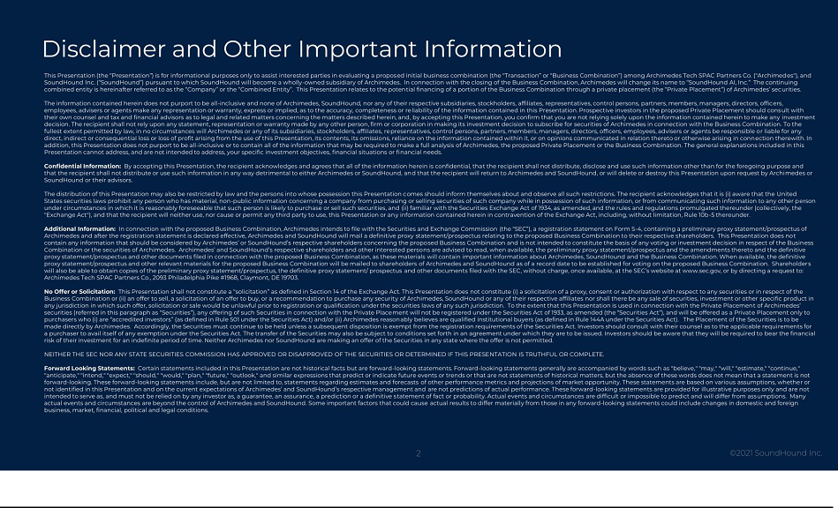

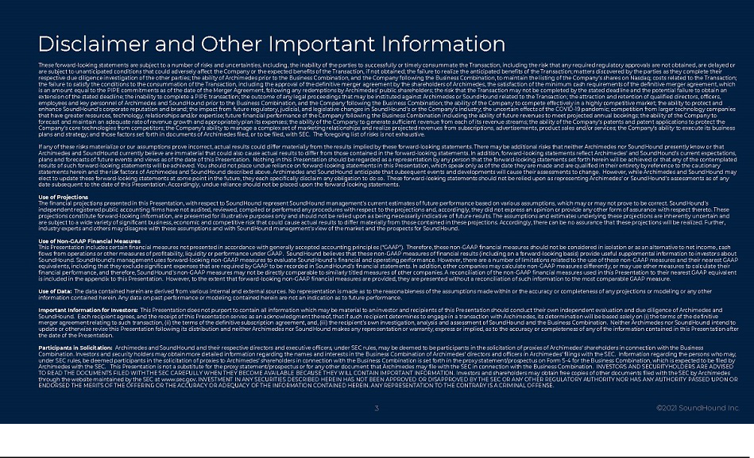

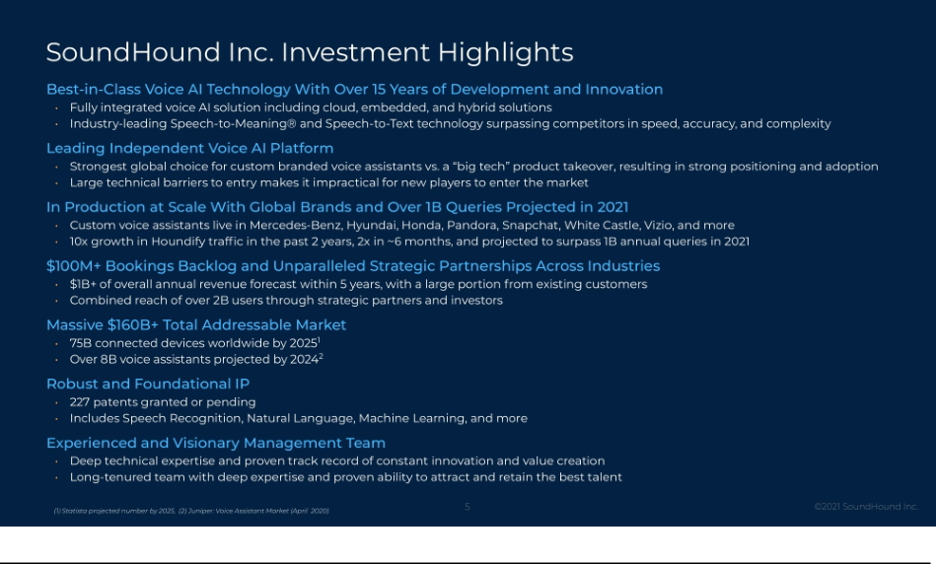



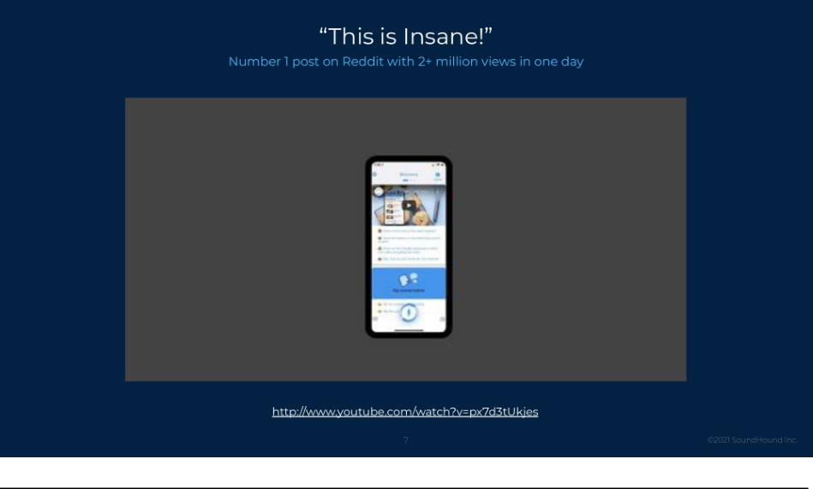



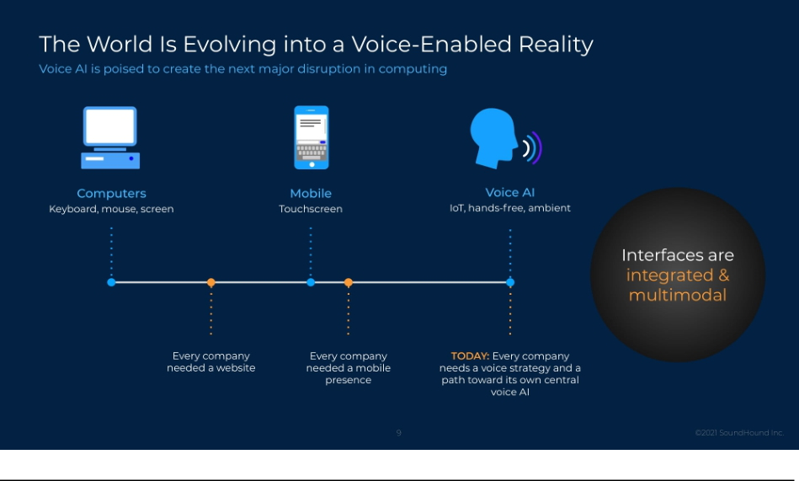

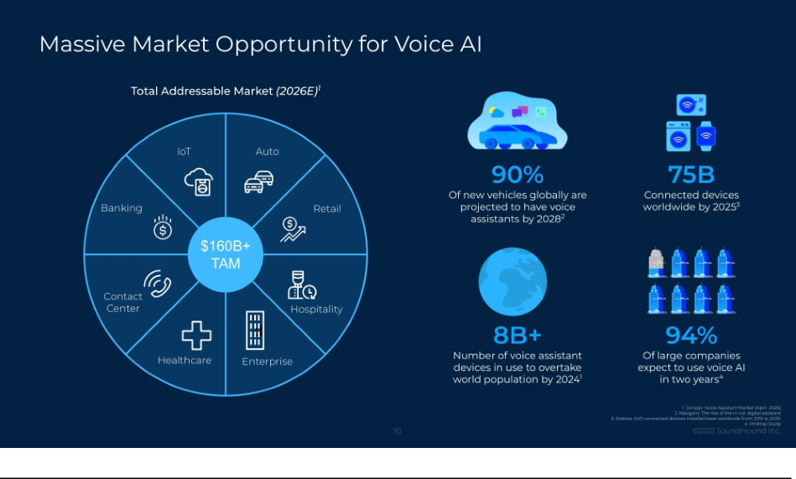

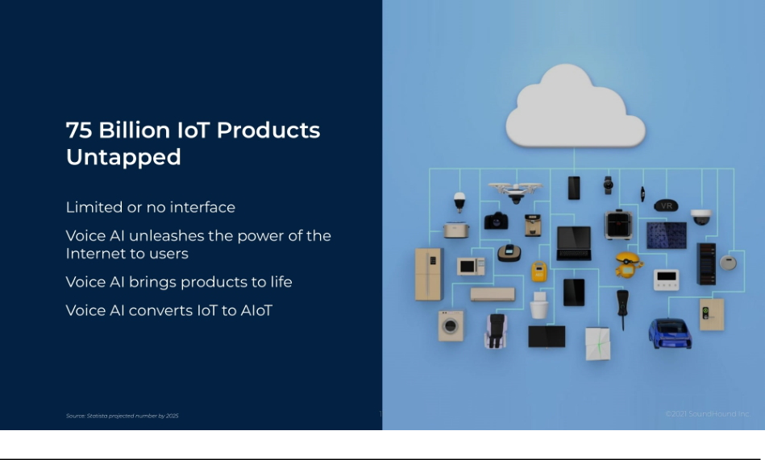

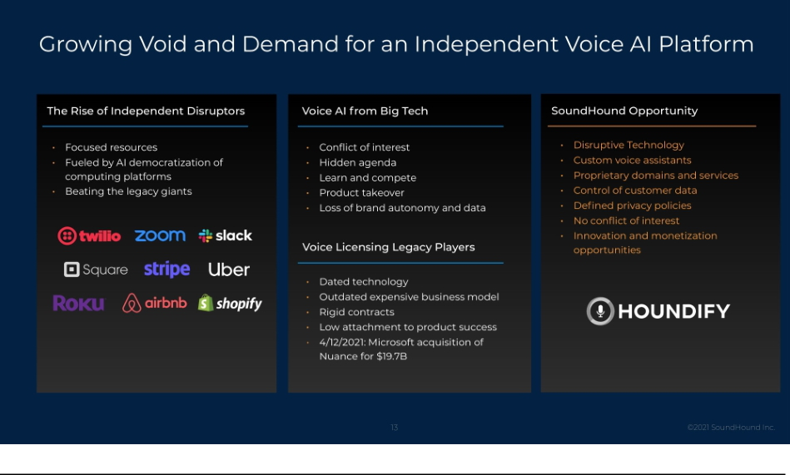

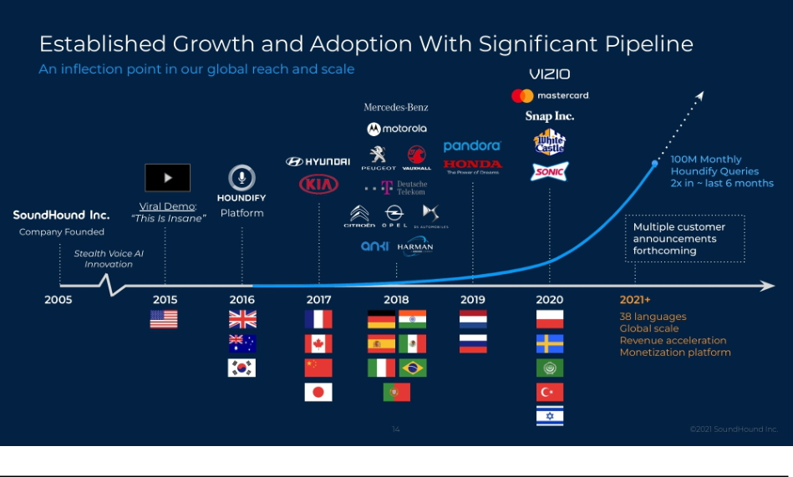

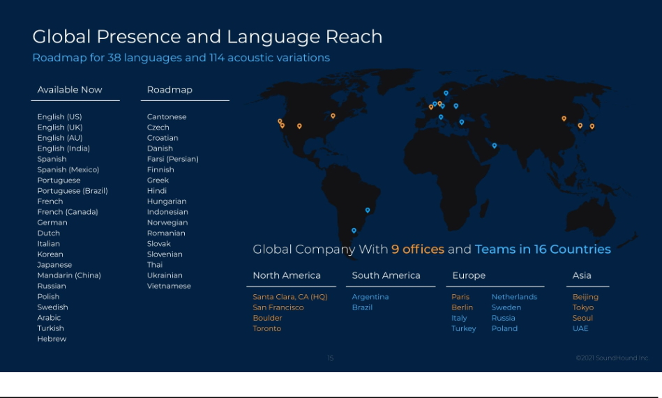



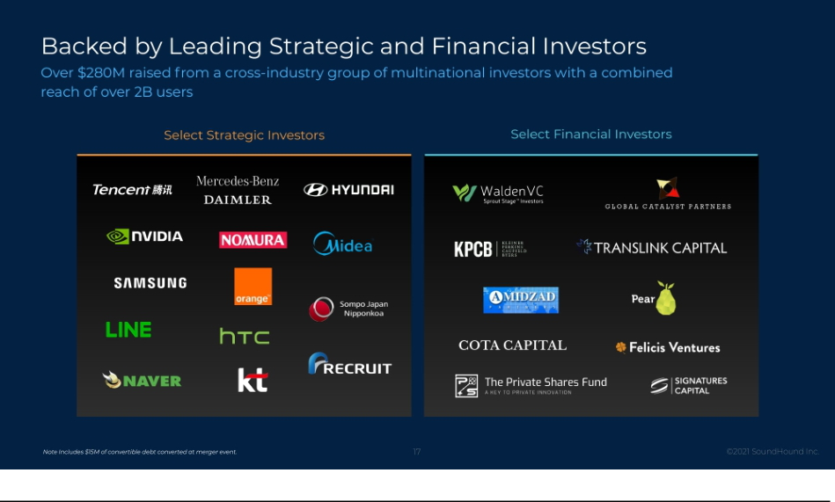

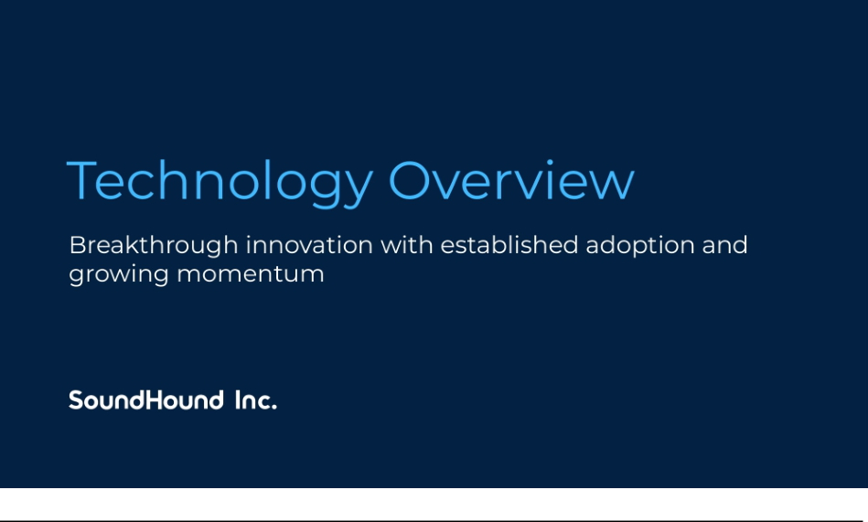

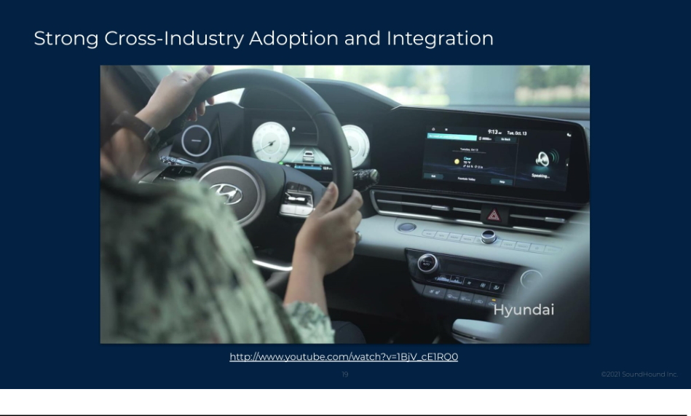



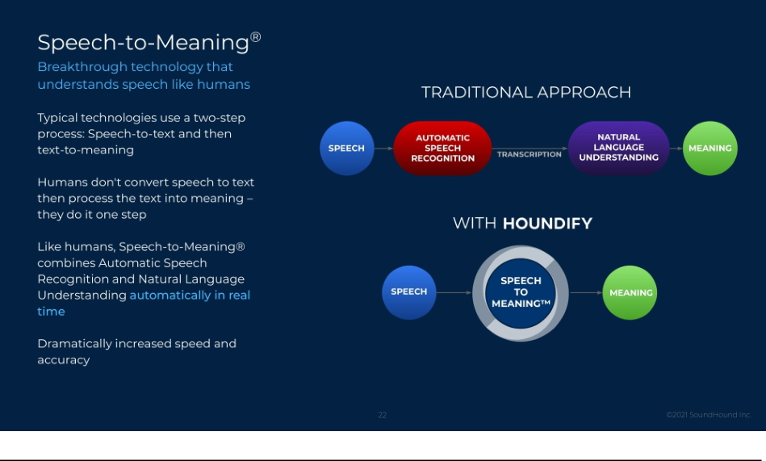

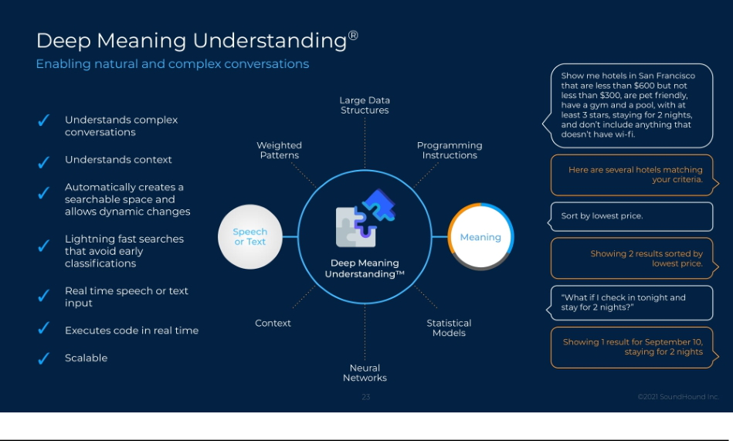

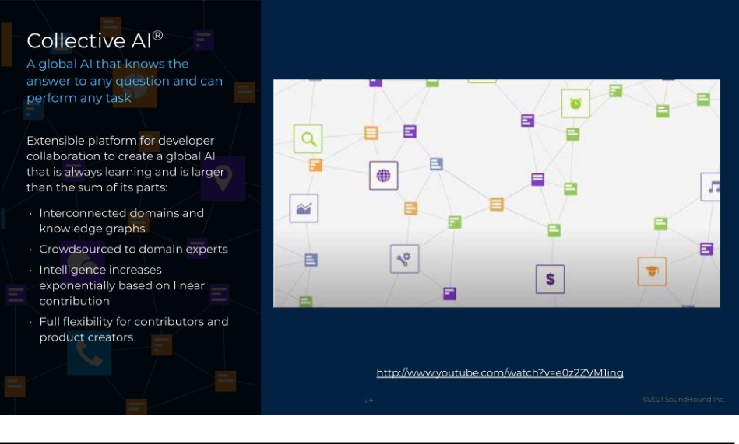

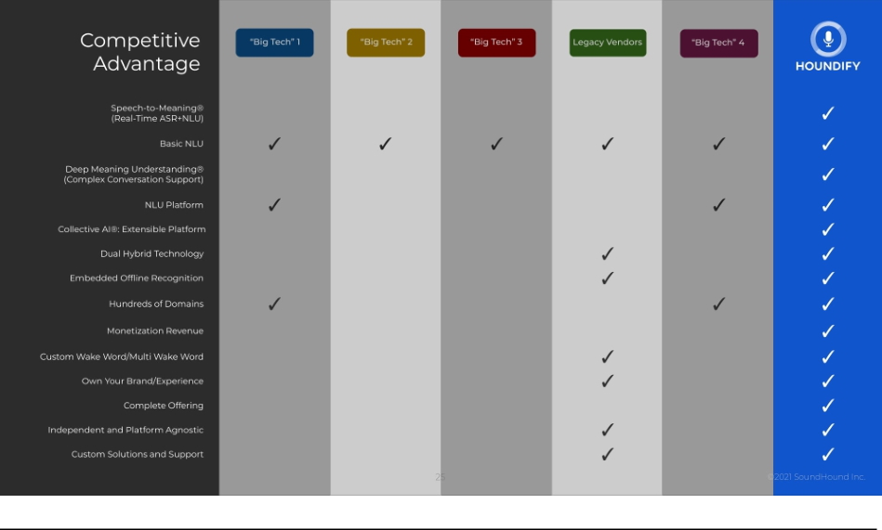

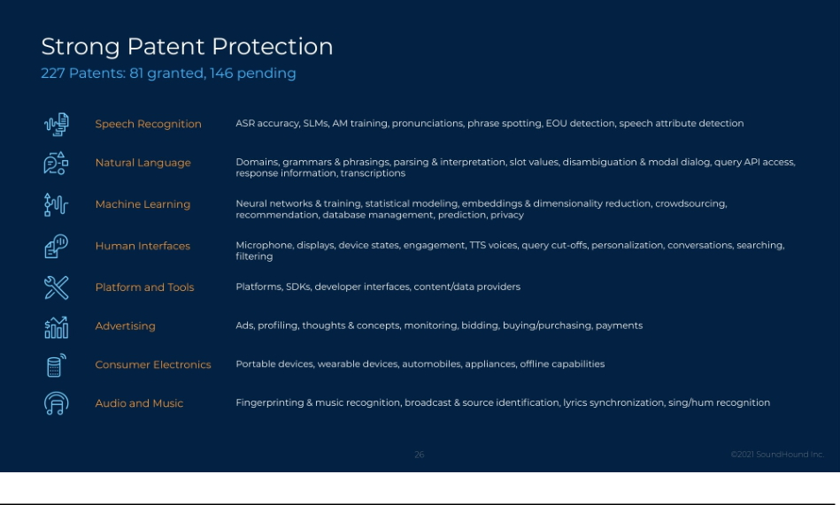

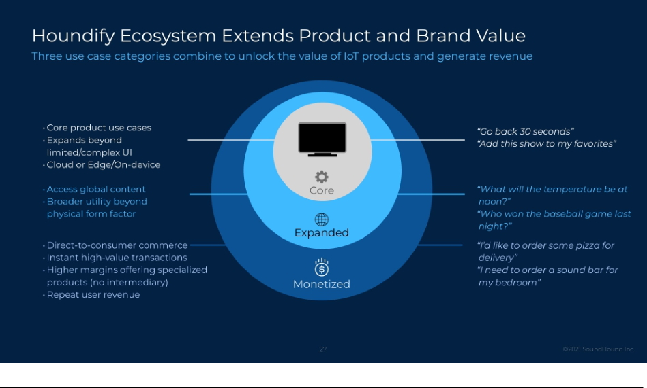

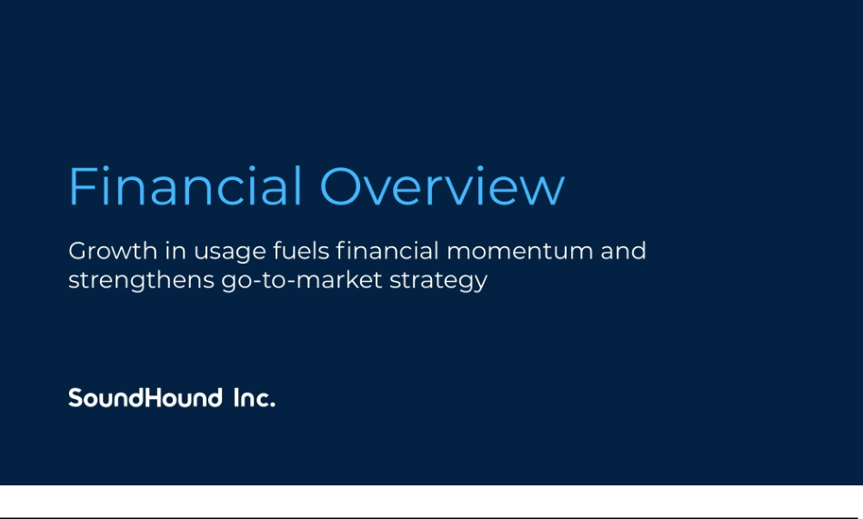

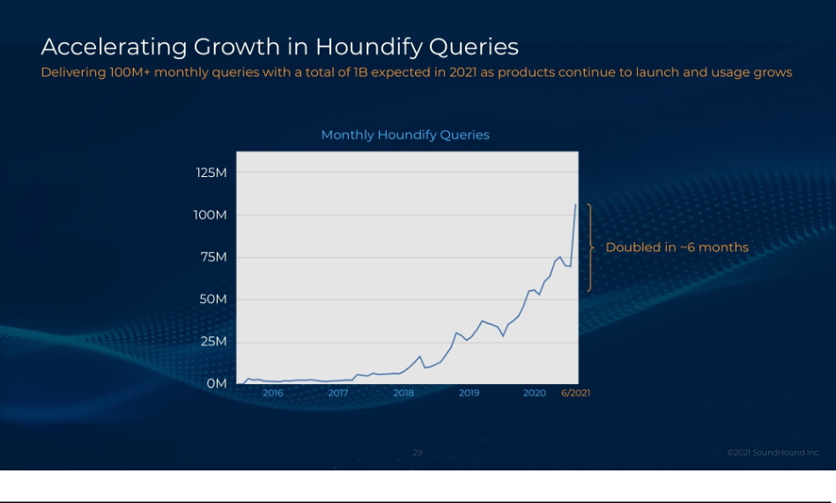

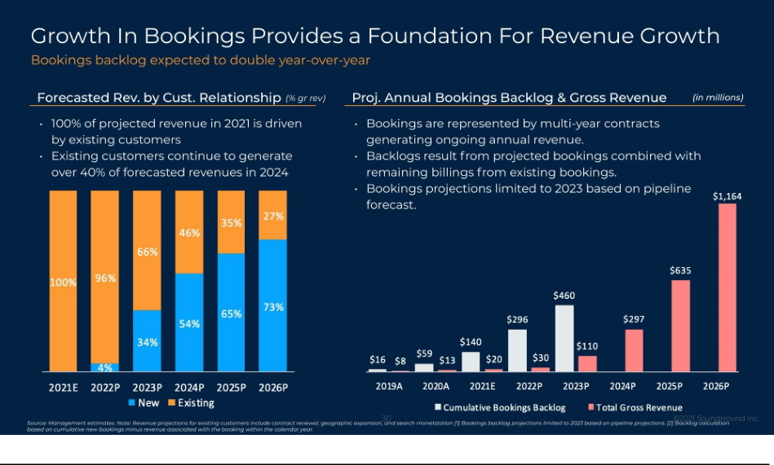

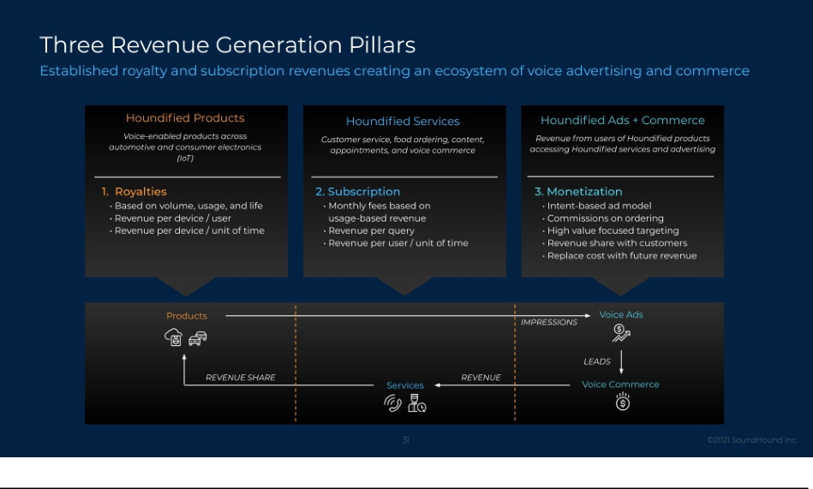

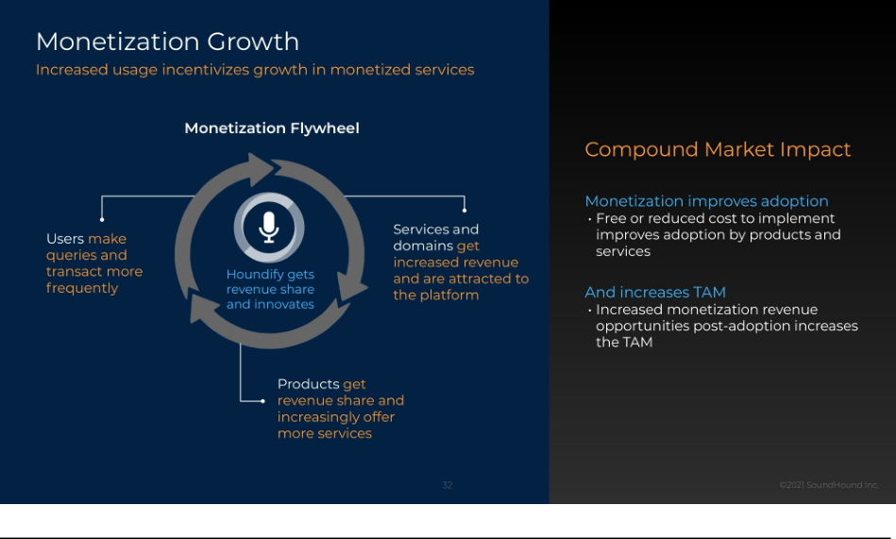

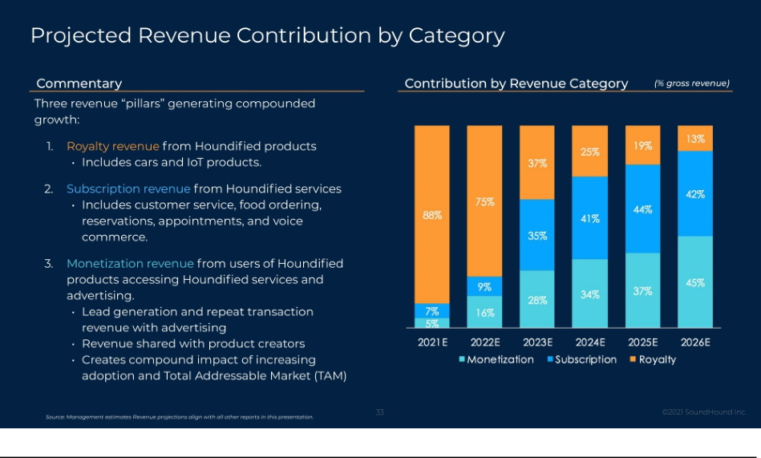



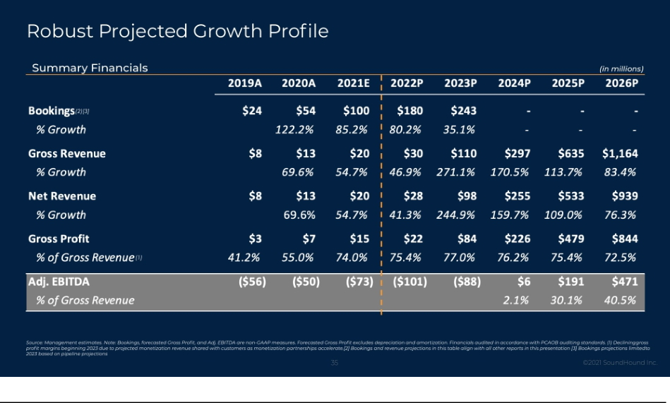

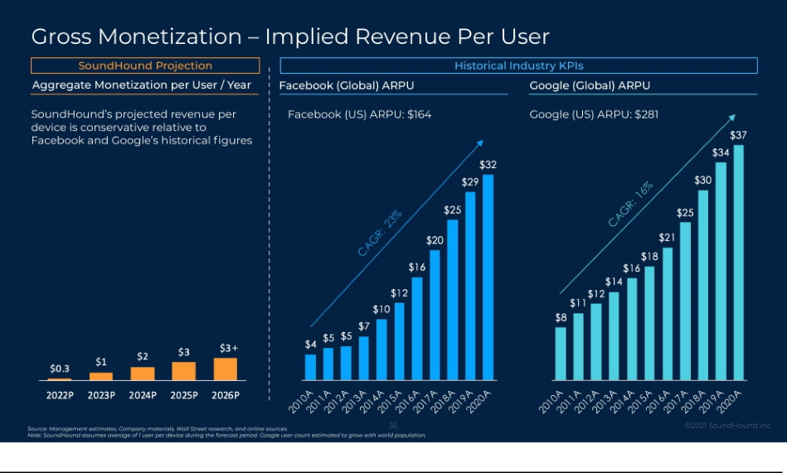

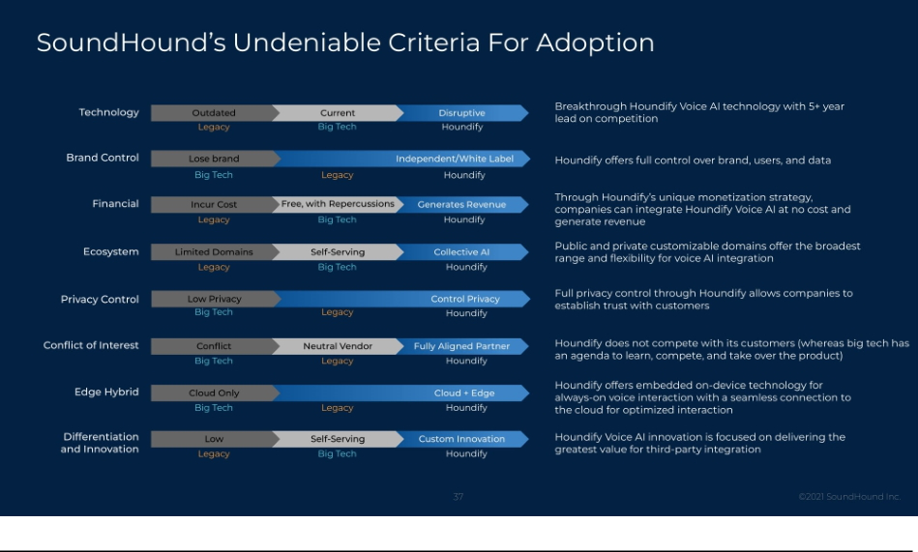



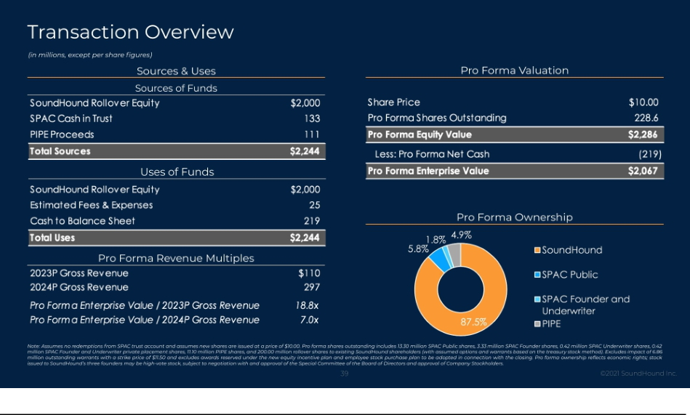

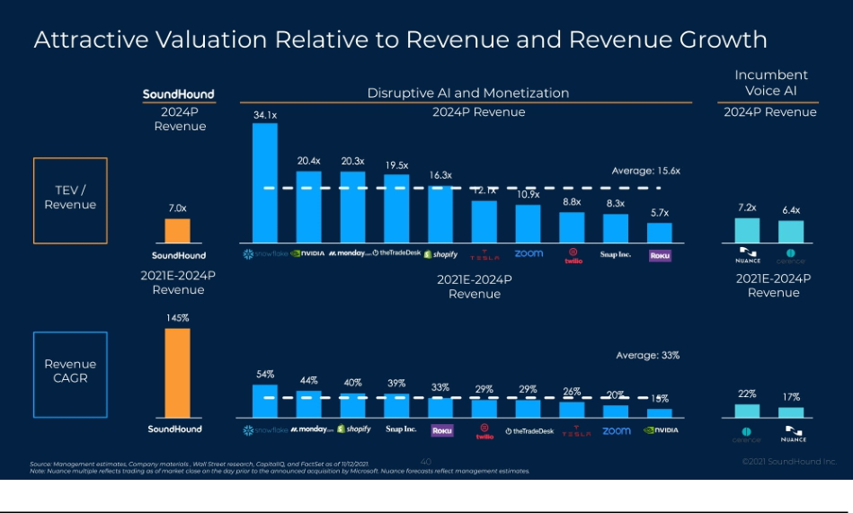

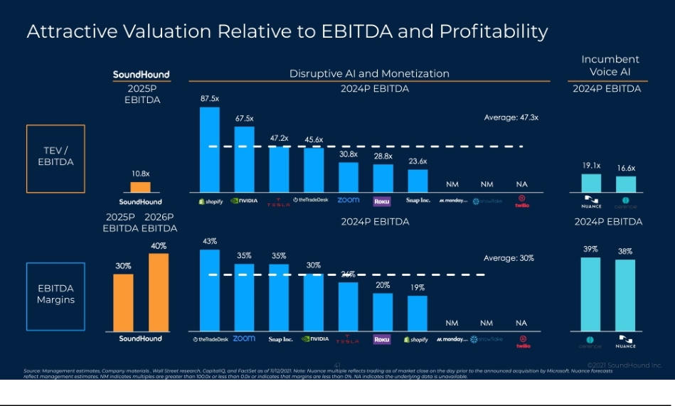

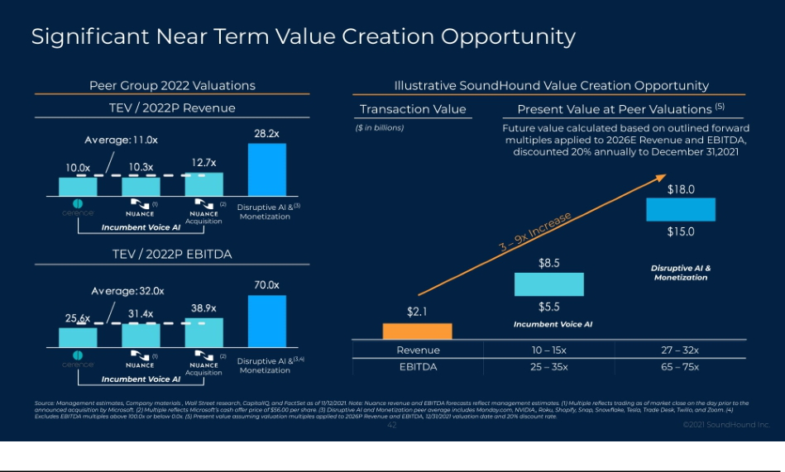

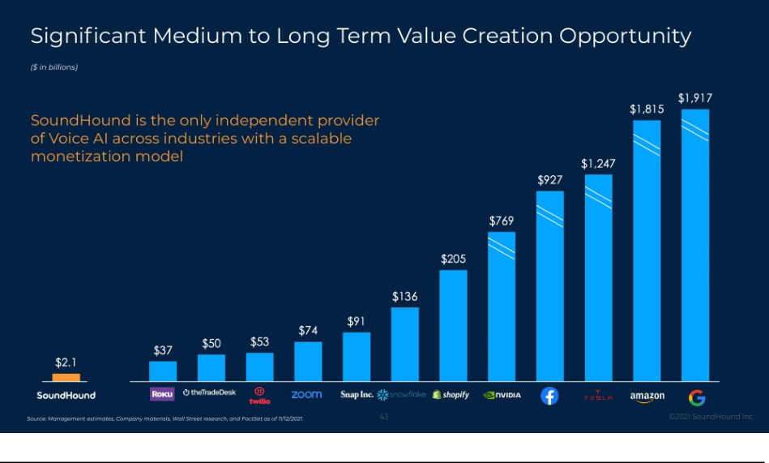



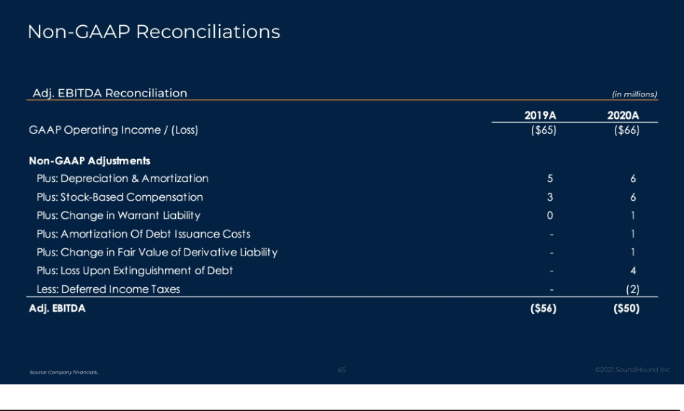

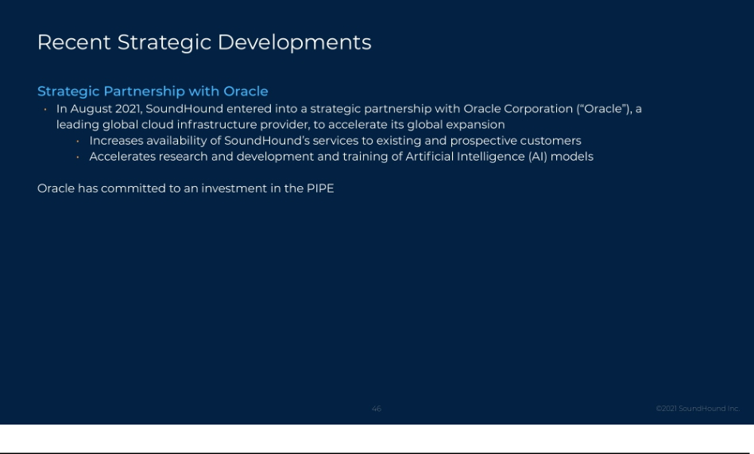

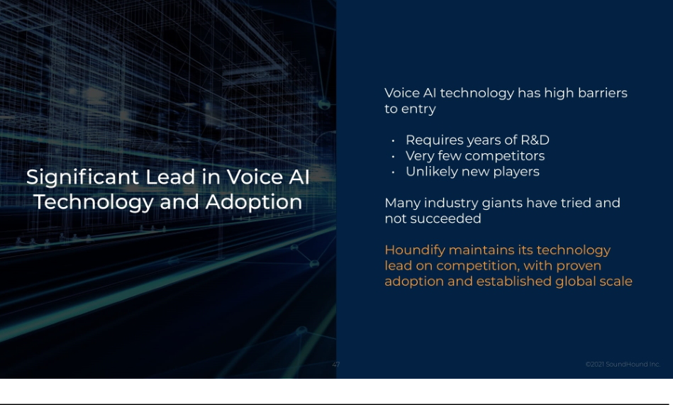



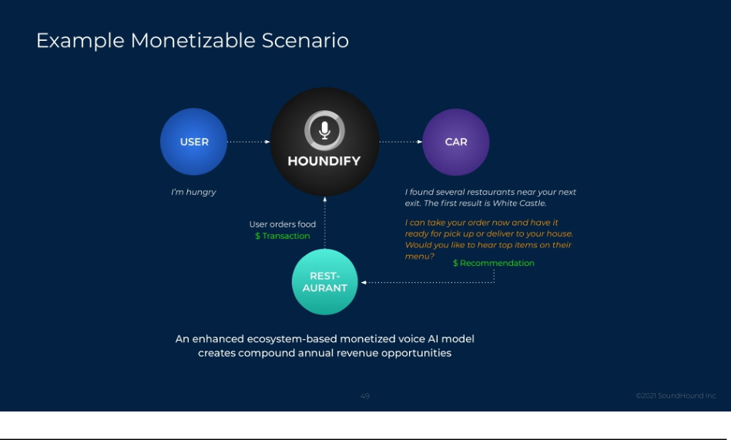

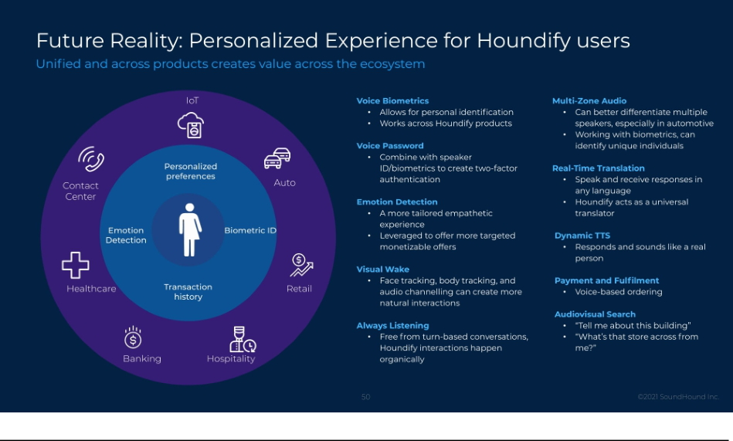

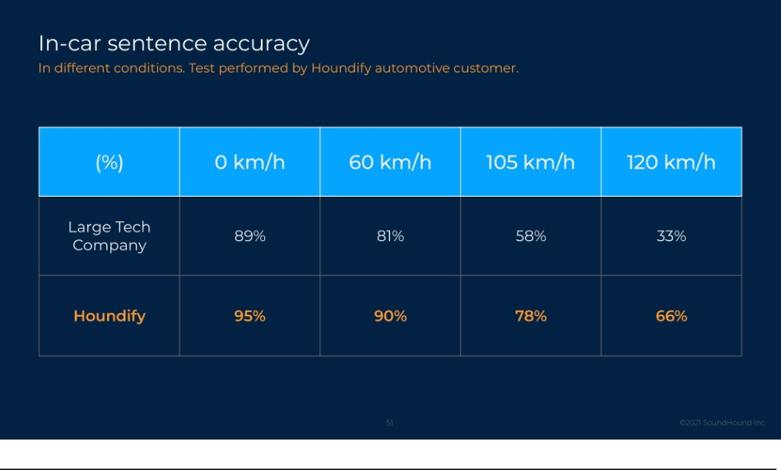

Exhibit 99.3

SoundHound Inc. & Archimedes Tech SPAC Partners Co. Investor Presentation Transcript November 16, 2021

SLIDE 1: Cover Page

Eric Ball: Hello everyone, I’m Eric Ball, chair of Archimedes Tech SPAC Partners Company. Thank you for joining us. We are very excited to announce that we have entered into a merger agreement with SoundHound, a global leader in voice AI. SoundHound’s independent voice AI platform, Houndify, enables leading businesses across a multitude of industries to incorporate high-speed, high accuracy, conversational voice AI capabilities into their products. We closed the Archimedes IPO in March, looking to identify and merge with a leading technology company in the Artificial Intelligence and Cloud Services industries. We sought companies that had the right technology, a business plan with momentum, and the right operating and finance team. In short, a company ready, not just to go public, but to be public. SoundHound fulfills all those criteria and we are thrilled to share the SoundHound story with you today.

SLIDE 2: Disclaimer and Other Important Information

Eric Ball: Before we begin our investor presentation, I would like to remind you that this presentation is neither an offering of securities nor the solicitation of a proxy vote. The information discussed in this recording is qualified in its entirety by the information in Archimedes current report on form 8-K that was filed in connection with the proposed transaction, which may be accessed on the SEC’s website. The shareholders of Archimedes are urged to read the form 8-K and Archimedes other SEC filings in connection with the proposed transaction carefully because they will contain important information about the proposed transaction and SoundHound’s business.

Additionally, during this presentation, we will make certain forward-looking statements that reflect our current views related to our future financial performance, future events and industry and market conditions, as well as forward-looking statements related to the business combination, such as anticipated timing, proceeds, and benefits of the transaction, as well as statements about the potential competitive standing of SoundHound’s AI technology platform and the timing of SoundHound’s proposed activities and expansion plans. These forward-looking statements are subject to risks, uncertainties, and assumptions that could cause actual results to differ materially from such forward-looking statements. We strongly encourage you to review the form 8-K that was filed in connection with the proposed transaction, along with the press release and presentation included as exhibits to the form 8-K as well as the other information that Archimedes filed with the SEC, particularly those described in the risk factors section of Archimedes’ filings.

Archimedes does not assume any obligation to update any forward-looking statements except as required by law. We note that the statements made regarding expected cash and equity owners that follow the closing of the proposed transaction do not take into account any possible redemptions by existing Archimedes shareholders prior to the closing of the business combination.

SLIDE 4: SoundHound + Archimedes

Eric Ball: With that, I would like to kick off our presentation by introducing Keyvan Mohajer, the founder and CEO of SoundHound. Keyvan founded SoundHound with his co-founders in 2005. And since then, has tirelessly built out the SoundHound team and its voice AI technology to realize his vision of a connected global voice AI ecosystem that will lead the next stage of disruption and revolution in human machine interaction. With that, I turn it over to Keyvan.

Keyvan Mohajer: Thank you, Eric, for the introduction. We are excited to announce SoundHound’s business combination with Archimedes, the next step in SoundHound’s journey. Thank you for joining us today to learn more about SoundHound and our mission to voice-enable the world – Houndify Everything.

SLIDE 5: SoundHound Inc. Investment Highlights

Keyvan Mohajer: I would like to begin by listing some of SoundHound’s key investment highlights.

With over 15 years of development and innovation, we have built what we believe is the best-in-class Voice AI technology. As a result, SoundHound is a leading independent cross-industry voice AI platform with global reach. We have proven adoption with leading global brands in multiple industries. We have proven scale with over one billion queries expected in 2021. We have contracts with over $100 million of bookings backlog from established leaders in the industry. We forecast over $1B of annual revenue within 5 years, with a large portion from existing customers. Our total addressable market is large and growing, expected to be $160 billion by 2026. We have a strong IP portfolio with over 200 patents granted or pending. We have an experienced and visionary management team with significant support from industry-leading clients and partners.

SLIDE 7: “This is Insane!”

Keyvan Mohajer: Now I am going to share a video of one of our internal demos that got posted on Reddit with the title “This is Insane” and went viral with over 2 million views.

Video: How many days are there between the day after tomorrow and three days before the second Thursday of November of 2022? There are 2,714 days between the day after tomorrow and Monday, November 7th, 2022. What is the population and capital for Japan and China and their areas in square miles in square kilometers? And also tell me how many people live in India. And what is the area code for Germany, France and Italy. The population is 127,288,000 for Japan, and 1,333,044,000 for China. And the capital is Tokyo for Japan and Beijing for China. The area is 145,882 square miles and 377,834 square kilometers for Japan and 3,705,386 square miles and 9,596,959 square kilometers for China. The population of India is 1,173,108,018. The area code is 49 for Germany, 33 for France and 39 for Italy. Thank you. You’re quite welcome.

SLIDE 8: Our Vision

Keyvan Mohajer: A typical reaction we get to our technologies is “Wow! Even humans cannot do this”, and this brings us to SoundHound’s vision: to build a conversational AI platform that exceeds human capabilities. We know computers are better than humans at computing, but they’re not always better than humans at performing certain tasks. For example, we used to easily beat computers in the game of chess, but now computers can beat us. When it comes to language understanding, we still don’t think computers are as good as humans. We talk with complex conversations with each other, but when we talk to voice assistants, we lower our expectations, and we talk in short, simple, keyword-based queries, and our vision is to change that. We aim to make computers better than humans in language understanding. And with that, we can make humans more productive and we can make the world a better place.

To give you another example, if you’re looking for a restaurant and you’re looking for anything other than Chinese, because you had Chinese food yesterday, you can ask the concierge of a hotel, “show me restaurants, excluding Chinese”, and the concierge can easily understand you and point you in the right direction. But when you’re talking to a voice assistant, usually you don’t ask the question, “show me restaurants, excluding Chinese”, because you don’t expect that it will work. And in fact, most other voice assistants will give you Chinese restaurants if you ask them to show you restaurants excluding Chinese. With our technology, you can ask even more complicated questions, such as “show me Asian restaurants in San Francisco, excluding Chinese and Japanese, and only show the ones that have more than three stars and are open after 9:00 PM on Wednesdays.” And it will give you exactly what you asked for. It will also speak the criteria back to you to provide you the verbal confirmation that it understood you and is giving you the results that you requested.

And it’s very conversational. You can follow up and ask it to refine the criteria such as “remove Korean and Vietnamese, sort by rating then by price, and only show the ones that are good for kids and have a patio.”

We note that today’s voice assistants are far from being able to answer every question and perform every task. This means our vision is a long-term vision, but we have already achieved superhuman capabilities in many of the domains that we have delivered to our customers.

2

Where do we want to go with this? We want to be in billions of devices and enable innovation and monetization opportunities for the product creators that integrate our platform. It means product creators can use voice-AI to make their product better. And, in addition, generate incremental recurring revenues from customer interactions.

It’s important to note that our vision has a high emphasis on user experience. Before we focus on monetization, we need to deliver value and delight to the end users. This means that the monetization interactions that we generally envision are those that flow naturally based on context, create value for the end-user, and would not be perceived by users as intrusive advertisements.

SLIDE 9: The World Is Evolving into a Voice-Enabled Reality

Keyvan Mohajer: The timing is right for our company and our vision. The world is evolving to be voice-enabled. We believe that voice AI is poised to be the next disruption in computers. We started with computers that had a keyboard and mouse. Then we had mobile devices with touch screens. And now we have IoT devices with voice AI. After the internet became mainstream, every company needed to have a website. Today, when you create a company, one of the first things you do is register a domain name. After the mobile ecosystem became mature, every company needed to have a mobile strategy. In fact, some very successful companies were created purely on the mobile ecosystem. We think the same concept will apply to the voice AI world. Every company will need to have a strategy in voice AI, and there will be success stories built on top of platforms like ours. We note that these interfaces will co-exist. Mobile and touch screen did not completely replace computers with a keyboard and mouse. Voice AI will also co-exist with computers and mobile. However, with billions of IoT devices that don’t have a keyboard or a mouse or a touch screen, voice will we be the preferred or the only way to interact with these devices

SLIDE 10: Massive Market Opportunity for Voice AI

Keyvan Mohajer: We have a large and growing TAM, $160 billion by 2026, enabled by a growing need of voice AI in many industries.

90% of cars are expected have their own voice assistant by 2028 and 75 billion IoT devices are expected to exist by 2025.

The number of devices with their own voice assistant will overtake the world’s population within four years and 94% of large companies expect to use voice AI within two years.

SLIDE 11: 75 Billion IoT Products Untapped

Keyvan Mohajer: As previously mentioned, there will be an estimated 75 billion IoT devices in existence by 2025. This represents an enormous opportunity for us since many of these devices have limited or no interface with humans. These devices typically don’t have the physical or economical room to add a keyboard or a mouse or a touch screen, but they can more easily have a small, inexpensive microphone. And with that microphone, you can add voice AI to these products, unleash the power of internet to the end users, bring these products to life, and convert IoT to AI IoT. So again, a massive potential, that we believe is mostly currently untapped.

SLIDE 12: Technology Leaders Disrupted Markets and Expanded Upon Them

Keyvan Mohajer: We have high ambitions for SoundHound. We are inspired by other technology leaders that disrupted and expanded the market and reached high market caps.

If you look at SoundHound’s positioning on the right, we expect to be a leader in human computer interaction and the next generation of search monetization.

Again, we want to be in billions of devices with voice AI and provide conversational interactions with these devices.

3

We envision these interactions to be reactive and proactive. In traditional internet search, users initiate a search to get the result and monetization opportunities. We believe that devices around you can ultimately initiate the conversation based on certain triggers and context before you start talking to them. This leads to more interactions with more devices and more monetization opportunities.

Out of our over 200 patents granted and pending, 35 of these patents are in conversational monetization. We predict that search traffic will change from keyword-based queries to conversational interactions and we have a large number of patents in the area of conversational advertising.

SLIDE 13: Growing Void and Demand for an Independent Voice AI Platform

Keyvan Mohajer: There is a growing void and demand for an independent voice AI platform.

Outside of voice AI, we can reference the rise of independent disruptors - these companies were able to beat the legacy giants using focused technology and business model. Within voice AI, before SoundHound, we see two types of players, the big tech companies and legacy vendors. The offerings from the big tech usually take over your products, hijack your brand, user, and data, and you mostly lose your ability to innovate, differentiate, and customize. In some cases, those providers even compete with your product, which make them less attractive. The alternative options are generally legacy vendors with dated technologies at a high price, and these technologies still require significant effort by the product creators to turn them into solutions that can compete with the quality of the big tech offering, and that is not very practical. Due to the high barrier to entry in voice-AI, there are not many independent players. In addition, earlier this year in 2021, Microsoft announced the acquisition of Nuance for almost $20 billion, which further reduced the number of options in the voice-AI space. This creates the opportunity for SoundHound to provide disruptive technologies better than the alternatives, at terms better than alternatives, allowing customers to maintain their brand, control the user experience, get access to the data, and define their own privacy policies, while being able to customize, differentiate, innovate, and monetize.

SLIDE 14: Established Growth and Adoption with Significant Pipeline

Keyvan Mohajer: We show our timeline here: starting with 10 years of constant innovation in stealth, building what we believe are disruptive technologies in voice-AI using innovative approaches. Our goal was to build a differentiated voice AI technology that we fully own and which is significantly better than other solutions in the market. We achieved that goal and unveiled the result in 2015, launching it as Houndify platform in 2016.

Since then, we have rapidly expanded our capabilities and global reach: we have globalized our solution from 1 language to 22 languages, with a roadmap of 38 languages and 114 acoustic variations.

The timeline also shows incredible adoption from global customers in multiple regions and industries. In 2020, the traffic to our voice-AI platform surpassed 50 million queries per month. We started this year with the target to double that number, a milestone that we achieved within 6 months when in June of 2021 we received over 100 million queries per month, and we are on track to surpass 1 billion queries in 2021.

SLIDE 15: Global Presence and Language Reach

Keyvan Mohajer: SoundHound currently has a team of over 400 members, with presence in 16 countries. Globalization remains a top priority and commitment. We aim to be one of the most comprehensive global providers of voice AI with a roadmap of 114 acoustic variations across 38 languages, and more than half of that has already been delivered to customers.

4

SLIDE 16: SoundHound Inc. Leadership

Keyvan Mohajer: We have a strong leadership team with diverse backgrounds in technology, operations, business, legal, and finance. Our ability to attract and retain talent across the company is a strong metric that we are particularly proud of, and one that is necessary to succeed in pursuing the long-term vision of SoundHound.

SLIDE 17: Backed by Leading Strategic and Financial Investors

Keyvan Mohajer: The company has raised over $280 million from investors across multiple industries and regions. We have both strategic investors and financial investors. The alliance that we have created with our strategic investors has a reach of over two billion users. Our strategic investors include Tencent, Mercedes-Benz, Hyundai, NVIDIA, Nomura, Midea, Samsung, Orange, Sompo, LINE, HTC, Naver, Korea Telecom, and Recruit. We also highlight some of our financial investors on the right.

SLIDE 19: Strong Cross-Industry Adoption and Integration

Keyvan Mohajer: We would now like to show you a quick video of the integration of our technology in different products and settings, to give you an appreciation for the breadth and applications for our voice AI technology.

Video: It was the absolute foundation to open up a world of possibilities that we didn’t have before. The flexibility of the SoundHound platform allows us to build rich and interesting use cases and to adapt quickly as we get the learnings from the field. Hyundai and Houndify are together, making driving more convenient, interactive, and safer. Do I need an umbrella today? No, it doesn’t appear to be raining at the moment. Navigate to sleep [inaudible]. Hey, Pandora, turn the volume all the way up. I’d like a bacon cheeseburger, extra onions and no pickles or mustard, a small fries and a medium diet Coke. Okay. Please also add the following action item, Morris to put together marketing. More service. Here, I’ve added this action item. Show me my spending report last month and sort them by amount, excluding gas stations. Hey, Mercedes, Italian restaurants within 10 miles that have outdoor seating and at least a four star rating, excluding pizzerias. Hey Mercedes. How may I help you? Tell me a joke. Sorry, my engineer’s were German. Turn me into a baby.

SLIDE 20: Adoption From Market Leaders

Keyvan Mohajer: As you can see, our technology is adopted in many products across multiple industries. We have highlighted a few of the products on the right. We power Mercedes-Benz in North America. We power Hyundai and Kia in multiple regions and languages. We power Honda in Europe and Japan. We power Snapchat, Pandora, Vizio smart TVs, several drive through restaurants, Deutsche Telekom’s smart speakers, and robots. We have many positive public testimonials, and we have highlighted a few of those on the left.

SLIDE 21: Technology Breakthroughs

Keyvan Mohajer: SoundHound has a large number of technology breakthroughs and I would like to highlight and present three important ones: Speech-to-Meaning, Deep Meaning Understanding and Collective AI.

SLIDE 22: Speech-to-Meaning

Keyvan Mohajer: Speech to Meaning refers to SoundHound’s ability to convert speech to meaning simultaneously and in real time. Most other traditional approaches, as highlighted on the top right, first convert speech to text, then convert text to meaning. We see two problems with that approach. It’s slower, and less accurate. It’s slower because the two steps are done in sequence, and the processing time of the second step is perceived by the end user. It can also be less accurate because if the first step of speech to text makes a mistake, the resulting incorrect text is then sent to the second step, and the error further propagates.

While we were working hard to fix these problems, we were inspired by the human brain. As we listen to someone speaking, our brain does not convert speech to text, then text to meaning. Our brain converts speech to meaning simultaneously and in real time. With our Speech-to-Meaning, as you speak to SoundHound’s technology, we perform both speech recognition and language understanding, which results in faster response time and higher accuracy, because real time language understanding can feed into the real time speech recognizer as additional information to reduce the potential errors.

5

SLIDE 23: Deep Meaning Understanding

Keyvan Mohajer: The next breakthrough is Deep Meaning Understanding. This is our innovative approach to language understanding that allows us to understand highly complex conversations. You’ve seen some of those in our demos today. We highlight another example on the top right:

“Show me hotels in San Francisco that are less than $600, but not less than $300, are pet friendly, have a gym and a pool with at least three stars staying for two nights, and don’t include anything that doesn’t have Wi-Fi.”

A complex search like this will take many minutes to perform on a website with complex forms, but it can be done within a few seconds using our technology and, to our knowledge, our voice AI technology is the only technology that can handle complex queries of this nature.

SLIDE 24: Collective AI

Keyvan Mohajer: Our third breakthrough is called collective AI, which is an architecture that allows us to improve the understanding capability of our platform super-linearly and even exponentially based on linear contributions.

Most other platforms add skills or domains that are separate from each other and don’t interact with each other. That means for them, linear contribution results in linear growth in understanding, which is less scalable.

With Collective AI architecture, our domains can be inter-connected and learn from each other and, as developers contribute to the platform, the platform’s understanding capability can grow exponentially. With that explanation, I would like to show you a quick video of how Collective AI works.

Video: Houndify is the only independent AI platform that gives businesses complete control over how they integrate voice and conversational intelligence into their products. Now there’s still time before we see a fully generalized AI that can understand everything, but with Houndify, we’ve introduced a sophisticated architecture to help us get there fast. We call this architecture collective AI picture. This developer A creates a domain for location like San Francisco or 3979 Freedom Circle and marks it shared and extensible. Developer B creates a domain for a ride sharing product. And since location was marked as shared, he can use location in the new ride sharing domain to ask, how much does it cost to go from location to location? Developer C creates a new domain for a restaurant rating product. And since location was also marked as extensible, she can extend the location domain because the result of a restaurant search, even with very complex criteria can be a location.

Developer B can then enable the extension with a simple click, instantly enhancing his ride sharing domain, using location. Now users can ask how much does it cost to go from the nearest airport to the best Italian restaurant in San Francisco that has more than four stars, is good for kids, is not a chain and is open after 9:00 PM on Wednesdays. And how long is the trip? That’s not much work for developer B to make his ride sharing domain even more powerful and comprehensive. Here’s why that’s smart. We get a crowdsourced and interconnected architecture. That’s bigger than the sum of its parts, always learning and growing exponentially into an open collective AI that can answer any question or perform any task giving control to the users of Houndify means we can bring a collaborative and collective AI to everyone, everywhere.

6

SLIDE 25: Competitive Advantage

Keyvan Mohajer: This slide shows our competitive landscape.

Due to the high barrier to entry in voice-AI, the number of full solution platform providers is very limited. In our view, it takes many years and significant investment to build all the components of voice-AI. It then takes further time and resources to make the solutions competitive, mature, and viable for adoption, and it requires significant investment to globalize the solution in multiple languages and regions. Although the number of platforms is limited, we note that the big tech players have significant resources. This landscape has led SoundHound to achieve its wins with technology innovation, business model innovation and global alliances that have turned us into a strong player with notable advantages that we have highlighted on this page.

SLIDE 26: Strong Patent Protection

Keyvan Mohajer: SoundHound has a strong IP Portfolio, with over 200 granted or pending patents. These patents cover areas such as speech recognition, natural language understanding, machine learning, human interfaces, and others, including monetization and advertising.

SLIDE 27: Extensive Selection of Voice AI Content and Services

Keyvan Mohajer: Content is another area we create value.

When we understand a user’s question using our technology, we then have to provide the answer to the user’s question.

For many of our domains, the answer is provided by us directly. For example, if a user asks, “what is the population of Japan?” or “what is the capital of China?”, we crawl the web and organize the information like other search engines do and provide the answer to the user.

For some other domains such as weather, sport scores, flight status, and restaurant search, we partner with content partners to get access to their data and APIs to fulfill the user request in corresponding domains.

We also work hard to secure the rights to offer our content partners’ data and API to our customers under our customers’ brand, so that our customers don’t have to directly make deals with these content partners.

We source the content, create the domains, secure the licenses, and as we monetize the content of our content partners with the revenues that we generate from our customers, we share a percentage of the revenue with our content partners.

This is both disruptive and necessary to enable product creators to more seamlessly offer customized voice assistants under their own brand without having to aggregate and secure content and create complex domains.

SLIDE 28: Houndify Ecosystem Extends Product and Brand Value

Keyvan Mohajer: When a product is voice enabled, we see three stages of integration and value propositions.

The first stage is to enable the core use cases of the product. For example, the product could be a TV, a coffee machine, a car, a wearable device, a robot, a smart speaker, or an appliance, and with your voice you can control the functionality of the device and the product. On a TV, you can ask it to change the channel, increase the volume, rewind by 30 seconds, search for movies, and even add personalization by adding a TV show to your favorites. Note that this is different from adding a third-party voice assistant to the product. Our view is that every product needs to have an interface, and voice-AI is a natural and compelling interface that unlocks new use cases and potential. Consider just the simple example of rewinding or fast forwarding by a specific duration. That is a command that can be done with voice within a few seconds, but it can take many steps to do using alternative interfaces such as a remote control or a companion app.

7

Once the core features of a product are voice-enabled, it can be further enhanced in the second stage of integration: the addition of third-party content and domains. SoundHound has extensive partnerships with content providers and, through these partnerships, can fulfill many needs of our customers. For example, your TV, car, or even a coffee machine can answer questions about weather, sports scores, stock prices, flight status, and even search for local businesses. The addition of these public domains further enhances the value proposition of the product.

Finally, as the third step, you enter the world of monetization where you can add features that deliver value to the end user, and also generate revenues that we share with the product creators.

To summarize with an example, imagine walking up to your coffee machine and asking for a triple shot extra hot latte. While you are waiting for your drink, you can ask for weather and sports scores, and if you desire, you can even order bagels from your favorite nearby bakery.

SLIDE 29: Financial Overview

Keyvan Mohajer: I now would like to introduce Nitesh Sharan, our Chief Financial Officer. We are pleased that Nitesh has recently joined SoundHound as our CFO. Nitesh brings over 25 years of experience in corporate finance. He has previously held leadership roles in major public companies including Nike and Hewlett-Packard. This is an important milestone for SoundHound as we lay the foundations for our successful transition from a private to a public company. With that background, I introduce Nitesh, who is going to present the financial sections.

Nitesh Sharan: Thank you Keyvan! And hello everyone.

SLIDE 30: Accelerating Growth in Houndify Queries

Nitesh Sharan: I will start by highlighting the traffic growth to our Houndify platform. In the first half of 2021 we have surpassed 100 million queries per month, which represents an inflection point and a doubling of traffic in about 6 months. This is the result of new products launching and existing products scaling. We expect that trend to continue as Houndify gets further integrated into partner products. This is an important metric because the usage of our platform ultimately translates to revenues from licensing, subscription, and other forms of monetization.

SLIDE 31: Growth In Bookings Provides a Foundation For Revenue Growth

Nitesh Sharan: SoundHound has strong and proven growth in bookings from its diverse customer base. On the bottom right of this slide we show our bookings backlog and GAAP revenue. Our bookings backlog represents contract values that will be realized over subsequent years. These are mostly committed contracts that consist of minimum guarantees and forecasted product volumes provided by customers. In our experience, these estimates are generally understated. They do not include monetization and they do not include overages. When the customer goes over their minimum guarantee, for example, the revenue that we realize from these contracts would be higher, and that potential upside is not captured in the bookings backlog shown here.

Our cumulative bookings backlog grew from $16 million in 2019 to $59 million in 2020. And we expect it to be $140 million in 2021. Supported by bookings, we anticipate GAAP revenue will surpass $100 million in 2023 and a billion dollars in 2026. We have also projected our bookings backlog for the next two years until 2023 based on the visibility we have from our pipeline.

We show the composition of our forecasted revenue on the left side of the slide. We expect all of the revenue in 2021 and most of the revenue in 2022 to come from existing customers. In 2024, we expect over 40% of the revenue to come from existing customers. This shows the strong foundation of SoundHound’s customer base and revenue potential that the company has generated over the years, including key strategic relationships with numerous customers and investors from diverse industries and regions.

8

SLIDE 32: Three Revenue Generation Pillars

Nitesh Sharan: On this page, we highlight the three pillars of our business model. The first pillar is Royalties - where we voice enable a product and the product creator pays us a royalty based on volume, usage or duration. SoundHound collects royalties when Houndify is placed in a car, smart speaker or an appliance, for example.

The second pillar is Subscription. This is when, for example, SoundHound enables customer service or food ordering for restaurants or content management, appointments and voice commerce. And, for that, we generate subscription revenue from the service providers. Pillars one and two can grow independently and they are proven, established business models.

The third pillar is disruptive as it creates a monetization ecosystem that brings the services from pillar two to the products in pillar one. When the users of a voice-enabled product in pillar one access the voice-enabled services of pillar two, these services generate new leads and transactions. SoundHound generates monetization revenue from the services for generating these leads and transactions, and we will share the revenue with the product creators of pillar one.

For example, when the driver of a voice-enabled car places an order to a restaurant that’s also voice enabled, we will have unlocked a seamless transaction. Accordingly, the restaurant will pay us for that order and we will share that revenue with the product creator or the car manufacturer. In this example, each party receives value in the ecosystem. The restaurant is happy because they generated a new lead and booked a sale. The user is happy because they have received value through a natural ordering process, simply by speaking to their car. And the car manufacturer is happy because they delivered value to the end user and generated additional revenue from the usage of their product.

SLIDE 33: Monetization Growth

Nitesh Sharan: We expect the disruptive three-pillar business model will create a monetization flywheel. As more products integrate into our platform, more users will use it and more services will choose to integrate as well. This creates even more usage, and results in a flow of revenue share to product creators, which further encourages even greater adoption and integration with our platform…and the cycle will perpetually continue and expand.

As noted on the right, this ecosystem has a compound impact on our business. First, it increases adoption because more products will be motivated to integrate into our platform. Without the three-pillar model, only products that can afford the cost of voice-AI would be able to adopt it. With this model, products will be able to see a path to add incremental recurring revenue from the usage of their product, increasing overall ROI while making their product better, which will increase overall adoption.

Second, our TAM increases with new revenue streams and puts SoundHound on a trajectory with much higher potential.

SLIDE 34: Projected Revenue Contribution by Category

Nitesh Sharan: All three pillars contribute to our revenues today in 2021. While the majority of the contribution is currently from our first pillar of royalties, over time, the subscription and monetization portions are expected to grow and make a bigger contribution to our overall revenue.

SLIDE 35: Robust Projected Growth Profile

Nitesh Sharan: On this page, we show our P&L from the last two years and our projections through 2026 showing bookings, gross revenue, net revenue, gross profit, and adjusted EBITDA. Our net revenue takes into account the monetization revenue share that we will offer product partners, as mentioned in the previous slides. Revenue is expected to grow significantly as SoundHound is integrated into partner products and existing bookings are realized. Gross margin is expected to increase through 2023, and then moderate as monetization revenue and associated revenue share with partners increases. Lastly, we expect to become EBITDA positive in 2024.

9

SLIDE 36: Gross Monetization – Implied Revenue Per User

Nitesh Sharan: In our view, the monetization revenue projections are conservative. On the left-hand side of the slide, we show our expectation of average revenue per user per year growing from 30 cents to just over $3 in the next five years. As a comparison, Facebook and Google, shown on the right, have seen their average revenue per user grow from $4 per year to over $30 over the past ten years. And these numbers are global. If you look at their US numbers, in 2020 Facebook generated $164 per user, and Google generated $281 per user annually.

Accordingly, again, we think our monetization projections are conservative, and we hope to overachieve them.

With that, I will now pass it back to Keyvan to continue.

SLIDE 37: SoundHound’s Undeniable Criteria For Adoption

Keyvan Mohajer: Thank you Nitesh!

When it comes to criteria for adoption, our goal is to win on every dimension. We envision that if we win on all criteria for adoption, the only reason not to choose SoundHound is human error.

The first two criteria that customers typically consider are technology and brand control, and we believe we win on both. We claim and strive to prove to our customers to be the best technology, and we provide that with friendly terms under the brand of our customers. We note that in some industries one of these dimensions can result in significant adoption. There are examples of customers choosing an inferior quality to maintain the brand and control. In our case, we offer our customers the best of both, we enable them to offer disruptive technologies to their users while maintaining control of their brand and user experience.

With our disruptive monetization strategy, we also provide a path to monetization, which means by choosing our platform, product creators can generate additional revenue while making their product better using voice-AI, and that provides additional incentive to choose our platform. To that, we further add a superior ecosystem with our Collective AI as well as definable privacy controls, which are becoming increasingly important in the industry of voice AI. Additionally, there is no conflict of interest between us and our partners and customers as SoundHound does not compete with them as some other voice AI vendors do.

We also offer Houndify edge and hybrid, which means our technology can optionally run without cloud connection and we support our partners to differentiate and innovate. We strongly believe that product creators know their product and users best and the idea of a single third-party assistant taking over their product and reducing their ability to innovate is not the way of the future. In a world where we live among robots and smart devices, it’s not practical that all those robots and devices will have the same name. We envision that every product will have its own identity, and they will be specialized in different ways. They can all tap into a single Collective AI to access the ever-growing knowledge domains, but the product creators can innovate and create value for the end users in their own way, and that is the future that SoundHound is pursuing to enable.

SLIDE 38: Transaction Overview Section Break

Keyvan Mohajer: I would now like to introduce Long Long, the CFO of Archimedes, to present the transaction overview of our business combination.

Long Long: Thank you Keyvan!

SLIDE 39: Transaction Overview

Long Long: On this slide, we present the transaction overview. Our transaction values SoundHound at a $2 billion valuation prior to the SPAC merger. We have raised over $110 million of PIPE from notable strategic and financial investors at $10 per share and, assuming there are no redemptions to the $133 million of cash in Trust and estimated transaction expenses of approximately $25 million, SoundHound will receive in excess of $215 million of proceeds from the merger, net of merger expenses. I would like to highlight that there will be no cash consideration paid to SoundHound’s existing shareholders and that all proceeds of the merger, minus the customary merger-related fees, will be retained by SoundHound to support its growth plans. SoundHound’s Pro Forma Enterprise Value will be approximately $2.1 billion with SoundHound’s existing shareholders owning approximately 88% of the combined company. The Pro Forma Enterprise Value represents a 7.0x enterprise value to gross revenue multiple using SoundHound’s projected 2024 gross revenue of $297 million.

10

SLIDE 40: Attractive Valuation Relative to Revenue and Revenue Growth

Long Long: On the top of this slide, we show the details behind SoundHound’s 2024 enterprise value to gross revenue multiple compared to its peers. In the middle, we show that SoundHound’s peers in the disruptive AI and monetization space are projecting an average of over 15 times 2024 enterprise value to gross revenue multiple. On the right-hand side, we show that the legacy voice AI providers are projecting 2024 enterprise value to gross revenue multiples ranging from 6 to 7 times. Given SoundHound’s disruptive technology and business model, we feel that it is far more appropriate to compare SoundHound versus its disruptive AI and monetization peers than the mature legacy voice AI providers. As such, we feel SoundHound’s projected 7 times 2024 enterprise value to gross revenue multiple represents an attractive discount as compared to the approximate 15 to 16 times 2024 enterprise value to gross revenue multiple of SoundHound’s disruptive AI and monetization peers.

SLIDE 41: Attractive Valuation Relative to EBITDA and Profitability

Long Long: On the top of this slide, we show the comparison of SoundHound’s projected enterprise value to EBITDA multiple as compared to that of its peers. Please note that we used SoundHound’s projected 2025 EBITDA for the comparison because that is when SoundHound’s EBITDA is expected to ramp up to scale and prior years’ EBITDA multiple for SoundHound are not meaningful. We used SoundHound’s peers’ projected 2024 EBITDA for the comparison because no public projections beyond 2024 are available for those peers.

As you can see, once SoundHound’s EBITDA ramps to scale, we expect SoundHound’s projected enterprise value to EBITDA multiple of 10.8 times to be at a significant discount to both its disruptive AI and Monetization peers as well as incumbent legacy providers.

SLIDE 42: Significant Near Term Value Creation Opportunity

Long Long: In the illustrative analysis presented on this slide, we take SoundHound’s 2026 projected revenue and EBITDA and apply to it the 2022 multiples of its peers, which we show on the left-hand side of the slide. We further apply an annual 20% discount rate to bring the valuation from 2026 to December 31, 2021. The resulting analysis shows that the valuation of SoundHound should be between $5.5 billion to $8.5 billion based on Nuance and Cerence’s valuation multiples and between $15 billion to $18 billion based on SoundHounds’ disruptive peers’ valuation multiples. At the $2.1 billion valuation contemplated by our merger transaction, we believe there is opportunity for significant value creation for public investors in the near-term.

SLIDE 43: Significant Medium to Long Term Value Creation Opportunity

Long Long: On this slide, we show SoundHound’s current valuation compared to the market capitalization of its disruptive peers. We firmly believe that, once SoundHound realizes its vision of establishing a disruptive voice AI ecosystem, it will join these disruptive peers and provide significant medium to long-term value creation opportunity to its investors.

And now I will pass it back to Keyvan.

SLIDE 44: Appendix

Keyvan Mohajer: Thank you Long!

This is the end of the main section of the presentation. We have included a few additional slides in the appendix section to expand upon certain details. We thank you for your time and I will pass it to Eric to make the closing remarks.

SLIDE 52: Final Slide

Eric Ball: Thank you, Keyvan. Keyvan envisioned a world where we could speak naturally with devices around us and started pursuing that dream while doing his engineering doctorate at Stanford. Very few entrepreneurs have as much reason to be proud of their achievements. I and the broader Archimedes’ team are proud to be Keyvan and SoundHound’s partner in this endeavor. Our SPAC’s stated goal was to identify and merge with a high-quality merger target in the artificial intelligence, cloud services and automotive technology sectors and we believe that we have certainly accomplished that goal. We are thrilled to be the one to bring SoundHound to the public market. We appreciate your time today. Thank you.

11

