SEC Form 4

FORM 4

Check this box if no longer subject to Section 16. Form 4 or Form 5 obligations may continue. See Instruction 1(b).

UNITED STATES SECURITIES AND EXCHANGE
COMMISSION
 |  | OMB APPROVAL
Washington, D.C. 20549
 |  | OMB Number: | 3235-0287
STATEMENT OF CHANGES IN BENEFICIAL OWNERSHIP |  | Estimated average burden
 |  | hours per response: | 0.5

Filed pursuant to Section 16(a) of the Securities Exchange Act of 1934
or Section 30(h) of the Investment Company Act of 1940
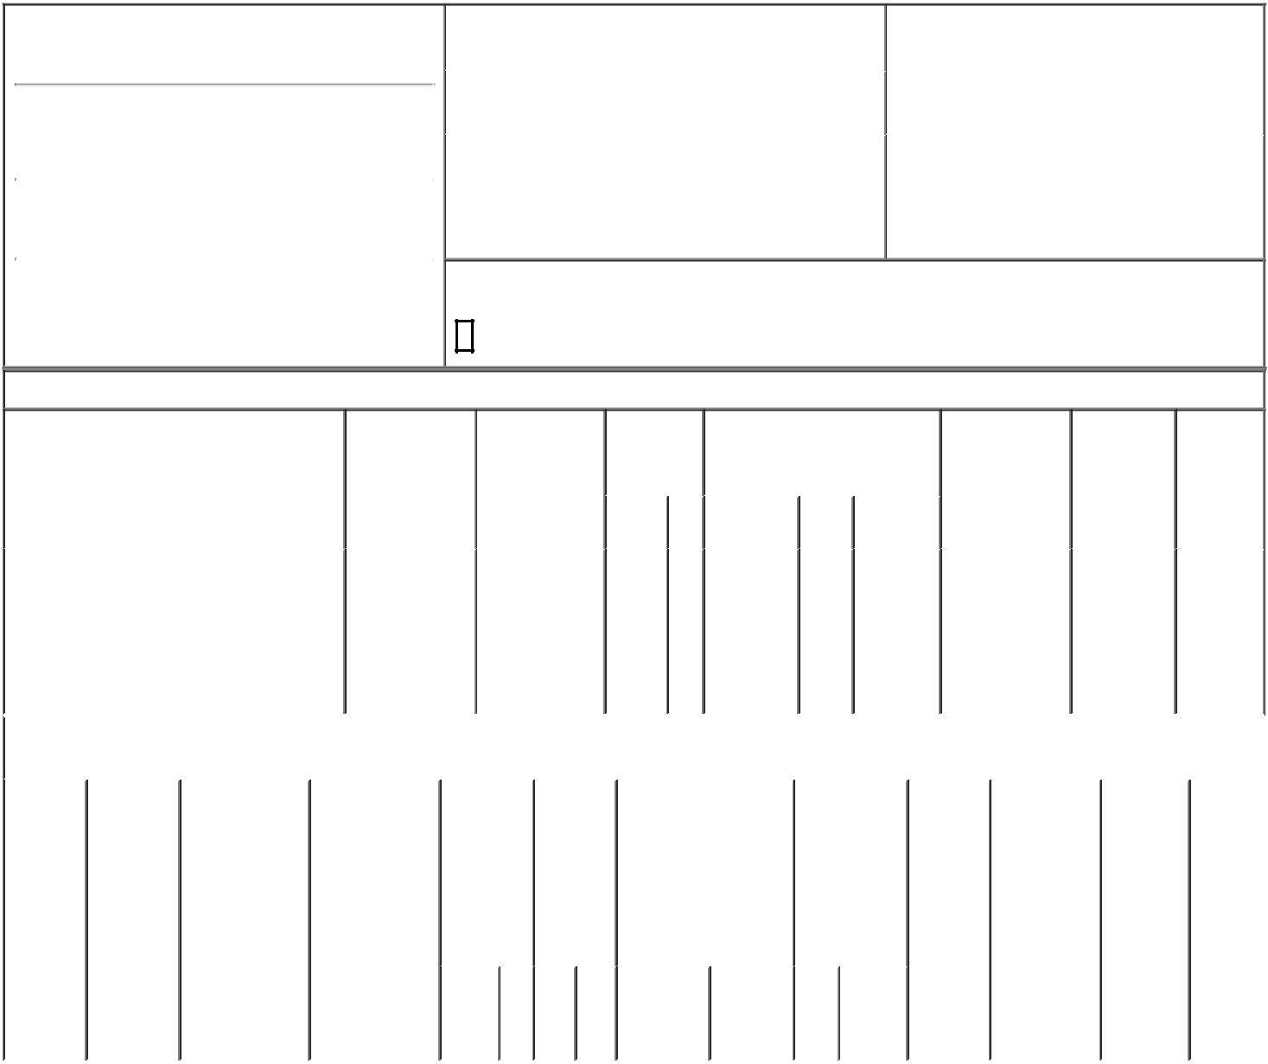

1. Name and Address of Reporting Person*
MARCUS LAWRENCE

 | (Last) | (First) | (Middle)
 | 2105 WOODSIDE RD.
(Street)
 | WOODSIDE | CA | 94062
 | (City) | (State) | (Zip)

2. |  | Issuer Name and Ticker or Trading Symbol |  | 5. | Relationship of Reporting Person(s) to Issuer
 | SOUNDHOUND AI, INC. [ SOUN ] |  |  | (Check all applicable)
 |  |  |  |  | X Director | 10% Owner
3. |  | Date of Earliest Transaction (Month/Day/Year) |  |  | Officer (give title | Other (specify
05/15/2023 |  |  |  |  | below) | below)
4. |  | If Amendment, Date of Original Filed (Month/Day/Year) |  | 6. | Individual or Joint/Group Filing (Check Applicable
Line)
X Form filed by One Reporting Person

Form filed by More than One Reporting
Person

Rule 10b5-1(c) Transaction Indication

Check this box to indicate that a transaction was made pursuant to a contract, instruction or written plan that is intended to satisfy the affirmative defense conditions of Rule 10b5-1(c). See Instruction 10.

Table I - Non-Derivative Securities Acquired, Disposed of, or Beneficially Owned

 | 1. Title of Security (Instr. 3) |  |  | 2. Transaction |  | 2A. Deemed |  |  | 3. | 4. Securities Acquired (A) or |  |  |  | 5. Amount of |  | 6. Ownership | 7. Nature
 |  |  |  | Date |  | Execution Date, |  |  | Transaction | Disposed Of (D) (Instr. 3, 4 and 5) |  |  |  | Securities |  | Form: Direct | of Indirect
 |  |  |  | (Month/Day/Year) |  | if any |  |  | Code (Instr. |  |  |  |  | Beneficially |  | (D) or | Beneficial
 |  |  |  |  |  | (Month/Day/Year) |  |  | 8) |  |  |  |  | Owned |  | Indirect (I) | Ownership
 |  |  |  |  |  |  |  |  |  |  |  |  |  | Following |  | (Instr. 4) | (Instr. 4)
 |  |  |  |  |  |  |  |  |  |  | (A) or |  |  | Reported
 |  |  |  |  |  |  |  |  | Code V | Amount |  | Price |  | Transaction(s)
 |  |  |  |  |  |  |  |  |  |  | (D) |  |  | (Instr. 3 and 4)
 |  |  |  |  |  |  |  |  |  |  |  |  |  |  |  |  | By
 |  |  |  |  |  |  |  |  |  |  |  |  |  |  |  |  | Marcus
 | Class A Common Stock |  |  | 05/15/2023 |  |  |  |  | S | 200,000 | D | $2.523⁽¹⁾ |  | 595,846 |  | I | Family
 |  |  |  |  |  |  |  |  |  |  |  |  |  |  |  |  | Trust,
 |  |  |  |  |  |  |  |  |  |  |  |  |  |  |  |  | Dated
 |  |  |  |  |  |  |  |  |  |  |  |  |  |  |  |  | 7/8/04
 |  |  | Table II - Derivative Securities Acquired, Disposed of, or Beneficially Owned
 |  |  |  | (e.g., puts, calls, warrants, options, convertible securities)
 | 1. Title of | 2. | 3. Transaction | 3A. Deemed | 4. |  | 5. |  | 6. Date Exercisable and |  | 7. Title and |  | 8. Price of |  | 9. Number of 10. |  | 11. Nature
 | Derivative | Conversion | Date | Execution Date, | Transaction |  | Number |  | Expiration Date |  | Amount of |  | Derivative |  | derivative | Ownership | of Indirect
 | Security | or Exercise | (Month/Day/Year) | if any | Code (Instr. |  | of |  | (Month/Day/Year) |  | Securities |  | Security |  | Securities | Form: | Beneficial
 | (Instr. 3) | Price of |  | (Month/Day/Year) | 8) |  | Derivative |  |  |  | Underlying |  | (Instr. 5) |  | Beneficially | Direct (D) | Ownership
 |  | Derivative |  |  |  |  | Securities |  |  |  | Derivative |  |  |  | Owned | or Indirect | (Instr. 4)
 |  | Security |  |  |  |  | Acquired |  |  |  | Security |  |  |  | Following | (I) (Instr. 4)
 |  |  |  |  |  |  | (A) or |  |  |  | (Instr. 3 and 4) |  |  |  | Reported
 |  |  |  |  |  |  | Disposed |  |  |  |  |  |  |  | Transaction(s)
 |  |  |  |  |  |  | of (D) |  |  |  |  |  |  |  | (Instr. 4)
 |  |  |  |  |  |  | (Instr. 3, 4
 |  |  |  |  |  |  | and 5)
 |  |  |  |  |  |  |  |  |  |  |  | Amount
 |  |  |  |  |  |  |  |  |  |  |  | or
 |  |  |  |  |  |  |  |  |  |  |  | Number
 |  |  |  |  |  |  |  |  | Date | Expiration |  | of
 |  |  |  |  | Code | V | (A) (D) |  | Exercisable | Date | Title | Shares

Explanation of Responses:

- This transaction was executed in multiple trades during the day at prices ranging from $2.45 to $2.57. The weighted-average price is reported above. The reporting person hereby undertakes to provide upon request to the SEC staff, the issuer or a security holder of the issuer full information regarding the number of shares and prices at which the transactions were effected.

Remarks:

/s /Warren Heit, attorney-in-
fact for MARCUS 05/17/2023
LAWRENCE

** Signature of Reporting Person Date

Reminder: Report on a separate line for each class of securities beneficially owned directly or indirectly.

* If the form is filed by more than one reporting person, see Instruction 4 (b)(v).

- Intentional misstatements or omissions of facts constitute Federal Criminal Violations See 18 U.S.C. 1001 and 15 U.S.C. 78ff(a). Note: File three copies of this Form, one of which must be manually signed. If space is insufficient, see Instruction 6 for procedure.

Persons who respond to the collection of information contained in this form are not required to respond unless the form displays a currently valid OMB Number.

LIMITED POWER OF ATTORNEY FOR REPORTING UNDER SECTION 16(a) OF THE SECURITIES EXCHANGE ACT OF 1934, AS AMENDED

MARCUS LAWRENCE - CIK # 0001248294

Know all by these presents, that the undersigned hereby constitutes and appoints Warren Heit, Nitesh Sharan, or Keyvan Mohajer, signing singly, the undersigned's true and lawful attorney-in-fact to:

- execute for and on behalf of the undersigned any Form 3, 4, or 5 in accordance with Section 16(a) of the Securities Exchange Act of 1934, as amended, and the rules thereunder;

- do and perform any and all acts for and on behalf of the undersigned which may be necessary or desirable to complete and execute any such Form 3, 4, or 5, complete and execute any amendment or amendments thereto, and timely file any such form with the United States Securities and Exchange Commission and any stock exchange or similar authority, including completing and executing a Uniform Application for Access Codes to File on Edgar on Form ID; and

- take any other action of any type whatsoever in connection with the foregoing which, in the opinion of such attorney-in-fact, may be of benefit to, in the best interest of, or legally required by, the undersigned, it being understood that the documents executed by such attorney-in-fact on behalf of the undersigned pursuant to this Power of Attorney shall be in such form and shall contain such terms and conditions as such attorney-in-fact may approve in such attorney-in-fact's discretion.

The undersigned hereby grants to each attorney-in-fact full power and authority to do and perform any and every act and thing whatsoever requisite, necessary, or proper to be done in the exercise of any of the rights and powers herein granted, as fully to all intents and purposes as the undersigned might or could do if personally present, with full power of substitution or revocation, hereby ratifying and confirming all that such attorney-in-fact, or such attorney-in-fact's substitute or substitutes, shall lawfully

do or cause to be done by virtue of this power of attorney and the rights and powers herein granted. The undersigned acknowledges that the foregoing attorneys-in-fact, in serving in such capacity at the request of the undersigned, are not assuming, any of the undersigned's responsibilities to comply with Section 16 of the Securities Exchange Act of 1934.

This Power of Attorney shall remain in full force and effect until the undersigned is no longer required to file Form 3, 4, or 5, or unless earlier revoked by the undersigned in a signed writing delivered to the foregoing attorney-in-fact.

IN WITNESS WHEREOF, the undersigned has caused this Power of Attorney to be executed as of this 22 day of April, 2022.

/s/ Lawrence Marcus

----------------------------
Signature

Lawrence Marcus

----------------------------
Print Name

